AWS Code Pipeline Integration with AWS EKS-EC2 Cluster
Overview:
Code pipeline integration with the EKS-EC2 cluster for the continuous integration and continuous deployment. To achieve this activity, Create a eks-EC2 cluster and Elastic Container Registry to push the docker image as part of the CI/CD, create a codebuild project where we use the buildspec.yaml. Build this sourcecode and configure the code pipeline with the multiple phases as code commit, code build and code deploy. In code deploy we use appspec.yaml. In this, we will define the source and destination to create a eks-ec2 cluster.
EKS Features :
Eksctl
LoadBalancing
Networking and Security
Serverless Compute
Hybrid Deployments
Logging.
Why Amazon EKS ?
Kubernetes is an open-source tool for automating the deployment, scaling, and management of containerized applications.
Amazon Elastic Kubernetes Service (Amazon EKS) is a managed service that makes it easy for us to run Kubernetes on AWS without maintaining our own Kubernetes control plane.
Amazon EKS runs Kubernetes control plane instances across multiple Availability Zones to ensure high availability and it automatically detects and replaces unhealthy control plane instances, and provides automated version upgrades and patching.
Amazon EKS is also integrated with many AWS services to provide scalability and security for your applications, including the following:
- Amazon ECR for container images
- Elastic Load Balancing for load distribution
- IAM for authentication
- Amazon VPC for isolation

How It Works?
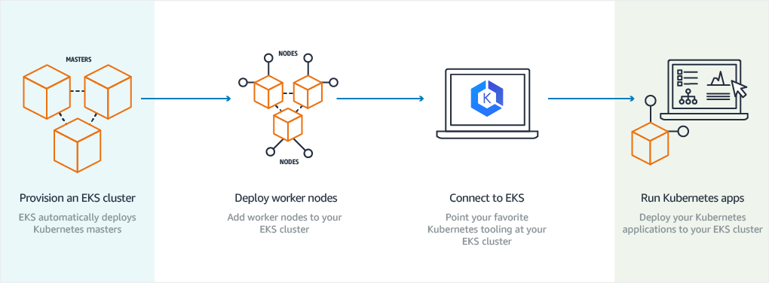

To get test the features of AWS Services, Create a free AWS account.
For more information on activity, please drop a mail to vamsi.rajudatla@infosys.com

