Applitools

Overview:
Applitools is an User Interface (UI) testing tool which helps in quick check of look and feel interface of any application without affecting UI elements, it comes with vast options of integration with different tools in the market like: - Jenkins, Selenium, Sauce labs, JIRA etc. It is a modern solution for web. Mobile and desktop applications.

Features:
- Bug Highlighting

It helps in finding out accurate change on the Application, and we can also create reports based on it to share with other teammates or developers, so that they can quickly find out exact difference in between base screenshot and actual screenshot.

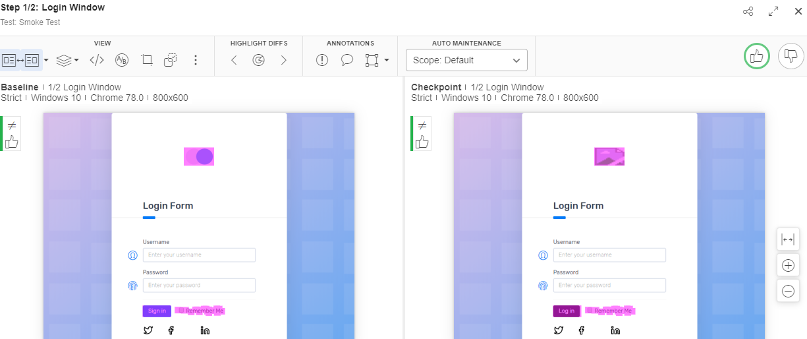

- User access Management

We can create multiple groups and assign roles accordingly, so that each team has specified controls on the application testing, we can give access based on Single sign on (SSO) or Identity provider mechanisms.

- Test Maintenance

We can quickly accept or reject the application test results based upon the validation which are generated as reports, it helps identifying the bugs easily.

- Cloud accessibility

We have a major advantage of setting up your company in Cloud environment as Private or Public, which helps in high level of security.

- Community

Applitools helps in engaging different organization teams by sharing reports or screenshots of visual test, so that we can immediately fetch solution to the bunch of issues to our real-world organization success.

- Artificial Intelligence

Applitools has very high level of algorithms implemented for easy predictable difference of Visual tests which helps in reducing maintenance/ reusable work.

- Cross-platform flexibility

Applitool uses single type of baseline to detect unfunctional components on different cross platform devices easily.

To get access to the tool, Create a free Applitools account.

For more information on applitools, please drop a note to Venkatesh.singu@infosys.com

