Kubernetes

Most of legacy systems contains big monolithic software applications which runs as a single processor (or) small number of processes spread across multiple different servers. In general, these applications have slower release cycles, in-frequent updates and delayed resolutions. In today’s context, such kind of big monolithic applications are slowly being broken down into smaller, scalable, independently running components called as microservices. Since by their design, microservices are de-coupled from each other and can be developed, deployed, scaled and updated individually. This helps us to update components quickly and keep us in pace with current rapidly changing business requirements.
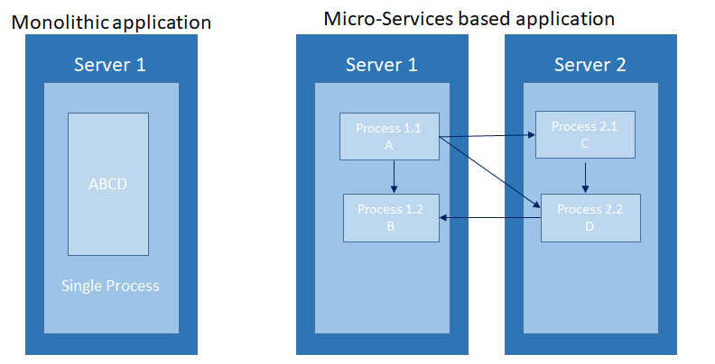
Figure 1: Monolithic application vs micro-services based application
But with bigger numbers of deployable components and their respective data scaling at faster pace, it becomes increasingly difficult to configure, manage and keep the whole system running as expected. It also becomes difficult to figure out where to put each of these components to achieve high resource utilization and thereby keeping hard cost down. In order to automate this, there was a need for automatic scheduling of these components to respective servers, automatic configurations, supervising components and fault handling. This has led to the need of Kubernetes.
Using Kubernetes, helps developers to deploy their respective applications (or) microservices by themselves without any assistance from operations team. Kubernetes also helps operations team by automatically monitoring and rescheduling the respective applications in case of hardware failure. There is a clear paradigm shift for administrators from managing and supervising individual applications to mostly supervising and managing Kubernetes which by itself takes care of respective applications.
Kubernetes allows us to deploy and run software components without having to know about the actual servers underneath. In a situation where we would like to deploy multi-component application through Kubernetes, it selects a server for each component, deploys it and enables it to easily find and communicate with all other respective components of the application.
This makes Kubernetes start to provide benefits for on-premise data centers but where it started to be great is when it is used in largest data centers used by cloud providers. With many organizations adopting Kubernetes in a very effective manner to run applications, it has become the standard way of running distributed applications both in cloud and as well as in on-premise data centers as well.
Kubernetes allows you to easily deploy and manage containerized applications on top of it. It relies on the features of Linux containers to run heterogeneous applications without having to know any internal details of the applications and without having manually deploy these applications on each host. Since these applications run in containers, they do not affect other applications running on the same server which is very critical when applications for completely different organizations run on the same hardware.
Kubernetes enables you to run software applications on thousands of computer nodes. It clearly abstracts away the underlying infrastructure resulting in simplified development, deployment and manageability. Deploying applications through Kubernetes is always same, whether cluster contains only two nodes (or) hundreds of nodes.
Kubernetes cluster is comprised of below mentioned types,
- Master Node – Hosts Kubernetes Control Plane that’s control and manages the whole Kubernetes System.

- Worker Nodes – Runs the actual application that we deploy.

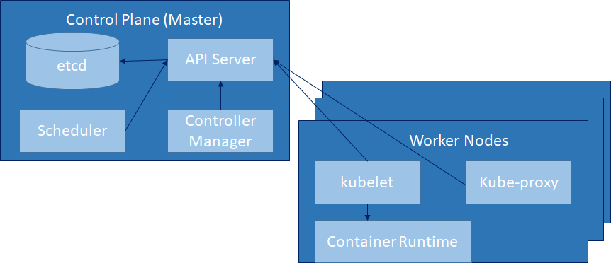
Figure 2: Components in a Kubernetes Cluster

Control Plane
The Control Plane is what controls the cluster and makes it function. It consists of multiple components that can run on a single master node or be split across multiple nodes and replicated to ensure high availability. These components are mentioned below,
- The Kubernetes API Server, which you and the other Control Plane components communicate.
- The Scheduler, which schedules apps (assigns a worker node to each deployable component of application)
- The Controller Manager, which performs cluster-level functions, such as replicating components, keeping track of worker nodes, handling node failures.
- etcd, a reliable distributed data store that persistently stores the cluster configuration.
The components of the Control Plane hold and control the state of the cluster, but they don’t run applications. This is done by the (worker) nodes.
The Nodes
The worker nodes are the machines that run containerized applications. The task of running, monitoring, and providing services to applications is done by the following components:
- Docker or another container runtime, which runs containers
- The Kubelet, which talks to the API server and manages containers on its node
- The Kubernetes Service Proxy (kube-proxy), which load-balances network traffic between application components.

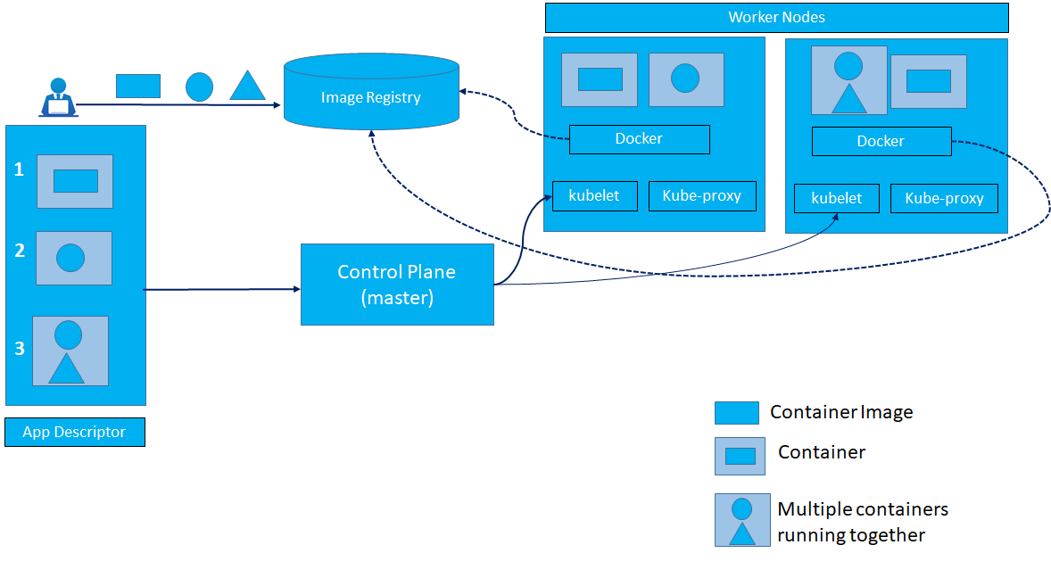
Figure 3: Overview of Kubernetes architecture and applications running on it.

Benefits of using Kubernetes
If you have Kubernetes deployed on all servers, the ops team does not need to deal with deploying application anymore. Because a containerized application already contains all it needs to run, the system administrators don’t need to install anything to deploy and run the app. On any node where Kubernetes is deployed, Kubernetes can run the application immediately without any help from the administrators.
- Simplifying application deployment and development
Kubernetes exposes all its worker nodes as a single deployment platform, application developers can start deploying applications on their own and don’t need to know anything about the servers that make up the cluster.
Since all the nodes are now a single set of computational resources that are waiting for applications to consume them, developers does not usually need to know the kind of server the respective application is running on, as long as the server can provide the application with adequate system resources.
- Health Checking and Self-Healing
Kubernetes monitors respective components and the nodes they run on and automatically reschedules them to other nodes in the event of a node failure.

- Automatic Scaling

Using Kubernetes to manage deployed applications also means the operations team does not need to constantly monitor the load of individual applications to react to sudden increase in spike. Kubernetes can monitor the resources used by each application and to keep adjusting the number of running instances of each application.

- Achieving better utilization of hardware

By setting up Kubernetes on servers and using it to run apps instead of running them manually, we had decoupled respective application from the infrastructure. The ability to move applications around the cluster at any time allows Kubernetes to utilize the infrastructure much better than manual process.

