**Fall 2022: CS5710 – Machine Learning**

**In-Class Programming Assignment-6**

Name: Vamsi Krishna Mekala

Id: 700742751

Video link: <https://drive.google.com/file/d/1sdEhQJXiqnVpf761pcNao8UKExpaP946/view?usp=share_link>

GitHub: <https://github.com/vamsi-mekala/ML-Assignment-6>

1) (Provide only mathematical solutions for this question)

Six points with the following attributes are given, calculate and find out clustering representations and dendrogram using Single, complete, and average link proximity function in hierarchical clustering technique.

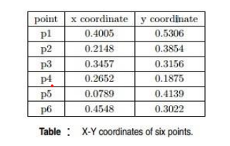

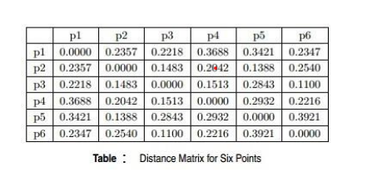

**Solution,Code&Output:**

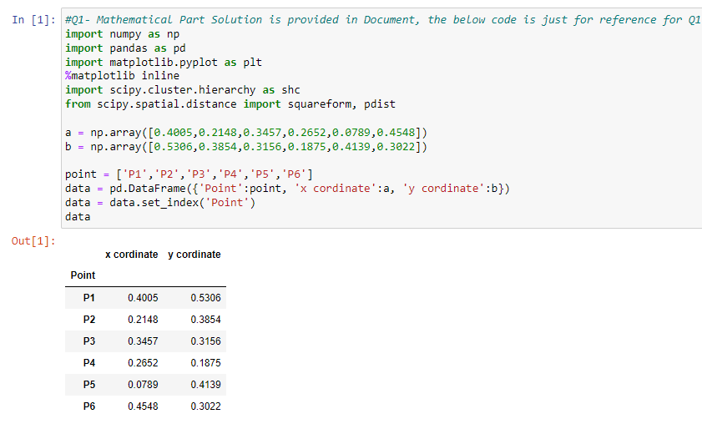

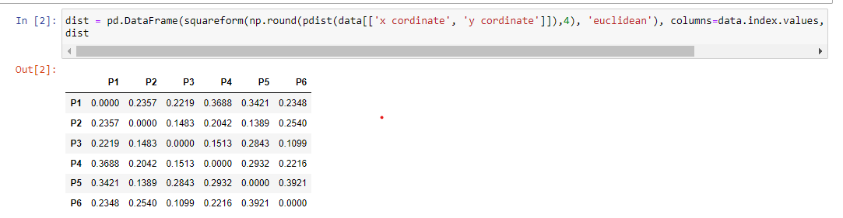

**Single Link Proximity:**

* In **Single Linkage,**the distance between two clusters is the minimum distance between members of the two clusters

|  |  |  |  |  |  |  |  |  |  |  |  |
| --- | --- | --- | --- | --- | --- | --- | --- | --- | --- | --- | --- |
|  | | **p1** | | **p2** | | **p3** | | **p4** | | **p5** | **p6** |
| **p1** | | 0 | | 0.2357 | | 0.2218 | | 0.3688 | | 0.3421 | 0.2347 |
| **p2** | | 0.2357 | | 0 | | 0.1483 | | 0.2042 | | 0.1388 | 0.254 |
| **p3** | | 0.2218 | | 0.1483 | | 0 | | 0.1513 | | 0.2843 | 0.11 |
| **p4** | | 0.3688 | | 0.2042 | | 0.1513 | | 0 | | 0.2932 | 0.2216 |
| **p5** | | 0.3421 | | 0.1388 | | 0.2843 | | 0.2932 | | 0 | 0.3921 |
| **p6** | | 0.2347 | | 0.254 | | 0.11 | | 0.2216 | | 0.3921 | 0 |
|  | |  | |  | |  | |  | |  |  |
| smallest distance from above data is | | | | | | | | | | 0.11 |  |
| so p3 and p6 forms first cluster | | | | | | | | | | |
|  | **p1** | | **p2** | | **p36** | | **p4** | | **p5** | |
| **p1** | 0 | | 0.2357 | | 0.2218 | | 0.3688 | | 0.3421 | |
| **p2** | 0.2357 | | 0 | | 0.1483 | | 0.2042 | | 0.1388 | |
| **p36** | 0.2218 | | 0.1483 | | 0 | | 0.1513 | | 0.2843 | |
| **p4** | 0.3688 | | 0.2042 | | 0.1513 | | 0 | | 0.2932 | |
| **p5** | 0.3421 | | 0.1388 | | 0.2843 | | 0.2932 | | 0 | |
|  |  | |  | |  | |  | |  | |
| smallest distance from above data is | | | | | | | | | 0.1388 | |

|  |  |  |  |  |  |
| --- | --- | --- | --- | --- | --- |
| so p2 and p5 forms 2nd cluster | | | | | |
|  | **p1** | **p25** | **p36** | **p4** |  |
| **p1** | 0 | 0.2357 | 0.2218 | 0.3688 |  |
| **p25** | 0.2357 | 0 | 0.1483 | 0.2042 |  |
| **p36** | 0.2218 | 0.1483 | 0 | 0.1513 |  |
| **p4** | 0.3688 | 0.2042 | 0.1513 | 0 |  |
|  |  |  |  |  |  |
| smallest distance from above data is | | | | | 0.1483 |
| so p25 and p36 forms 3rdcluster | | | | | |
|  |  |  |  |  |  |
|  | **p1** | **p(25)(36)** | **p4** |  |  |
| **p1** | 0 | 0.2218 | 0.3688 |  |  |
| **p(25)(36)** | 0.2218 | 0 | 0.1513 |  |  |
| **p4** | 0.3688 | 0.1513 | 0 |  |  |
|  |  |  |  |  |  |
| smallest distance from above data is | | | | | 0.153 |
| so p(25)(36)and p4 forms 4thcluster | | | | | |
|  | **p1** | **p4(25)(36)** |  |  |  |
| **p1** | 0 | 0.2218 |  |  |  |
| **p4(25)(36)** | 0.2218 | 0 |  |  |  |

**1 4 2 5 3 6**

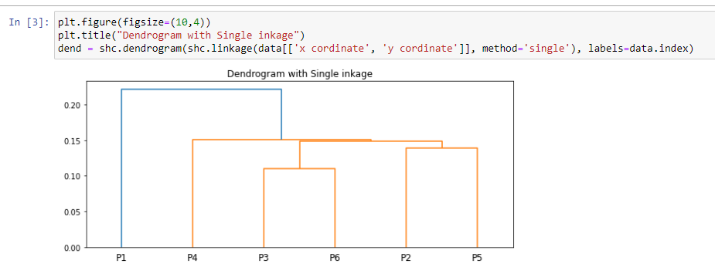

**Complete Link Proximity:**

* In **Complete Linkage,**the distance between two clusters is the maximum distance between members of the two clusters

|  |  |  |  |  |  |  |
| --- | --- | --- | --- | --- | --- | --- |
|  | **p1** | **p2** | **p3** | **p4** | **p5** | **p6** |
| **p1** | 0 | 0.2357 | 0.2218 | 0.3688 | 0.3421 | 0.2347 |
|  |  |  |  |  |  |  |
|  |  |  |  |  |  |  |
| **p2** | 0.2357 | 0 | 0.1483 | 0.2042 | 0.1388 | 0.254 |
| **p3** | 0.2218 | 0.1483 | 0 | 0.1513 | 0.2843 | 0.11 |
| **p4** | 0.3688 | 0.2042 | 0.1513 | 0 | 0.2932 | 0.2216 |
| **p5** | 0.3421 | 0.1388 | 0.2843 | 0.2932 | 0 | 0.3921 |
| **p6** | 0.2347 | 0.254 | 0.11 | 0.2216 | 0.3921 | 0 |
|  |  |  |  |  |  |  |
| smallest distance from above data is | | | | | 0.11 |  |
| so p3 and p6 forms first cluster | | | | | |  |
|  | **p1** | **p2** | **p36** | **p4** | **p5** |  |
| **p1** | 0 | 0.2357 | 0.2347 | 0.3688 | 0.3421 |  |
| **p2** | 0.2357 | 0 | 0.254 | 0.2042 | 0.1388 |  |
| **p36** | 0.2347 | 0.254 | 0 | 0.2216 | 0.3921 |  |
| **p4** | 0.3688 | 0.2042 | 0.2216 | 0 | 0.2932 |  |
| **p5** | 0.3421 | 0.1388 | 0.3921 | 0.2932 | 0 |  |
|  |  |  |  |  |  |  |
| smallest distance from above data is | | | | | 0.1388 |  |
| so p2 and p5 forms 2nd cluster | | | | | |  |
|  | **p1** | **p25** | **p36** | **p4** |  |  |
| **p1** | 0 | 0.3421 | 0.2347 | 0.3688 |  |  |
| **p25** | 0.3421 | 0 | 0.3921 | 0.2932 |  |  |
| **p36** | 0.2347 | 0.3921 | 0 | 0.2216 |  |  |
| **p4** | 0.3688 | 0.2932 | 0.2216 | 0 |  |  |
|  |  |  |  |  |  |  |
| smallest distance from above data is | | | | | 0.2216 |  |
| so p25 and p36 forms 3rdcluster | | | | | |  |
|  | **p1** | **p(25)(36)** | **p4** |  |  |  |
| **p1** | 0 | 0.3421 | 0.3688 |  |  |  |
| **p(25)(36)** | 0.3421 | 0 | 0.2932 |  |  |  |
| **p4** | 0.3688 | 0.2932 | 0 |  |  |  |
|  |  |  |  |  |  |  |
| smallest distance from above data is | | | | | 0.2932 |  |
| so p(25)(36)and p1 forms 4thcluster | | | | | |  |
|  | **p1(25)(36)** | **p4** |  |  |  |  |
| **p1(25)(36)** | 0 | 0.1483 |  |  |  |  |
| **p4** | 0.3688 | 0 |  |  |  |  |

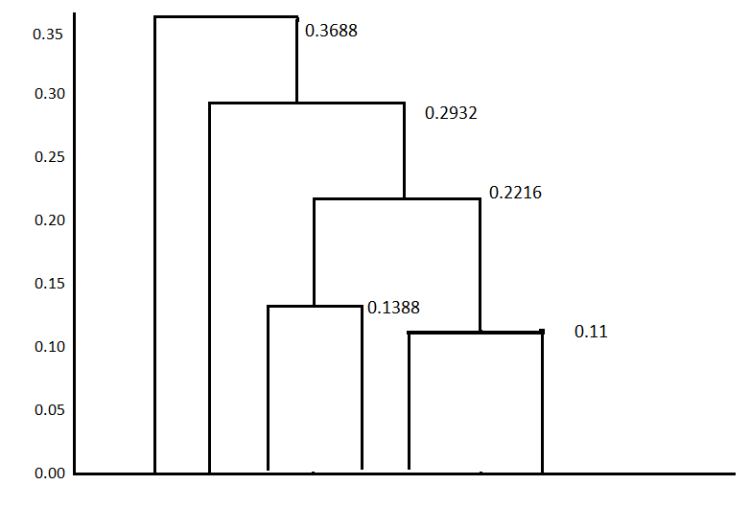

**4 1 2 5 3 6**

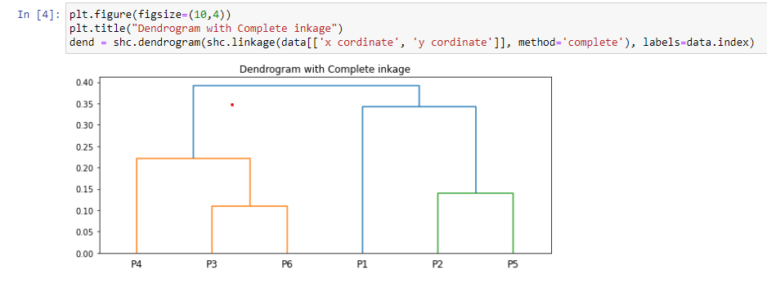

**Average Link Proximity:**

In **Average Linkage,**the distance between two clusters is the average of all distances between members of the two clusters

|  |  |  |  |  |  |  |
| --- | --- | --- | --- | --- | --- | --- |
|  | **p1** | **p2** | **p3** | **p4** | **p5** | **p6** |
| **p1** | 0 | 0.2357 | 0.2218 | 0.3688 | 0.3421 | 0.2347 |
| **p2** | 0.2357 | 0 | 0.1483 | 0.2042 | 0.1388 | 0.254 |
| **p3** | 0.2218 | 0.1483 | 0 | 0.1513 | 0.2843 | 0.11 |
| **p4** | 0.3688 | 0.2042 | 0.1513 | 0 | 0.2932 | 0.2216 |
| **p5** | 0.3421 | 0.1388 | 0.2843 | 0.2932 | 0 | 0.3921 |
| **p6** | 0.2347 | 0.254 | 0.11 | 0.2216 | 0.3921 | 0 |
|  |  |  |  |  |  |  |
| smallest distance from above data is | | | | | 0.11 |  |
| so p3 and p6 forms first cluster | | | | | |  |
|  | **p1** | **p2** | **p36** | **p4** | **p5** |  |
| **p1** | 0 | 0.2357 | 0.22825 | 0.3688 | 0.3421 |  |
| **p2** | 0.2357 | 0 | 0.20115 | 0.2042 | 0.1388 |  |
| **p36** | 0.22825 | 0.20115 | 0 | 0.18645 | 0.3382 |  |
| **p4** | 0.3688 | 0.2042 | 0.18645 | 0 | 0.2932 |  |
| **p5** | 0.3421 | 0.1388 | 0.3382 | 0.2932 | 0 |  |
|  |  |  |  |  |  |  |
| smallest distance from above data is | | | | | 0.1388 |  |
| so p2 and p5 forms 2nd cluster | | | | | |  |
|  | **p1** | **p25** | **p36** | **p4** |  |  |
| **p1** | 0 | 0.2889 | 0.2347 | 0.3688 |  |  |
| **p25** | 0.2889 | 0 | 0.269675 | 0.2487 |  |  |
| **p36** | 0.2347 | 0.269675 | 0 | 0.18645 |  |  |
| **p4** | 0.3688 | 0.2487 | 0.18645 | 0 |  |  |
|  |  |  |  |  |  |  |
| smallest distance from above data is | | | | | 0.18645 |  |
| so p25 and p36 forms 3rdcluster | | | | | |  |
|  | **p1** | **p(25)(36)** | **p4** |  |  |  |
| **p1** | 0 | 0.2618 | 0.3688 |  |  |  |
| **p(25)(36)** | 0.2618 | 0 | 0.217575 |  |  |  |
| **p4** | 0.3688 | 0.217575 | 0 |  |  |  |
|  |  |  |  |  |  |  |
| smallest distance from above data is | | | | | 0.217575 |  |
| so p(25)(36)and p1 forms 4thcluster | | | | | |  |
|  | **p1(25)(36)** | **p4** |  |  |  |  |
| **p1(25)(36)** | 0 | 0.3153 |  |  |  |  |
| **p4** | 0.3153 | 0 |  |  |  |  |

**4 1 2 5 3 6**

