**Maven**

**Part 1**

* What is Maven ?
* What are advantages of Maven ?
* What is pom.xml ?
* What is dependency & plugin ?

Maven is a build tool provided by apache software foundation

dependencies are responsible for downloading 3rd party libraries/jars

plugins have all the required configuration related to the project

plugins controls or organize the project

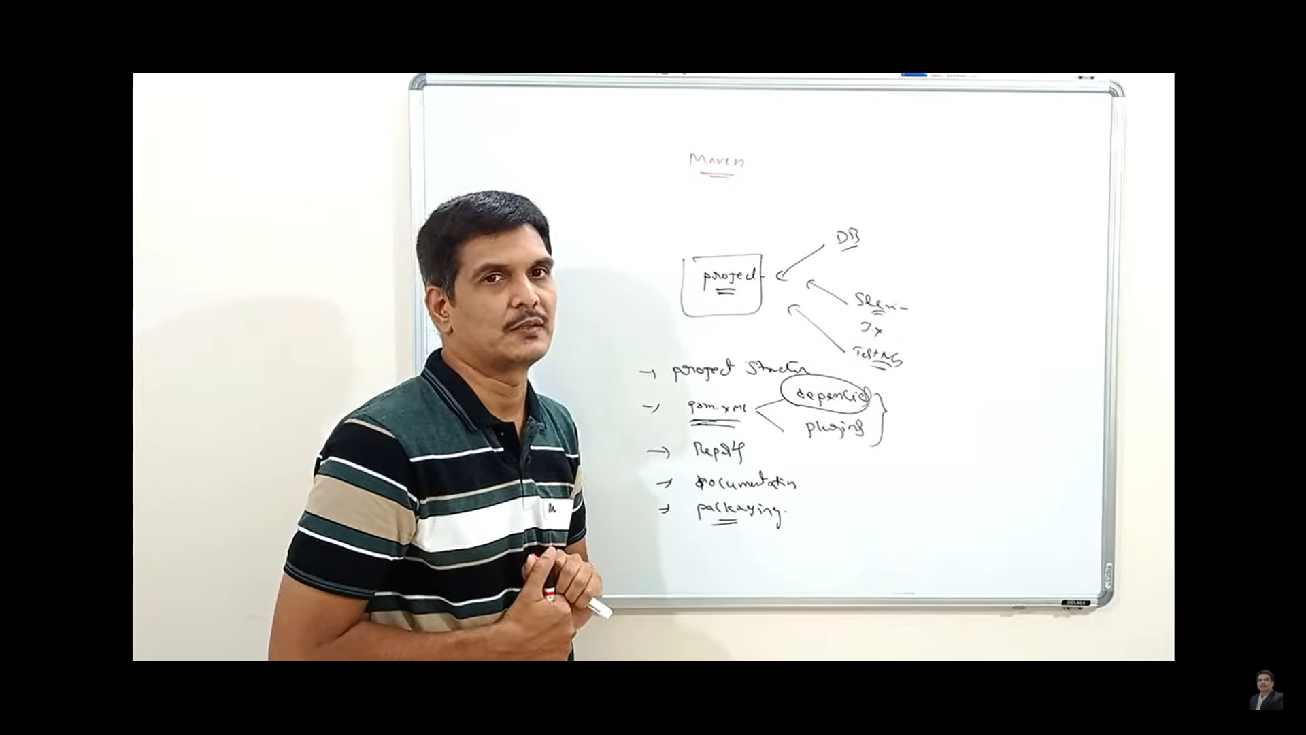

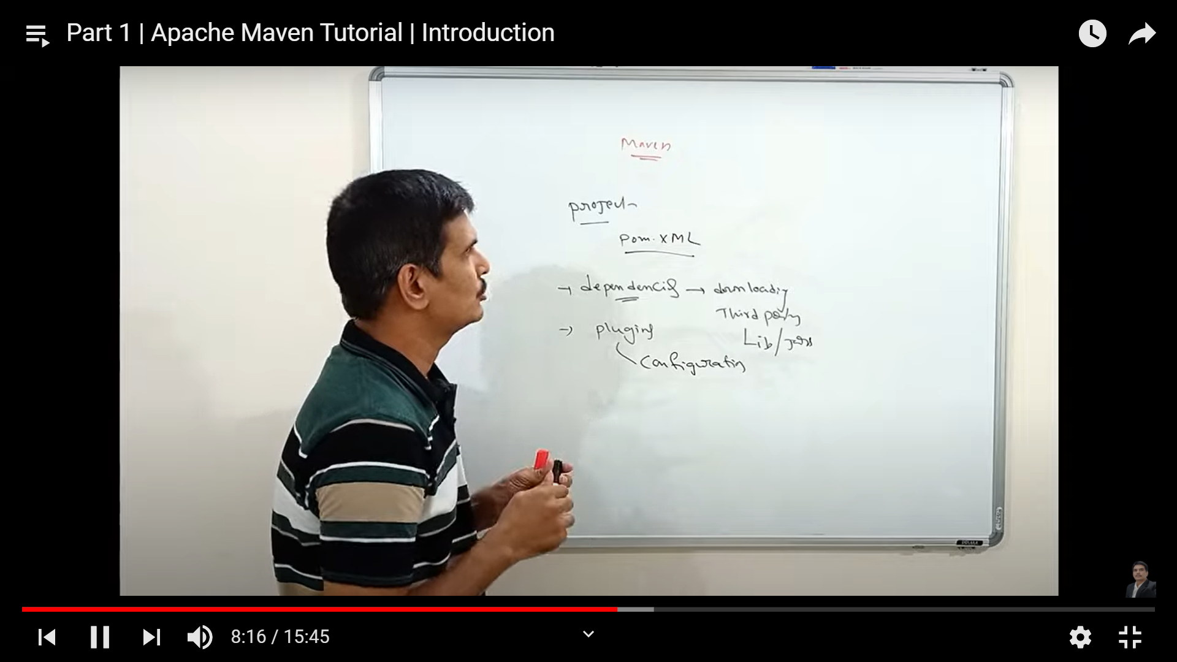

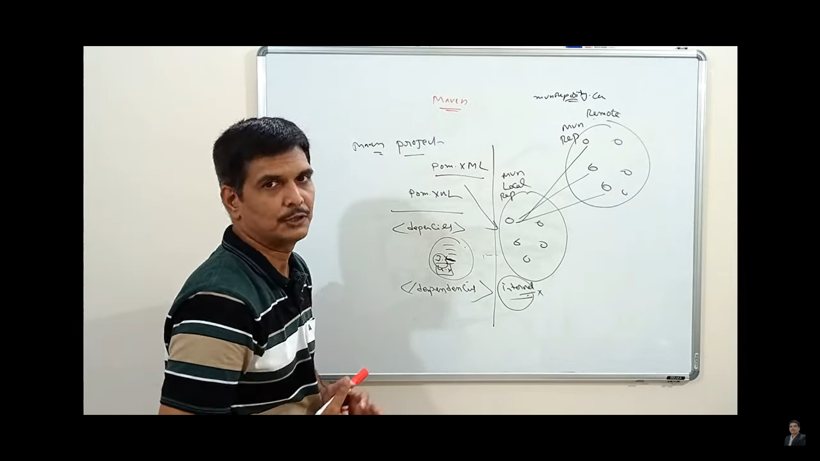

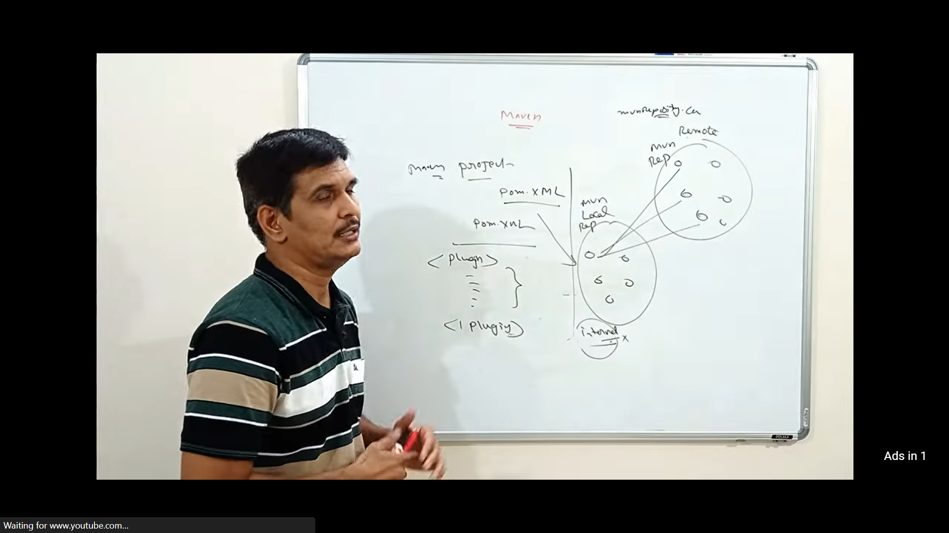

**Part 2**

* Create a Maven project in Eclipse
* Maven Project folder structure
* Project Object Model (pom.xml)
* Maven Build Life Cycle

<https://www.lambdatest.com/blog/how-to-install-testng-in-eclipse-step-by-step-guide/>

**Project folder structure**

src/main/java -> development code

src/main/resources -> resources used by development code

src/test/java -> testing code to perform unit tests using Junit, TestNG etc

src/test/resources -> resources used by testing code

Other folders like src, target are used by maven to create temporary files while running the project

**Project Object Model (pom.xml)**

<dependencies>

</dependencies>

Inside dependencies tag to import desired jars/libraries into our project we need to add dependency from maven

repository

<https://mvnrepository.com/artifact/org.testng/testng>

<!-- https://mvnrepository.com/artifact/org.testng/testng -->

<dependency>

<groupId>org.testng</groupId>

<artifactId>testng</artifactId>

<version>7.4.0</version>

<scope>test</scope>

</dependency>

**Maven Build Life Cycle**

* Validate
* Compile
* Test
* Package
* Integration Test
* Verify
* Install -> install in local repository
* Deploy -> install in remote rep’s to use by other projects

install command will create a jar file

**Part 3**

* How to integrate Selenium with maven project in Eclipse ?
* How to run Selenium Tests in Eclipse using Maven ?
* Maven Surefire plugin
* How to generate Maven report ?

Maven related outputs will be generated in target folder

Testng related outputs will be generated in test-output folder

Add dependencies in pom.xml file

Write code

To run testng test cases , first we need to generate testng.xml file, later we need to run testng.xml file as TestNG suite

To generate testng.xml file

* Right click on package
* Go to TestNG > Convert to TestNG
* Later one pop-up will come, click on finish button
* It will generate a testng.xml file inside the project folder

To run all testng tests using maven we need to add Surefire plugin in pom.xml file

Maven Surefire plugin url : <https://maven.apache.org/surefire/maven-surefire-plugin/usage.html>

After adding surefire plugin we need to add following

<**configuration**>

<**suiteXmlFiles**>

<**suiteXmlFile**>testng.xml</**suiteXmlFile**>>

</**suiteXmlFiles**>

</**configuration**>

Update project every time when we make changes in pom.xml file

To update project

* Right Click on Project
* Go to Maven > Update project

Then run as maven test to run all TestNG related test cases using pom.xml

To view maven report, go to target folder > index.html

**Part 4**

* How to install & setup maven on windows ?
* How to run Maven Project from command line (CLI) ?
* Maven Commands

Maven for windows: [Maven – Download Apache Maven](https://maven.apache.org/download.cgi?Preferred=ftp://ftp.osuosl.org/pub/apache/)

Set Environment Variables

MAVEN_HOME: D:\apache-maven-3.8.1\

M2_HOME: D:\apache-maven-3.8.1\

And also add path to path system variable

Project Location: C:\Users\vamsi\OneDrive\Desktop\Java-WS\mavenexample

Open command prompt, go to project location and try this commands 😊

Maven Commands

* mvn -version
* mvn clean
* mvn validate
* mvn compile
* mvn test
* mvn package
* mvn install
* mvn deploy