**Selenium with Java Tutorial**

**Selenium Documentaion:** [**https://www.selenium.dev/selenium/docs/api/java/index.html?overview-summary.html**](https://www.selenium.dev/selenium/docs/api/java/index.html?overview-summary.html)

**Part 1**

* What is selenium ?
* What are the components available in Selenium ?
* What is WebDriver ?
* Advantages & Disadvantages

Selenium

* **Selenium** is a free (open-source) automated testing framework used to validate web applications across different browsers and platforms
* Selenium Software is not just a single tool but a suite of software

Selenium Components

* Selenium IDE
* Selenium Remote Control (RC) (deprecated from 2.0)
* Selenium WebDriver
* Selenium Grid

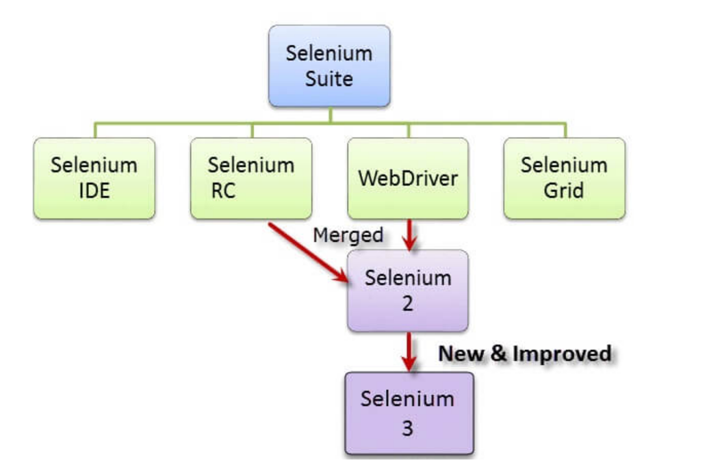

What is WebDriver

* It is a java interface
* It is also an API
* One of the components of the selenium suite to automate web browsers

Adavantages

* Supports multiple languages, web browsers, operating systems
* It is open source and freely available

Disadvantages

* Automates only web browsers
* It cannot automate the window based applications (Eg:File Upload)
* It doesn’t supoort graphs (because graphs generate data dynamically)
* It doesn’t generate the reports

Alternatives

* AutoIt for File Upload, Sikilui for screen scrolling
* For data driven testing using EXCEL we can use apache POI libraray
* For generating reports we could us external third parties reports like allure report [https://docs.qameta.io/allure/]

**Part 2**

* Selenium Web Driver Architecture

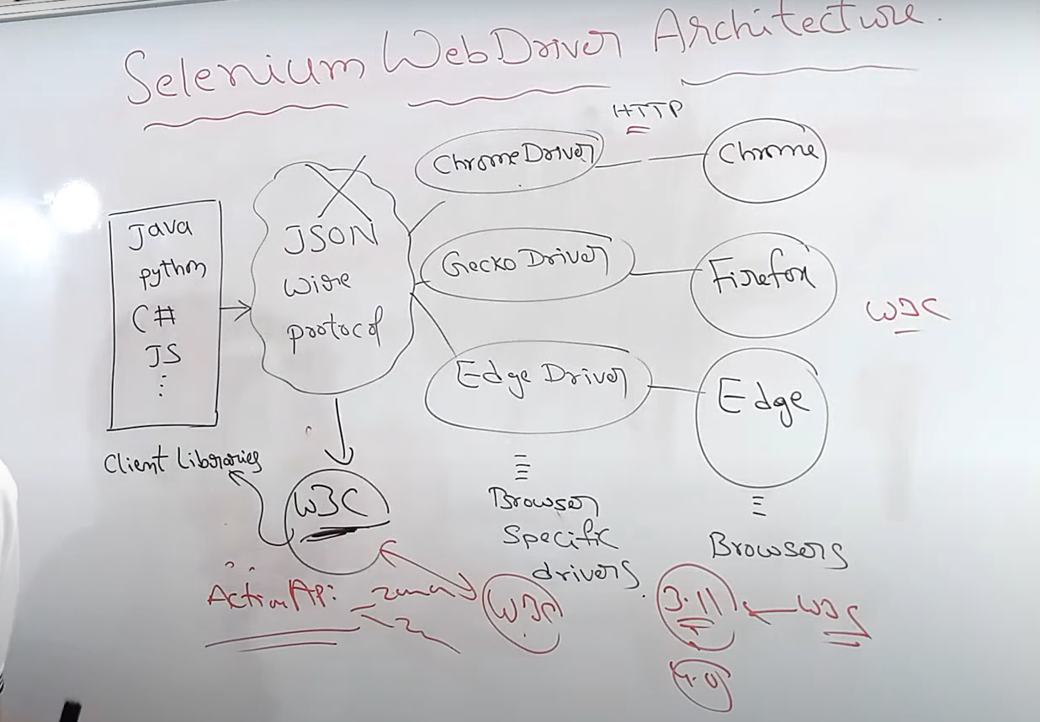

* Up to 3.8.x json wire protocol were used by client libraries to communicate with web drivers

which requires encoding and decoding for communication between them.

* From 3.11.0 w3c protocol is using for accessing web drivers because all the web drivers and web browsers support w3c protocol. This protocol also gives fast communication, stability, consistency between client libraries and web driver. And also support ActionApi classes to zoom in, zoom out the browsers, many more.

**Part 3**

* How to launch Browser in WebDriver ?
* How to open URL ?
* How to capture Title of the page ?
* How to capture URL of the page ?
* How to capture page source of the page ?

To add selenium jar dependencies into the maven project

<https://mvnrepository.com/artifact/org.seleniumhq.selenium/selenium-java>

**How to launch Browser in WebDriver**

Types of browsers

Chrome: chromedriver

<https://chromedriver.chromium.org/downloads>

Firefox: geckodriver

<https://github.com/mozilla/geckodriver/releases>

Edge: msedgedriver

<https://developer.microsoft.com/en-us/microsoft-edge/tools/webdriver/>

WebDriverManager

* Using this class, no need to add web drivers paths explicitly to our program
* Instead we can add WebDriverManager Dependency in pom.xml file
* <https://mvnrepository.com/artifact/io.github.bonigarcia/webdrivermanager>

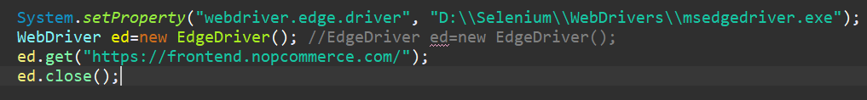

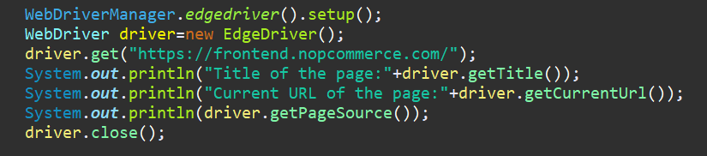

**Part 4**

* How to check WebElement is Displayed, Enabled and Selected ?

Methods

* isDisplayed ()
* isEnabled()
* isSelected()

These methods are called conditional methods or conditional commands

For demo purpose, use the following web site

<https://demo.nopcommerce.com/register>

**Part 5**

* How to navigate Back & Forward ?
* How to refresh Page ?
* What is the difference between get() & navigate.to() ?

Methods

* driver.navigate().back()
* driver.navigate().forward()
* driver.navigate().refresh()
* driver.navigate().to()

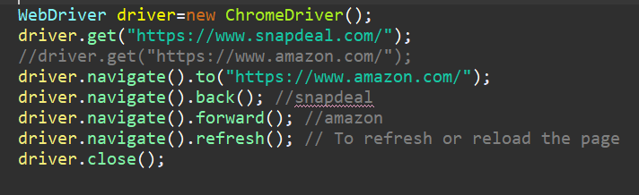

Difference between get() and navigate.to() **according to internet**

* get() is used to navigate particular URL(website) and wait till page loads.
* naviagate().to() is used to navigate particular URL(website) and does not

wait till page loads.It maintains browser history or cookies to navigate back and forward.

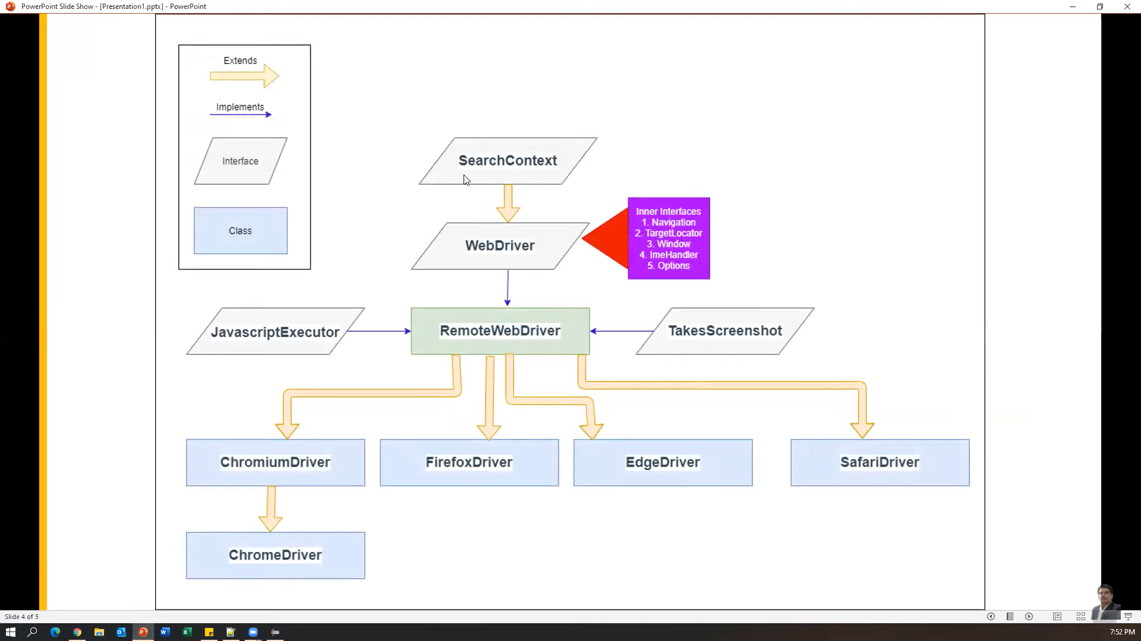

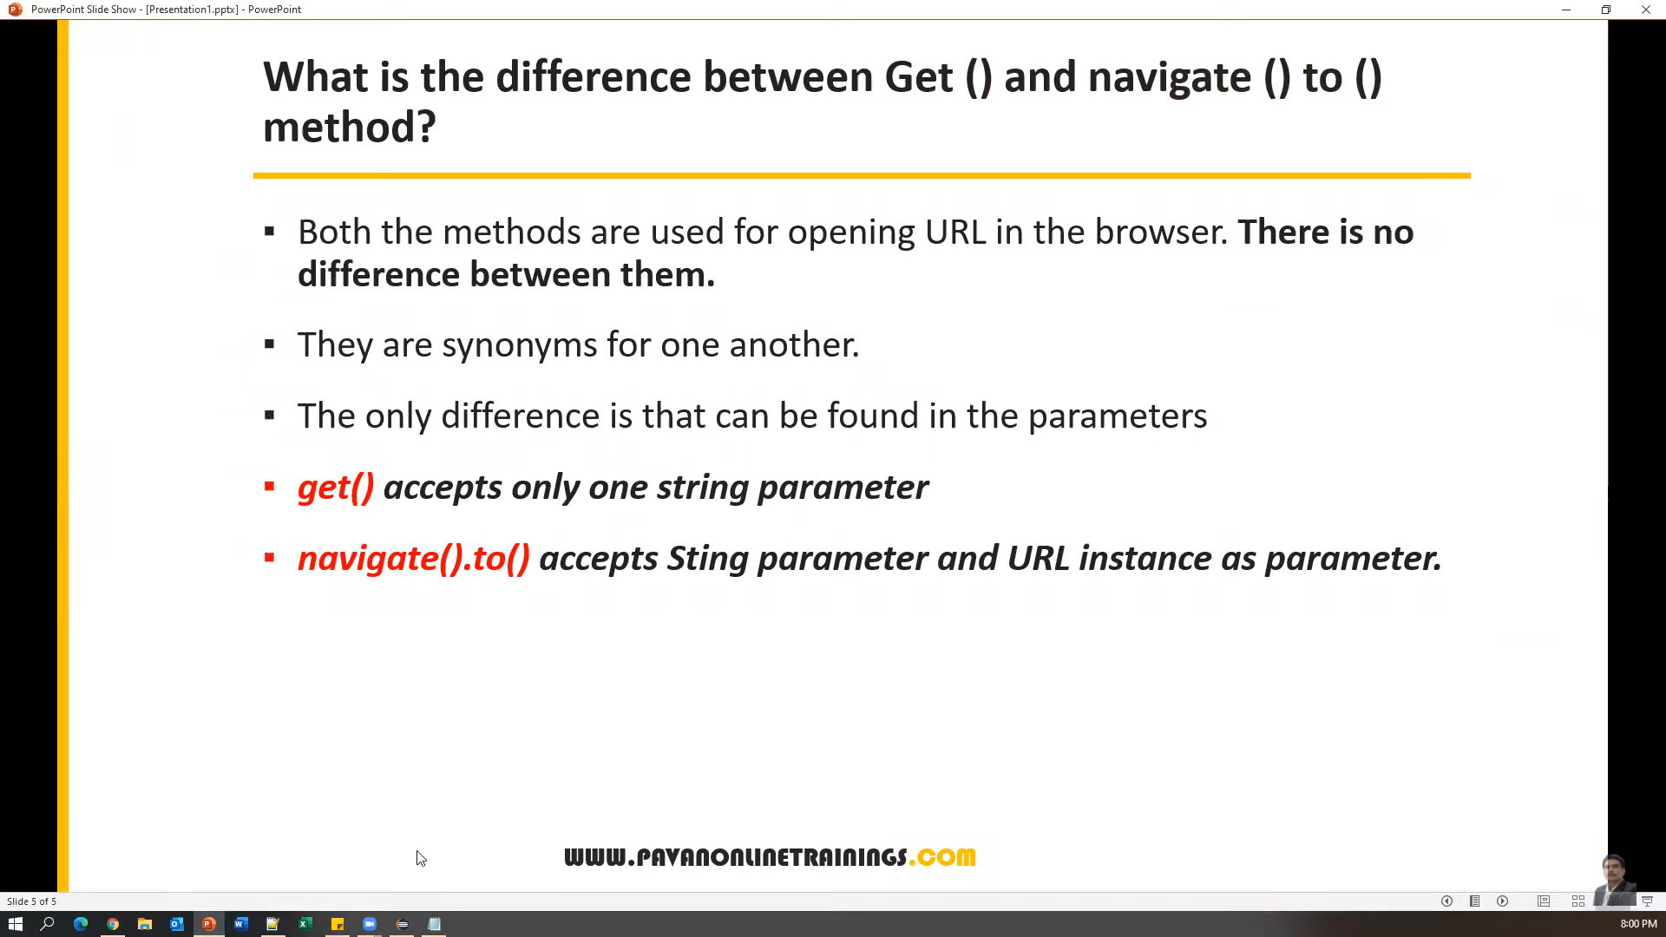

**Part 6**

* What is the difference between findElement() and findElements() in Selenium WebDriver ?

Practice URL: [nopCommerce demo store](https://demo.nopcommerce.com/)

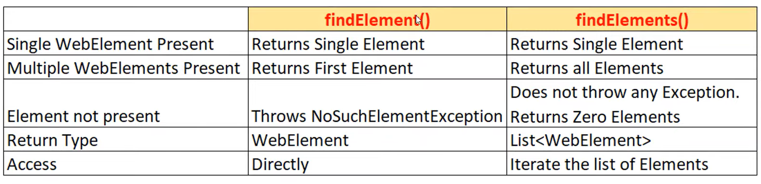

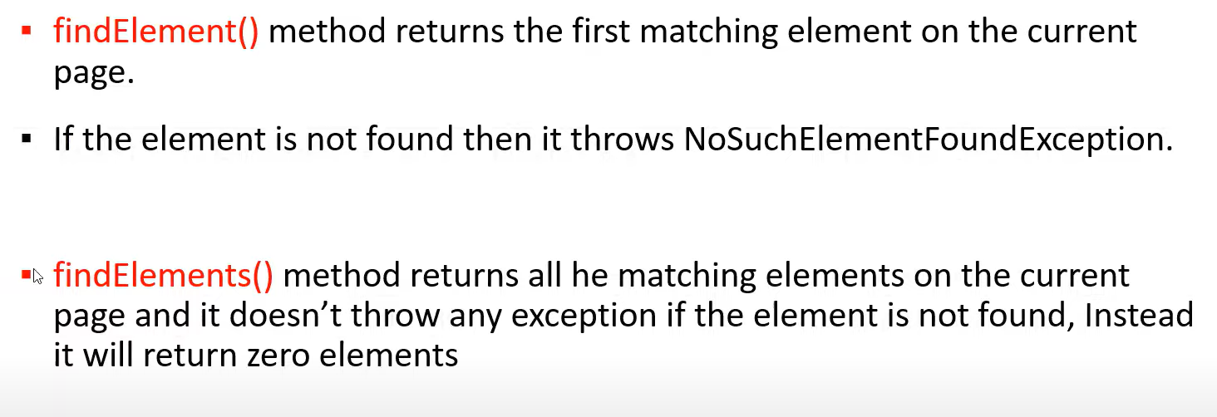

**Part 7**

* How to enter & clear text from Input box ?
* How to capture Text from Input box ?
* What is the difference between getText() and getAttribute(‘value’) ?

Practice URL : <https://admin-demo.nopcommerce.com/>

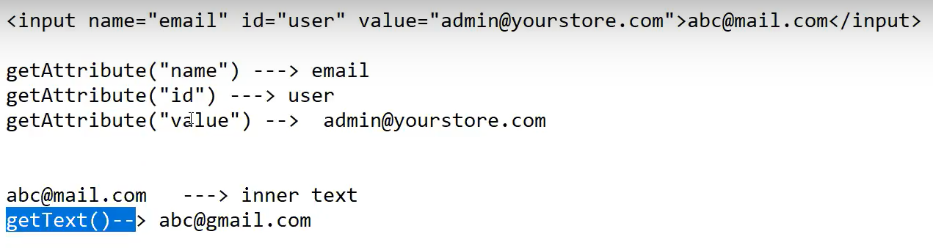

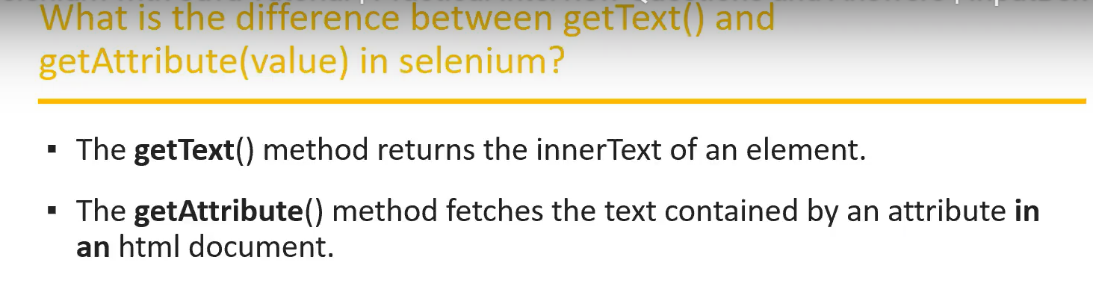

**Part 8**

* How to handle Dropdown in Selenium WebDriver ?

Practice URL:

* <https://www.opencart.com/index.php?route=account/register>
* <https://www.orangehrm.com/orangehrm-30-day-trial/>

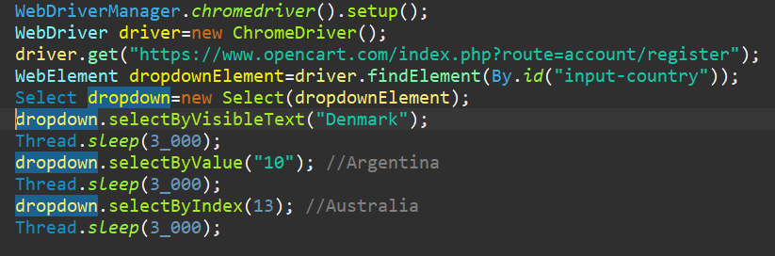

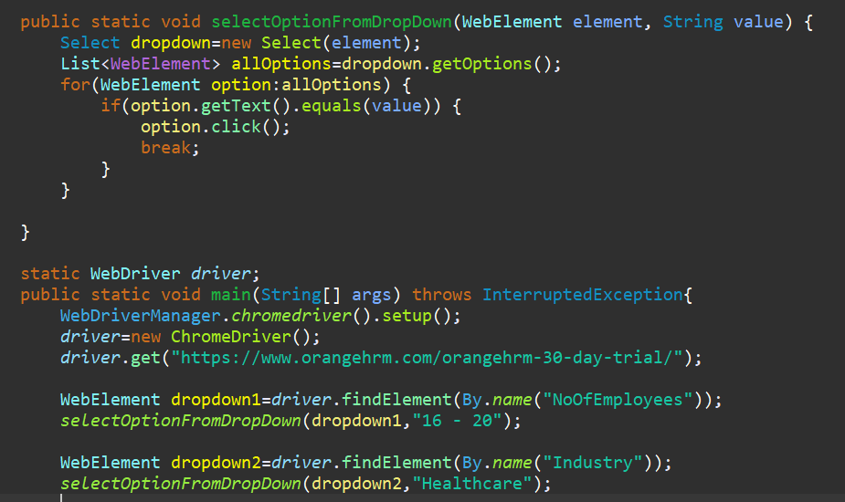

**Part 9**

* How to handle Bootstrap Dropdown in Selenium WebDriver ?

Bootstrap dropdown url

<https://getbootstrap.com/docs/4.0/components/dropdowns/>

Practice url:

<https://www.hdfcbank.com/>

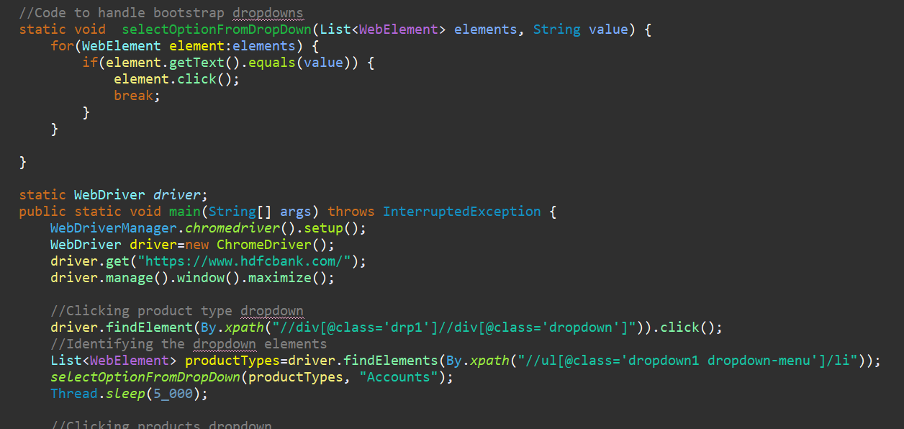

**Part 10**

* How to handle Jquery Dropdown in Selenium WebDriver ?

Practice Url: [ComboTree jQuery Plugin Demos (jqueryscript.net)](https://www.jqueryscript.net/demo/Drop-Down-Combo-Tree/)

**Part 11**

* How to check drop down options are sorted in selenium WebDriver ?

Practice url: [twoPLUGS - A plug for your Service and another for your Need](https://www.twoplugs.com/newsearchserviceneed)

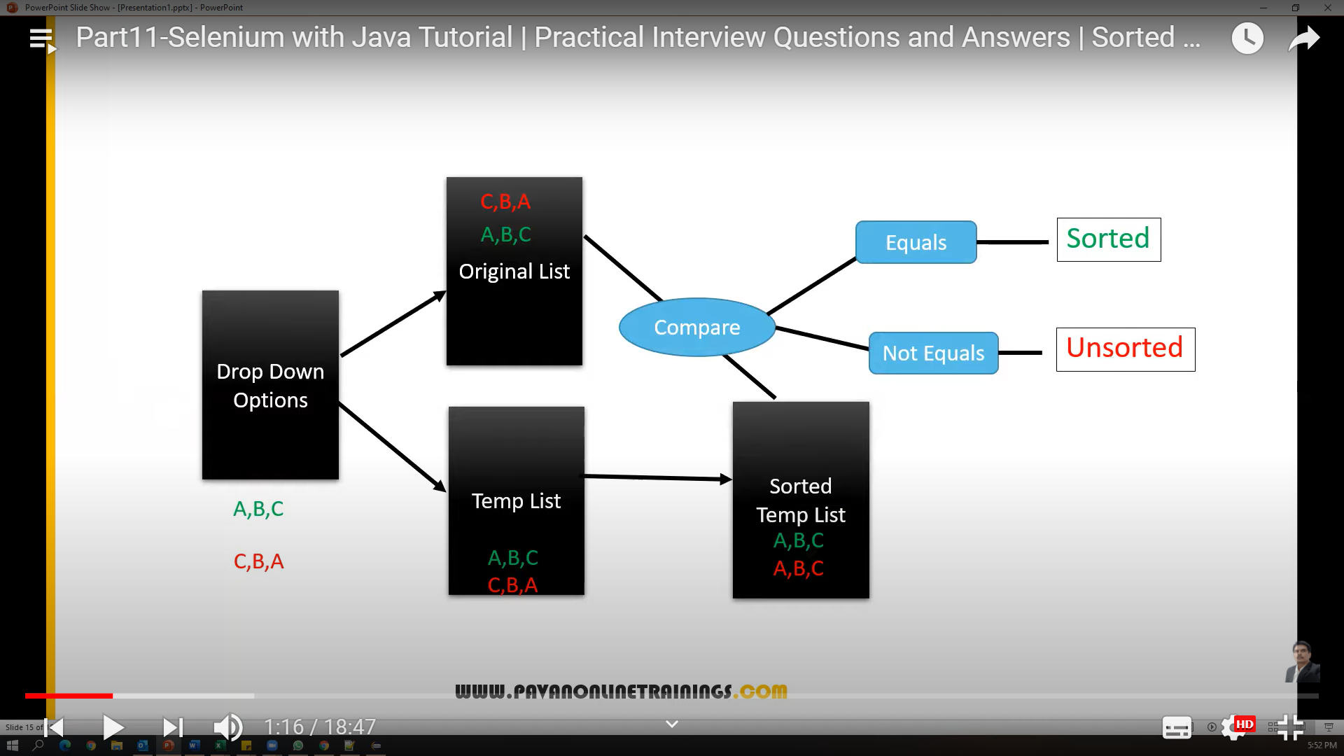

**Part 12**

* How to handle Auto Suggest Drop Down in Selenium Web Driver ?

Practice URL:

<https://www.bing.com/>

[**https://www.google.com/**](https://www.google.com/)

**Part 13**

* How to handle Autocomplete Google Places drop down in selenium web driver ?

Prcatice url: <https://www.twoplugs.com/newsearchserviceneed>

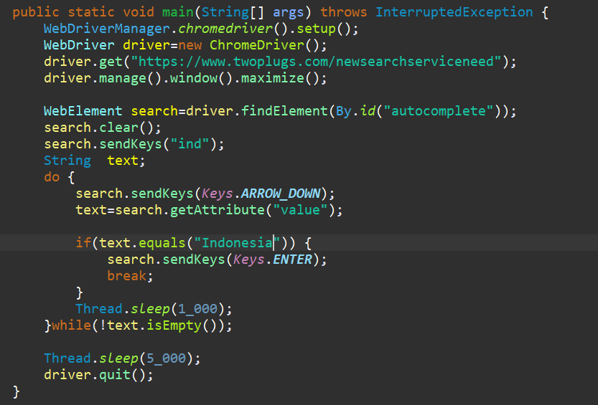

**Part 14**

* How to select specific Check box ?
* How to select all the check boxes ?
* How to select multiple check boxes by choice ?
* How to select last 2 check boxes ?
* How to select first 2 check boxex ?

Prcatice URL: <https://itera-qa.azurewebsites.net/home/automation>

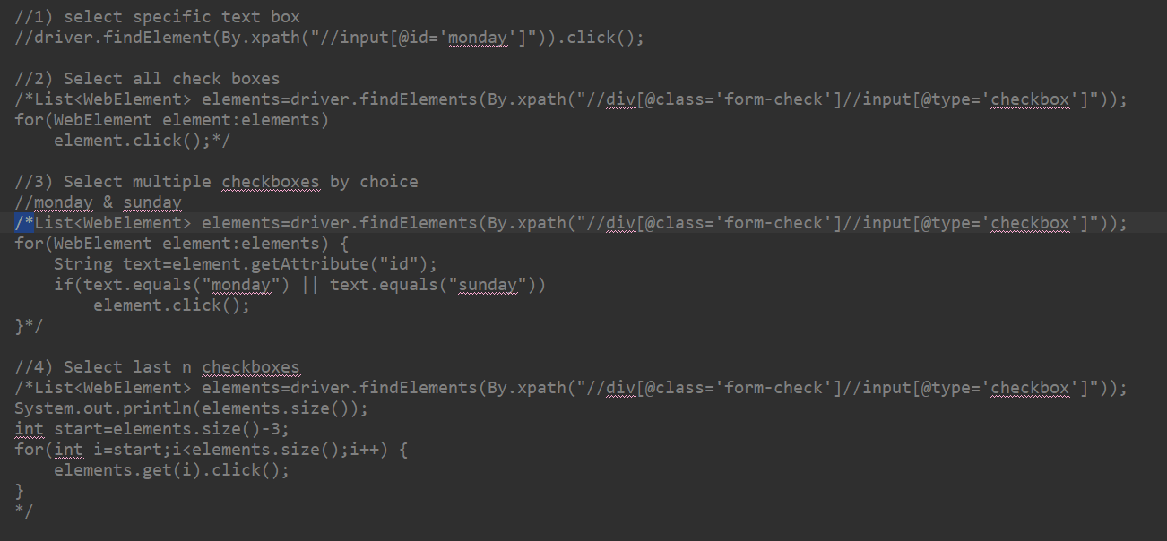

**Part 15**

* How to handle browser windows in Selenium WebDriver ?
* What is the difference between getWindowHandle() & getWindowhandles() methods ?
* How to switch between Multiple Browser Windows ?
* How to close all browser windows ?
* How to close specific browser window by choice ?

Practice Url:

<https://opensource-demo.orangehrmlive.com/>

<https://www.orangehrm.com/>

**Part 16**

* How to Locate links in Selenium WebDriver ?
* What is the difference between LinkText() and PartialLinText() ?
* How to capture all the links from Web Page ?
* What is Broken Link ? How to check broken links ?

Prcatice URL:

<https://www.amazon.in/>

<http://www.deadlinkcity.com/>

**Part 17**

* How to handle Java Script Alerts ?
* How to handle Authentication Popup ?
* How to handle permission based Pop-ups ?

Practice Urls:

<https://the-internet.herokuapp.com/javascript_alerts>

For Authenticated Popiup:

<https://the-internet.herokuapp.com/basic_auth>

For Permision pop-up:

<https://www.cleartrip.com/>

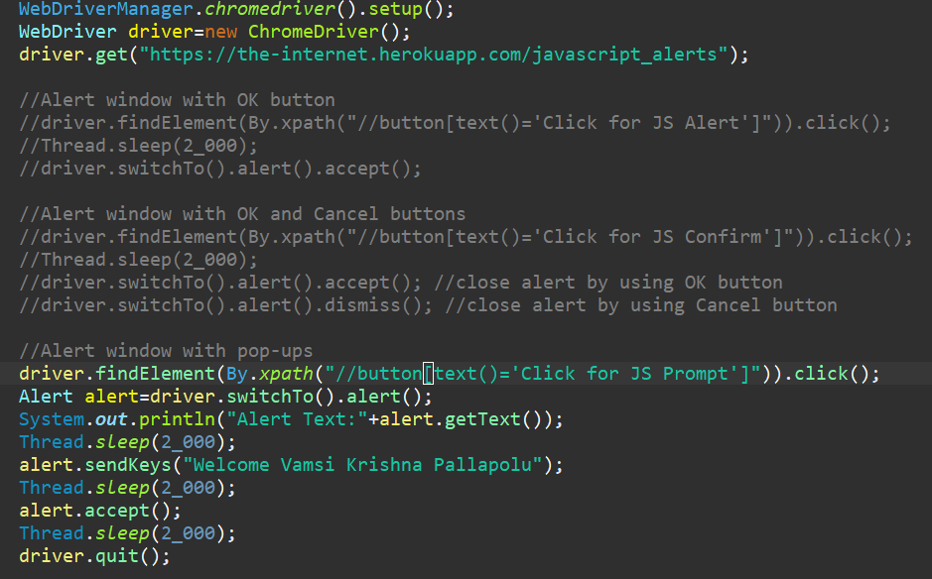

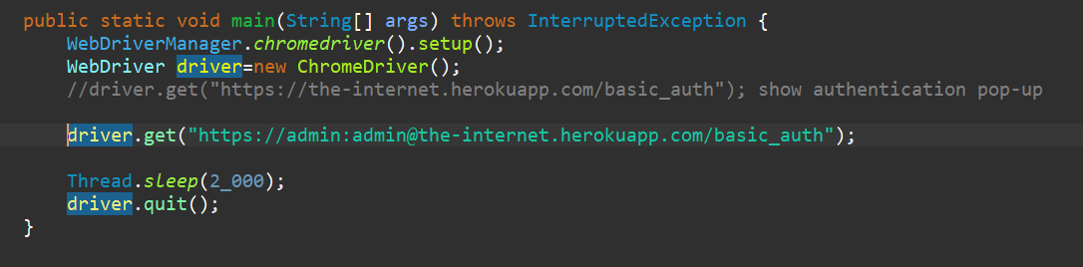

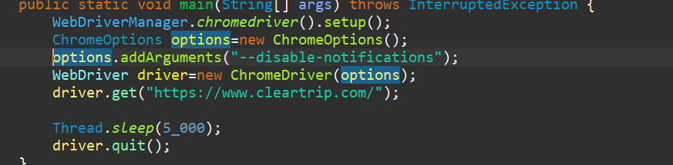

**Part 18**

* What is the difference between frame and iframe ?
* How to handle iframes in WebDriver ?
* How to switch between multiple iFrames ?
* How to work with inner iFrames ?

Practice Urls:

* <https://www.selenium.dev/selenium/docs/api/java/index.html?overview-summary.html>
* [Frames (automationtesting.in)](http://demo.automationtesting.in/Frames.html)
* [Tryit Editor v3.6 (w3schools.com)](https://www.w3schools.com/html/tryit.asp?filename=tryhtml_iframe)

iframe means content coming from other sources

Ways to switch to iframes

* driver.switchTo().frame(index)
* driver.switchTo().frame(WebElement)
* driver.switchTo().frame(name/id)

Other

* driver.switchTo().defaultContent()
* driver.switchTo().parentFrame()

**Part 19**

* What is Synchronization problem in Automation ?
* What are the different types of waits available in Selenium WebDriver ?

Practice URL: <https://www.google.com/>

Application scripts execute faster than page responses

**Waits in Selenium**

* Implicit Wait
* Explicit Wait
* Fluent Wait
* Thread.sleep(MILLI_SECONDS)
* Implicit Wait applicable for all the elements in the web page
* driver.manage().timeouts().implicitlyWait(10, TimeUnit.SECONDS)
* We can add only once in the script
* Maximum time is 10 seconds, we can give any amount of time
* If element is taking more than 10 seconds then there are chances that exceptions will come
* Explicit Wait is applicable for specific element
* Fluent Wait is also similar to WebDriverWait with more flexibility in polling time and ignoring Exceptions
* It’s not recommended to useThread.sleep()

**Part 20**

* How to handle Web Table in Selenium WebDriver ?
  + How many rows in table ?
  + How many columns in table ?
  + Retrieve the specific row/column data
  + Print release date, versionno of java language of selenium

Practice Url: <https://www.selenium.dev/downloads/>

**Part 21**

* How to handle Dynamic Web Table with Pagination in Selenium ?