**SQLTutorial**

**PlayList Link:** [**https://www.youtube.com/playlist?list=PLUDwpEzHYYLvWEwDxZViN1shP-pGyZdtT**](https://www.youtube.com/playlist?list=PLUDwpEzHYYLvWEwDxZViN1shP-pGyZdtT)

**Tutorial 1: Overview on Database, DBMS/RDBMS, SQL | Database Components**

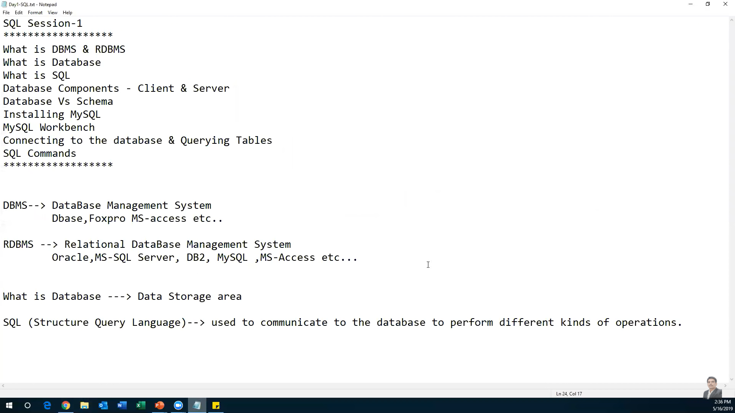

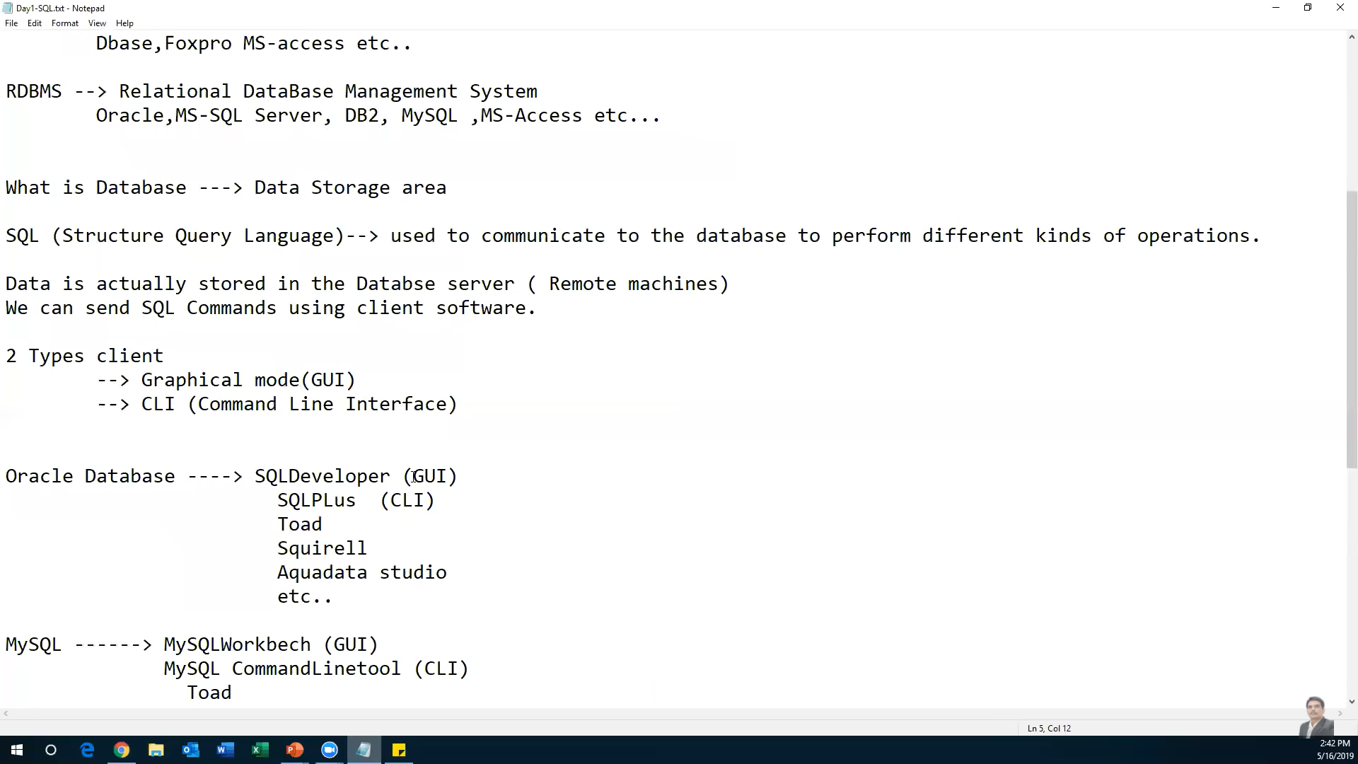

**Tutorial 2: Installing MySQL, Working with SQL Workbench & Command Line Clients**

To download MySQL software

<https://dev.mysql.com/downloads/windows/installer/8.0.html>

**CLI commnads**

Show databases;

use <table-name>;

select * from <table-name>;

**Tutorial 3: Create Database,Table, Inserting Records and Retrieving Data**

Describe command gives the structure of the table

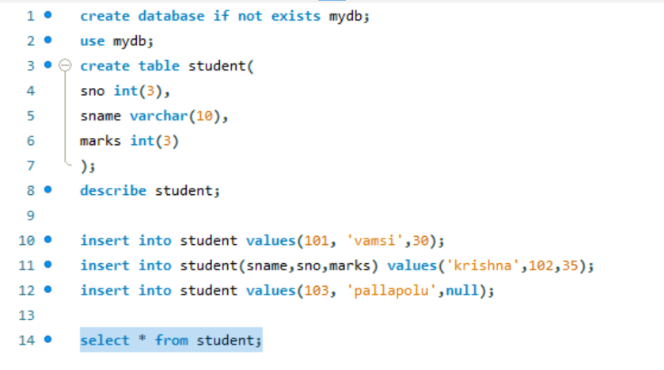

**Tutorial 4: Filtering Rows(Where Clause), Operators & Pattern Matching**

**Where clause**

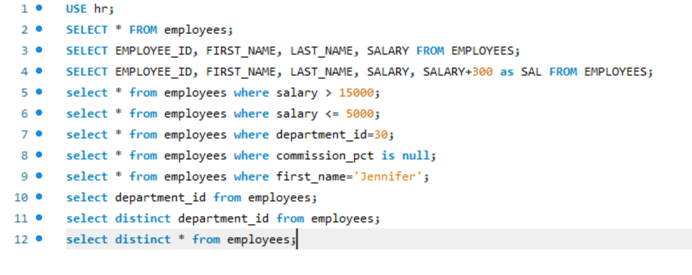

**Logical Operators**

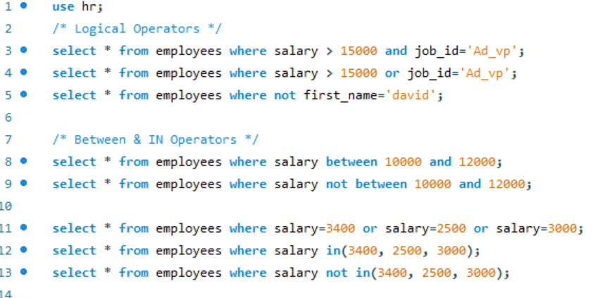

**Wild Card Operators**

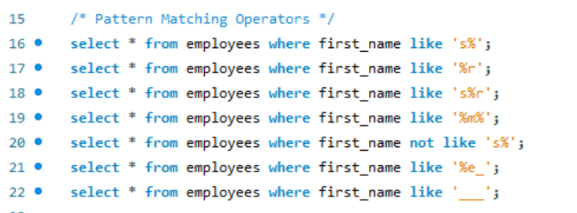

**Tutorial 5: DDL (Data Definition Language) Commands**

**DDL Commands**

* create
* alter
  + add column
  + drop column
  + modify column
  + rename column <old-col-name> to <new-col-name>
* drop
* truncate
* rename

If we want to reduce the size of the column, no data should be present in the column

Drop

To drop all the data bases object (both table defination and data will be deleted)

Truncate

Table struture will be present but data will be deleted

Data will be deleted permanently, we cannot roll back the data

Delete

Table struture will be present

Data will be deleted but we can roll back the data

**Tutorial 6: MySQL Built-in Functions in SQL**

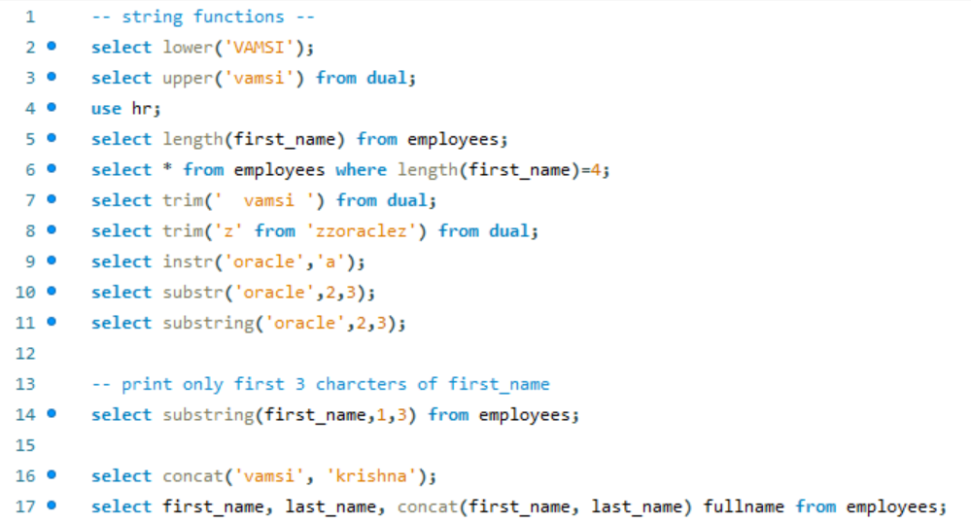

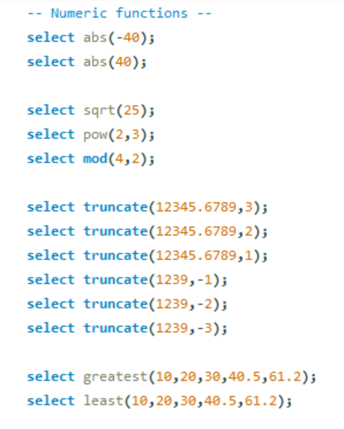

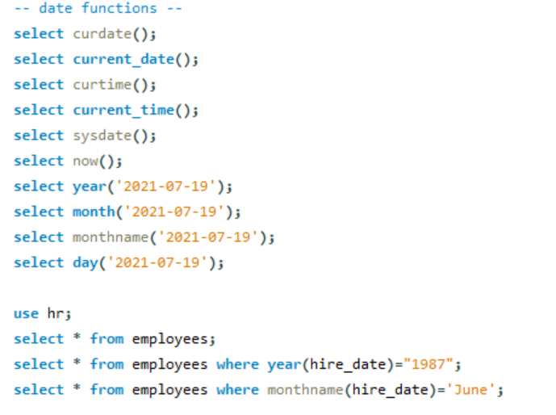

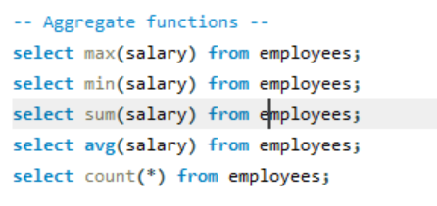

**Tutorial 7: Group By, Having & ,Order By Clauses in SQL**

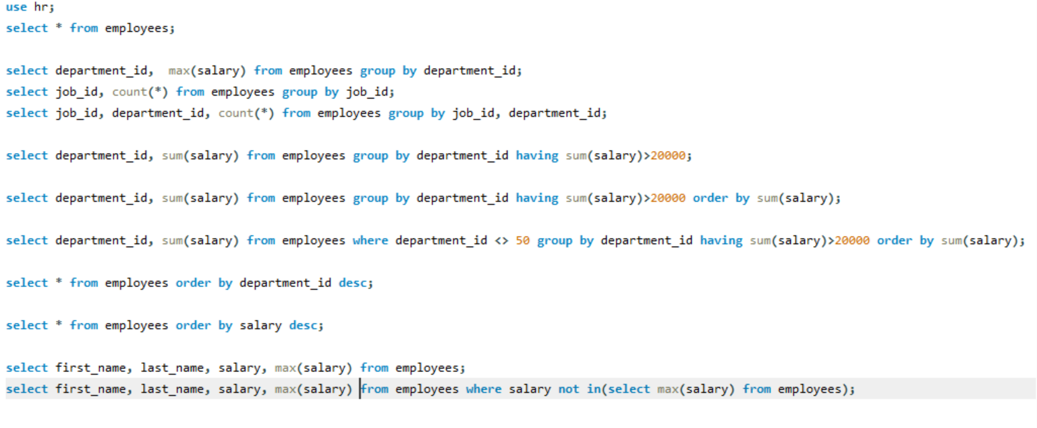

**Tutorial 8: Union & Union All in SQL**

Set operators

* Union
* Union All
* Intersect
* Minus

To retrieve the data from multiple tables we can use:

* Set operators
* Joins
* Sub queries

UNION

* It retrieve the data from both the tables but it eliminate the duplictes

UNION ALL

* It retrieve the data from both the tables but it does not eliminate the duplictes

INTERSECT

* It retrieve the common data among the tables

MINUS

* T1 – T2
* It retrieves the data which is present in T1 but not T2

MySQL doesn’t support intersect and minus operators

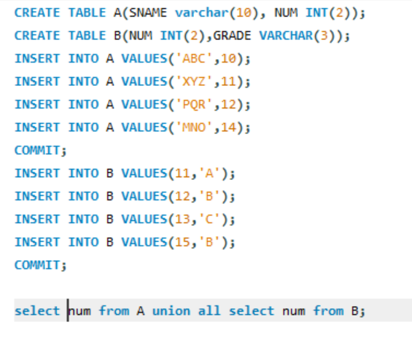

**Tutorial 9: SQL Joins and Sub Queries**

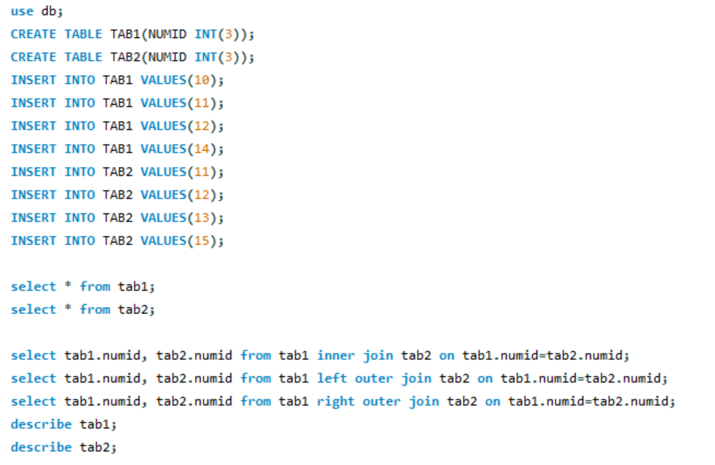

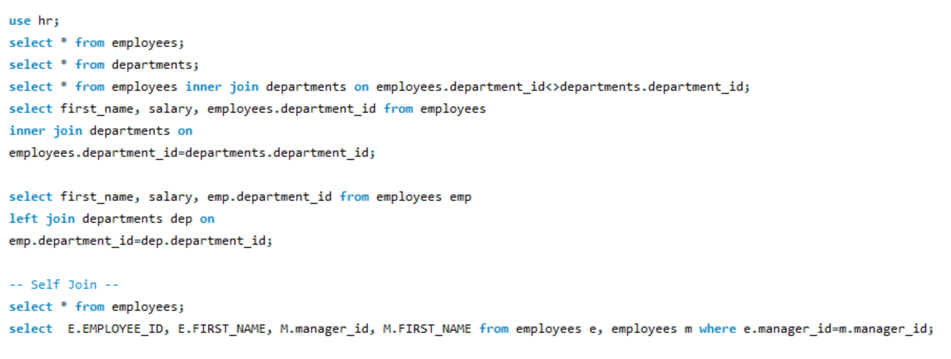

Sub Queries

