

UID ASSIGNMENT

SUBMITTED BY
NAME | Y.VAMSI
ROLL NO | AV.SC.U4CSE25154
YEAR/SEM/SECTION | 1ST YEAR/ SEM-2/CSE-B
CREDITS | 03

SUBMITTED TO
NAME | DR. RAJ KUMAR BATCHU
DESIGNATION | ASST.PROFFESSOR (Sl. Grade)
DEPARTMENT | SCHOOL OF COMPUTING

AIM :
Create a responsive frontend clone of YONEX (https://www.us.yonexcom/) using the concepts with separate index.html, style.css, and script.js files

CODE :

HTML CODE :

<!DOCTYPE html>
<html lang="en">
<head>
<meta charset="UTF-8">
<meta name="viewport" content="width=device-width, initial-scale=1.0">
<title>YONEX | For Beyond Ordinary</title>
<link rel="stylesheet" href="style.css">
<link rel="stylesheet" href="https://cdnjs.cloudflare.com/ajax/libs/font-awesome/6.6.0/css/all.min.css">
</head>
<body>
<!-- Progress Bar -->
<div class="scroll-progress" id="progressBar"></div>

<!-- Navigation -->
<header>
<nav>
<div class="logo">
<a href="https://www.yonex.com">YONEX</a>
</div>
<div class="nav-links">
<a href="https://us.yonex.com/collections/racquets">RACQUETS</a>
<a href="https://us.yonex.com/collections/sports">SPORTS</a>
<a href="https://us.yonex.com/collections/men">MEN</a>
<a href="https://us.yonex.com/collections/women">WOMEN</a>
<a href="https://us.yonex.com/collections/juniors">JUNIORS</a>
<a href="https://us.yonex.com/collections/athlete-inspired">ATHLETE INSPIRED</a>
<a href="https://us.yonex.com/collections/made-by-yonex">MADE BY YONEX</a>
</div>
<div class="nav-right">
<i class="fas fa-search"></i>
<i class="fas fa-user"></i>
<i class="fas fa-shopping-bag"></i>
</div>
</nav>
</header>

<!-- Hero -->
<section class="hero">
<div class="hero-content">
<div class="hero-badge">NEW VCORE</div>
<h1>CLAY SETS<br>THE TONE</h1>
<p>Explore the latest arrivals designed for peak performance on every surface.</p>
<img src=" " alt="" >

<a href="https://us.yonex.com/collections/vcore" class="btn">EXPLORE NEW ARRIVALS</a>
</div>
</section>

<!-- Two Column Featured -->
<section class="section">
<div class="two-column">
<div class="product-card">
<img src="https://upload.wikimedia.org/wikipedia/commons/thumb/3/3e/Tennis_Racket_and_Balls.jpg/250px-Tennis_Racket_and_Balls.jpg" alt="Tennis">
<div class="overlay">
<h3>TENNIS</h3>
<p>VCORE — PROVEN AT THE TOP</p>
<a href="https://us.yonex.com/collections/vcore" class="btn">EXPLORE NOW</a>
</div>
</div>
<div class="product-card">
<img src="https://encrypted-tbn0.gstatic.com/images?q=tbn:ANd9GcSSpSIpM_uniyi-sGI5UvspSqef8HASJLf5-Q&s" alt="Snowboarding">
<div class="overlay">
<h3>SNOWBOARDING</h3>
<p>BEYOND THE EDGE</p>
<a href="#" class="btn">EXPLORE NOW</a>
</div>
</div>
</div>
</section>

<!-- MUSE Section -->
<section class="muse-section">
<div class="muse-content">
<h2>MUSE — AVAILABLE NOW</h2>
<p>Smooth swings, full freedom, pure tennis joy.</p>
<div class="muse-buttons">
<a href="#" class="btn">LEARN MORE</a>
<a href="https://us.yonex.com/cdn/shop/files/HP_Banner_GraduationGifts.jpg?v=1778790773&width=1100" class="btn primary">SHOP MUSE</a>
</div>
</div>
<img src="https://encrypted-tbn0.gstatic.com/images?q=tbn:ANd9GcTEYPpEuAo-T5XJPN8K_af-cd5xwyEIH&sIjvdQ" alt="MUSE">
</section>

<!-- Badminton Essentials -->
<section class="section badminton-section">
<h2 class="section-title">BADMINTON ESSENTIALS</h2>
<div class="product-grid">
<div class="product-item">
<img src="https://rukminim2.flixcart.com/image/1536/1536/xif0q/racquet/q/r/z/-original-imah6sygd5zhpmua.jpeg?q=90" alt="Astrox 100ZZ">
<h4>Astrox 100ZZ</h4>
<p>Power • Steep Attack</p>
<a href="https://us.yonex.com/products/astrox-100zz" class="shop-btn">Shop Now</a>
</div>
<div class="product-item">
<img src="https://rukminim2.flixcart.com/image/1536/1536/xif0q/racquet/w/n/c/g5-3-inches-strung-nanoflare-800-play-1-nanoflare-800play-83-original-imagwht9fau54guw.jpeg?q=90" alt="Nanoray 800">
<h4>Nanoray 800</h4>
<p>Speed • Control</p>
<a href="https://us.yonex.com/products/nanoray-800" class="shop-btn">Shop Now</a>
</div>
<div class="product-item">
<img src="https://rukminim2.flixcart.com/image/1536/1536/xif0q/string/j/a/x/bg-aerobite-boost-badminton-string-1-0-72-18-yonex-badminton-original-imah2twyh4fhb9fh.jpeg?q=90" alt="BG Strings">
<h4>BG Aerobite Boost</h4>
<p>Explosive Response</p>
<a href="https://us.yonex.com/collections/badminton-strings" class="shop-btn">Shop Now</a>
</div>
<div class="product-item">
<img src="https://rukminim2.flixcart.com/image/1536/1536/shuttle/d/h/h/12-yonex-feather-aerosensa-50-original-imadgybspghvzafv.jpeg?q=90" alt="Aerosensa 20">
<h4>Aerosensa 20</h4>
<p>Premium Feather Shuttle</p>
<a href="https://us.yonex.com/collections/shuttlecocks" class="shop-btn">Shop Now</a>
</div>
<div class="product-item">
<img src="https://m.media-amazon.com/images/I/51orB-gndzL._SY695_.jpg" alt="Badminton Shoes">
<h4>Power Cushion 65 Z4</h4>
<p>Ultimate Comfort</p>
<a href="https://us.yonex.com/collections/badminton-shoes" class="shop-btn">Shop Now</a>
</div>
</div>
</section>

<!-- Athletes -->
<section class="section athletes-section">
<h2 class="section-title">OUR ATHLETES</h2>
<div class="athlete-grid">
<div class="athlete">
<img src="https://upload.wikimedia.org/wikipedia/commons/thumb/3/35/2017_Citi_Open_Tennis_Tommy_Paul_%28cropped%29.jpg/500px-2017_Citi_Open_Tennis_Tommy_Paul_%28cropped%29.jpg" alt="Tommy Paul">
<h4>TOMMY PAUL</h4>
<p>USA | Tennis</p>
</div>
<div class="athlete">
<img src="https://upload.wikimedia.org/wikipedia/commons/thumb/4/4b/Jessica_Pegula_%282025_DC_Open%29_05_%28cropped%29.jpg/500px-Jessica_Pegula_%282025_DC_Open%29_05_%28cropped%29.jpg" alt="Jessica Pegula">
<h4>JESSICA PEGULA</h4>
<p>USA | Tennis</p>
</div>
<div class="athlete">
<img src="https://res.cloudinary.com/usopc-prod/image/upload/v1710948851/TeamUSA%20Assets/Athlete%20Profiles/Miles%20Krajewski%201095742/Krajewski_m_thumbnail_1095742.jpg" alt="Miles Krajewski">
<h4>MILES KRAJEWSKI</h4>
<p>USA | Badminton</p>
</div>
</div>
</section>

<!-- Footer -->
<footer>
<div class="footer-grid">
<div>
<h3>YONEX</h3>
<p>For Beyond Ordinary</p>
</div>
<div>
<h4>GET HELP</h4>
<a href="https://us.yonex.com/pages/account">Account</a>
<a href="#">Track Orders</a>
<a href="#">Returns</a>
<a href="#">Warranty</a>
</div>
<div>
<h4>COMPANY</h4>
<a href="https://us.yonex.com/pages/about-yonex">About Yonex</a>
<a href="#">Careers</a>
<a href="#">News</a>
</div>
<div>
<h4>LEGAL</h4>
<a href="#">Privacy Policy</a>
<a href="#">Terms & Conditions</a>
</div>
<div>
<h4>JOIN YONEX INSIDER</h4>
<form>
<input type="email" placeholder="Enter your email address">
<button type="submit">→</button>
</form>
</div>
</div>
<div class="copyright">
© 2026 Yonex Co., Ltd. All Rights Reserved.
</div>
</footer>

<script src="script.js"></script>
</body>
</html>

JAVA SCRIPT CODE:
// Scroll Progress Bar
window.addEventListener('scroll', () => {
const winScroll = document.body.scrollTop || document.documentElement.scrollTop;
const height = document.documentElement.scrollHeight - document.documentElement.clientHeight;
const scrolled = (winScroll / height) * 100;
document.getElementById("progressBar").style.width = scrolled + "%";
});

// Smooth Scroll for Anchor Links
document.querySelectorAll('a[href^="#"]').forEach(anchor => {
anchor.addEventListener('click', function(e) {
const target = document.querySelector(this.getAttribute('href'));
if (target) {
e.preventDefault();
target.scrollIntoView({
behavior: 'smooth'
});
}
});
});

// Search Icon Alert (Demo)
document.querySelector('.fa-search').addEventListener('click', () => {
const query = prompt("🔍 Search Yonex products:");
if (query) {
window.open(`https://us.yonex.com/search?q=${encodeURIComponent(query)}`, '_blank');
}
});

// Console Message
console.log('%c✅ Yonex Official Website Clone Loaded Successfully!', 'color: #00A651; font-size: 16px; font-weight: bold;');

CSS CODE:

:root {
--yonex-green: #00A651;
--dark: #1a1a1a;
}

* {
margin: 0;
padding: 0;
box-sizing: border-box;
}

body {
font-family: 'Helvetica Neue', Arial, sans-serif;
color: #333;
}

header {
position: fixed;
top: 0;
width: 100%;
background: white;
box-shadow: 0 2px 10px rgba(0,0,0,0.1);
z-index: 1000;
}

nav {
max-width: 1400px;
margin: 0 auto;
display: flex;
align-items: center;
justify-content: space-between;
padding: 15px 40px;
}

.logo a {
font-size: 28px;
font-weight: bold;
color: var(--yonex-green);
text-decoration: none;
}

.nav-links a {
margin: 0 18px;
text-decoration: none;
color: #333;
font-weight: 500;
}

.nav-links a:hover {
color: var(--yonex-green);
}

.nav-right i {
font-size: 1.4rem;
margin-left: 20px;
cursor: pointer;
}

.hero {
height: 100vh;
background: linear-gradient(rgba(0,0,0,0.4), rgba(0,0,0,0.4)), url('https://us.yonex.com/cdn/shop/files/VCORE_Hero_Desktop_1.jpg') center/cover;
display: flex;
align-items: center;
color: white;
}

.hero-content {
max-width: 1400px;
margin: 0 auto;
padding: 0 40px;
}

.hero-badge {
background: white;
color: black;
padding: 8px 22px;
border-radius: 30px;
display: inline-block;
margin-bottom: 20px;
font-weight: 600;
}

.hero h1 {
font-size: 4.8rem;
line-height: 1.05;
margin-bottom: 20px;
}

.hero p {
font-size: 1.5rem;
max-width: 520px;
margin-bottom: 40px;
}

.btn {
padding: 14px 36px;
background: white;
color: black;
text-decoration: none;
font-weight: 600;
border-radius: 4px;
display: inline-block;
transition: 0.3s;
}

.btn.primary {
background: var(--yonex-green);
color: white;
}

.btn:hover {
transform: translateY(-4px);
box-shadow: 0 10px 25px rgba(0,0,0,0.2);
}

.section {
padding: 100px 40px;
max-width: 1400px;
margin: 0 auto;
}

.section-title {
text-align: center;
font-size: 2.8rem;
margin-bottom: 60px;
}

.two-column {
display: grid;
grid-template-columns: 1fr 1fr;
gap: 30px;
}

.product-card {
position: relative;
border-radius: 12px;
overflow: hidden;
}

.product-card img {
width: 100%;
height: 100%;
object-fit: cover;
transition: transform 0.6s ease;
}

.product-card:hover img {
transform: scale(1.08);
}

.overlay {
position: absolute;
bottom: 0;
left: 0;
right: 0;
background: linear-gradient(transparent, rgba(0,0,0,0.85));
color: white;
padding: 50px 35px 35px;
}

.muse-section {
background: #f8f8f8;
padding: 80px 40px;
text-align: center;
}

.muse-content h2 {
font-size: 3rem;
margin-bottom: 15px;
}

.product-grid {
display: grid;
grid-template-columns: repeat(auto-fit, minmax(260px, 1fr));
gap: 30px;
}

.product-item {
text-align: center;
background: white;
padding: 20px;
border-radius: 12px;
box-shadow: 0 5px 15px rgba(0,0,0,0.08);
transition: 0.3s;
}

.product-item:hover {
transform: translateY(-10px);
}

.product-item img {
width: 100%;
height: 280px;
object-fit: contain;
margin-bottom: 15px;
}

.shop-btn {
margin-top: 15px;
display: inline-block;
padding: 10px 24px;
background: var(--yonex-green);
color: white;
text-decoration: none;
border-radius: 4px;
font-size: 0.95rem;
}

.athlete-grid {
display: grid;
grid-template-columns: repeat(auto-fit, minmax(300px, 1fr));
gap: 40px;
}

.athlete img {
width: 100%;
height: 380px;
object-fit: cover;
border-radius: 12px;
}

footer {
background: #111;
color: #ccc;
padding: 80px 40px 40px;
}

.footer-grid {
display: grid;
grid-template-columns: 2fr 1fr 1fr 1fr 1.5fr;
gap: 40px;
max-width: 1400px;
margin: 0 auto;
}

footer a {
color: #ccc;
text-decoration: none;
display: block;
margin-bottom: 10px;
}

footer a:hover {
color: white;
}

.copyright {
text-align: center;
margin-top: 80px;
padding-top: 30px;
border-top: 1px solid #333;
font-size: 0.9rem;
}

.scroll-progress {
position: fixed;
top: 0;
left: 0;
height: 4px;
background: var(--yonex-green);
z-index: 2000;
transition: width 0.1s;
}

OUTPUT:

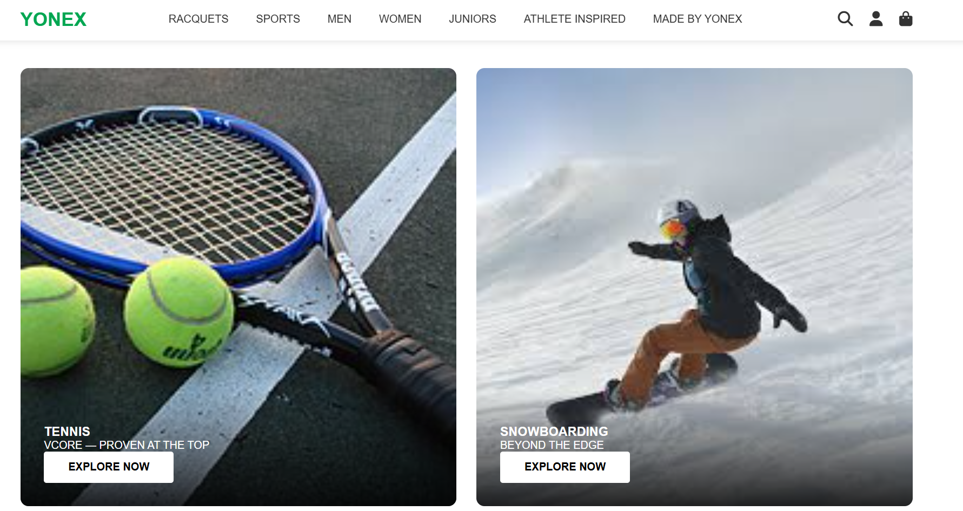

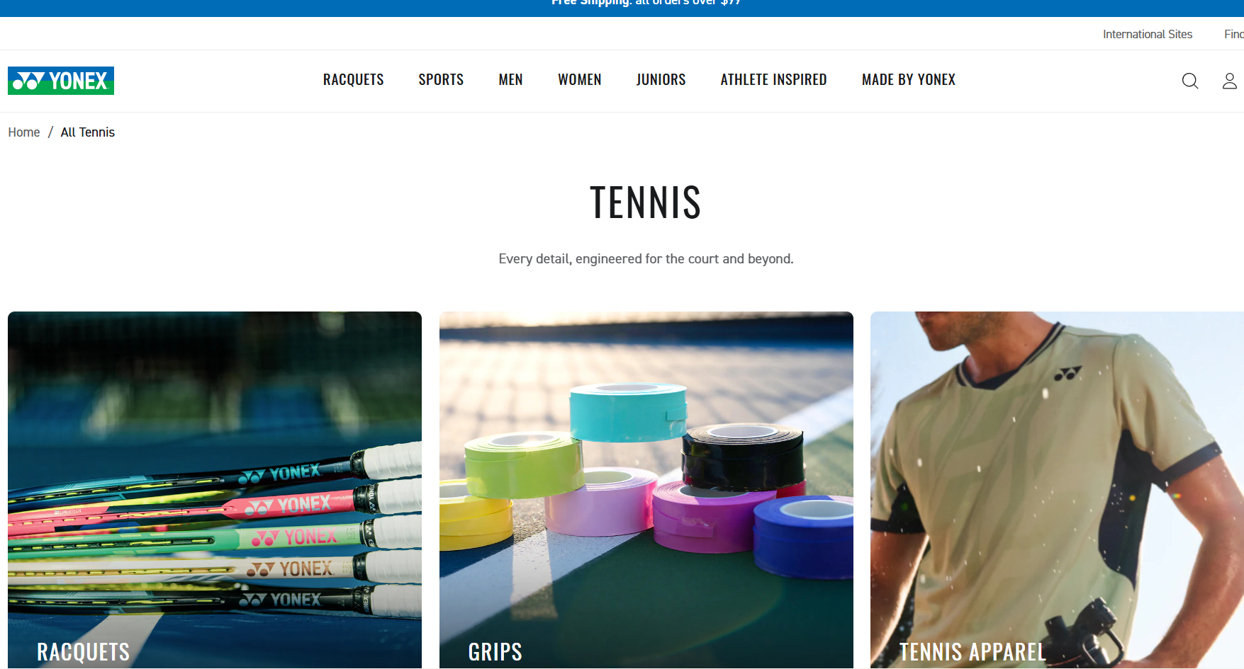

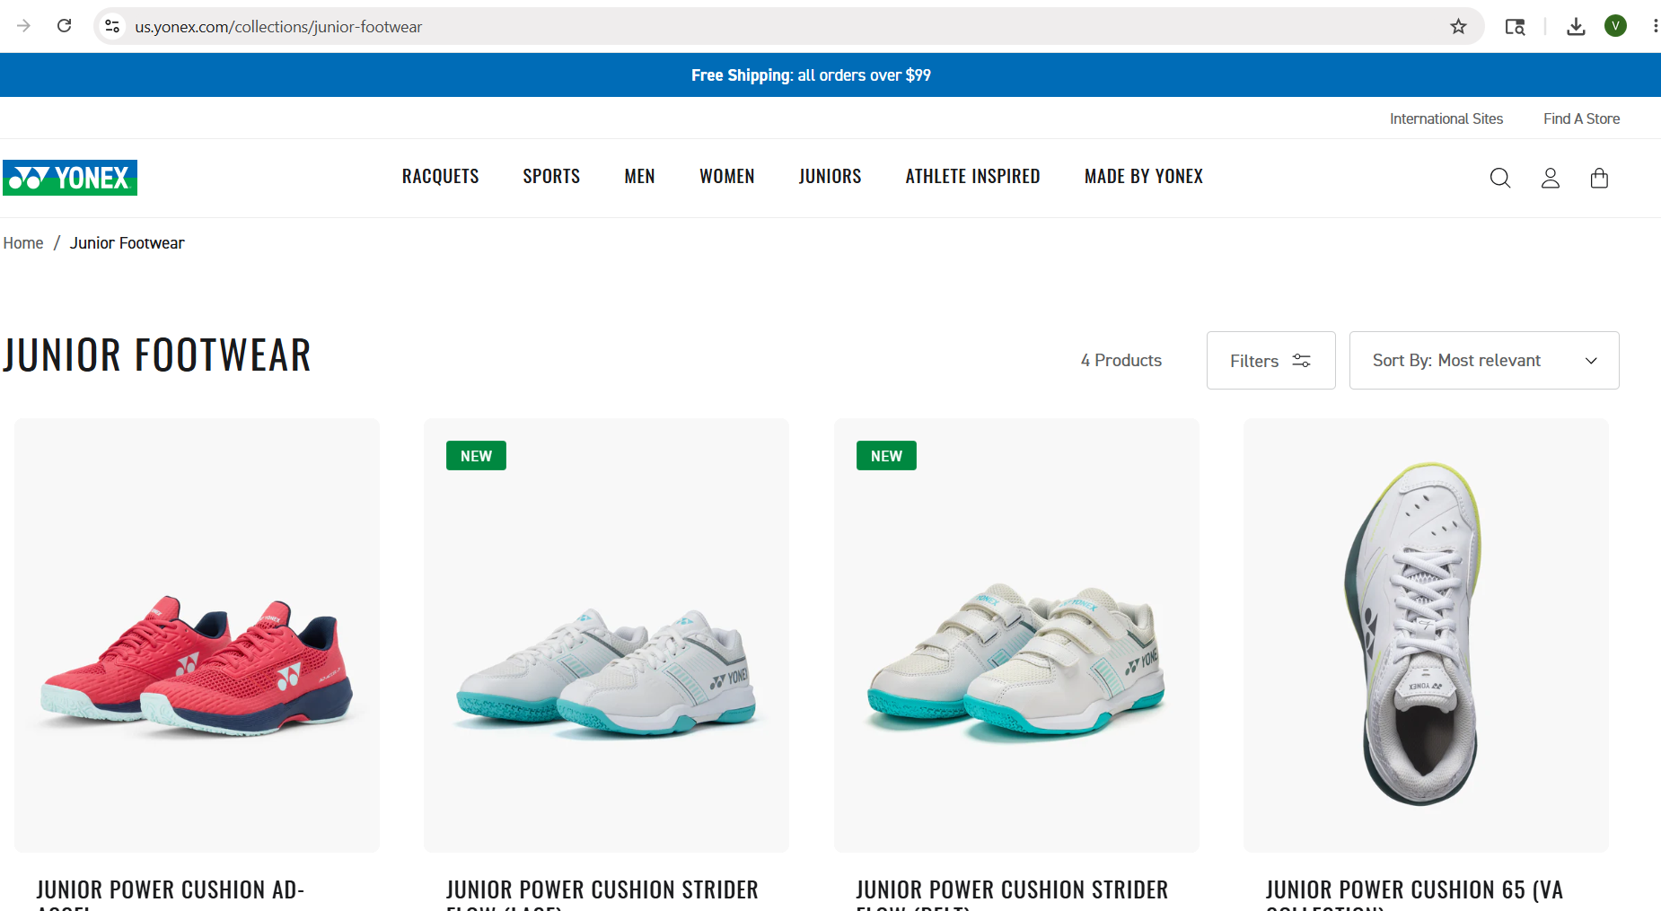
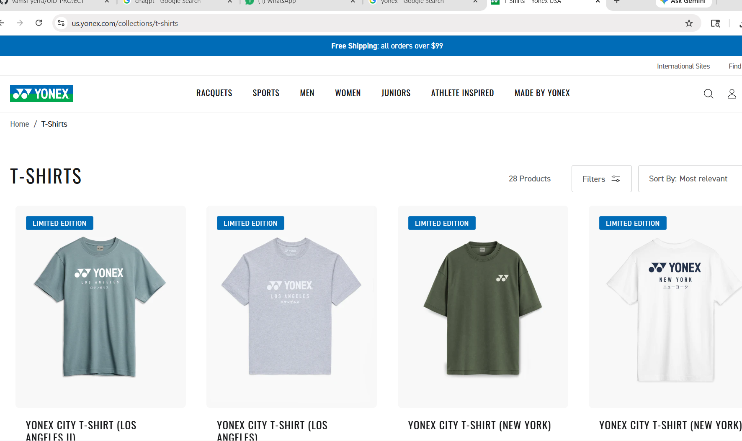

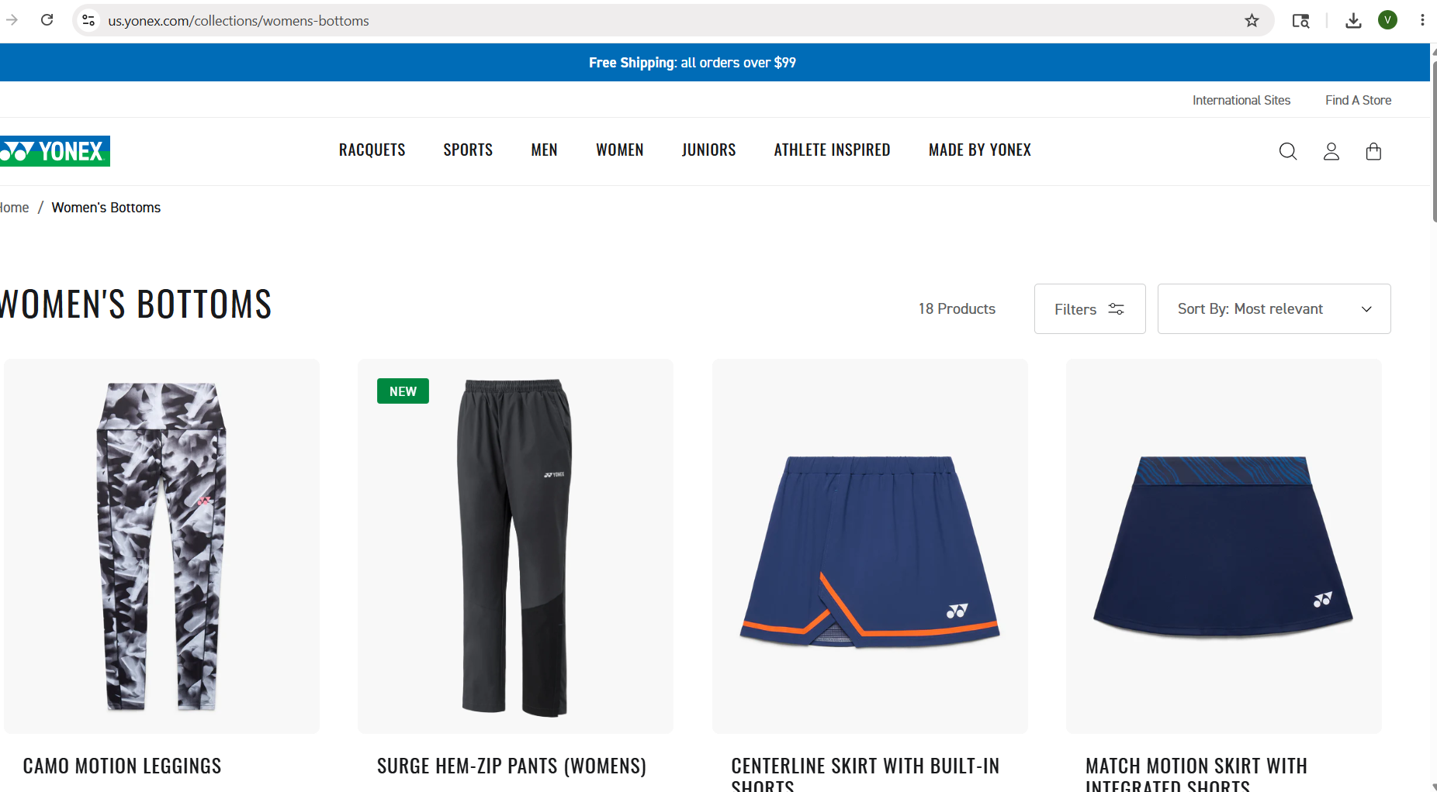
EXPLANATION:

## 📄 index.html
- `charset`, `viewport`, Font Awesome CDN, `style.css` linked in `<head>`
- Fixed `<header>` with logo linking to yonex.com, 7 nav links, 3 icons (search, user, bag)
- `scroll-progress` div at top — width updated live by JS
- Hero section — badge, `<h1>`, paragraph, CTA button linking to VCORE collection
- Empty `<img>` in hero — placeholder for product image
- Two-column section — Tennis (Wikipedia img) and Snowboarding cards with overlays
- MUSE section — `<h2>`, description, "LEARN MORE" + "SHOP MUSE" buttons
- Broken image URL in MUSE section — needs fixing
- Badminton grid — 5 items (Astrox 100ZZ, Nanoray 800, BG Aerobite, Aerosensa 20, Shoes)
- All badminton images sourced from Flipkart and Amazon CDNs
- Each product item has image, name, subtitle, and green "Shop Now" button
- Athletes section — Tommy Paul, Jessica Pegula (Wikipedia), Miles Krajewski (USOPC CDN)
- Footer — 5 columns: brand, help, company, legal, newsletter email input
- `<script>` loaded at end of `<body>` for faster page rendering

---

## 🎨 style.css
- `--yonex-green: #00A651` defined in `:root` for global reuse
- Full CSS reset via `* { margin: 0; padding: 0; box-sizing: border-box }`
- `header` is `position: fixed`, `z-index: 1000`, with subtle `box-shadow`
- `nav` uses flexbox `space-between` — logo left, links center, icons right
- `max-width: 1400px` + `margin: 0 auto` centers layout on wide screens
- Hero is `100vh`, background image with dark `linear-gradient` overlay
- `.btn` — white bg, black text, `border-radius: 4px`, lifts `4px` on hover
- `.btn.primary` overrides to green background with white text
- `.two-column` uses `grid-template-columns: 1fr 1fr` with `gap: 30px`
- `.product-card:hover img` scales to `1.08` — smooth `0.6s` transition
- `.overlay` absolutely positioned at card bottom with gradient fade
- `.product-grid` uses `auto-fit, minmax(260px, 1fr)` — no media queries needed
- `.product-item:hover` lifts `10px`, image fixed at `280px`, `object-fit: contain`
- `.shop-btn` green, rounded, `0.95rem` — consistent across all product cards
- `.athlete-grid` uses `minmax(300px, 1fr)`, images `380px`, `object-fit: cover`
- Footer `#111` bg, `#ccc` text, 5-column grid `2fr 1fr 1fr 1fr 1.5fr`
- `.copyright` has `border-top: 1px solid #333` separator, pushed down `80px`
- `.scroll-progress` fixed at top, `4px` height, `z-index: 2000`, green bg

---

## ⚙️ script.js
- Scroll listener gets `scrollTop` using `||` for cross-browser support
- `(winScroll / height) * 100` gives scroll percentage, applied to `#progressBar` width
- `querySelectorAll('a[href^="#"]')` attaches smooth scroll to all anchor links
- `e.preventDefault()` stops instant jump, `scrollIntoView({ behavior: 'smooth' })` animates it
- `if (target)` guard prevents errors when target ID is missing
- Search icon click triggers `prompt()` dialog for user input
- `encodeURIComponent()` safely encodes spaces and special characters in query
- Opens `https://us.yonex.com/search?q=` + query in a new tab via `window.open()`
- `console.log` styled with `%c`, green color, bold — confirms page loaded in DevTools

