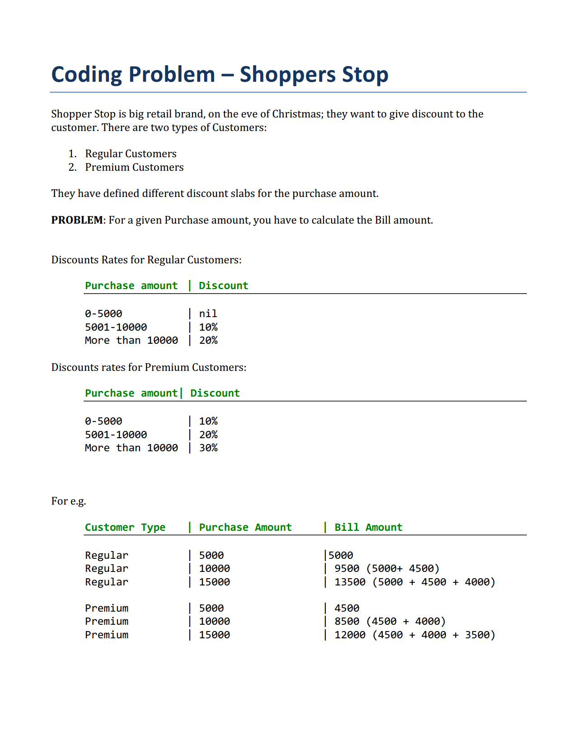

* *Structure of your classes and their relationships*
* *Usage of appropriate data structures (collections) and algorithms*
* *Usage of reusable design patterns*
* *Flexible, Extensible, Maintainable and testable code*
* *For Java, testing of your program can be done using* 
  + *main function (public static void main (String [] args) or via*
  + *JUnit test cases*