CSA0911 - JAVA PROGRAMMING
COLLECTIONS ALL
A.Vamsi (192372242)

Scenario 1: Library Book Management System
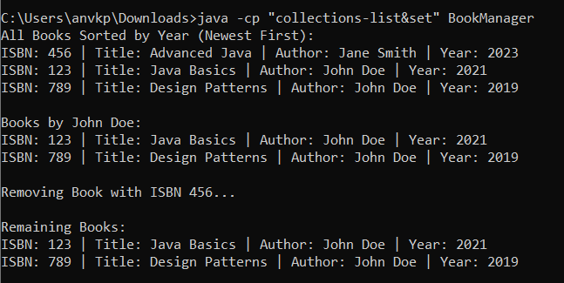
import java.util.ArrayList;
import java.util.Collections;
import java.util.Comparator;
import java.util.HashSet;
import java.util.Iterator;
import java.util.List;

class Book {
String isbn;
String title;
String author;
int year;

Book(String isbn, String title, String author, int year) {
this.isbn = isbn;
this.title = title;
this.author = author;
this.year = year;
}

@Override
public boolean equals(Object o) {
if (this == o) return true;
if (!(o instanceof Book)) return false;
Book book = (Book) o;
return isbn.equals(book.isbn);
}

@Override
public int hashCode() {
return isbn.hashCode();
}

@Override
public String toString() {
return "ISBN: " + isbn + " | Title: " + title + " | Author: " + author + " | Year: " + year;
}
}

public class BookManager {
private HashSet<Book> books = new HashSet<>();

public void addBook(Book book) {
books.add(book);
}

public void removeBook(String isbn) {
Iterator<Book> it = books.iterator();
while (it.hasNext()) {
if (it.next().isbn.equals(isbn)) {
it.remove();
break;
}
}
}

public void displaySortedByYear() {
List<Book> sortedList = new ArrayList<>(books);
Collections.sort(sortedList, new Comparator<Book>() {
@Override
public int compare(Book b1, Book b2) {
return Integer.compare(b2.year, b1.year);
}
});

Iterator<Book> it = sortedList.iterator();
while (it.hasNext()) {
System.out.println(it.next());
}
}

public void findBooksByAuthor(String author) {
Iterator<Book> it = books.iterator();
while (it.hasNext()) {
Book b = it.next();
if (b.author.equalsIgnoreCase(author)) {
System.out.println(b);
}
}
}

public static void main(String[] args) {
BookManager manager = new BookManager();
manager.addBook(new Book("123", "Java Basics", "John Doe", 2021));
manager.addBook(new Book("456", "Advanced Java", "Jane Smith", 2023));
manager.addBook(new Book("123", "Duplicate Book", "John Doe", 2022));
manager.addBook(new Book("789", "Design Patterns", "John Doe", 2019));

System.out.println("All Books Sorted by Year (Newest First):");
manager.displaySortedByYear();

System.out.println("\nBooks by John Doe:");
manager.findBooksByAuthor("John Doe");

System.out.println("\nRemoving Book with ISBN 456...");
manager.removeBook("456");

System.out.println("\nRemaining Books:");
manager.displaySortedByYear();
}
}

Scenario 2: Student Grade Analyzer
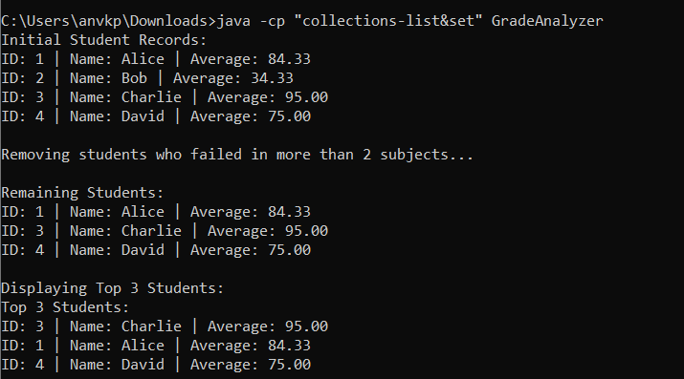
import java.util.ArrayList;
import java.util.Collections;
import java.util.Comparator;
import java.util.HashMap;
import java.util.Iterator;
import java.util.List;
import java.util.Map;

class Student {
String id;
String name;
Map<String, Integer> grades;

Student(String id, String name, Map<String, Integer> grades) {
this.id = id;
this.name = name;
this.grades = grades;
}

double getAverageGrade() {
if (grades.isEmpty()) return 0;
double sum = 0;
for (int grade : grades.values()) {
sum += grade;
}
return sum / grades.size();
}

int getFailedSubjectCount() {
int count = 0;
for (int grade : grades.values()) {
if (grade < 40) {
count++;
}
}
return count;
}

@Override
public String toString() {
return "ID: " + id + " | Name: " + name + " | Average: " + String.format("%.2f", getAverageGrade());
}
}

public class GradeAnalyzer {
private ArrayList<Student> studentList = new ArrayList<>();

public void addStudent(Student s) {
studentList.add(s);
}

public void removeFailedStudents() {
Iterator<Student> it = studentList.iterator();
while (it.hasNext()) {
if (it.next().getFailedSubjectCount() > 2) {
it.remove();
}
}
}

public void displayTopThree() {
ArrayList<Student> sortedList = new ArrayList<>(studentList);
Collections.sort(sortedList, new Comparator<Student>() {
@Override
public int compare(Student s1, Student s2) {
return Double.compare(s2.getAverageGrade(), s1.getAverageGrade());
}
});

System.out.println("Top 3 Students:");
int limit = Math.min(3, sortedList.size());
for (int i = 0; i < limit; i++) {
System.out.println(sortedList.get(i));
}
}

public void displayAll() {
Iterator<Student> it = studentList.iterator();
while (it.hasNext()) {
System.out.println(it.next());
}
}

public static void main(String[] args) {
GradeAnalyzer analyzer = new GradeAnalyzer();

Map<String, Integer> g1 = new HashMap<>();
g1.put("Math", 85); g1.put("Science", 90); g1.put("English", 78);
analyzer.addStudent(new Student("1", "Alice", g1));

Map<String, Integer> g2 = new HashMap<>();
g2.put("Math", 30); g2.put("Science", 35); g2.put("English", 38); // Failed in 3
analyzer.addStudent(new Student("2", "Bob", g2));

Map<String, Integer> g3 = new HashMap<>();
g3.put("Math", 95); g3.put("Science", 98); g3.put("English", 92);
analyzer.addStudent(new Student("3", "Charlie", g3));

Map<String, Integer> g4 = new HashMap<>();
g4.put("Math", 70); g4.put("Science", 75); g4.put("English", 80);
analyzer.addStudent(new Student("4", "David", g4));

System.out.println("Initial Student Records:");
analyzer.displayAll();

System.out.println("\nRemoving students who failed in more than 2 subjects...");
analyzer.removeFailedStudents();

System.out.println("\nRemaining Students:");
analyzer.displayAll();

System.out.println("\nDisplaying Top 3 Students:");
analyzer.displayTopThree();
}
}

Scenario 3: Navigation History (Web Browser)
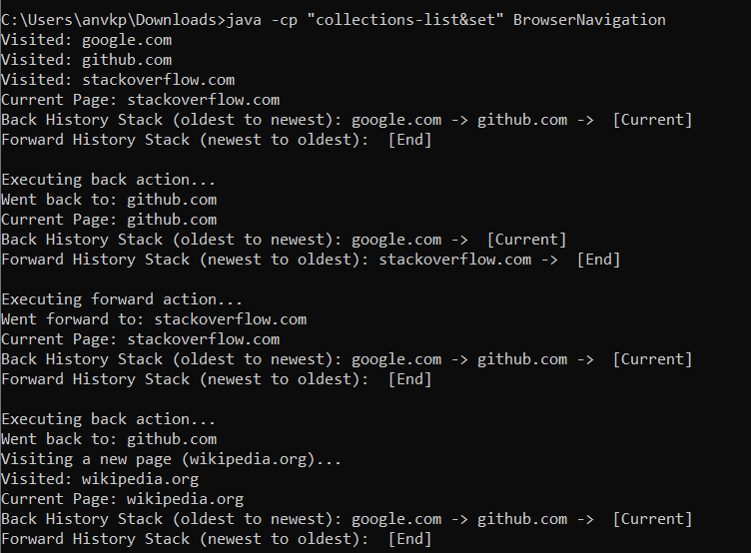
import java.util.Iterator;
import java.util.Stack;

public class BrowserNavigation {
private Stack<String> backHistory = new Stack<>();
private Stack<String> forwardHistory = new Stack<>();
private String currentPage = null;

public void visitPage(String url) {
if (currentPage != null) {
backHistory.push(currentPage);
}
currentPage = url;
forwardHistory.clear();
System.out.println("Visited: " + url);
}

public void goBack() {
if (backHistory.isEmpty()) {
System.out.println("Cannot go back. Back history is empty.");
return;
}
forwardHistory.push(currentPage);
currentPage = backHistory.pop();
System.out.println("Went back to: " + currentPage);
}

public void goForward() {
if (forwardHistory.isEmpty()) {
System.out.println("Cannot go forward. Forward history is empty.");
return;
}
backHistory.push(currentPage);
currentPage = forwardHistory.pop();
System.out.println("Went forward to: " + currentPage);
}

public void displayState() {
System.out.println("Current Page: " + (currentPage != null ? currentPage : "None"));

System.out.print("Back History Stack (oldest to newest): ");
Iterator<String> backIt = backHistory.iterator();
while (backIt.hasNext()) {
System.out.print(backIt.next() + " -> ");
}
System.out.println(" [Current]");

System.out.print("Forward History Stack (newest to oldest): ");
Iterator<String> forwardIt = forwardHistory.iterator();
while (forwardIt.hasNext()) {
System.out.print(forwardIt.next() + " -> ");
}
System.out.println(" [End]");
}

public static void main(String[] args) {
BrowserNavigation nav = new BrowserNavigation();
nav.visitPage("google.com");
nav.visitPage("github.com");
nav.visitPage("stackoverflow.com");
nav.displayState();

System.out.println("\nExecuting back action...");
nav.goBack();
nav.displayState();

System.out.println("\nExecuting forward action...");
nav.goForward();
nav.displayState();

System.out.println("\nExecuting back action...");
nav.goBack();
System.out.println("Visiting a new page (wikipedia.org)...");
nav.visitPage("wikipedia.org");
nav.displayState();
}
}

Scenario 4: Employee Payroll System
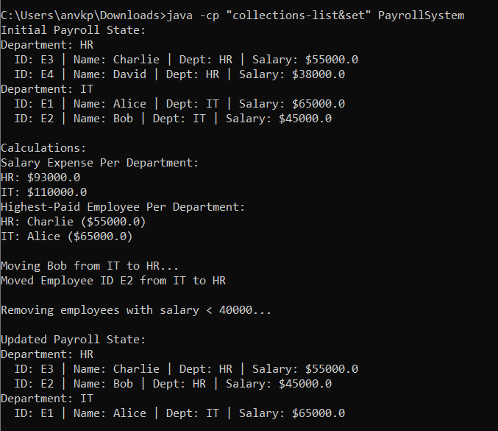
import java.util.ArrayList;
import java.util.HashMap;
import java.util.Iterator;
import java.util.List;
import java.util.Map;

class Employee {
String id;
String name;
String department;
double salary;

Employee(String id, String name, String department, double salary) {
this.id = id;
this.name = name;
this.department = department;
this.salary = salary;
}

@Override
public String toString() {
return "ID: " + id + " | Name: " + name + " | Dept: " + department + " | Salary: $" + salary;
}
}

public class PayrollSystem {
private HashMap<String, List<Employee>> departmentMap = new HashMap<>();

public void addEmployee(Employee emp) {
departmentMap.putIfAbsent(emp.department, new ArrayList<>());
departmentMap.get(emp.department).add(emp);
}

public void calculateSalaryExpense() {
System.out.println("Salary Expense Per Department:");
for (Map.Entry<String, List<Employee>> entry : departmentMap.entrySet()) {
double total = 0;
for (Employee emp : entry.getValue()) {
total += emp.salary;
}
System.out.println(entry.getKey() + ": $" + total);
}
}

public void findHighestPaid() {
System.out.println("Highest-Paid Employee Per Department:");
for (Map.Entry<String, List<Employee>> entry : departmentMap.entrySet()) {
Employee highest = null;
for (Employee emp : entry.getValue()) {
if (highest == null || emp.salary > highest.salary) {
highest = emp;
}
}
if (highest != null) {
System.out.println(entry.getKey() + ": " + highest.name + " ($" + highest.salary + ")");
}
}
}

public void removeLowEarners(double threshold) {
Iterator<Map.Entry<String, List<Employee>>> mapIt = departmentMap.entrySet().iterator();
while (mapIt.hasNext()) {
Map.Entry<String, List<Employee>> entry = mapIt.next();
List<Employee> list = entry.getValue();
Iterator<Employee> listIt = list.iterator();
while (listIt.hasNext()) {
if (listIt.next().salary < threshold) {
listIt.remove();
}
}
}
}

public void moveEmployee(String id, String fromDept, String toDept) {
List<Employee> sourceList = departmentMap.get(fromDept);
if (sourceList == null) return;

Employee target = null;
Iterator<Employee> it = sourceList.iterator();
while (it.hasNext()) {
Employee emp = it.next();
if (emp.id.equals(id)) {
target = emp;
it.remove();
break;
}
}

if (target != null) {
target.department = toDept;
addEmployee(target);
System.out.println("Moved Employee ID " + id + " from " + fromDept + " to " + toDept);
} else {
System.out.println("Employee ID " + id + " not found in department " + fromDept);
}
}

public void displayAll() {
for (Map.Entry<String, List<Employee>> entry : departmentMap.entrySet()) {
System.out.println("Department: " + entry.getKey());
for (Employee emp : entry.getValue()) {
System.out.println(" " + emp);
}
}
}

public static void main(String[] args) {
PayrollSystem system = new PayrollSystem();
system.addEmployee(new Employee("E1", "Alice", "IT", 65000));
system.addEmployee(new Employee("E2", "Bob", "IT", 45000));
system.addEmployee(new Employee("E3", "Charlie", "HR", 55000));
system.addEmployee(new Employee("E4", "David", "HR", 38000));

System.out.println("Initial Payroll State:");
system.displayAll();

System.out.println("\nCalculations:");
system.calculateSalaryExpense();
system.findHighestPaid();

System.out.println("\nMoving Bob from IT to HR...");
system.moveEmployee("E2", "IT", "HR");

System.out.println("\nRemoving employees with salary < 40000...");
system.removeLowEarners(40000);

System.out.println("\nUpdated Payroll State:");
system.displayAll();
}
}

