CSA0911 - JAVA PROGRAMMING
CO2-AT1-SCENERIO BASED ASSESSMENT

A.Vamsi (192372242)

Q1: Student Registration System
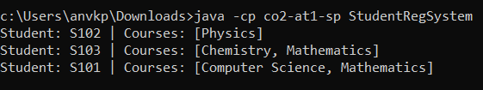
import java.util.HashMap;
import java.util.HashSet;
import java.util.Iterator;
import java.util.Map;

public class StudentRegSystem {
public static void main(String[] args) {
HashSet<String> students = new HashSet<>();
HashMap<String, HashSet<String>> enrollment = new HashMap<>();

students.add("S101");
students.add("S102");
students.add("S103");

HashSet<String> s101Courses = new HashSet<>();
s101Courses.add("Mathematics");
s101Courses.add("Computer Science");
enrollment.put("S101", s101Courses);

HashSet<String> s102Courses = new HashSet<>();
s102Courses.add("Physics");
enrollment.put("S102", s102Courses);

HashSet<String> s103Courses = new HashSet<>();
s103Courses.add("Chemistry");
s103Courses.add("Mathematics");
enrollment.put("S103", s103Courses);

Iterator<Map.Entry<String, HashSet<String>>> iterator = enrollment.entrySet().iterator();
while (iterator.hasNext()) {
Map.Entry<String, HashSet<String>> entry = iterator.next();
System.out.println("Student: " + entry.getKey() + " | Courses: " + entry.getValue());
}
}
}

Q2: E-Commerce Cart System
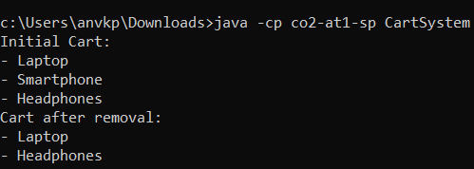
import java.util.ArrayList;
import java.util.Iterator;

public class CartSystem {
public static void main(String[] args) {
ArrayList<String> cart = new ArrayList<>();

cart.add("Laptop");
cart.add("Smartphone");
cart.add("Headphones");

System.out.println("Initial Cart:");
displayCart(cart);

cart.remove("Smartphone");

System.out.println("Cart after removal:");
displayCart(cart);
}

private static void displayCart(ArrayList<String> cart) {
Iterator<String> iterator = cart.iterator();
while (iterator.hasNext()) {
System.out.println("- " + iterator.next());
}
}
}

Q3: Library Management System
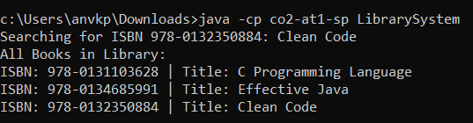
import java.util.HashMap;
import java.util.Map;

public class LibrarySystem {
public static void main(String[] args) {
HashMap<String, String> library = new HashMap<>();

library.put("978-0134685991", "Effective Java");
library.put("978-0132350884", "Clean Code");
library.put("978-0131103628", "C Programming Language");

String isbnToSearch = "978-0132350884";
System.out.println("Searching for ISBN " + isbnToSearch + ": " + library.get(isbnToSearch));

System.out.println("All Books in Library:");
for (Map.Entry<String, String> entry : library.entrySet()) {
System.out.println("ISBN: " + entry.getKey() + " | Title: " + entry.getValue());
}
}
}

Q4: Employee Data Processing
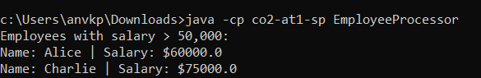
import java.util.ArrayList;
import java.util.Iterator;

class Employee {
String name;
double salary;

Employee(String name, double salary) {
this.name = name;
this.salary = salary;
}

@Override
public String toString() {
return "Name: " + name + " | Salary: $" + salary;
}
}

public class EmployeeProcessor {
public static void main(String[] args) {
ArrayList<Employee> employees = new ArrayList<>();

employees.add(new Employee("Alice", 60000.00));
employees.add(new Employee("Bob", 45000.00));
employees.add(new Employee("Charlie", 75000.00));
employees.add(new Employee("David", 48000.00));

System.out.println("Employees with salary > 50,000:");
Iterator<Employee> iterator = employees.iterator();
while (iterator.hasNext()) {
Employee emp = iterator.next();
if (emp.salary > 50000) {
System.out.println(emp);
}
}
}
}

Q5: Online Voting System
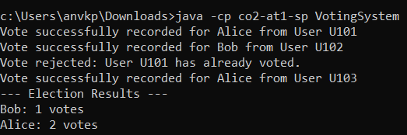
import java.util.HashMap;
import java.util.HashSet;
import java.util.Map;

public class VotingSystem {
private HashSet<String> votedUsers = new HashSet<>();
private HashMap<String, Integer> candidates = new HashMap<>();

public VotingSystem() {
candidates.put("Alice", 0);
candidates.put("Bob", 0);
}

public void castVote(String userId, String candidate) {
if (votedUsers.contains(userId)) {
System.out.println("Vote rejected: User " + userId + " has already voted.");
return;
}

if (!candidates.containsKey(candidate)) {
System.out.println("Vote rejected: Candidate " + candidate + " does not exist.");
return;
}

votedUsers.add(userId);
candidates.put(candidate, candidates.get(candidate) + 1);
System.out.println("Vote successfully recorded for " + candidate + " from User " + userId);
}

public void displayResults() {
System.out.println("--- Election Results ---");
for (Map.Entry<String, Integer> entry : candidates.entrySet()) {
System.out.println(entry.getKey() + ": " + entry.getValue() + " votes");
}
}

public static void main(String[] args) {
VotingSystem system = new VotingSystem();

system.castVote("U101", "Alice");
system.castVote("U102", "Bob");
system.castVote("U101", "Bob");
system.castVote("U103", "Alice");

system.displayResults();
}
}

