CSA0911 - JAVA PROGRAMMING
CO2-AT2-LAB QUESTIONS REPORT

A.Vamsi (192372242)

1. ATM PIN Security Validator
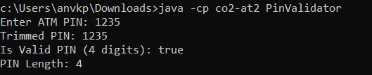
import java.util.Scanner;

public class PinValidator {
public static void main(String[] args) {
Scanner scanner = new Scanner(System.in);
System.out.print("Enter ATM PIN: ");
String input = scanner.nextLine();

String trimmed = input.trim();
boolean isValid = trimmed.matches("\\d{4}");

System.out.println("Trimmed PIN: " + trimmed);
System.out.println("Is Valid PIN (4 digits): " + isValid);
System.out.println("PIN Length: " + trimmed.length());
scanner.close();
}
}

2. Employee ID Normalization System
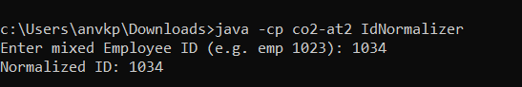
import java.util.Scanner;

public class IdNormalizer {
public static void main(String[] args) {
Scanner scanner = new Scanner(System.in);
System.out.print("Enter mixed Employee ID (e.g. emp 1023): ");
String input = scanner.nextLine();

String trimmed = input.trim();
String prefix = trimmed.substring(0, 3).toUpperCase();
String idNumber = trimmed.substring(3).trim();
String normalized = prefix.concat(idNumber);

System.out.println("Normalized ID: " + normalized);
scanner.close();
}
}

3. Online Shopping Coupon Verification
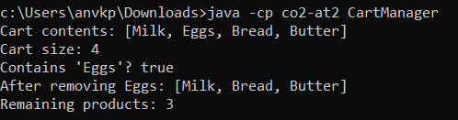
import java.util.Scanner;

public class CouponVerifier {
public static void main(String[] args) {
String originalCoupon = "SAVE50";
Scanner scanner = new Scanner(System.in);
System.out.print("Enter coupon code: ");
String input = scanner.nextLine();

String processed = input.trim().toUpperCase();
boolean isValid = processed.equalsIgnoreCase(originalCoupon);

System.out.println("Processed Code: " + processed);
System.out.println("Is Coupon Valid: " + isValid);
scanner.close();
}
}

4. Student Email Username Extractor
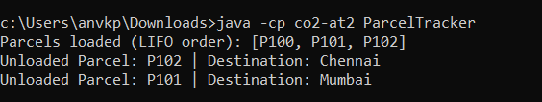
import java.util.Scanner;

public class UsernameExtractor {
public static void main(String[] args) {
Scanner scanner = new Scanner(System.in);
System.out.print("Enter email address: ");
String email = scanner.nextLine();

int atIndex = email.indexOf('@');
if (atIndex != -1) {
String username = email.substring(0, atIndex);
System.out.println("Extracted Username: " + username);
System.out.println("Username Length: " + username.length());
} else {
System.out.println("Invalid email address.");
}
scanner.close();
}
}

5. Restaurant Digital Order Analyzer
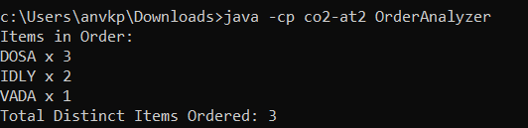
public class OrderAnalyzer {
public static void main(String[] args) {
String order = "DOSA-3-IDLY-2-VADA-1";
String[] tokens = order.split("-");

System.out.println("Items in Order:");
int itemCount = 0;
for (int i = 0; i < tokens.length; i += 2) {
String food = tokens[i].toUpperCase();
String qty = tokens[i+1];
System.out.println(food + " x " + qty);
itemCount++;
}
System.out.println("Total Distinct Items Ordered: " + itemCount);
}
}

6. Railway Coach and Seat Parser
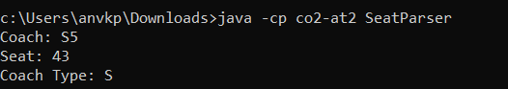
public class SeatParser {
public static void main(String[] args) {
String ticket = "S5-43";
String[] parts = ticket.split("-");
String coach = parts[0];
String seat = parts[1];

char coachType = coach.charAt(0);

System.out.println("Coach: " + coach);
System.out.println("Seat: " + seat);
System.out.println("Coach Type: " + coachType);
}
}

7. Inventory Product Search System
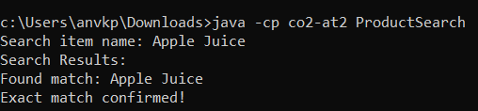
import java.util.Scanner;

public class ProductSearch {
public static void main(String[] args) {
String[] inventory = {"Apple Juice", "Orange Soda", "Wheat Bread", "Fresh Milk"};
Scanner scanner = new Scanner(System.in);
System.out.print("Search item name: ");
String query = scanner.nextLine().trim();

System.out.println("Search Results:");
for (String item : inventory) {
String lowerItem = item.toLowerCase();
String lowerQuery = query.toLowerCase();

if (lowerItem.contains(lowerQuery)) {
System.out.println("Found match: " + item);
if (item.equalsIgnoreCase(query)) {
System.out.println("Exact match confirmed!");
}
}
}
scanner.close();
}
}

8. Grocery Shopping Cart Management System
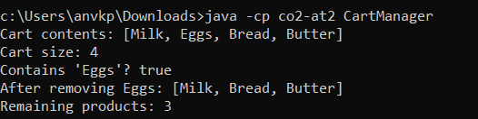
import java.util.ArrayList;

public class CartManager {
public static void main(String[] args) {
ArrayList<String> cart = new ArrayList<>();

cart.add("Milk");
cart.add("Eggs");
cart.add("Bread");
cart.add("Butter");

System.out.println("Cart contents: " + cart);
System.out.println("Cart size: " + cart.size());

System.out.println("Contains 'Eggs'? " + cart.contains("Eggs"));

cart.remove("Eggs");
System.out.println("After removing Eggs: " + cart);
System.out.println("Remaining products: " + cart.size());
}
}

9. Bank Token Queue Management System
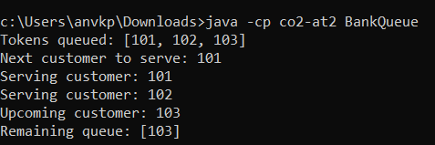
import java.util.LinkedList;
import java.util.Queue;

public class BankQueue {
public static void main(String[] args) {
Queue<Integer> queue = new LinkedList<>();

queue.offer(101);
queue.offer(102);
queue.offer(103);
System.out.println("Tokens queued: " + queue);

System.out.println("Next customer to serve: " + queue.peek());

System.out.println("Serving customer: " + queue.poll());
System.out.println("Serving customer: " + queue.poll());

System.out.println("Upcoming customer: " + queue.peek());
System.out.println("Remaining queue: " + queue);
}
}

10. Railway Parcel Dispatch Tracking System
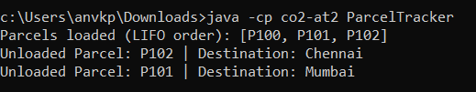
import java.util.HashMap;
import java.util.Stack;

public class ParcelTracker {
public static void main(String[] args) {
Stack<String> stack = new Stack<>();
HashMap<String, String> destinations = new HashMap<>();

stack.push("P100");
destinations.put("P100", "New Delhi");

stack.push("P101");
destinations.put("P101", "Mumbai");

stack.push("P102");
destinations.put("P102", "Chennai");

System.out.println("Parcels loaded (LIFO order): " + stack);

String unloaded = stack.pop();
System.out.println("Unloaded Parcel: " + unloaded + " | Destination: " + destinations.get(unloaded));

unloaded = stack.pop();
System.out.println("Unloaded Parcel: " + unloaded + " | Destination: " + destinations.get(unloaded));
}
}

11. Hospital Appointment Scheduling System
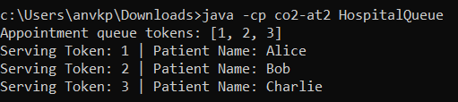
import java.util.HashMap;
import java.util.LinkedList;
import java.util.Queue;

public class HospitalQueue {
public static void main(String[] args) {
Queue<Integer> queue = new LinkedList<>();
HashMap<Integer, String> patients = new HashMap<>();

queue.offer(1);
patients.put(1, "Alice");

queue.offer(2);
patients.put(2, "Bob");

queue.offer(3);
patients.put(3, "Charlie");

System.out.println("Appointment queue tokens: " + queue);

while (!queue.isEmpty()) {
int token = queue.poll();
System.out.println("Serving Token: " + token + " | Patient Name: " + patients.get(token));
}
}
}

12. University Course Enrollment Manager
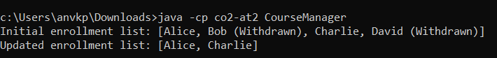
import java.util.ArrayList;
import java.util.Iterator;

public class CourseManager {
public static void main(String[] args) {
ArrayList<String> students = new ArrayList<>();
students.add("Alice");
students.add("Bob (Withdrawn)");
students.add("Charlie");
students.add("David (Withdrawn)");

System.out.println("Initial enrollment list: " + students);

Iterator<String> iterator = students.iterator();
while (iterator.hasNext()) {
String student = iterator.next();
if (student.contains("(Withdrawn)")) {
iterator.remove();
}
}

System.out.println("Updated enrollment list: " + students);
}
}

13. Warehouse Damaged Item Removal
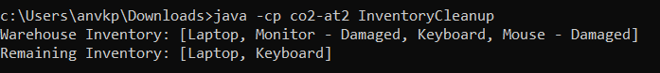
import java.util.ArrayList;
import java.util.Iterator;

public class InventoryCleanup {
public static void main(String[] args) {
ArrayList<String> inventory = new ArrayList<>();
inventory.add("Laptop");
inventory.add("Monitor - Damaged");
inventory.add("Keyboard");
inventory.add("Mouse - Damaged");

System.out.println("Warehouse Inventory: " + inventory);

Iterator<String> iterator = inventory.iterator();
while (iterator.hasNext()) {
String item = iterator.next();
if (item.contains("Damaged")) {
iterator.remove();
}
}

System.out.println("Remaining Inventory: " + inventory);
}
}

14. Bank Token Management System
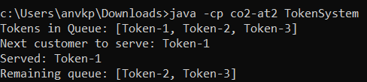
import java.util.LinkedList;
import java.util.Queue;

public class TokenSystem {
public static void main(String[] args) {
Queue<String> tokens = new LinkedList<>();

tokens.offer("Token-1");
tokens.offer("Token-2");
tokens.offer("Token-3");

System.out.println("Tokens in Queue: " + tokens);
System.out.println("Next customer to serve: " + tokens.peek());

System.out.println("Served: " + tokens.poll());
System.out.println("Remaining queue: " + tokens);
}
}

15. Web Browser Back Navigation
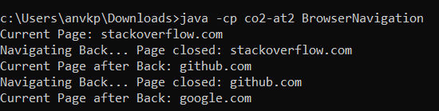
import java.util.Stack;

public class BrowserNavigation {
public static void main(String[] args) {
Stack<String> history = new Stack<>();

history.push("google.com");
history.push("github.com");
history.push("stackoverflow.com");

System.out.println("Current Page: " + history.peek());

System.out.println("Navigating Back... Page closed: " + history.pop());
System.out.println("Current Page after Back: " + history.peek());

System.out.println("Navigating Back... Page closed: " + history.pop());
System.out.println("Current Page after Back: " + history.peek());
}
}

