CSA0911 - JAVA PROGRAMMING
CO3 - INHERITANCE AND KEYWORDS (SUPER, FINAL) REPORT
A.Vamsi (192372242)

Q1: Animal and Dog Hierarchy (super keyword)
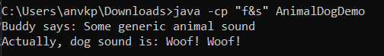
class Animal {
String name;

Animal(String name) {
this.name = name;
}

void makeSound() {
System.out.println("Some generic animal sound");
}
}

class Dog extends Animal {
String sound = "Woof! Woof!";

Dog(String name) {
super(name);
}

@Override
void makeSound() {
System.out.println(sound);
}

void displayInfo() {
System.out.print(super.name + " says: ");
super.makeSound();
System.out.print("Actually, dog sound is: ");
this.makeSound();
}
}

public class AnimalDogDemo {
public static void main(String[] args) {
Dog dog = new Dog("Buddy");
dog.displayInfo();
}
}

Q2: MathConstants (final variables and methods)
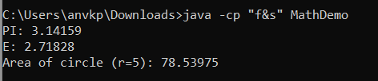class MathConstants {
final double PI = 3.14159;
final double E;

MathConstants(double eValue) {
this.E = eValue;
}

final double calculateCircleArea(double radius) {
return PI * radius * radius;
}
}

class ExtendedMath extends MathConstants {
ExtendedMath(double eValue) {
super(eValue);
}

/*
@Override
double calculateCircleArea(double radius) {
return radius * radius;
}
*/
}

public class MathDemo {
public static void main(String[] args) {
ExtendedMath math = new ExtendedMath(2.71828);
System.out.println("PI: " + math.PI);
System.out.println("E: " + math.E);
System.out.println("Area of circle (r=5): " + math.calculateCircleArea(5));
}
}

Q3: Person, Employee, and Manager Hierarchy
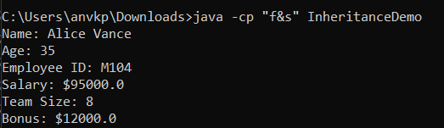class Person {
String name;
int age;

Person(String name, int age) {
this.name = name;
this.age = age;
}

void displayDetails() {
System.out.println("Name: " + name);
System.out.println("Age: " + age);
}
}

class Employee extends Person {
String employeeId;
double salary;

Employee(String name, int age, String employeeId, double salary) {
super(name, age);
this.employeeId = employeeId;
this.salary = salary;
}

@Override
void displayDetails() {
super.displayDetails();
System.out.println("Employee ID: " + employeeId);
System.out.println("Salary: $" + salary);
}
}

class Manager extends Employee {
int teamSize;
double bonus;

Manager(String name, int age, String employeeId, double salary, int teamSize, double bonus) {
super(name, age, employeeId, salary);
this.teamSize = teamSize;
this.bonus = bonus;
}

@Override
void displayDetails() {
super.displayDetails();
System.out.println("Team Size: " + teamSize);
System.out.println("Bonus: $" + bonus);
}
}

public class InheritanceDemo {
public static void main(String[] args) {
Manager mgr = new Manager("Alice Vance", 35, "M104", 95000.00, 8, 12000.00);
mgr.displayDetails();
}
}

Q4: Security Utilities (final classes)
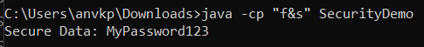final class SecurityUtils {
final String encrypt(String data) {
return new StringBuilder(data).reverse().toString();
}

final String decrypt(String encrypted) {
return new StringBuilder(encrypted).reverse().toString();
}
}

/*
class AttemptSubclass extends SecurityUtils {
}
*/

class SecureData {
private String data;
private SecurityUtils utils = new SecurityUtils();

SecureData(String data) {
this.data = utils.encrypt(data);
}

final String getSecureData() {
return utils.decrypt(data);
}
}

class ExtendedData extends SecureData {
ExtendedData(String data) {
super(data);
}

/*
@Override
String getSecureData() {
return "HackData";
}
*/
}

public class SecurityDemo {
public static void main(String[] args) {
SecureData sd = new SecureData("MyPassword123");
System.out.println("Secure Data: " + sd.getSecureData());
}
}

Q5: Bank Account System (Composition)
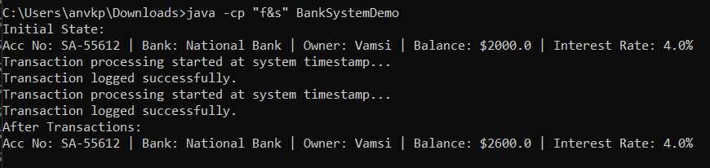final class BankAccount {
final String accountNumber;
final String bankName = "National Bank";
private double balance;
private String ownerName;

BankAccount(String accountNumber, double balance, String ownerName) {
this.accountNumber = accountNumber;
this.balance = balance;
this.ownerName = ownerName;
}

final String getAccountInfo() {
return "Acc No: " + accountNumber + " | Bank: " + bankName + " | Owner: " + ownerName + " | Balance: $" + balance;
}

void deposit(double amount) {
balance += amount;
}

double getBalance() {
return balance;
}
}

/*
class SavingsAccountExtension extends BankAccount {
}
*/

class SavingsAccount {
private BankAccount account;
double interestRate;
double minimumBalance;

SavingsAccount(String accountNumber, double balance, String ownerName, double interestRate, double minimumBalance) {
this.account = new BankAccount(accountNumber, balance, ownerName);
this.interestRate = interestRate;
this.minimumBalance = minimumBalance;
}

void applyInterest() {
double interest = account.getBalance() * interestRate;
account.deposit(interest);
}

void deposit(double amount) {
account.deposit(amount);
}

String getInfo() {
return account.getAccountInfo() + " | Interest Rate: " + (interestRate * 100) + "%";
}
}

class AccountManager {
final void processTransaction(Runnable transaction) {
System.out.println("Transaction processing started at system timestamp...");
transaction.run();
System.out.println("Transaction logged successfully.");
}
}

public class BankSystemDemo {
public static void main(String[] args) {
SavingsAccount savings = new SavingsAccount("SA-55612", 2000.00, "Vamsi", 0.04, 500.00);
AccountManager manager = new AccountManager();

System.out.println("Initial State:");
System.out.println(savings.getInfo());

manager.processTransaction(() -> {
savings.deposit(500.00);
});

manager.processTransaction(() -> {
savings.applyInterest();
});

System.out.println("After Transactions:");
System.out.println(savings.getInfo());
}
}

