CSA0911 - JAVA PROGRAMMING
Collections-List & Set
A.Vamsi (192372242)

1.course enrolment system
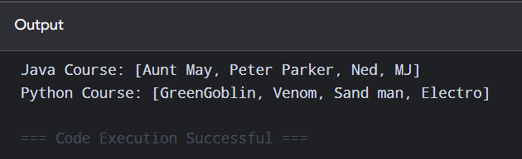
import java.util.TreeSet;
import java.util.LinkedHashSet;
import java.util.HashSet;
class Main{
public static void main(String[] args){
HashSet<String> javaCourse =new HashSet<>();
HashSet<String> pythonCourse =new HashSet<>();

javaCourse.add("Peter Parker");
javaCourse.add("MJ");
javaCourse.add("Ned");
javaCourse.add("Aunt May")
javaCourse.add("Rama");

pythonCourse.add("GreenGoblin");
pythonCourse.add("Sand man");
pythonCourse.add("Venom");
pythonCourse.add("Electro");
pythonCourse.add("Rama");

javaCourse.remove("Rama");
pythonCourse.remove("Rama");

System.out.println("Java Course: "+javaCourse);
System.out.println("Python Course: "+pythonCourse);

}
}
2.student management system
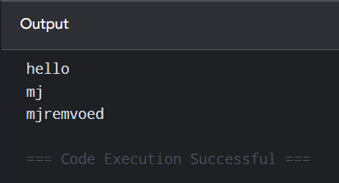
import java.util.*;
class Main{
public static void main(String[] args){
System.out.println("hello");
Scanner sc=new Scanner(System.in);
ArrayList<String> wait=new ArrayList<>();
ArrayList<String> conf=new ArrayList<>();
wait.add("peter");
wait.add("mj");
wait.add("ned");
conf.add("gg");
conf.add("sandman");
conf.add("dr.octavious");
String name=sc.nextLine();
if(wait.contains(name)){
wait.remove(name);
System.out.println(name + "remvoed");
}
Collections.sort(conf);
conf.addAll(wait);
}
}

