CSA0911 - JAVA PROGRAMMING
CO3-AT3-LAB PERFORMANCE QUESTIONS REPORT

A.Vamsi (192372242)

1. Student Grade Calculator
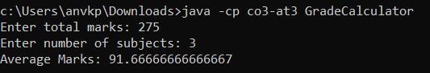
import java.util.Scanner;

public class GradeCalculator {
public static void main(String[] args) {
Scanner scanner = new Scanner(scannerSource());
try {
System.out.print("Enter total marks: ");
double totalMarks = scanner.nextDouble();
System.out.print("Enter number of subjects: ");
int subjects = scanner.nextInt();

if (subjects == 0) {
throw new ArithmeticException("Division by zero");
}

double average = totalMarks / subjects;
System.out.println("Average Marks: " + average);
} catch (ArithmeticException e) {
System.out.println("Error: Number of subjects cannot be zero.");
} catch (Exception e) {
System.out.println("Error: Invalid input.");
} finally {
scanner.close();
}
}

private static java.io.InputStream scannerSource() {
return System.in;
}
}

2. Bank Withdrawal
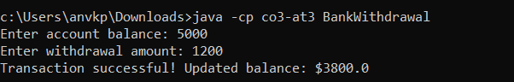
import java.util.Scanner;

class InsufficientBalanceException extends Exception {
public InsufficientBalanceException(String message) {
super(message);
}
}

public class BankWithdrawal {
public static void main(String[] args) {
Scanner scanner = new Scanner(System.in);
try {
System.out.print("Enter account balance: ");
double balance = scanner.nextDouble();
System.out.print("Enter withdrawal amount: ");
double amount = scanner.nextDouble();

withdraw(balance, amount);
} catch (InsufficientBalanceException e) {
System.out.println("Error: " + e.getMessage());
} catch (Exception e) {
System.out.println("Error: Invalid input.");
} finally {
scanner.close();
}
}

public static void withdraw(double balance, double amount) throws InsufficientBalanceException {
if (amount > balance) {
throw new InsufficientBalanceException("Insufficient Balance! Withdrawal amount exceeds balance.");
}
double remaining = balance - amount;
System.out.println("Transaction successful! Updated balance: $" + remaining);
}
}

3. Employee Age Validator
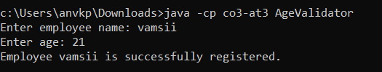
import java.util.Scanner;

class InvalidAgeException extends Exception {
public InvalidAgeException(String message) {
super(message);
}
}

public class AgeValidator {
public static void main(String[] args) {
Scanner scanner = new Scanner(System.in);
try {
System.out.print("Enter employee name: ");
String name = scanner.nextLine();
System.out.print("Enter age: ");
int age = scanner.nextInt();

validate(age);
System.out.println("Employee " + name + " is successfully registered.");
} catch (InvalidAgeException e) {
System.out.println("Error: " + e.getMessage());
} catch (Exception e) {
System.out.println("Error: Invalid input.");
} finally {
scanner.close();
}
}

public static void validate(int age) throws InvalidAgeException {
if (age < 18 || age > 60) {
throw new InvalidAgeException("Invalid Age! Age must be between 18 and 60.");
}
}
}

4. Student Record Search
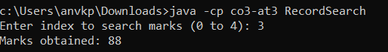
import java.util.Scanner;

public class RecordSearch {
public static void main(String[] args) {
int[] marks = {85, 92, 78, 88, 95};
Scanner scanner = new Scanner(System.in);
try {
System.out.print("Enter index to search marks (0 to 4): ");
int index = scanner.nextInt();

System.out.println("Marks obtained: " + marks[index]);
} catch (ArrayIndexOutOfBoundsException e) {
System.out.println("Error: Invalid index. Please enter an index between 0 and " + (marks.length - 1));
} catch (Exception e) {
System.out.println("Error: Invalid input.");
} finally {
scanner.close();
}
}
}

5. Product Price Input
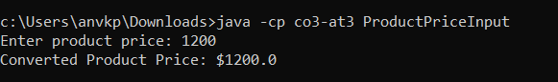
import java.util.Scanner;

public class ProductPriceInput {
public static void main(String[] args) {
Scanner scanner = new Scanner(System.in);
try {
System.out.print("Enter product price: ");
String priceStr = scanner.nextLine();

double price = Double.parseDouble(priceStr);
System.out.println("Converted Product Price: $" + price);
} catch (NumberFormatException e) {
System.out.println("Error: Price input is not a valid numeric value.");
} finally {
scanner.close();
}
}
}

