CSA0911 - JAVA PROGRAMMING
CO4-AT1-INTEGRATED PERFORMANCE (IP)

A.Vamsi (192372242)

1. Hospital Appointment Management System
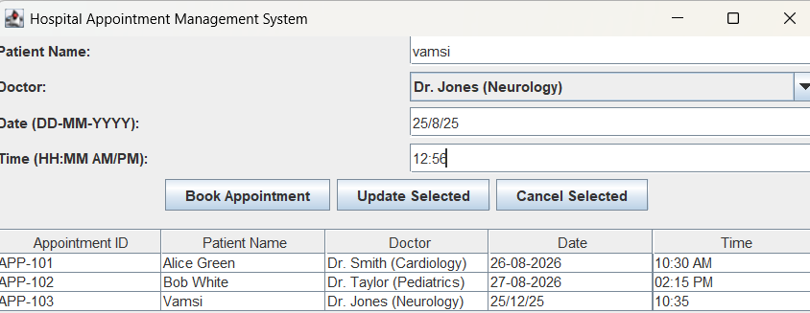
import java.awt.*;
import java.util.Vector;
import javax.swing.*;

public class HospitalApp extends JFrame implements ActionListener {
private JTextField txtPatientName, txtDate, txtTime;
private JComboBox<String> comboDoctor;
private JTable tableAppointments;
private DefaultTableModel tableModel;
private JButton btnBook, btnUpdate, btnCancel;

public HospitalApp() {
setTitle("Hospital Appointment Management System");
setSize(700, 500);
setDefaultCloseOperation(JFrame.EXIT_ON_CLOSE);
setLayout(new BorderLayout(10, 10));

JPanel inputPanel = new JPanel(new GridLayout(4, 2, 5, 5));
inputPanel.add(new JLabel("Patient Name:"));
txtPatientName = new JTextField();
inputPanel.add(txtPatientName);

inputPanel.add(new JLabel("Doctor:"));
String[] doctors = {"Dr. Smith (Cardiology)", "Dr. Jones (Neurology)", "Dr. Taylor (Pediatrics)"};
comboDoctor = new JComboBox<>(doctors);
inputPanel.add(comboDoctor);

inputPanel.add(new JLabel("Date (DD-MM-YYYY):"));
txtDate = new JTextField();
inputPanel.add(txtDate);

inputPanel.add(new JLabel("Time (HH:MM AM/PM):"));
txtTime = new JTextField();
inputPanel.add(txtTime);

JPanel buttonPanel = new JPanel(new FlowLayout());
btnBook = new JButton("Book Appointment");
btnUpdate = new JButton("Update Selected");
btnCancel = new JButton("Cancel Selected");

btnBook.addActionListener(this);
btnUpdate.addActionListener(this);
btnCancel.addActionListener(this);

buttonPanel.add(btnBook);
buttonPanel.add(btnUpdate);
buttonPanel.add(btnCancel);

JPanel topPanel = new JPanel(new BorderLayout());
topPanel.add(inputPanel, BorderLayout.CENTER);
topPanel.add(buttonPanel, BorderLayout.SOUTH);

add(topPanel, BorderLayout.NORTH);

String[] columnNames = {"Appointment ID", "Patient Name", "Doctor", "Date", "Time"};
tableModel = new DefaultTableModel(columnNames, 0);
tableAppointments = new JTable(tableModel);
JScrollPane scrollPane = new JScrollPane(tableAppointments);

add(scrollPane, BorderLayout.CENTER);

tableModel.addRow(new Object[]{"APP-101", "Alice Green", "Dr. Smith (Cardiology)", "26-08-2026", "10:30 AM"});
tableModel.addRow(new Object[]{"APP-102", "Bob White", "Dr. Taylor (Pediatrics)", "27-08-2026", "02:15 PM"});
}

@Override
public void actionPerformed(ActionEvent e) {
Object source = e.getSource();
String patient = txtPatientName.getText().trim();
String doc = (String) comboDoctor.getSelectedItem();
String date = txtDate.getText().trim();
String time = txtTime.getText().trim();

if (source == btnBook) {
if (patient.isEmpty() || date.isEmpty() || time.isEmpty()) {
JOptionPane.showMessageDialog(this, "Please fill in all details.", "Error", JOptionPane.ERROR_MESSAGE);
return;
}
String id = "APP-" + (100 + tableModel.getRowCount() + 1);
tableModel.addRow(new Object[]{id, patient, doc, date, time});
clearFields();
JOptionPane.showMessageDialog(this, "Appointment Booked Successfully!");
}
else if (source == btnUpdate) {
int selectedRow = tableAppointments.getSelectedRow();
if (selectedRow == -1) {
JOptionPane.showMessageDialog(this, "Select an appointment from the table to update.", "Error", JOptionPane.ERROR_MESSAGE);
return;
}
if (patient.isEmpty() || date.isEmpty() || time.isEmpty()) {
JOptionPane.showMessageDialog(this, "Please fill in patient name, date, and time to update.", "Error", JOptionPane.ERROR_MESSAGE);
return;
}
tableModel.setValueAt(patient, selectedRow, 1);
tableModel.setValueAt(doc, selectedRow, 2);
tableModel.setValueAt(date, selectedRow, 3);
tableModel.setValueAt(time, selectedRow, 4);
clearFields();
JOptionPane.showMessageDialog(this, "Appointment Updated Successfully!");
}
else if (source == btnCancel) {
int selectedRow = tableAppointments.getSelectedRow();
if (selectedRow == -1) {
JOptionPane.showMessageDialog(this, "Select an appointment from the table to cancel.", "Error", JOptionPane.ERROR_MESSAGE);
return;
}
tableModel.removeRow(selectedRow);
JOptionPane.showMessageDialog(this, "Appointment Cancelled Successfully!");
}
}

private void clearFields() {
txtPatientName.setText("");
txtDate.setText("");
txtTime.setText("");
}

public static void main(String[] args) {
SwingUtilities.invokeLater(() -> {
new HospitalApp().setVisible(true);
});
}
}

2. Online Banking Interface
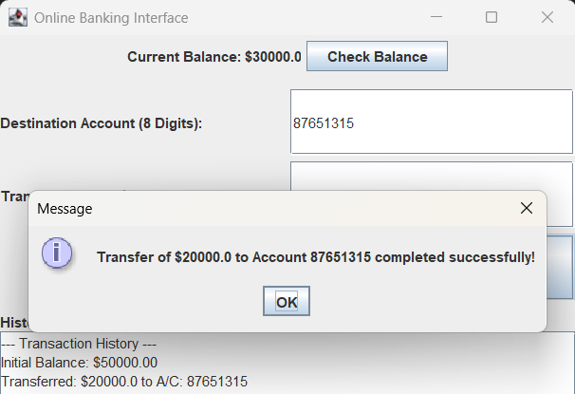
import java.awt.*;
import javax.swing.*;

public class OnlineBanking extends JFrame implements ActionListener {
private double balance = 50000.00;
private JTextField txtDestAccount, txtAmount;
private JLabel lblBalance;
private JTextArea txtAreaHistory;
private JButton btnTransfer, btnInquiry;

public OnlineBanking() {
setTitle("Online Banking Interface");
setSize(500, 450);
setDefaultCloseOperation(JFrame.EXIT_ON_CLOSE);
setLayout(new BorderLayout(10, 10));

JPanel balancePanel = new JPanel(new FlowLayout());
lblBalance = new JLabel("Current Balance: $" + balance);
btnInquiry = new JButton("Check Balance");
btnInquiry.addActionListener(this);
balancePanel.add(lblBalance);
balancePanel.add(btnInquiry);
add(balancePanel, BorderLayout.NORTH);

JPanel transferPanel = new JPanel(new GridLayout(3, 2, 5, 5));
transferPanel.add(new JLabel("Destination Account (8 Digits):"));
txtDestAccount = new JTextField();
transferPanel.add(txtDestAccount);

transferPanel.add(new JLabel("Transfer Amount ($):"));
txtAmount = new JTextField();
transferPanel.add(txtAmount);

btnTransfer = new JButton("Transfer Funds");
btnTransfer.addActionListener(this);
transferPanel.add(new JLabel(""));
transferPanel.add(btnTransfer);

add(transferPanel, BorderLayout.CENTER);

JPanel historyPanel = new JPanel(new BorderLayout());
txtAreaHistory = new JTextArea(10, 40);
txtAreaHistory.setEditable(false);
txtAreaHistory.setText("--- Transaction History ---\nInitial Balance: $50000.00\n");
JScrollPane scrollPane = new JScrollPane(txtAreaHistory);
historyPanel.add(new JLabel("History:"), BorderLayout.NORTH);
historyPanel.add(scrollPane, BorderLayout.CENTER);

add(historyPanel, BorderLayout.SOUTH);
}

@Override
public void actionPerformed(ActionEvent e) {
Object source = e.getSource();

if (source == btnInquiry) {
JOptionPane.showMessageDialog(this, "Your current balance is: $" + balance);
lblBalance.setText("Current Balance: $" + balance);
}
else if (source == btnTransfer) {
String acc = txtDestAccount.getText().trim();
String amtStr = txtAmount.getText().trim();

if (!acc.matches("\\d{8}")) {
JOptionPane.showMessageDialog(this, "Error: Account number must be exactly 8 digits.", "Invalid Input", JOptionPane.ERROR_MESSAGE);
return;
}

try {
double amount = Double.parseDouble(amtStr);
if (amount <= 0) {
JOptionPane.showMessageDialog(this, "Error: Transfer amount must be positive.", "Invalid Input", JOptionPane.ERROR_MESSAGE);
return;
}
if (amount > balance) {
JOptionPane.showMessageDialog(this, "Error: Insufficient funds.", "Transaction Failed", JOptionPane.ERROR_MESSAGE);
return;
}

balance -= amount;
lblBalance.setText("Current Balance: $" + balance);
txtAreaHistory.append("Transferred: $" + amount + " to A/C: " + acc + "\n");
JOptionPane.showMessageDialog(this, "Transfer of $" + amount + " to Account " + acc + " completed successfully!");
txtDestAccount.setText("");
txtAmount.setText("");
} catch (NumberFormatException ex) {
JOptionPane.showMessageDialog(this, "Error: Please enter a valid number for amount.", "Invalid Input", JOptionPane.ERROR_MESSAGE);
}
}
}

public static void main(String[] args) {
SwingUtilities.invokeLater(() -> {
new OnlineBanking().setVisible(true);
});
}
}

3. Inventory Management Dashboard
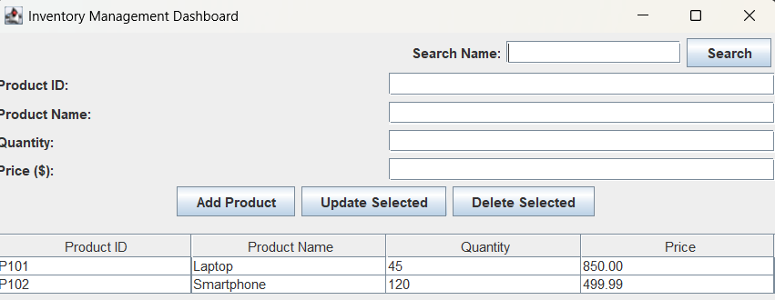
import java.awt.*;
import javax.swing.*;

public class InventoryApp extends JFrame implements ActionListener {
private JTextField txtID, txtName, txtQty, txtPrice, txtSearch;
private JTable tableInventory;
private DefaultTableModel tableModel;
private JButton btnAdd, btnUpdate, btnDelete, btnSearch;

public InventoryApp() {
setTitle("Inventory Management Dashboard");
setSize(700, 500);
setDefaultCloseOperation(JFrame.EXIT_ON_CLOSE);
setLayout(new BorderLayout(10, 10));

JPanel formPanel = new JPanel(new GridLayout(4, 2, 5, 5));
formPanel.add(new JLabel("Product ID:"));
txtID = new JTextField();
formPanel.add(txtID);

formPanel.add(new JLabel("Product Name:"));
txtName = new JTextField();
formPanel.add(txtName);

formPanel.add(new JLabel("Quantity:"));
txtQty = new JTextField();
formPanel.add(txtQty);

formPanel.add(new JLabel("Price ($):"));
txtPrice = new JTextField();
formPanel.add(txtPrice);

JPanel buttonPanel = new JPanel(new FlowLayout());
btnAdd = new JButton("Add Product");
btnUpdate = new JButton("Update Selected");
btnDelete = new JButton("Delete Selected");
buttonPanel.add(btnAdd);
buttonPanel.add(btnUpdate);
buttonPanel.add(btnDelete);

btnAdd.addActionListener(this);
btnUpdate.addActionListener(this);
btnDelete.addActionListener(this);

JPanel searchPanel = new JPanel(new FlowLayout(FlowLayout.RIGHT));
searchPanel.add(new JLabel("Search Name:"));
txtSearch = new JTextField(15);
btnSearch = new JButton("Search");
btnSearch.addActionListener(this);
searchPanel.add(txtSearch);
searchPanel.add(btnSearch);

JPanel topContainer = new JPanel(new BorderLayout());
topContainer.add(formPanel, BorderLayout.CENTER);
topContainer.add(buttonPanel, BorderLayout.SOUTH);
topContainer.add(searchPanel, BorderLayout.NORTH);

add(topContainer, BorderLayout.NORTH);

String[] cols = {"Product ID", "Product Name", "Quantity", "Price"};
tableModel = new DefaultTableModel(cols, 0);
tableInventory = new JTable(tableModel);
JScrollPane scrollPane = new JScrollPane(tableInventory);
add(scrollPane, BorderLayout.CENTER);

tableModel.addRow(new Object[]{"P101", "Laptop", "45", "850.00"});
tableModel.addRow(new Object[]{"P102", "Smartphone", "120", "499.99"});
}

@Override
public void actionPerformed(ActionEvent e) {
Object source = e.getSource();
String id = txtID.getText().trim();
String name = txtName.getText().trim();
String qty = txtQty.getText().trim();
String price = txtPrice.getText().trim();

if (source == btnAdd) {
if (id.isEmpty() || name.isEmpty() || qty.isEmpty() || price.isEmpty()) {
JOptionPane.showMessageDialog(this, "Please fill in all details.", "Error", JOptionPane.ERROR_MESSAGE);
return;
}
tableModel.addRow(new Object[]{id, name, qty, price});
clearFields();
}
else if (source == btnUpdate) {
int selectedRow = tableInventory.getSelectedRow();
if (selectedRow == -1) {
JOptionPane.showMessageDialog(this, "Select a product from table to update.", "Error", JOptionPane.ERROR_MESSAGE);
return;
}
if (name.isEmpty() || qty.isEmpty() || price.isEmpty()) {
JOptionPane.showMessageDialog(this, "Fields cannot be empty for updating.", "Error", JOptionPane.ERROR_MESSAGE);
return;
}
tableModel.setValueAt(name, selectedRow, 1);
tableModel.setValueAt(qty, selectedRow, 2);
tableModel.setValueAt(price, selectedRow, 3);
clearFields();
}
else if (source == btnDelete) {
int selectedRow = tableInventory.getSelectedRow();
if (selectedRow == -1) {
JOptionPane.showMessageDialog(this, "Select a product from table to delete.", "Error", JOptionPane.ERROR_MESSAGE);
return;
}
tableModel.removeRow(selectedRow);
}
else if (source == btnSearch) {
String query = txtSearch.getText().trim().toLowerCase();
if (query.isEmpty()) {
JOptionPane.showMessageDialog(this, "Enter search query.", "Warning", JOptionPane.WARNING_MESSAGE);
return;
}
boolean found = false;
for (int i = 0; i < tableModel.getRowCount(); i++) {
String val = tableModel.getValueAt(i, 1).toString().toLowerCase();
if (val.contains(query)) {
tableInventory.setRowSelectionInterval(i, i);
found = true;
break;
}
}
if (!found) {
JOptionPane.showMessageDialog(this, "No matching product found.", "Not Found", JOptionPane.INFORMATION_MESSAGE);
}
}
}

private void clearFields() {
txtID.setText("");
txtName.setText("");
txtQty.setText("");
txtPrice.setText("");
}

public static void main(String[] args) {
SwingUtilities.invokeLater(() -> {
new InventoryApp().setVisible(true);
});
}
}

4. Customer Feedback System
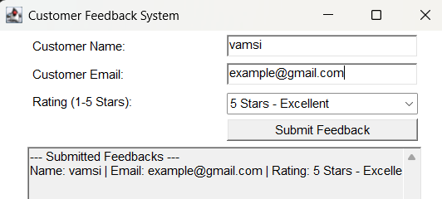
import java.applet.Applet;
import java.awt.*;

public class CustomerFeedback extends Applet implements ActionListener {
private TextField txtName, txtEmail;
private Choice choiceRating;
private TextArea txtAreaDisplay;
private Button btnSubmit;

@Override
public void init() {
setLayout(new FlowLayout());

Panel formPanel = new Panel(new GridLayout(4, 2, 5, 5));
formPanel.add(new Label("Customer Name:"));
txtName = new TextField(20);
formPanel.add(txtName);

formPanel.add(new Label("Customer Email:"));
txtEmail = new TextField(20);
formPanel.add(txtEmail);

formPanel.add(new Label("Rating (1-5 Stars):"));
choiceRating = new Choice();
choiceRating.add("5 Stars - Excellent");
choiceRating.add("4 Stars - Very Good");
choiceRating.add("3 Stars - Good");
choiceRating.add("2 Stars - Average");
choiceRating.add("1 Star - Poor");
formPanel.add(choiceRating);

btnSubmit = new Button("Submit Feedback");
btnSubmit.addActionListener(this);
formPanel.add(new Label(""));
formPanel.add(btnSubmit);

add(formPanel);

txtAreaDisplay = new TextArea(10, 45);
txtAreaDisplay.setEditable(false);
txtAreaDisplay.setText("--- Submitted Feedbacks ---\n");
add(txtAreaDisplay);
}

@Override
public void actionPerformed(ActionEvent e) {
String name = txtName.getText().trim();
String email = txtEmail.getText().trim();
String rating = choiceRating.getSelectedItem();

if (name.isEmpty() || email.isEmpty()) {
txtAreaDisplay.setText("Error: Name and Email cannot be empty.\n");
return;
}

if (!email.contains("@") || !email.contains(".")) {
txtAreaDisplay.setText("Error: Please enter a valid Email address.\n");
return;
}

txtAreaDisplay.append("Name: " + name + " | Email: " + email + " | Rating: " + rating + "\n");
txtName.setText("");
txtEmail.setText("");
}

public static void main(String[] args) {
Frame frame = new Frame("Customer Feedback System");
CustomerFeedback applet = new CustomerFeedback();

applet.init();
applet.start();

frame.add(applet);
frame.setSize(450, 400);
frame.setVisible(true);

frame.addWindowListener(new WindowAdapter() {
@Override
public void windowClosing(WindowEvent e) {
System.exit(0);
}
});
}
}

5. Ticket Booking System
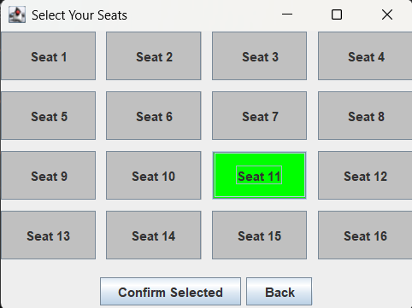
import java.awt.*;
import java.util.ArrayList;
import javax.swing.*;

public class TicketBooking extends JFrame implements ActionListener {
private JLabel lblStatus;
private JButton btnOpenSelection, btnCancelBooking;
private ArrayList<String> bookedSeats = new ArrayList<>();
private SeatSelectionWindow selectionWindow;

public TicketBooking() {
setTitle("Movie Ticket Booking Dashboard");
setSize(400, 200);
setDefaultCloseOperation(JFrame.EXIT_ON_CLOSE);
setLayout(new BorderLayout(10, 10));

lblStatus = new JLabel("Status: No booking confirmed.", JLabel.CENTER);
add(lblStatus, BorderLayout.CENTER);

JPanel panelButtons = new JPanel(new FlowLayout());
btnOpenSelection = new JButton("Select Seats");
btnCancelBooking = new JButton("Cancel Booking");

btnOpenSelection.addActionListener(this);
btnCancelBooking.addActionListener(this);

panelButtons.add(btnOpenSelection);
panelButtons.add(btnCancelBooking);
add(panelButtons, BorderLayout.SOUTH);
}

@Override
public void actionPerformed(ActionEvent e) {
Object src = e.getSource();
if (src == btnOpenSelection) {
if (selectionWindow == null) {
selectionWindow = new SeatSelectionWindow(this);
}
selectionWindow.setVisible(true);
}
else if (src == btnCancelBooking) {
if (bookedSeats.isEmpty()) {
JOptionPane.showMessageDialog(this, "No active booking to cancel.", "Error", JOptionPane.ERROR_MESSAGE);
return;
}
bookedSeats.clear();
lblStatus.setText("Status: Booking Cancelled.");
JOptionPane.showMessageDialog(this, "Booking cancelled successfully.");
}
}

public void updateBookingStatus(ArrayList<String> selectedSeats) {
this.bookedSeats = new ArrayList<>(selectedSeats);
if (bookedSeats.isEmpty()) {
lblStatus.setText("Status: No seats selected.");
} else {
lblStatus.setText("Status: Confirmed seats " + bookedSeats.toString());
}
}

public static void main(String[] args) {
SwingUtilities.invokeLater(() -> {
new TicketBooking().setVisible(true);
});
}
}

class SeatSelectionWindow extends JFrame implements ActionListener {
private TicketBooking parent;
private JButton[] seatButtons;
private ArrayList<String> selectedSeatsList = new ArrayList<>();
private JButton btnConfirm, btnClose;

public SeatSelectionWindow(TicketBooking parent) {
this.parent = parent;
setTitle("Select Your Seats");
setSize(400, 300);
setLayout(new BorderLayout(10, 10));

JPanel gridPanel = new JPanel(new GridLayout(4, 4, 10, 10));
seatButtons = new JButton[16];

for (int i = 0; i < 16; i++) {
String label = "Seat " + (i + 1);
seatButtons[i] = new JButton(label);
seatButtons[i].setBackground(Color.LIGHT_GRAY);
seatButtons[i].addActionListener(this);
gridPanel.add(seatButtons[i]);
}
add(gridPanel, BorderLayout.CENTER);

JPanel controlPanel = new JPanel(new FlowLayout());
btnConfirm = new JButton("Confirm Selected");
btnClose = new JButton("Back");

btnConfirm.addActionListener(this);
btnClose.addActionListener(this);

controlPanel.add(btnConfirm);
controlPanel.add(btnClose);
add(controlPanel, BorderLayout.SOUTH);
}

@Override
public void actionPerformed(ActionEvent e) {
Object src = e.getSource();

if (src == btnClose) {
setVisible(false);
return;
}

if (src == btnConfirm) {
if (selectedSeatsList.isEmpty()) {
JOptionPane.showMessageDialog(this, "Please select at least one seat.", "Warning", JOptionPane.WARNING_MESSAGE);
return;
}
parent.updateBookingStatus(selectedSeatsList);
JOptionPane.showMessageDialog(this, "Booking confirmed for: " + selectedSeatsList.toString());
setVisible(false);
return;
}

for (int i = 0; i < 16; i++) {
if (src == seatButtons[i]) {
String seatLabel = "Seat " + (i + 1);
if (selectedSeatsList.contains(seatLabel)) {
selectedSeatsList.remove(seatLabel);
seatButtons[i].setBackground(Color.LIGHT_GRAY);
} else {
selectedSeatsList.add(seatLabel);
seatButtons[i].setBackground(Color.GREEN);
}
break;
}
}
}
}

