CSA0911-JAVA PROGRAMMING
CO4-AT2-LABORATORY PERFORMANCE QUESTIONS
A.Vamsi (192372242)
1.
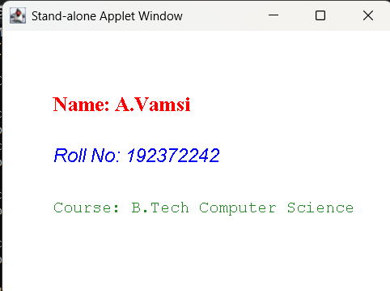
import java.applet.Applet;
import java.awt.*;

public class PersonalInfoApplet extends Applet {

@Override
public void paint(Graphics g) {
g.setColor(Color.RED);
g.setFont(new Font("Serif", Font.BOLD, 20));
g.drawString("Name: A.Vamsi", 50, 80);

g.setColor(Color.BLUE);
g.setFont(new Font("SansSerif", Font.ITALIC, 18));
g.drawString("Roll No: 192372242", 50, 130);
g.setColor(new Color(34, 139, 34)); // Forest Green
g.setFont(new Font("Monospaced", Font.PLAIN, 16));
g.drawString("Course: B.Tech Computer Science", 50, 180);
}

public static void main(String[] args) {
Frame frame = new Frame("Stand-alone Applet Window");
PersonalInfoApplet applet = new PersonalInfoApplet();
applet.init();
applet.start();

frame.add(applet);
frame.setSize(400, 300);
frame.setVisible(true);

frame.addWindowListener(new WindowAdapter() {
@Override
public void windowClosing(WindowEvent e) {
System.exit(0);
}
});
3.
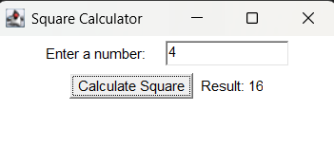
import java.applet.Applet;
import java.awt.*;

/*
<applet code="SquareCalculatorApplet.class" width="300" height="150">
</applet>
*/
public class SquareCalculatorApplet extends Applet implements ActionListener {
Label inputLabel, resultLabel;
TextField inputField;
Button calcButton;

@Override
public void init() {
setLayout(new FlowLayout());

inputLabel = new Label("Enter a number:");
inputField = new TextField(10);
calcButton = new Button("Calculate Square");
resultLabel = new Label("Result: ");

add(inputLabel);
add(inputField);
add(calcButton);
add(resultLabel);

calcButton.addActionListener(this);
}

@Override
public void actionPerformed(ActionEvent e) {
try {
double num = Double.parseDouble(inputField.getText());
double square = num * num;
resultLabel.setText("Result: " + square);
} catch (NumberFormatException ex) {
resultLabel.setText("Result: Please enter a valid number!");
}
}
public static void main(String[] args) {
Frame frame = new Frame("Square Calculator");
SquareCalculatorApplet applet = new SquareCalculatorApplet();

applet.init();
applet.start();

frame.add(applet);
frame.setSize(300, 150);
frame.setVisible(true);

frame.addWindowListener(new WindowAdapter() {
@Override
public void windowClosing(WindowEvent e) {
System.exit(0);
}
});
}
}

4.
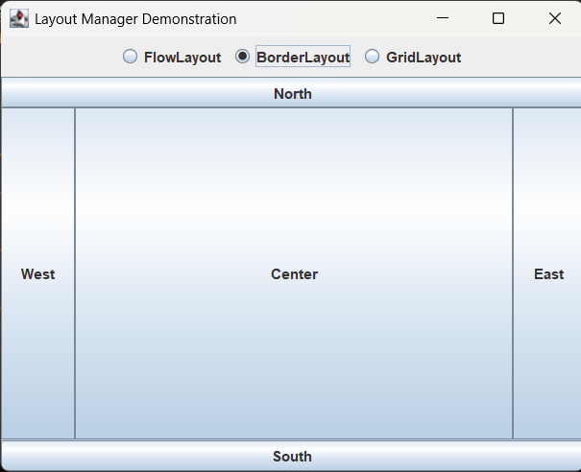
import java.awt.*;
import javax.swing.*;

public class LayoutManagerDemo extends JFrame implements ActionListener {
private JPanel displayCardPanel;
private CardLayout cardLayout;
private JRadioButton flowRadio, borderRadio, gridRadio;

public LayoutManagerDemo() {
setTitle("Layout Manager Demonstration");
setSize(500, 400);
setDefaultCloseOperation(JFrame.EXIT_ON_CLOSE);
setLayout(new BorderLayout());

JPanel controlPanel = new JPanel();
flowRadio = new JRadioButton("FlowLayout", true);
borderRadio = new JRadioButton("BorderLayout");
gridRadio = new JRadioButton("GridLayout");

ButtonGroup group = new ButtonGroup();
group.add(flowRadio);
group.add(borderRadio);
group.add(gridRadio);

controlPanel.add(flowRadio);
controlPanel.add(borderRadio);
controlPanel.add(gridRadio);

flowRadio.addActionListener(this);
borderRadio.addActionListener(this);
gridRadio.addActionListener(this);

add(controlPanel, BorderLayout.NORTH);

cardLayout = new CardLayout();
displayCardPanel = new JPanel(cardLayout);

JPanel flowPanel = new JPanel(new FlowLayout());
for (int i = 1; i <= 5; i++) {
flowPanel.add(new JButton("Flow Button " + i));
}

JPanel borderPanel = new JPanel(new BorderLayout());
borderPanel.add(new JButton("North"), BorderLayout.NORTH);
borderPanel.add(new JButton("South"), BorderLayout.SOUTH);
borderPanel.add(new JButton("East"), BorderLayout.EAST);
borderPanel.add(new JButton("West"), BorderLayout.WEST);
borderPanel.add(new JButton("Center"), BorderLayout.CENTER);

JPanel gridPanel = new JPanel(new GridLayout(3, 2, 5, 5));
for (int i = 1; i <= 6; i++) {
gridPanel.add(new JButton("Grid Cell " + i));
}

displayCardPanel.add(flowPanel, "Flow");
displayCardPanel.add(borderPanel, "Border");
displayCardPanel.add(gridPanel, "Grid");

add(displayCardPanel, BorderLayout.CENTER);
}

@Override
public void actionPerformed(ActionEvent e) {
if (flowRadio.isSelected()) {
cardLayout.show(displayCardPanel, "Flow");
} else if (borderRadio.isSelected()) {
cardLayout.show(displayCardPanel, "Border");
} else if (gridRadio.isSelected()) {
cardLayout.show(displayCardPanel, "Grid");
}
}

public static void main(String[] args) {
SwingUtilities.invokeLater(() -> {
new LayoutManagerDemo().setVisible(true);
});
}
}

5.
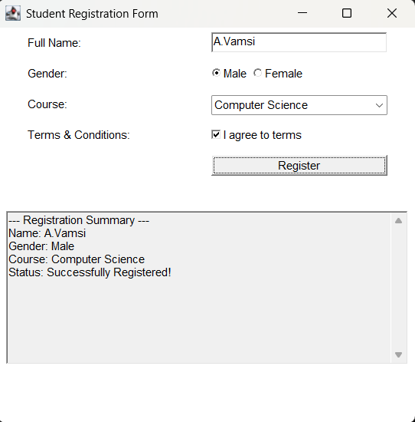
import java.awt.*;
import java.awt.event.*;

public class RegistrationForm extends Frame implements ActionListener {
Label lblTitle, lblName, lblGender, lblCourse, lblTerms;
TextField txtName;
Checkbox cbMale, cbFemale, cbTerms;
CheckboxGroup cbgGender;
Choice choiceCourse;
Button btnSubmit;
TextArea txtOutput;

public RegistrationForm() {
setTitle("Student Registration Form");
setSize(450, 450);
setLayout(new FlowLayout());

Panel formPanel = new Panel(new GridLayout(6, 2, 10, 10));

lblName = new Label("Full Name:");
txtName = new TextField(20);

lblGender = new Label("Gender:");
cbgGender = new CheckboxGroup();
cbMale = new Checkbox( "Male", cbgGender, true);
cbFemale = new Checkbox("Female", cbgGender, false);
Panel genderPanel = new Panel(new FlowLayout(FlowLayout.LEFT, 0, 0));
genderPanel.add(cbMale);
genderPanel.add(cbFemale);

lblCourse = new Label("Course:");
choiceCourse = new Choice();
choiceCourse.add("Computer Science");
choiceCourse.add("Information Technology");
choiceCourse.add("Electronics & Comm.");
choiceCourse.add("Mechanical Engineering");

lblTerms = new Label("Terms & Conditions:");
cbTerms = new Checkbox("I agree to terms", false);

btnSubmit = new Button("Register");
btnSubmit.addActionListener(this);

formPanel.add(lblName);
formPanel.add(txtName);
formPanel.add(lblGender);
formPanel.add(genderPanel);
formPanel.add(lblCourse);
formPanel.add(choiceCourse);
formPanel.add(lblTerms);
formPanel.add(cbTerms);
formPanel.add(new Label(""));
formPanel.add(btnSubmit);

add(formPanel);

txtOutput = new TextArea(10, 50);
txtOutput.setEditable(false);
add(txtOutput);

addWindowListener(new WindowAdapter() {
@Override
public void windowClosing(WindowEvent e) {
System.exit(0);
}
});
}

@Override
public void actionPerformed(ActionEvent e) {
if (!cbTerms.getState()) {
txtOutput.setText("Error: You must agree to the Terms & Conditions.");
return;
}

String name = txtName.getText();
String gender = cbgGender.getSelectedCheckbox().getLabel();
String course = choiceCourse.getSelectedItem();

String data = "--- Registration Summary ---\n" +
"Name: " + name + "\n" +
"Gender: " + gender + "\n" +
"Course: " + course + "\n" +
"Status: Successfully Registered!\n";

txtOutput.setText(data);
}

public static void main(String[] args) {
new RegistrationForm().setVisible(true);
}
}

6.
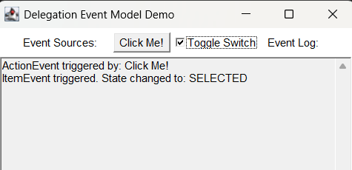
import java.awt.*;
public class DelegationEventDemo extends Frame implements ActionListener, ItemListener {
Button clickButton;
Checkbox toggleCheckbox;
TextArea logArea;

public DelegationEventDemo() {
setTitle("Delegation Event Model Demo");
setSize(400, 350);
setLayout(new FlowLayout());

clickButton = new Button("Click Me!");
toggleCheckbox = new Checkbox("Toggle Switch");
logArea = new TextArea(10, 45);
logArea.setEditable(false);

clickButton.addActionListener(this);
toggleCheckbox.addItemListener(this);

add(new Label("Event Sources:"));
add(clickButton);
add(toggleCheckbox);
add(new Label("Event Log:"));
add(logArea);

addWindowListener(new WindowAdapter() {
@Override
public void windowClosing(WindowEvent e) {
System.exit(0);
}
});
}

@Override
public void actionPerformed(ActionEvent e) {
logArea.append("ActionEvent triggered by: " + e.getActionCommand() + "\n");
}

@Override
public void itemStateChanged(ItemEvent e) {
String state = (e.getStateChange() == ItemEvent.SELECTED) ? "SELECTED" : "DESELECTED";
logArea.append("ItemEvent triggered. State changed to: " + state + "\n");
}

public static void main(String[] args) {
new DelegationEventDemo().setVisible(true);
}
}

7.
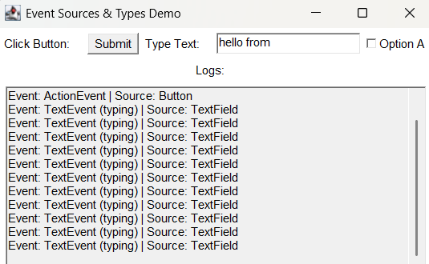
import java.awt.*;

public class EventSourceDemo extends Frame implements ActionListener, ItemListener, TextListener, WindowListener {
Button btnClick;
TextField txtInput;
Checkbox cbSelect;
TextArea logArea;

public EventSourceDemo() {
setTitle("Event Sources & Types Demo");
setSize(450, 400);
setLayout(new FlowLayout());

btnClick = new Button("Submit");
txtInput = new TextField(15);
cbSelect = new Checkbox("Option A");
logArea = new TextArea(12, 50);
logArea.setEditable(false);

btnClick.addActionListener(this);
txtInput.addTextListener(this);
cbSelect.addItemListener(this);
addWindowListener(this);

add(new Label("Click Button:"));
add(btnClick);
add(new Label("Type Text:"));
add(txtInput);
add(cbSelect);
add(new Label("Logs:"));
add(logArea);
}

private void log(String eventType, Object source) {
logArea.append("Event: " + eventType + " | Source: " + source.getClass().getSimpleName() + "\n");
}

@Override
public void actionPerformed(ActionEvent e) {
log("ActionEvent", e.getSource());
}

@Override
public void itemStateChanged(ItemEvent e) {
log("ItemEvent", e.getSource());
}

@Override
public void textValueChanged(TextEvent e) {
log("TextEvent (typing)", e.getSource());
}

@Override
public void windowClosing(WindowEvent e) {
log("WindowEvent (Closing)", e.getSource());
System.exit(0);
}

@Override public void windowOpened(WindowEvent e) { log("WindowEvent (Opened)", e.getSource()); }
@Override public void windowClosed(WindowEvent e) {}
@Override public void windowIconified(WindowEvent e) { log("WindowEvent (Iconified)", e.getSource()); }
@Override public void windowDeiconified(WindowEvent e) { log("WindowEvent (Deiconified)", e.getSource()); }
@Override public void windowActivated(WindowEvent e) { log("WindowEvent (Activated)", e.getSource()); }
@Override public void windowDeactivated(WindowEvent e) { log("WindowEvent (Deactivated)", e.getSource()); }

public static void main(String[] args) {
new EventSourceDemo().setVisible(true);
}
}

8.
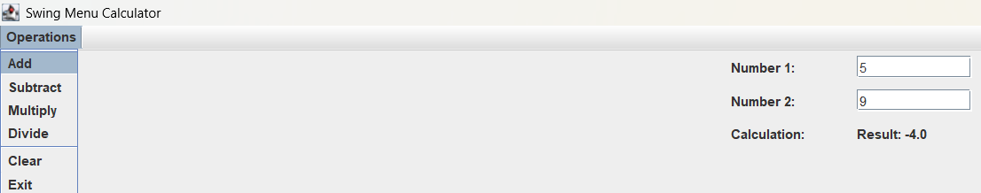
import java.awt.*;
import javax.swing.*;

public class SwingCalculator extends JFrame implements ActionListener {
private JTextField txtNum1, txtNum2;
private JLabel lblResult;
private JMenuItem itemAdd, itemSub, itemMul, itemDiv, itemClear, itemExit;

public SwingCalculator() {
setTitle("Swing Menu Calculator");
setSize(350, 250);
setDefaultCloseOperation(JFrame.EXIT_ON_CLOSE);
setLayout(new FlowLayout());

JMenuBar menuBar = new JMenuBar();
JMenu menuCalc = new JMenu("Operations");

itemAdd = new JMenuItem("Add");
itemSub = new JMenuItem("Subtract");
itemMul = new JMenuItem("Multiply");
itemDiv = new JMenuItem("Divide");
itemClear = new JMenuItem("Clear");
itemExit = new JMenuItem("Exit");

itemAdd.addActionListener(this);
itemSub.addActionListener(this);
itemMul.addActionListener(this);
itemDiv.addActionListener(this);
itemClear.addActionListener(this);
itemExit.addActionListener(this);

menuCalc.add(itemAdd);
menuCalc.add(itemSub);
menuCalc.add(itemMul);
menuCalc.add(itemDiv);
menuCalc.addSeparator();
menuCalc.add(itemClear);
menuCalc.add(itemExit);
menuBar.add(menuCalc);
setJMenuBar(menuBar);

JPanel inputPanel = new JPanel(new GridLayout(3, 2, 10, 10));
inputPanel.add(new JLabel("Number 1:"));
txtNum1 = new JTextField(10);
inputPanel.add(txtNum1);

inputPanel.add(new JLabel("Number 2:"));
txtNum2 = new JTextField(10);
inputPanel.add(txtNum2);

lblResult = new JLabel("Result: ");
inputPanel.add(new JLabel("Calculation:"));
inputPanel.add(lblResult);

add(inputPanel);
}

@Override
public void actionPerformed(ActionEvent e) {
Object source = e.getSource();

if (source == itemExit) {
System.exit(0);
}

if (source == itemClear) {
txtNum1.setText("");
txtNum2.setText("");
lblResult.setText("Result: ");
return;
}

try {
double num1 = Double.parseDouble(txtNum1.getText());
double num2 = Double.parseDouble(txtNum2.getText());
double result = 0;

if (source == itemAdd) {
result = num1 + num2;
lblResult.setText("Result: " + result);
} else if (source == itemSub) {
result = num1 - num2;
lblResult.setText("Result: " + result);
} else if (source == itemMul) {
result = num1 * num2;
lblResult.setText("Result: " + result);
} else if (source == itemDiv) {
if (num2 == 0) {
lblResult.setText("Error: Div by 0");
} else {
result = num1 / num2;
lblResult.setText("Result: " + result);
}
}
} catch (NumberFormatException ex) {
lblResult.setText("Error: Invalid inputs");
}
}

public static void main(String[] args) {
SwingUtilities.invokeLater(() -> {
new SwingCalculator().setVisible(true);
});
}
}

9.
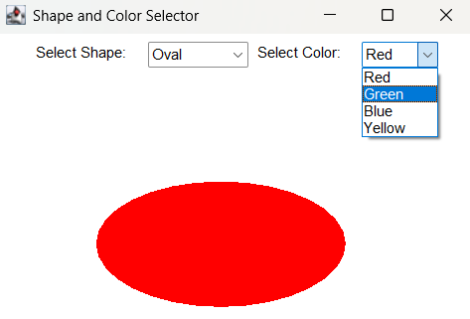
package co4_at2_lab.Program9;

import java.applet.Applet;
import java.awt.*;

public class ShapeSelectorApplet extends Applet implements ItemListener {
Choice choiceShape, choiceColor;

@Override
public void init() {
setLayout(new FlowLayout());

add(new Label("Select Shape:"));
choiceShape = new Choice();
choiceShape.add("Line");
choiceShape.add("Rectangle");
choiceShape.add("Oval");
add(choiceShape);

add(new Label("Select Color:"));
choiceColor = new Choice();
choiceColor.add("Red");
choiceColor.add("Green");
choiceColor.add("Blue");
choiceColor.add("Yellow");
add(choiceColor);

choiceShape.addItemListener(this);
choiceColor.addItemListener(this);
}

@Override
public void itemStateChanged(ItemEvent e) {
repaint();
}

@Override
public void paint(Graphics g) {
String shape = choiceShape.getSelectedItem();
String colorStr = choiceColor.getSelectedItem();

switch (colorStr) {
case "Red": g.setColor(Color.RED); break;
case "Green": g.setColor(Color.GREEN); break;
case "Blue": g.setColor(Color.BLUE); break;
case "Yellow": g.setColor(Color.YELLOW); break;
default: g.setColor(Color.BLACK); break;
}

switch (shape) {
case "Line":
g.drawLine(50, 150, 300, 150);
break;
case "Rectangle":
g.drawRect(80, 120, 200, 100);
g.fillRect(80, 120, 200, 100);
break;
case "Oval":
g.drawOval(80, 120, 200, 100);
g.fillOval(80, 120, 200, 100);
break;
}
}

public static void main(String[] args) {
Frame frame = new Frame("Shape and Color Selector");
ShapeSelectorApplet applet = new ShapeSelectorApplet();

applet.init();
applet.start();

frame.add(applet);
frame.setSize(400, 350);
frame.setVisible(true);

frame.addWindowListener(new WindowAdapter() {
@Override
public void windowClosing(WindowEvent e) {
System.exit(0);
}
});
}
}

10.
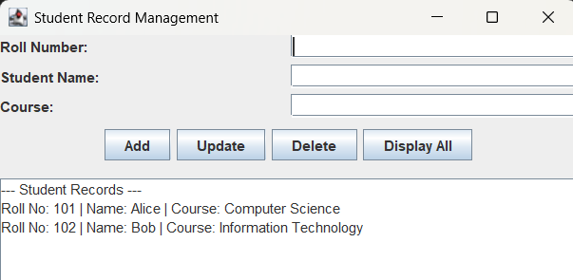
import java.awt.*;
import java.util.ArrayList;
import javax.swing.*;

public class StudentRecordApp extends JFrame implements ActionListener {
static class Student {
String rollNo;
String name;
String course;

Student(String rollNo, String name, String course) {
this.rollNo = rollNo;
this.name = name;
this.course = course;
}

@Override
public String toString() {
return "Roll No: " + rollNo + " | Name: " + name + " | Course: " + course;
}
}

private ArrayList<Student> studentList = new ArrayList<>();
private JTextField txtRollNo, txtName, txtCourse;
private JTextArea txtAreaDisplay;
private JButton btnAdd, btnUpdate, btnDelete, btnDisplay;

public StudentRecordApp() {
setTitle("Student Record Management");
setSize(500, 450);
setDefaultCloseOperation(JFrame.EXIT_ON_CLOSE);
setLayout(new BorderLayout(10, 10));

JPanel inputPanel = new JPanel(new GridLayout(3, 2, 5, 5));
inputPanel.add(new JLabel("Roll Number:"));
txtRollNo = new JTextField();
inputPanel.add(txtRollNo);

inputPanel.add(new JLabel("Student Name:"));
txtName = new JTextField();
inputPanel.add(txtName);

inputPanel.add(new JLabel("Course:"));
txtCourse = new JTextField();
inputPanel.add(txtCourse);

JPanel buttonPanel = new JPanel(new FlowLayout());
btnAdd = new JButton("Add");
btnUpdate = new JButton("Update");
btnDelete = new JButton("Delete");
btnDisplay = new JButton("Display All");

btnAdd.addActionListener(this);
btnUpdate.addActionListener(this);
btnDelete.addActionListener(this);
btnDisplay.addActionListener(this);

buttonPanel.add(btnAdd);
buttonPanel.add(btnUpdate);
buttonPanel.add(btnDelete);
buttonPanel.add(btnDisplay);

JPanel topPanel = new JPanel(new BorderLayout(5, 5));
topPanel.add(inputPanel, BorderLayout.CENTER);
topPanel.add(buttonPanel, BorderLayout.SOUTH);

add(topPanel, BorderLayout.NORTH);

txtAreaDisplay = new JTextArea(15, 40);
txtAreaDisplay.setEditable(false);
JScrollPane scrollPane = new JScrollPane(txtAreaDisplay);

add(scrollPane, BorderLayout.CENTER);

studentList.add(new Student("101", "Alice", "Computer Science"));
studentList.add(new Student("102", "Bob", "Information Technology"));
displayAll();
}

private void displayAll() {
txtAreaDisplay.setText("--- Student Records ---\n");
if (studentList.isEmpty()) {
txtAreaDisplay.append("No records found.\n");
return;
}
for (Student s : studentList) {
txtAreaDisplay.append(s.toString() + "\n");
}
}

private Student findStudent(String rollNo) {
for (Student s : studentList) {
if (s.rollNo.equalsIgnoreCase(rollNo)) {
return s;
}
}
return null;
}

@Override
public void actionPerformed(ActionEvent e) {
Object source = e.getSource();
String roll = txtRollNo.getText().trim();
String name = txtName.getText().trim();
String course = txtCourse.getText().trim();

if (source == btnAdd) {
if (roll.isEmpty() || name.isEmpty() || course.isEmpty()) {
txtAreaDisplay.setText("Error: All fields are required to Add.");
return;
}
if (findStudent(roll) != null) {
txtAreaDisplay.setText("Error: Student with Roll No " + roll + " already exists.");
return;
}
studentList.add(new Student(roll, name, course));
txtAreaDisplay.setText("Success: Record Added!\n");
displayAll();
}
else if (source == btnUpdate) {
if (roll.isEmpty()) {
txtAreaDisplay.setText("Error: Roll Number is required to Update.");
return;
}
Student student = findStudent(roll);
if (student == null) {
txtAreaDisplay.setText("Error: Student with Roll No " + roll + " not found.");
return;
}
if (!name.isEmpty()) student.name = name;
if (!course.isEmpty()) student.course = course;
txtAreaDisplay.setText("Success: Record Updated!\n");
displayAll();
}
else if (source == btnDelete) {
if (roll.isEmpty()) {
txtAreaDisplay.setText("Error: Roll Number is required to Delete.");
return;
}
Student student = findStudent(roll);
if (student == null) {
txtAreaDisplay.setText("Error: Student with Roll No " + roll + " not found.");
return;
}
studentList.remove(student);
txtAreaDisplay.setText("Success: Record Deleted!\n");
displayAll();
}
else if (source == btnDisplay) {
displayAll();
}
}

public static void main(String[] args) {
SwingUtilities.invokeLater(() -> {
new StudentRecordApp().setVisible(true);
});
}
}

