Name: Vamsi Krishna

1. If You give margin to inline element it will apply to ______Left and Right

_______

1. Top and bottom b) Left and Right c) All sides D) No sides

2) Which of the following is true about visibility: hidden

1. It occupies space
2. It is removed from the layout flow
3. It can still be clicked on
4. It is the same as opacity : 0

Ans : b

3)

**HTML**

<div class=”container”>

Some Text

</div>

**Css**

.container{

font-size : 15px;

background-color : blue;

Color : white;

padding : 5em;

}

How many pixels of padding the above layout will take

1 em = 16 pixels

5em = 5 * 16 = 80 pixels.

_____________________________________________________________________

4) Explain Margin-collapse and when it will occur?

_Some times two margins get collapsed into single margin then it is called as margin-collapse.__________________________________________________

5) Write all the data types in Javascript

Data types :- It defined as operations that can be done on data and the type of value to be stored.

Types of datatypes in javascript :-

1. Number
2. Boolean
3. Null
4. Undefined
5. String

_____________________________________________________________________

6) What is difference between primitive data types and non primitive data types

Primitive data types in javascript are number, boolean, null, undefined,string.

Non - Primitive data types in javascript are objects and arrays, functions.

_____________________________________________________________________

7) What is the output of following code

var bool = true;

let result = bool ? ‘one’ : ‘two’;

console.log(result);

____Output : one

___________________________________________________________

8) How to center a div to web page using flex properties (write css code)

Display : flex;

Justify-content : center; ( For horizontal alignment )

Align-items : center; ( For vertical alignment )

9) What is the difference between undefined and null in JavaScript?

_ Undefined : - If we don’t assign any value to the variable then it results undefined value by default.

Null : - Null means absense of value i.e it returns nothing.________________________________

10) What is difference between box-sizing : content-box and box-sizing : border-box in CSS?

_____Content-box : It is calculated by adding padding + border + content.

Border- box : It is automatically adjusted by adding padding + border   
+ content ._________________________________ _

11) What is the output of following code

console.log(typeof null); Ans : undefined

|  |  |  |  |  |  |  |  |
| --- | --- | --- | --- | --- | --- | --- | --- |
| A | Number | B | Object | C | undefined | D | None of these |

12) What is the output of following code

let firstValue=10,secondValue=20,

if((firstValue<=10 && secondValue>=15)) || (secondValue < 40)){

console.log(‘true’);

}

else{

console.log(‘false’);

}

Output : True

13) Giving which property the parent element will be not get effected by the child float property?

_____________________________________________________________________________

14)

**HTML**

<div class=”container>

<p class=”child”> CSS is awesome </p>

</div>

**CSS**

**.**container{

border : 1px solid red;

}

.child{

color : current-color;

border : 2px solid initial;

}

What is the border color of p tag ?

Ans : Red

15) You have to make the given layout to vertical using flex , Write you CSS code

.parent{

border: 1px solid viole;

background :violet;

height: 600px;

display: flex;

align-items: center;

}

.parent-1{

flex: 1;

border: 1px solid blue;

display: flex;

height: 400px;

padding: 20px;

background: blue;

margin: 20px;

border-radius: 10px;

}

.child{

border : 1px solid pink;

flex: 1;

background: pink;

margin : 20px;

border-radius: 10px;

text-align: center;

padding: 30px;

}

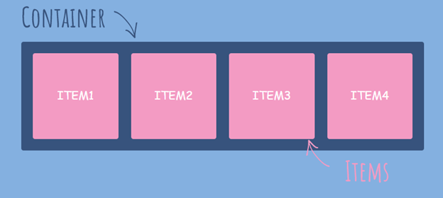

16)

**HTML**

<div class=”main__product” id=”product”> AchieversIT Training Institute Bangalore </div>

*{

color : lightgreen;

}

.main__product{

color : red;

}

#product{

color : blue;

}

div{

color : orange

}

Which color will be applied to text ?

__________________________Ans : Lightgreen___________________________________