

Name:

1. Create a below layout

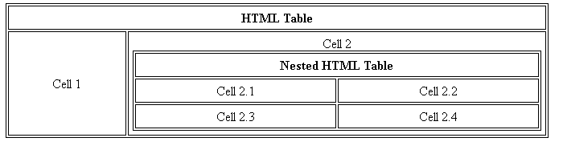

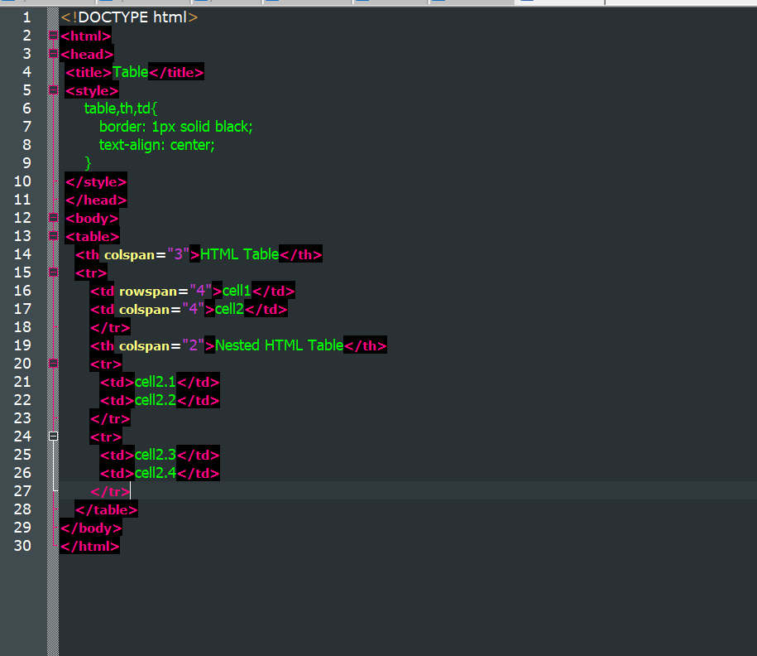

1. What is the difference between em’s and rem’s in css units

EM unit means it related to parent elements font size.

REM stands for root em. It defines root elements font-size.

1. What is specificity in CSS?

Specificity is the set of rules applied to css selectors in order to determine which style is applied to an element.

1. What is function and Why we use function in JavaScript?

Function is used to perform a particular task.

It is also use for code reusability.

1. Write a Program in JavaScript to capitalize the third word of a string

Example

**Input:**

It was peak of summer.

Season = It was peak of summer.

Console.log(season.toUpperCase());

**Output**

It was PEAK of summer.

1. Write a Program to Remove duplicates from an array?

**Input**

arr = [‘a’,’b’,’c’,’d’,’e’,’e’,’e’,’f’,’f’];

**Output**

arr = [‘a’,’b’,’c’,’d’,’e’,’f’]

1. What is anonymous function in Javascript?

____It is the type of function which has no

name._______

__________________________________________

1. Guess the output of below code

let i = 0;

For(;;){

If(i>3) break;

Console.log(i);

i++;

}

Option : B

|  |  |  |  |  |  |  |  |
| --- | --- | --- | --- | --- | --- | --- | --- |
| A | Infinity loop | B | Error | C | 0,1,2 | D | None of this |

1. What is the output of following code

let a = 5;

let size = 4;

for(let j = size ; j>=0;j--){

console.log(a);

a = a-2;

}

Output : 5,3,1,-1,-3

_______________________________________________________________________

1. Which of the following is true about variable naming conventions in JavaScript?

|  |  |  |  |  |  |  |  |
| --- | --- | --- | --- | --- | --- | --- | --- |
| A | You should not use any of the JavaScript reserved keyword as variable name. | B | JavaScript variable names should not start with a numeral 0 − 9. | C | Both of the above. | D | None Of the above |

__________Option : C

______________________________________________________________