**IMPLEMENTATION:**

1. Asking for swipe the rfid tag.

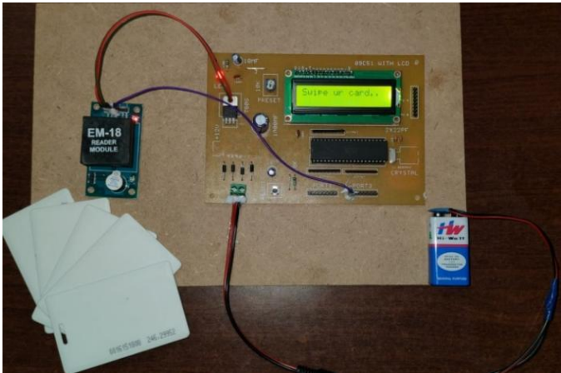

1. displaying information the rfid tag.

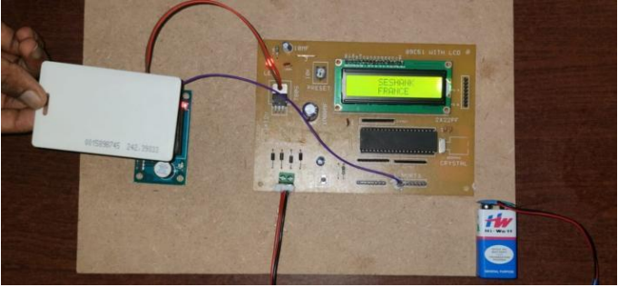

1. Display the user not found.

