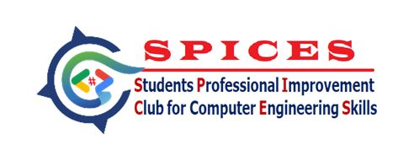 | NRI INSTITUTE OF TECHNOLOGY  (Autonomous)  Department of Computer Science and Engineering  Students Professional Improvement Club for Computer Engineering Skills (SPICES)
NBA Cycle – 2 Accredited (CSE, ECE & EEE) | Permanently Affiliated to JNTU Kakinada
| NAAC Accredited with ”A” Grade | ISO 9001:2015 Certified
Pothavarappadu (V), Agiripalli (M), Krishna Dt, A.P - 521212.

Department of Computer Science and Engineering

Date: 06-03-26

Circular
We wish to inform that the Department of Computer Science and Engineering is organizing a Hackathon Event – “Creathon” for II & III Year CSE, B.Tech, and CSE-RL students on 10th March 2026. Interested students are requested to participate in the program. The registration link will be provided by the Coordinators

The participants should work in teams within a limited time to develop innovative solutions or prototypes for given problems.

Rules and Regulations:
• Team Size: Maximum 3–4 members per team
• Participants must carry their own laptops
• Problem statements will be given at the beginning of the event
• The hackathon will be conducted in two rounds
• Top teams from Round-1 will be qualify for Round-2
• Evaluation will be based on innovation, technical approach, and presentation

Coordinators HoD
Faculty Coordinators: Mr. B. Venu Gopal,
Mr. M. V. P. Uma Maheswara Rao
Student Coordinators: T. Sree Venkat, V. Krishna Manikanta

Circulated to:
All II & III Year class rooms

