SKILLSYNC
Microservices-Based Skill Development & Mentoring Platform

1. Project Overview
SkillSync is a microservices-based platform designed for skill development and mentoring. It enables users to register, discover skills, book mentoring sessions, join community groups, and provide reviews. The architecture is engineered for scalability using a decentralised database approach and event-driven communication.

2. High-Level Architecture

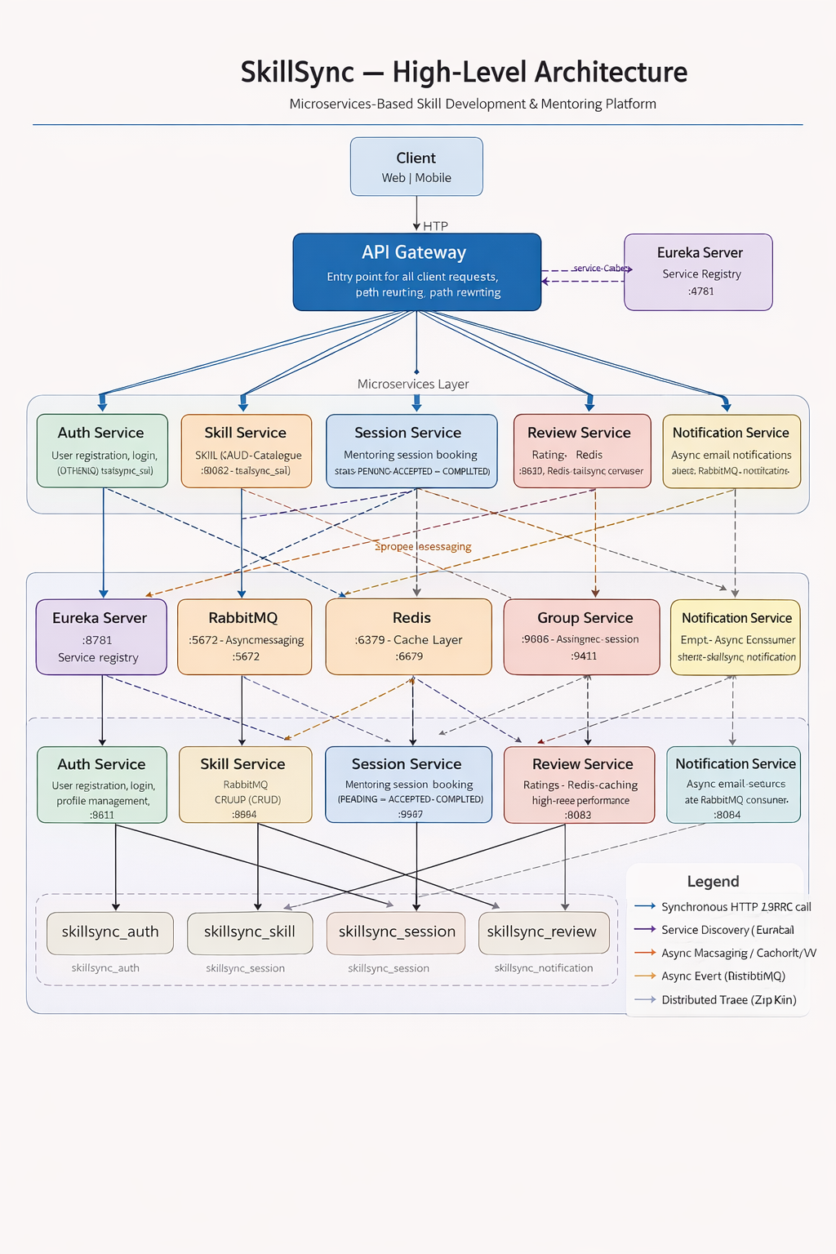
Figure 1: SkillSync High-Level Microservices Architecture

How It Works (Step-by-Step)
- Service Registration: On startup every microservice registers its IP and port with the Eureka Server.
- Request Entry: All client requests hit the API Gateway. The gateway queries Eureka to locate the target service and routes the request with path rewriting.
- Authentication: Clients include a JWT token obtained from Auth Service. Downstream services validate it locally to authorise the request.
- Business Logic & Persistence: Each service performs its task and persists data to its own private PostgreSQL database.
- Caching: The Review Service uses Redis to cache high-frequency read data (e.g. top-rated mentors), reducing database load.
- Asynchronous Events: When a session is completed, Session Service publishes an event to RabbitMQ. Notification Service consumes it and sends an email without blocking the user.
- Observability: Every request generates a unique Trace ID propagated across services via Zipkin, enabling end-to-end latency and flow analysis.

3. Technology Stack
All implemented technologies are marked ✅ in green below.

Category | Technology / Version | Status
Backend Framework | Spring Boot 3.2.5 | ✅ Implemented
Language | Java 17 | ✅ Implemented
Microservices Orchestration | Spring Cloud 2025.0.1 | ✅ Implemented
Service Discovery | Netflix Eureka Server :8761 | ✅ Implemented
API Gateway | Spring Cloud Gateway :8080 | ✅ Implemented
Database | PostgreSQL (6 independent DBs) | ✅ Implemented
Cache | Redis :6379 | ✅ Implemented
Messaging | RabbitMQ :5672 | ✅ Implemented
Distributed Tracing | Zipkin :9411 | ✅ Implemented
Security | Spring Security + JWT | ✅ Implemented
API Documentation | Swagger / SpringDoc OpenAPI | ✅ Implemented
Containerisation | Docker & Docker Compose | ✅ Implemented
Inter-service Comm (sync) | Spring Cloud OpenFeign | ✅ Implemented

4. Microservices Architecture

Service | Port | Responsibility | Database
API Gateway | :8080 | Entry point for all client requests; dynamic routing, Swagger aggregation, path rewriting | —
Eureka Server | :8761 | Service registry — all services register on startup and discover each other dynamically | —
Auth Service | :8081 | User registration, login, profile management; JWT token issuance | skillsync_auth
Skill Service | :8082 | Skill catalogue management (CRUD); discovery and listing of skills | skillsync_skill
Session Service | :8083 | Mentoring session booking; status tracking (PENDING → ACCEPTED → COMPLETED) | skillsync_session
Notification Service | :8084 | Async email notifications via RabbitMQ consumer | skillsync_notification
Review Service | :8085 | Ratings and reviews; Redis caching for high-read performance | skillsync_review
Group Service | :8086 | Community groups and membership management | skillsync_group

5. Inter-Service Communication

5.1 Synchronous Communication — Spring Cloud OpenFeign
Services communicate directly using Feign clients for real-time data needs:
- Session Service → Auth Service: AuthClient fetches user profile data (e.g. email) when updating session status.
- Review Service → Session Service: SessionClient verifies a session exists and is COMPLETED before allowing a review to be posted.

5.2 Asynchronous Communication — RabbitMQ
Asynchronous messaging decouples services and handles long-running or non-critical tasks:
- Session Service → Notification Service: When a session is ACCEPTED or COMPLETED, a NotificationEvent is published to RabbitMQ.
- Notification Service listens on notification_queue via NotificationConsumer and sends the email to the user in the background.

5.3 Service Discovery & Routing Flow
- Client sends: GET localhost:8080/skillservice/api/skills
- API Gateway identifies the service ID (skillservice) and queries Eureka.
- Eureka returns the current IP:Port for skillservice.
- Gateway forwards the request (with path rewrite) to the resolved address.

6. Implemented Features
The following features have been fully built and are marked as implemented:

- User Authentication — Registration, Login, JWT-based authorisation
- Dynamic Skill Catalogue — Skill management with administrative controls
- Mentorship Workflow — Session booking, status transitions (PENDING → ACCEPTED → COMPLETED)
- Asynchronous Notifications — Decoupled email notifications via RabbitMQ message broker
- Feedback System — Ratings and reviews with Redis caching for read performance
- Group Management — Community building through groups and memberships
- Observability — Distributed tracing with Zipkin across all services
- Database Isolation — Independent PostgreSQL database per service
- API Documentation — Aggregated Swagger/OpenAPI via API Gateway
- Containerisation — Full Docker Compose orchestration with init-db.sql bootstrapping

7. Infrastructure & Deployment
The entire ecosystem is orchestrated using Docker Compose. On first run, init-db.sql automatically provisions all six PostgreSQL databases.

Infrastructure containers
- postgres — shared PostgreSQL host running six isolated databases
- rabbitmq — message broker for async event delivery
- redis — in-memory cache for the Review Service
- zipkin — distributed tracing backend

Application containers
- eurekaserver — service registry
- authservice, skillservice, sessionservice, reviewservice, groupservice, notificationservice — core domain services
- apigateway — single ingress point for all client traffic

8. Summary
SkillSync demonstrates a production-grade microservices pattern: each service owns its data, communicates through well-defined synchronous (Feign) and asynchronous (RabbitMQ) contracts, is dynamically discoverable via Eureka, and is fully observable through Zipkin distributed tracing. The entire stack runs on Docker Compose, making it straightforward to spin up locally or deploy to a container orchestration platform.

All thirteen technology components listed in Section 3 have been implemented and are verified as working.

