**1. Introduction**

“Think about it: there is no experience you have had that you are not the absolute center of the world as you experience it is there in front of YOU or behind YOU, to the left or right of YOU, on YOUR TV or YOUR monitor. And so on. Other people's thoughts and feelings have to be communicated to you somehow, but your own are so immediate, urgent, real.” – David Foster Wallace.

**VR: Virtual Reality**

All reality-altering technology changes the way we perceive the world in some way, but virtual reality (VR) completely changes the visual environment around us.

VR is said as "an artificial environment which is experienced through sensory stimuli (as sights and sounds) provided by a computer and in which one's actions partially determine what happens in the environment."How we interact with this virtual environment, however, depends heavily on the platform in use. Some VR headsets were designed to be used while staying seated and moving yourself through the virtual space with a handheld controller, like you would in a video game. The difference here is simply that the screen is attached to your face (by way of a headset) and covers a much larger portion of your field of vision, immersing you in the virtual, 360-degree world.

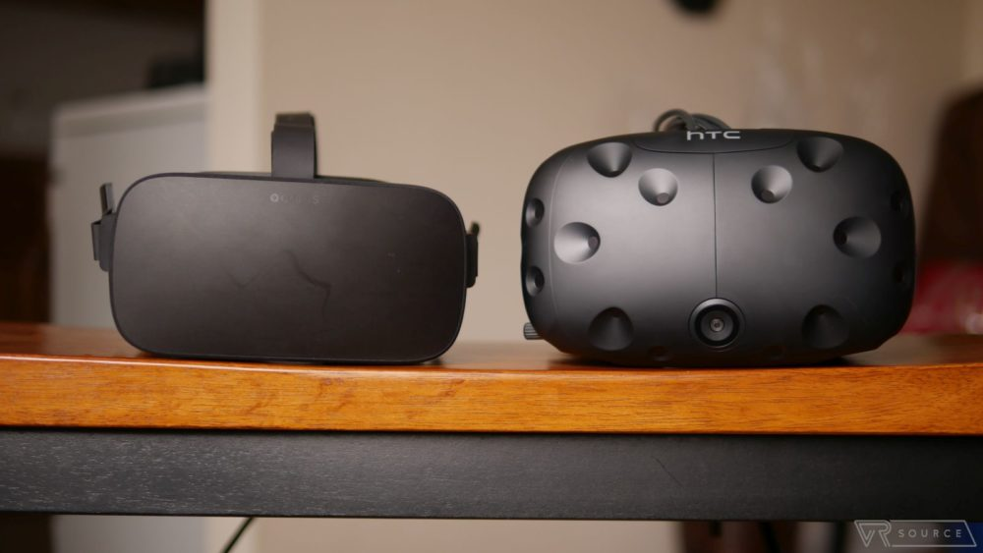

**fig.1.1**.VR-headsets.

## MR: Mixed Reality

Mixed reality (MR), on the other hand, takes AR to the next level and is, essentially, what many of us initially expected or hoped for AR to be. Instead of just a layer on top of the world we see every day, MR refers to the ability to mix digitally rendered objects into our real environment.

MR is said as "the merging of real and virtual worlds to produce new environments and visualizations where physical and digital objects co-exist and interact in real time. Mixed reality takes place not only in the physical world or the virtual world, but is a mix of reality and virtual reality, encompassing both augmented reality and augmented virtuality."

**Paint with me:**

Virtual reality technology is not new, recent advances in the technology allow it to be more suited as a communication medium rather than just trying to render an “ideal copy” or perfect simulacra of an experience that is indistinguishable from that which could be had in the physical world (Biocca and Levy, 1995). Termed “embodied experiences” (Ahn, Le, & Bailenson, 2015) or “embodied simulations (Bertrand, Franco, Pointeau, & Cherene, 2014), Immersive virtual environment technology (IVET) can allow users to embody the first-person point-of-view of another person while seeing and hearing sounds from the experiential locus of another person, as though the viewer can wear another person’s sensory apparatus. This simulation allows for the illusion of being in another person’s shoes and embodying their perspective.

The Machine to Be Another (by BeAnother Lab) is an artistic project based out of the Massachusetts Institute of Technology (MIT) Media Lab whereby two people wear an Oculus with a camera on it that is live streamed into the other person’s Oculus screen, such that they see from one another’s point-of-view in real time. This study is motivated by BeAnother Lab’s claim that these embodied simulations in IVET can “stimulate empathy through embodied interaction between individuals.”

This study specifically addresses the communication issue of relaying the creative process of artistic expression to a novice, or inexperienced artist. The hypothesis is that moving together (in this case, drawing) during an embodied experience in IVET can enhance empathic accuracy and stimulate creativity.

The methods design for this study was inspired by the Machine to Be Another’s performance. It is important to note that within this framework, the user becomes visually blind to their own body, which is replaced by the virtual simulation of the sensory apparatus of the performer. BeAnother Lab emphasizes shared movements, similar physical environments, and using real physical objects to enhance the sensorimotor contingencies between a user and a performer and to increase “the illusion of being in the place depicted by the virtual reality” (p. 3, Bertrand et al., 2014). However, Be Another Lab instructs the “performer” (the person wearing the cameras) to copy the movements of the “user” (the person wearing the Oculus), and the present study does the opposite. The present study involves handing the user, who is the experimental subject, a real paintbrush, palette, and seating them in front of a real canvas so that the physical reality of the user will match that of the performer and mirror what the user sees in the virtual simulation.

However, recent advances in filmed, streamed, and simulated virtual reality environments allow subjects to see first-personally from the point-of-view of another person, character, or avatar. Thus, in this sense, it could be argued that through this technology it is now possible to have exactly the type of experience that Wallace suggests our day-to-day mode of being occludes: an experience in which a person is not the absolute center of their own experience. Instead, through this technology the individual is placed in the center of someone else’s experience. This inductive study explores how this virtual simulation can transform our ability to relate to and learn from one another.