**4. METHODS**

IVET simulations of space shuttle take-off experience similar states of awe and wonder as actual astronauts report when being on a space shuttle and seeing the Earth from space. Gallagher et al.’s (2015) study thus tested the stimulation of certain types of experience (which the researchers classified as “awe” and “wonder”) in a virtual simulation. Based on 16 interviews with professional painters, this study similarly collected experiential categories for the creative process of painting. Painters were asked to describe their cognitive and affective experience of creativity in painting. Through content analysis, the transcripts from these interviews were coded and clustered into two major themes: as lack of judgment and the ability to watch something emerge without preconceptions. These features were analysed in the interview transcriptions with subjects after the IVET experience. The present study used a qualitative interview method inspired by Høffding and Martiny’s (2015) phenomenological interview. This semi-structured interview was designed to explore the plausible stimulation of key aspects of the creative process of painting.

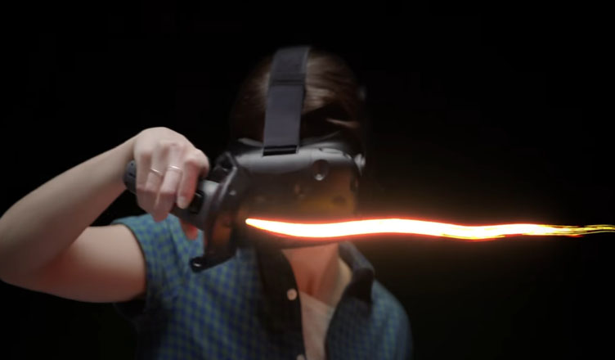

**fig.4.1.**User with the Tilt-Brush.

The setup is a Mixed Reality (MR) setup that utilizes mapping the apparent location of a virtual canvas and easel onto the physical canvas and easel that the user paints upon. The experimenter calibrated the easel and canvas in proximity to the user to match and accommodate every subject such that the physical canvas mapped onto where the virtual canvas appears. Using Leap Motion integration with the Oculus DK2 virtual reality headset, the user sees a tracked rendering of their own hand, scaled to the painter's hand in the video, and was told to place their hand on top of the painter's hand while following the painter’s movements and painting synchronously on their physical canvas.

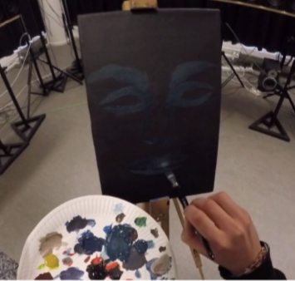

fig.4.2. Still from the video shown to the User in Oculus DK2.

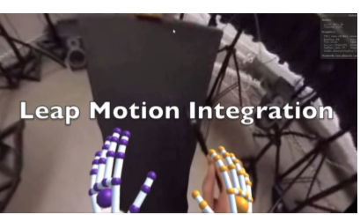

fig.4.3. Still of the Leap Motion hand tracking for User’s hands on top of the Painter’s hands.

Binaural point-of-view audio was recorded using Roland CS-10EM binaural microphones, which work simultaneously as headphones. The microphones are electret and omnidirectional, and capture frequency range from 20hZ to 20khZ (average hearing range of a human). Ebba was instructed to wear the bicycle helmet camera mount and binaural microphones and talk aloud about her creative process while painting. The experiment was conducted over the span of two weeks at the Experience Lab in the Human-Computer Communication department at University of Copenhagen. The Leap Motion infrared camera was attached to the front of the DK2 with tape and positioned a downward angle to capture hand movements. The spherical stereoscopic video with Leap Motion was coded in Unity (version 6.4) and masked onto 3D models of the spherical shape of the human eyes to simulate human vision**.**

**Oneness:**

The Inclusion of Other in the Self Scale measured how close the participants felt to the painter. Developed by Aron and colleagues (1992), this scale depicts seven drawings of increasingly overlapping circles, starting with the first picture of non-overlapping circles and the seventh picture of two almost completely overlapping circles. The participant was instructed to select the figure that best captures the extent to which they felt close to the painter.

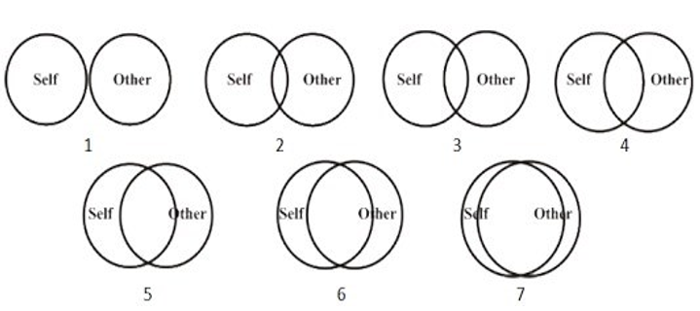

fig.4.4. Inclusion of the Self in the Other Scale.

**Empathic Accuracy:**

To operationalize empathy, this study utilizes William Ickes (1993) empathic accuracy technique and coding. Ickes adapted the humanist psychologist Carl Rogers’ criteria for assessing the convergence between the therapist’s and the client’s perception of the client’s self-concept. Specifically, the Rogerian view stipulates that empathy involves a moment-to-moment sensitivity to the changing feelings and emotions in another person, and thus a measurement of empathic accuracy should be a temporally extended, repeatedmeasures assessment to track empathy as a developing and ongoing process. Moreover, the perceiver should generate his or her own inferences about the content of the target person’s thoughts and feelings, as opposed to choosing from a set of pre-specified optional responses. Most importantly, the operational definition of empathy should be the degree to which a perceiver’s inferences matches and is congruent with the target person’s actual thoughts and feelings (Rogers, 1974, as cited in Ickes, 1993). Thus, subjects generated their own inferences about the painter’s experience while painting, and this was compared with the painter’s generated report. Responses were coded from 0 to 2, 0 being “completely different”, 1 being “different thoughts but along the same lines”, and 2 being “almost identical.” The experimenter and an independent coder both coded the responses for inter-coder reliability. Percent agreement was 90-100% across all subjects except for one (70%), which the coders discussed to increase to 90% agreement. Scott's Pi was between .52 and 1. Cohen's Kappa was also between .55 and 1, and Krippendorff's Alpha for inter-coder reliability was between .66 and 1. The following four dependent measure survey items were adapted from Osimo, Pizarro, Spanlang, & Slater (2015). All items were measured on a 5-point Likert Scale.

**Presence:**

Two items on the Virtual Reality Survey measured presence and immersion. The items “user felt the canvas that user was painting in the virtual environment” and it seems user lost sense of my physical body and felt myself to be in the world presented in the virtual environment.