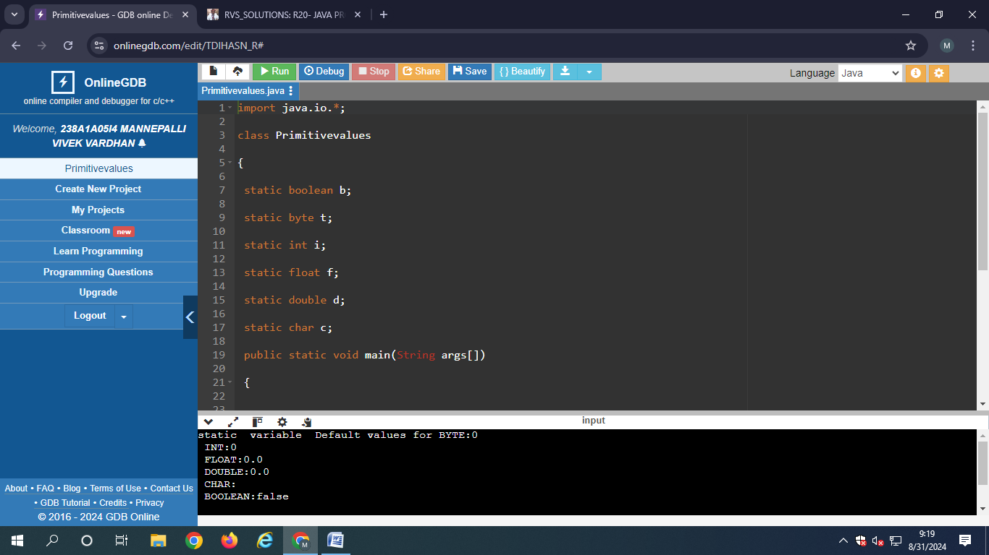

Output:

static variable Default values for BYTE:0

INT:0

FLOAT:0.0

DOUBLE:0.0

CHAR:

BOOLEAN:false

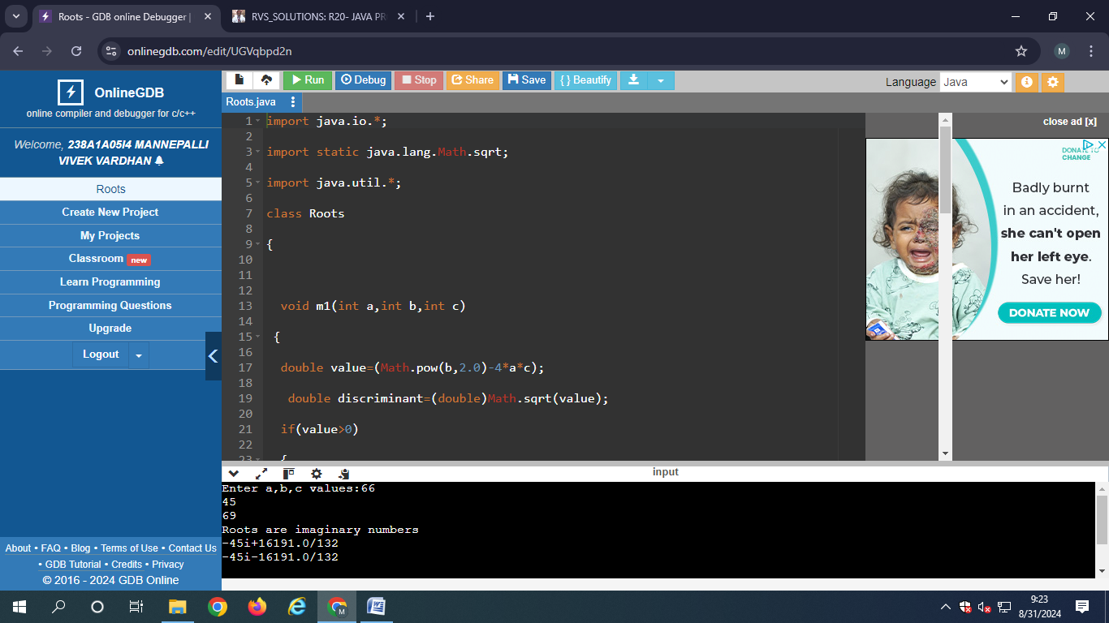

Output:

Enter a,b,c values:66

45

69

Roots are imaginary numbers

-45i+16191.0/132

-45i-16191.0/132

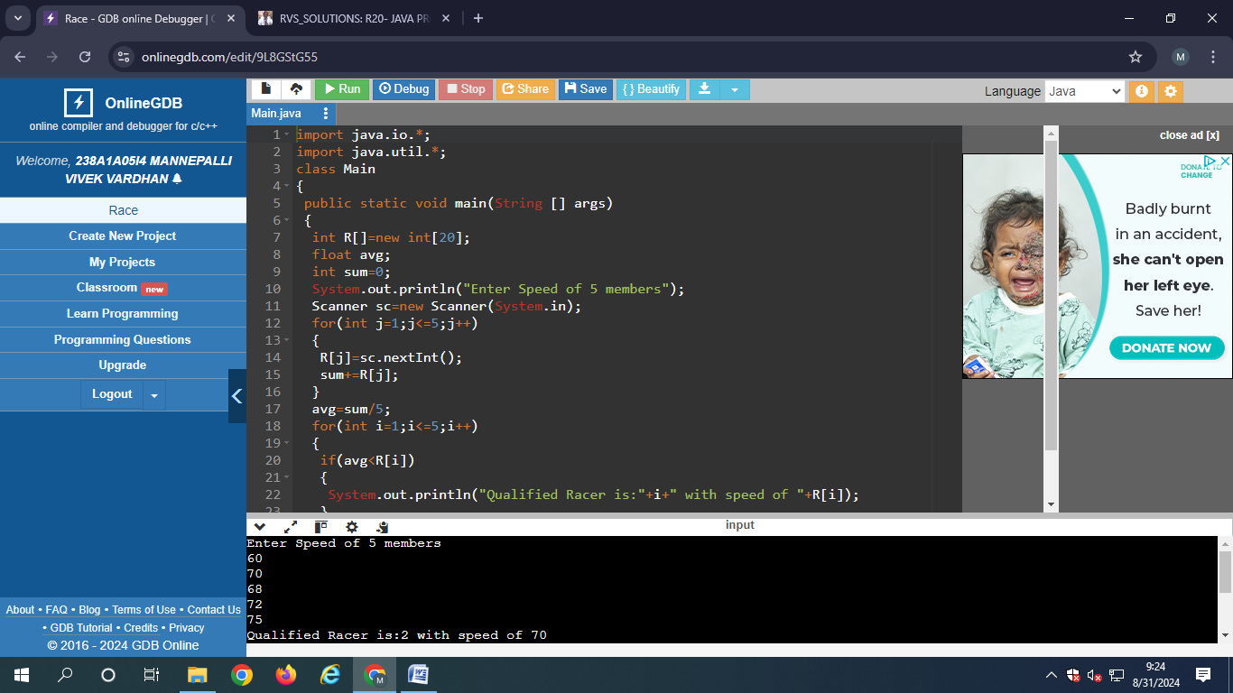

Output:

Enter Speed of 5 members

60

70

68

72

75

Qualified Racer is:2 with speed of 70

Qualified Racer is:4 with speed of 72

Qualified Racer is:5 with speed of 75

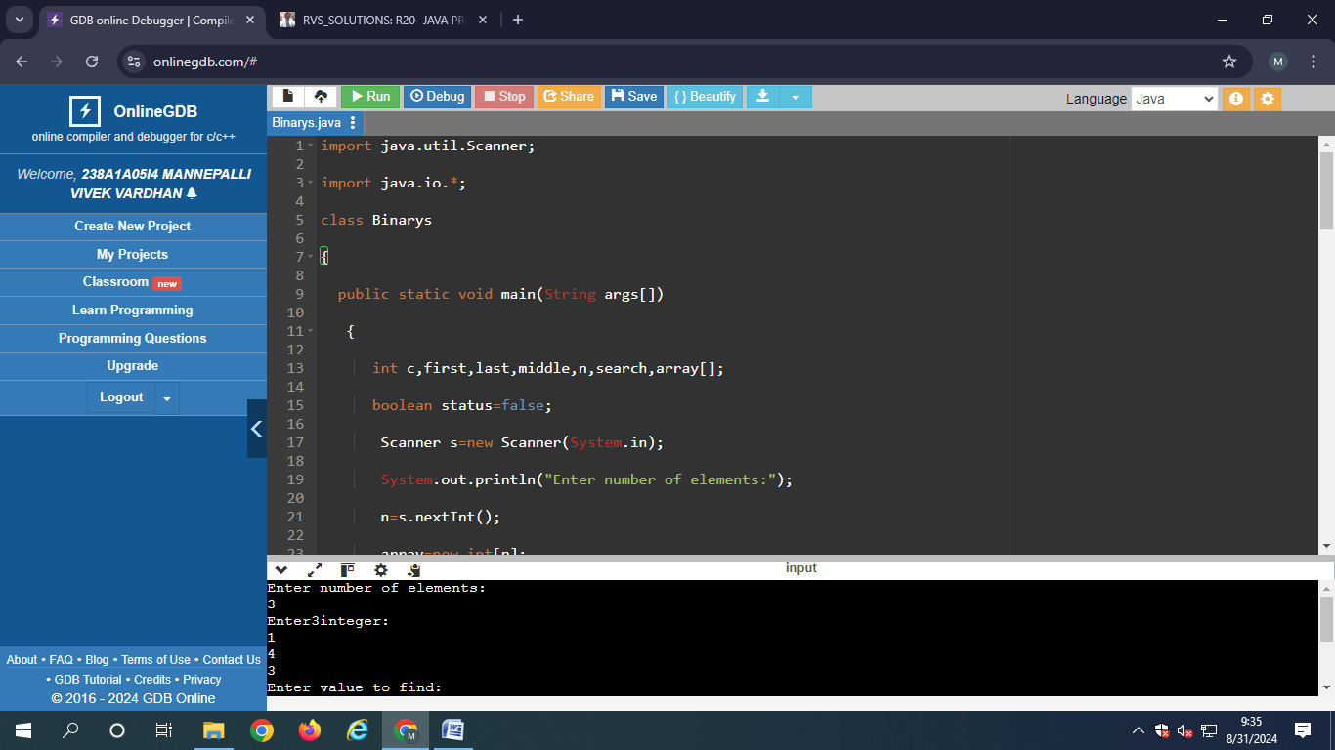

Output:

Enter number of elements:

3

Enter3integer:

1

4

3

Enter value to find:

4

4found at location3

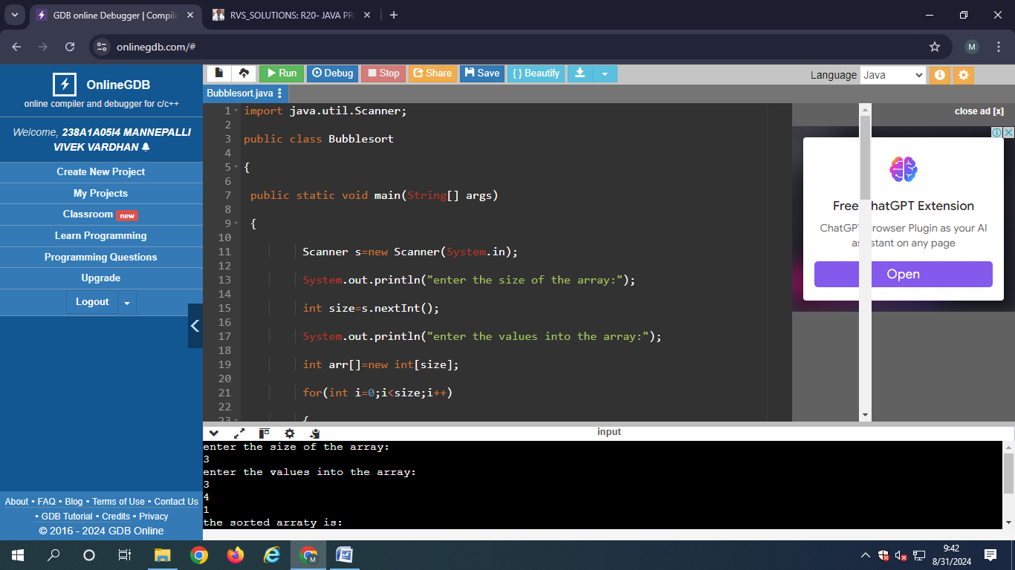

Output:

enter the size of the array:

3

enter the values into the array:

3

4

1

the sorted arraty is:

1 3 4

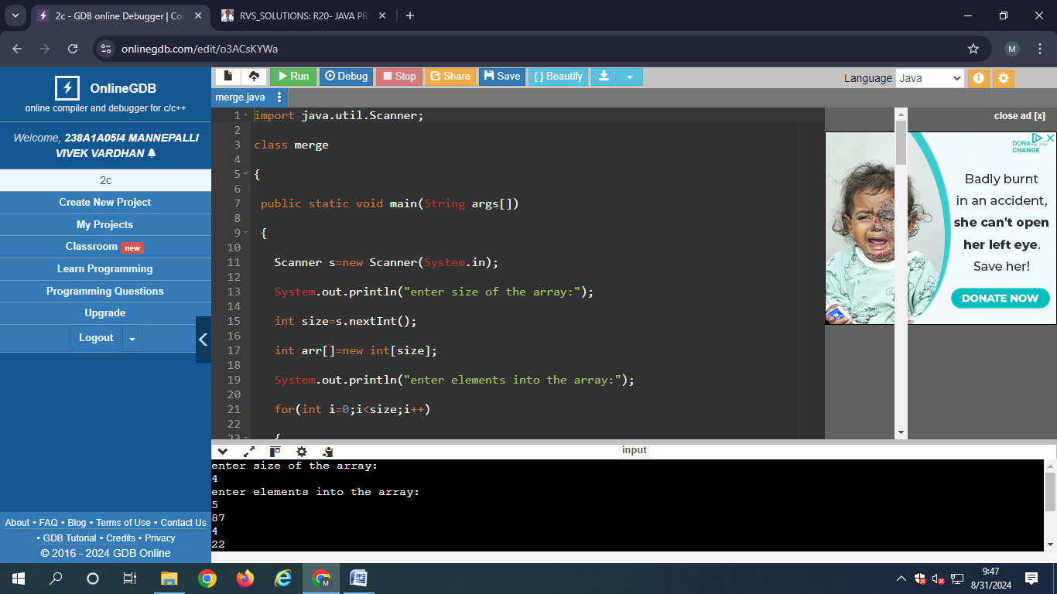

Output:

enter size of the array:

4

enter elements into the array:

5

87

4

22

the sorted array is:

4 5 22 87

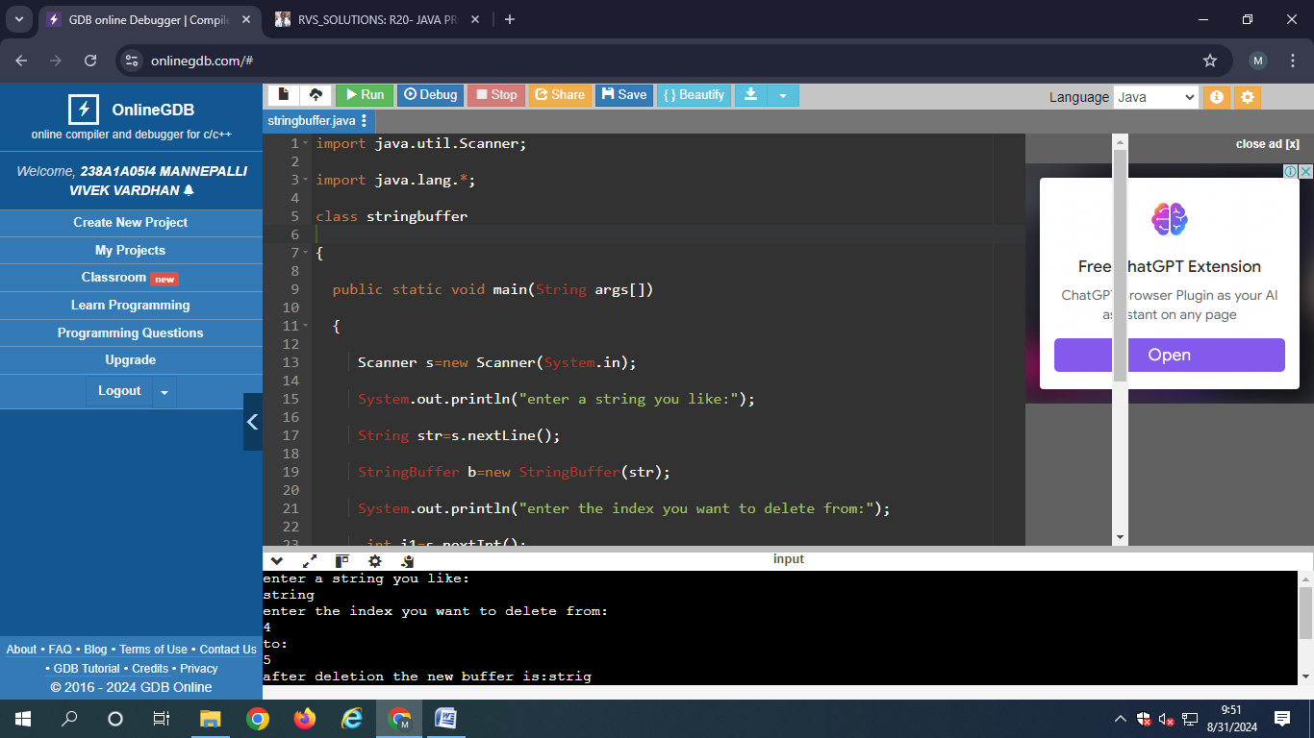

Output:

enter a string you like:

string

enter the index you want to delete from:

4

to:

5

after deletion the new buffer is:strig

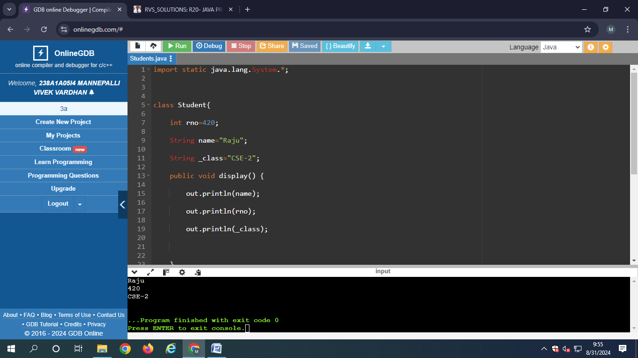

Output:

Raju

420

CSE-2

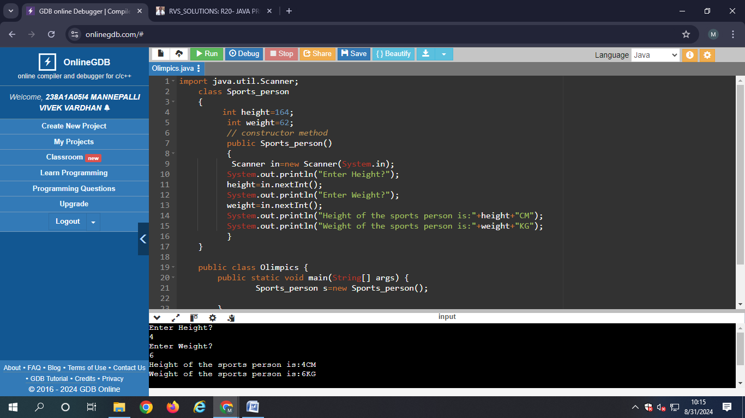

Output:

Enter Height?

4

Enter Weight?

6

Height of the sports person is:4CM

Weight of the sports person is:6KG

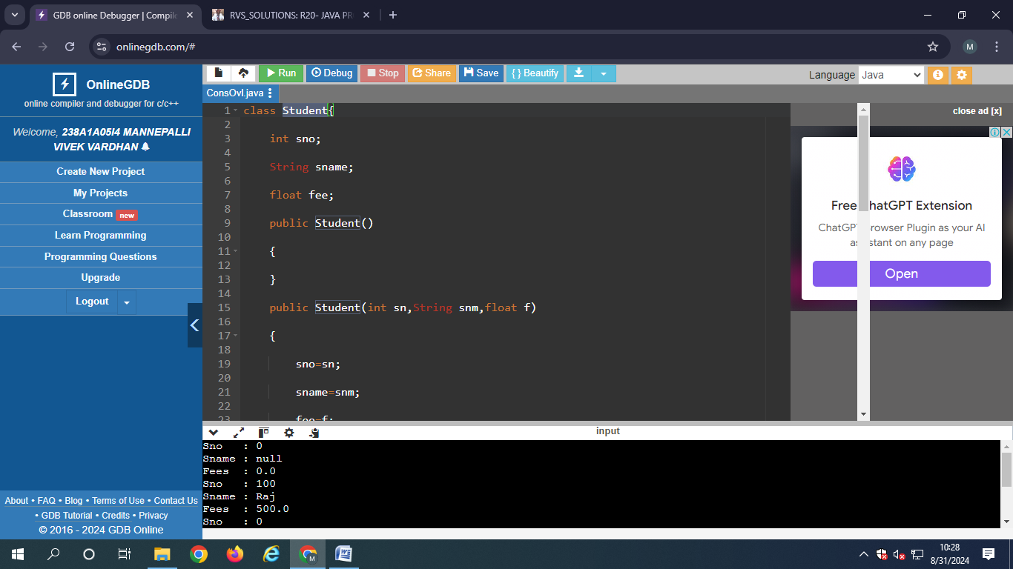

Output:

Sno : 0

Sname : null

Fees : 0.0

Sno : 100

Sname : Raj

Fees : 500.0

Sno : 0

Sname : null

Fees : 0.0

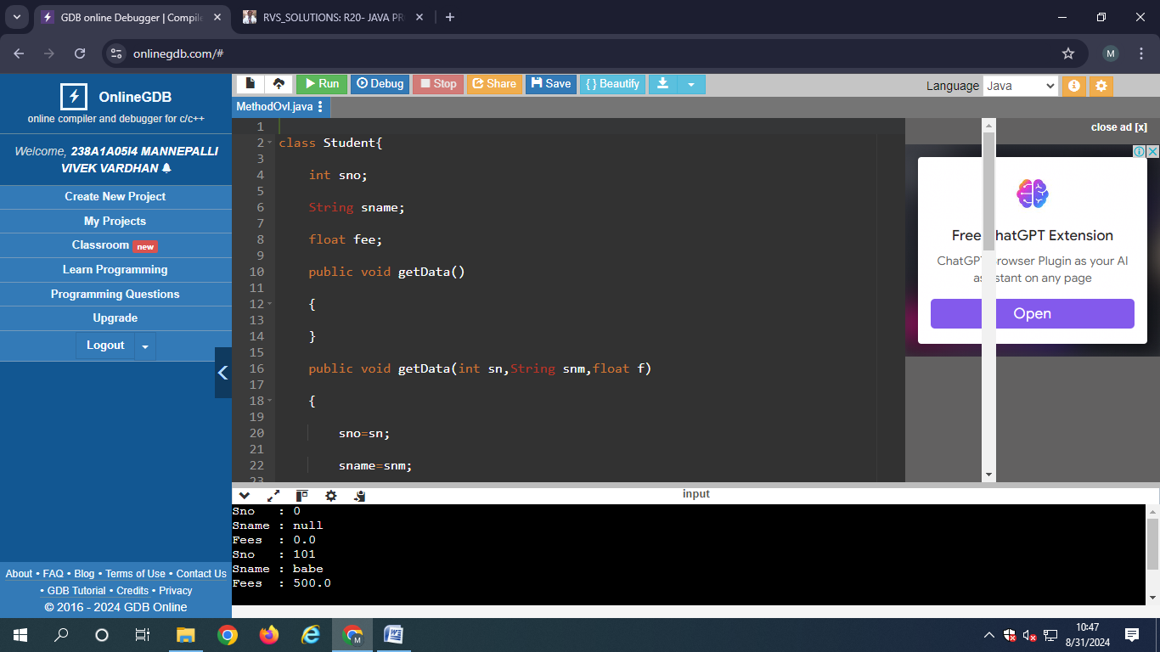

Output:

Sno : 0

Sname : null

Fees : 0.0

Sno : 101

Sname : babe

Fees : 500.0