**Drowsiness and Emotion Detector for Safety Driving**

A Project Report

Submitted in the partial fulfilment of the requirements for the award of the degree of

**Bachelor of Technology**

**In**

**Computer Science Engineering**

By

Kawali Nitin Raj 180330203

Kurumaddali Krishna Vamsi 180330207

Siddhantham Vardhan Kumar 180330225

Under the supervision of

**Mrs. NANDULA ANURADHA**

Assistant Professor – Department of Computer Science and Engineering



**Department of Computer Science and Engineering**

**K L University Hyderabad**

Aziz Nagar, Moinabad Road, Hyderabad – 500 075, Telangana, India

March, 2022

**Declaration**

The Project Report entitled “**Drowsiness and Emotion Detector for Safety Driving**” is a record of bonafide work of Kawali Nitin Raj - 180330203, Kurumaddali Krishna Vamsi - 180330207, Siddhantham Vardhan Kumar - 180330225, submitted in partial fulfilment for the award of B. Tech in the Department of Computer Science and Engineering to the K L University, Hyderabad. The results embodied in this report have not been copied from any other Departments/ University/ Institute.

Kawali Nitin Raj

Kurumaddali Krishna Vamsi

Siddhantham Vardhan Kumar

**Certificate**

This is to certify that the Project Report entitled “**Drowsiness and Emotion Detector for Safety Driving**” is being submitted by Kawali Nitin Raj - 180330203, Kurumaddali Krishna Vamsi - 180330207, Siddhantham Vardhan Kumar - 180330225, submitted in partial fulfilment for the award of B.Tech in Computer Science and Engineering to the K L University, Hyderabad is a record of bonafide work carried out under our guidance and supervision.

The results embodied in this report have not been copied from any other departments/ University/Institute.

**Signature of the Supervisor**

**Mrs. NANDULA ANURADHA**

**Assistant Professor – Dept. CSE**

**Signature of HOD Signature of the External Examiner**

**Acknowledgement**

First and foremost, we thank the lord almighty for all his grace & mercy showered upon us, for completing this project successfully.

We take grateful opportunity to thank our beloved Founder and Chairman who has given constant encouragement during our course and motivated us to do this project. We are grateful to our Principal **Dr. L. Koteswara Rao** who has been constantly bearing the torch for all the curricular activities undertaken by us.

We pay our grateful acknowledgement & sincere thanks to our Head of the Department **Dr. Chiranjeevi Manike** for his exemplary guidance, monitoring and constant encouragement throughout the course of the project. We pay our sincere thanks to our Project Coordinator **Mrs. Udaya Rani Gurala** who has been constantly inculcating logistic support and has given constant encouragement during our project. We thank **Mrs. Nandula Anuradha** of our Department who has supported throughout this project holding a position of supervisor.

We whole heartedly thank all the teaching and non-teaching staff of our department without whom we won’t have made this project a reality. We would like to extend our sincere thanks especially to our parent, our family members and friends who have supported us to make this project a grand success.

**Abstract**

Now-a-days, one of the major causes of road accidents and death is a drowsy driving. Due to this, the detection of driver’s fatigue and its indication is an active research area. Many of the prescribed conventional methods are either vehicle based or behavioural based or physiological based. Few methods are intrusive and distractive to the driver, some require expensive sensors and data handling to obtain the data.

As there have been focus on self-driving cars and autonomous vehicles as the future, monitoring of driver’s safety is also becoming a major priority in developing these systems. The usage of sensors, cameras, etc are helping in determining body and head posture which draw conclusions of a person being in the state of sleepiness. By the advent of computer vision and deep learning, these enables the possibility of making a robust system which tries to prevent accidents occur through drowsiness to drivers.

Therefore, in this project, a low-cost real-time driver’s drowsiness detection system is developed with emotions also been measured. In the proposed system, a webcam records the video and the driver’s face are detected in each frame employing image processing techniques. Facial landmarks on the detected face are pointed and subsequently the eye aspect ratio, mouth-opening ratio, and nose-length ratio are computed and depending on their values, drowsiness is detected based on thresholding.

**Table of Contents**

Declaration ii

Certificate iii

Acknowledgement iv

Abstract v

Table of Content vi

Table of Figures vii

Chapter 1 Introduction 1

Chapter 2 Literature Survey 4

Chapter 3 Hardware & Software Requirements 8

3.1 Software Requirements 9

3.2 Hardware Requirements 10

Chapter 4 Functional & Non-Functional Requirements 11

4.1 Functional Requirements 12

4.2 Non-Functional Requirements 12

Chapter 5 Proposed System & Description 13

5.1 Proposed System 14

5.2 Description 16

Chapter 6 Implementation 17

6.1 CNN Model 18

6.2 InceptionV3 Model 19

Chapter 7 Results Discussion 23

Chapter 8 Conclusion and Future Work 29

Chapter 9 References 32

**Table of Figures**

Fig 5.1.1 Convolutional Neural Network (CNN) 14

Fig 5.1.2 Proposed InceptionV3 Model 15

Fig 5.1.3 InceptionV3 Model Visualisation 15

Fig 5.2.1 Process Flow Chart 16

Fig 6.1.1 CNN Flow Model 18

Fig 6.2.1 Detailed InceptionV3 Model Architecture 19

Fig 6.2.2 Smaller Convolutions 20

Fig 6.2.3 Asymmetric Convolutions 20

Fig 6.2.4 Auxiliary Classifier 21

Fig 6.2.5 Grid Size Reduction 21

Fig 7.1 InceptionV3 Model Summary 24

Fig 7.2 Training and Validation accuracy-loss graphs 25

Fig 7.3 Fire Introduction in Real-Time 26

Fig 7.4 Frames turn into Black & White when fire is Detected 27

Fig 7.5 Result of the Fake Fire Recognition 28

**CHAPTER 1**

**Introduction**

As we progress towards the possibility of possessing autonomous vehicles equipped with intelligent systems where the usage of sensors, a camera system is more, enable towards reduction of physical and mental difficulties endured by a driver. This progress aims toward replacing human drivers with intelligent systems. Many governments around the world have set targets to achieve high usage of electric vehicles with self-driving cars as a primary function.

To design these systems more reliable and robust requires making a driver safety system that can be integrated with the autonomous vehicle system and work in tandem. Driver safety systems are developed with advanced technologies like computer vision, deep learning, image processing which help in predicting any anomalies that occur when driving.

Feel of abnormal sleepiness during daytime can be referred to as drowsiness. Drowsy people tend to feel sleepy in inappropriate situations and times. Some of the major considerations may include excessive sleeping during the daytime can lead to sleeping disorders. Mental difficulties such as depression, anxiety, stress, and boredom also contribute to drowsiness. Many automobile companies like Tata, Mahindra, Tesla, Ford, Mercedes Benz, and many more working in this field to achieve the autonomous vehicles dream utilize innovation in vehicle wellness to anticipate mishaps when drivers are sluggish in behaviour.

The main objective of drowsiness identification among researchers was to propose prototypes that capture, track and store driver behaviours as signals. These signals are analysed where several features are extracted to detect driving drowsiness, especially those describing visual facial expressions such as eyes, mouth, and behaviour in general**.**

As the human eye plays a pivotal role in recognizing objects and in perceiving the surroundings. Continuous monitoring of the eyes and recording the shutting and opening pattern of the eyes helps develop an algorithm that can assist in creating a drowsiness detection system.

This project also tries to solve the problem of reducing the cost of hardware by utilizing existing hardware which can be cameras or light sensors or basic car systems. To achieve this requires the optimized techniques that computer vision and deep learning bring to the table. These methods contain prediction and estimation techniques with the help of mathematical formulas. Through this, we can make sure that driver safety is kept as a top priority along with manufacturing costs being reduced.

**CHAPTER 2**

**Literature Survey**

Sunagawa, Mika, et al. [1] proposed a drowsiness detection model devised to cover all drowsiness levels, from slight to harsh. The posture facts were particularly valuable in addition to twinkle information cause the posture index revealed bigger sense to weak lethargy than normal news and was able to fix the frailties of the ignore facts. Since blink and posture news maybe got even while not driving, this information has the potential to cause drowsiness discovery for occupants during electrical sink adding to manual forceful.

You, Feng, et al. [2] proposed a new forceful drowsiness discovery treasure with concern of individual dissimilarities. Firstly, they planned a deep cascaded convolutional interconnected system model chosen DCCNN, that avoids the process of fake feature origin in traditional face discovery algorithms, to acquire the face of a driver in live program.

Ramzan, Muhammad, et al. [3] The systematic review provides details of behavioral, vehicular and physiological parameters-based drowsiness detection techniques. These techniques are elaborated in detail and their pros and cons are also discussed.

Fujiwara, Koichi, et al. [4] A driver drowsiness detection method was proposed utilizing the framework of epileptic seizure prediction, by which multiple HRV features are extracted from the RRI data and MSPC monitors abnormalities in the extracted HRV features.

Guede-Fernandez, Federico, et al. [5] A drowsiness detection method based on changes in the respiratory signal is proposed. The respiratory signal, which has been obtained using an inductive plethysmography belt, has been processed in real time in order to classify the driver's state of alertness as drowsy or awake.

Esteves, Telma, et al. [6] This paper presented the breakthroughs and accomplishments towards driver lethargy listening throughout the AUTOMOTIVE project. Despite the difference of surveyed research affairs, AUTOMOTIVE has kept allure sole central target: to begin the new generation of driver drowsiness plans.

Tanveer, M. Asjid, et al. [7] This paper investigated the potential of drowsiness detection using deep learning algorithms and functional near-infrared spectroscopy for a passive brain-computer interface. A deep neural network was used to detect driver drowsiness using four windows (0~1, 0~3, 0~5, and 0~10).

Altameem, Ayman, et al. [8] In this paper, they have implemented the application of support vector machine and image processing clustering methods for real-time classifications and video analysis, which takes input from corresponding hardware.

Paulo, Joao Ruivo, Gabriel Pires, and Urbano J. Nunes. [9] proposes the application of image encrypting likenesses that exploit period recurrences and equating of EEG signals, to be used accompanying deep learning strategies, accompanying the objective of drowsiness discovery in forceful tasks. This paper proposes the use of countenance encrypting representations that exploit occasion recurrences and equating of EEG signals, expected used accompanying deep knowledge approaches, accompanying the objective of drowsiness discovery in forceful tasks.

Zhang, Chao, et al. [10] presents a method for drowsiness detection based on simultaneous detection of yawn, blink and BVP in this paper.

Alkinani, Monagi H., Wazir Zada Khan, and Quratulain Arshad. [11] proposes that HIDB and HIADB maybe efficiently discovered and correctly assessed by utilizing diversified beginnings of information. So far, deep knowledge creative electronics have shown the potential to offer progressive strategies and forms in detecting and forecasting strange, inattentive and assertive forceful act of a human driver and so many attempts have existed made to discover, think and categorize these behaviours while forceful.

Ngxande, Mkhuseli, Jules-Raymond Tapamo, and Michael Burke. [12] they introduced a novel framework that can be used to boost the performance of driver drowsiness detection models by reducing bias in the training dataset. A GAN network produces realistic images that are used when retraining a ResNet model on synthetic data generated based on failure cases in validation data.

Zhang, Wei, Bo Cheng, and Yingzi Lin. [13] they used Eye-tracking and image processing in a nonintrusive drowsiness recognition method. The problems caused by changes of illumination and driver posture that influence the eye detection algorithm were reduced by using a self-quotient image as input to the ASM statistical texture model and to provide a density distribution image to the mean-shift eye-tracking algorithm.

Deng, Wanghua, and Ruoxue Wu. [14] proposed that, by combining the features of the eyes and mouth, DriCare can alert the driver using a fatigue warning. The experimental results showed that DriCare achieved around 92% accuracy.

Fan, Xin-An, Lu-Zheng Bi, and Zhi-Long Chen [15] they used Bayesian Network (BNs) to develop a detection model of driver emotion with electroencephalogram (EEG), which considers two factors of driver personality and traffic situation. The preliminary experiment results suggest that this method is feasible and therefore can be used to provide adaptive aiding.

**CHAPTER 3**

**HARDWARE AND SOFTWARE REQUIREMENTS**

**3.1. Software Requirements**

***Python***

Python is a general purpose interpreted high level programming language. It emphasises on code readability with its significant indentation usage. It is dynamically-typed and garbage-collected. It includes many python standard libraries and also support for open-source and highly proactive community for development of python.

Key features of Python:

* General Purpose high-level interpreted programming language.
* Easy to code with code readability and indentation use.
* Readily available standard libraries.
* Support data visualization and superior for graph plotting.
* Highly used in Machine Learning, Deep Learning, Image Processing etc due to the extensive support of libraries.

***Tensorflow/Keras***

Tensorflow is a library in python which focuses on Machine Learning, Deep learning and other fields of Artificial Intelligence. Keras is a framework in tensorflow which contains all the functions and numericals to perform operations on complex data such as image, videos etc formats.

***Operating System***

The recommended operating system is Microsoft Windows 7/8/10/11 or Linux distributions like Ubuntu, Pop OS. The operating system should contain python with the mentioned packages to be installed.

**3.2. Hardware Requirements**

***Camera***

As the project requires the hardware such as camera, which can be of point and shoot type, mobile phone, or professional grade. The required specifications of the camera should be with 480p plus resolution with 4MP camera sensor. This allows to capture the image or record video with good amount of precision.

***Processor***

* A computer system with a dual core processor or more is required to perform computational works.
* The required frequency for the processor should be 1 gigahertz (GHz) or faster 32-bit (x86) or 64-bit (x64) processor.

***Random Access Memory (RAM) & Read Only Memory (ROM)***

* Minimum of 1 gigabyte (GB) RAM (32-bit) or 2 GB RAM (64-bit) or more of similar configuration.
* Minimum of 50GB or more Storage.

***Optional Hardware***

* Optionally, internet connection of 1 mbps or more.

**CHAPTER 4**

**FUNCTIONAL & NON-FUNCTIONAL REQUIREMENTS**

**4.1. Functional requirements**

* High-Definition video input through camera for detecting faces and surrounding.
* Detection under 5 seconds as in each frame that has been scanned will detect and give an output to the system within 5 seconds.
* Tracks video at 20+ fps that is per second 20 plus frames are scanned from the camera input.
* Sends an alert on detection of drowsiness, when the prediction made by the model is true i.e., it has detected the person with sleepy face gives an alert from the system to the driver through prompts and sounds.

**4.2. Non-Functional requirements**

* Highly scalable, the application is easy to implement as for all inputs the model can be connected to all the inputs.
* Easy to install, the model just needs to be connected to output stream of the camera and the start hr model and the prediction will start.
* Easy to maintain there is no updation that the model needs to be done as it is already prepared if and when there is a model updation the model is updated into the same work flow and no changes by the user are required.
* Video should not be stored in memory which helps in immediate processing.

**CHAPTER 5**

**PROPOSED SYSTEM**

**5.1. Proposed System**

As driver’s safety in vehicles has become the most essential and required system integrated to avoid fatal accidents. Depression, anxiety, stress, and boredom can all contribute to excessive sleepiness. However, these conditions more often cause fatigue and apathy. As driver’s safety in vehicles has become the most essential and required system integrated to avoid fatal accidents.

The proposed project is trained on dataset containing frontal human faces in an image and estimate their pose. The pose takes the form of 68 landmarks. These are points on the face such as the corners of the mouth, along the eyebrows, on the eyes, and so forth. The data set is taken from dib’s website repository. The face is detected using haar-like features since is a quick and efficient enough method and the eyes are detected using dib’s shape_predictor_68_face_landmarks.

The camera takes the live input of the person and divides it into frames. These frames are further taken into the model and sent to frame detection process. In the face detection process, the acquired frames are been compared to the pre-trained face landmark data.

If both eyes are classified as closed, a counter will increase its value, otherwise, it will be decreased. When the counter reaches a threshold, the driver will be declared drowsy, an alarm will start ringing, and a red border will be added to the application's window. The alarm will stop and the border will disappear when the value of the counter will be again smaller than the threshold.

* **Eye Aspect Ratio:** The Eye Aspect Ratio is an estimate of the eye-opening state. The Eye Aspect Ratio is a constant value when the eye is open, but rapidly falls to 0 when the eye is closed.
* Here, the eye-aspect- ratio, mouth-aspect-ratio and eye aspect ratio consecutive frames are set to be optimal. The frame height and width are set to be fixed dimensions. The image is converted into grey scale.
* The position of the eyes and the mouth is detected by the package by first finding the general shape and position of the head.

The process of detecting eye and mouth movements is calculated using mathematical formulas fig no and no which allows for drowsiness detected from face.

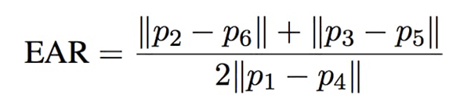

Fig no: Eye-aspect-ratio formula

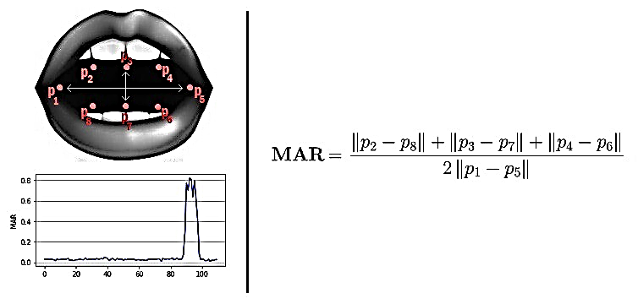

Fig no: Mouth-aspect-ratio formula.

**Facial landmark detection**

In this process, we utilize dlib library as a tool to label landmark point on the face. This tool helps in extraction of key point from human face. It gained world-wide popularity when it was introduced as it enabled to work with mobile technology to high-performance computers.

**Closing and opening of eye detection**

When it comes to closing and opening of eye, if eyes are open, the distance between the upper and lower feature points of the eyes will be relatively large. When the eyes are closed, the distance becomes smaller. The EYE value is calculated by using the distance of the eye feature points. Among the 68 feature points on the face, the eye points correspond to 37–42 and 43–48, respectively. Figures no show the state of open eyes.

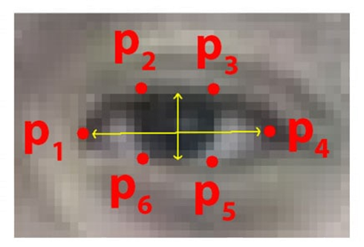

Fig no: Eye open state diagram

**Mouth opening for yawn detection**

Yawn detection is similar to closing and opening of eye detection. The key points of the mouth are 61–68. These points make up the landmark points of our inner lips. Some scholars use the points of the outer lips. However, due to the individual lip differences, the calculated value will not be accurate enough. The mouth aspect ratio value is calculated by using the distance of the mouth feature points, which can judge the state of the mouth. Figure no shows the open mouth state.

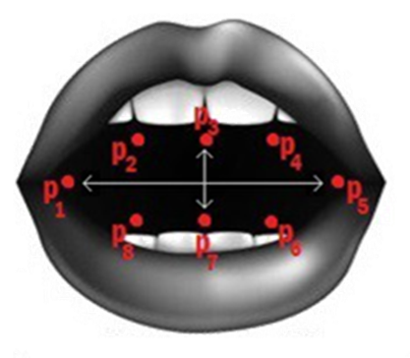

Fig no: Open mouth state diagram

**Drowsiness detection system**

Drowsiness is detected, through eye open and closing action, through mouth yawning. We calculate eye aspect ratio for both left and right eyes and find out the average eye aspect ratio for both eyes.

We calculate mouth aspect ratio by taking the shape of predefined mouth calculations such as the start and end point of mouth movement. Through OpenCV, we visualize the mouth by constructing mouth hull and draw contours on it.

After calculating eye aspect ratio, mouth aspect ratio and visualizing them, we draw the determinant image points on to the person’s face. If the values exceed the thresholds of eye aspect ratio and mouth aspect ratio, we generate alerts through prompts and sounds.

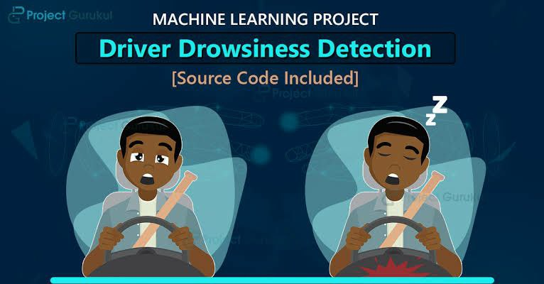

Fig: Driver without drowsiness detection system installed in his car

**CHAPTER 6**

**IMPLEMENTATION**

The basic idea of the project is to alert drivers if they fall asleep knowingly or unknowingly. The above problem can be addressed by a drowsiness detection system that utilizes hardware such as a camera, a mini-computer, etc. The use of computer vision for object recognition helps by recognizing a driver's face when he is driving and identification of the driver in order to allow the vehicle to automatically restore its preferences and settings.

**Detecting levels of driver impairment**

Using a camera and microphone for detecting drowsiness, distraction, yawn, eye closure, and joy in real-time. Monitoring driver fatigue and alert him when potential drowsiness situation is detected.

Monitoring driver attentiveness by ensuring he’s keeping his eyes on the road and that he is aware of any dangerous situation. Pilot a user interface thanks to the eyes by automatically selecting key area.

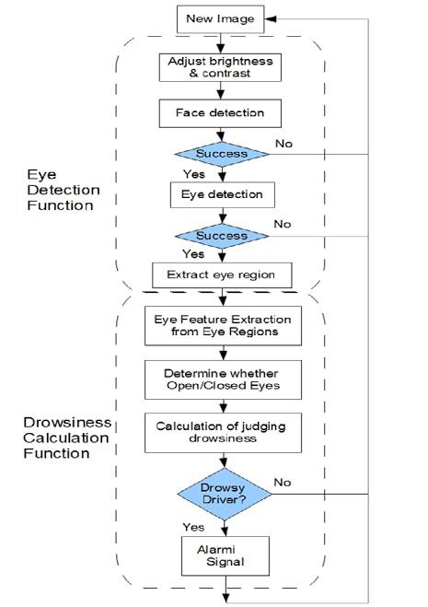

Fig: Flow Chart of Drowsiness Detection System

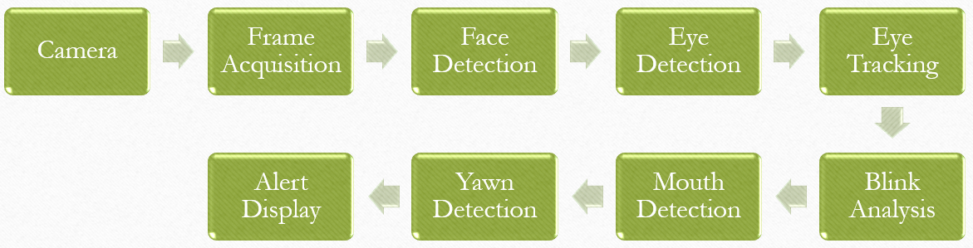

Fig no: Process Flow chart

Drowsiness is detected through eye aspect ratio – closing of eyes, through mouth aspect ratio – yawning. We calculate eye aspect ratio for both left and right eyes and find out the average eye aspect ratio for both eyes.

We calculate mouth aspect ratio by taking the shape of predefined mouth calculations such as the start and end point of mouth movement. Through OpenCV, we visualize the mouth by constructing mouth hull and draw contours on it.

After calculating eye aspect ratio, mouth aspect ratio and visualizing them, we draw the determinant image points on to the person’s face.

After exceeding the thresholds of eye aspect ratio and mouth aspect ratio we generate alerts through prompts and sounds.

**Algorithm**

* The face is detected using haar-like features since is a quick and efficient enough method and the eyes are detected using dlib’s shape_predictor_68_face_landmarks.
* The camera takes the live input of the person and divides it into frames. These frames are further taken into the model and sent to frame detection process.
* In the face detection process, the acquired frames are been compared to the pre-trained face landmark data.
* If both eyes are classified as closed, a counter will increase its value, otherwise, it will be decreased. When the counter reaches a threshold, the driver will be declared drowsy, an alarm will start ringing.
* The alarm will stop and the border will disappear when the value of the counter will be again smaller than the threshold.

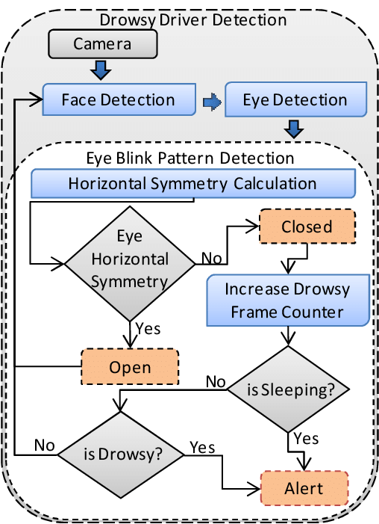

Fig no: System design

**Working**

The working of this system can be divided into two parts:

* Detecting or localizing the face.
* Predicting the landmarks of important regions in the detected face.

Once the landmarks are predicted, we use only the eye landmarks and the mouth landmarks to determine the Eye Aspect Ratio (EAR) and Mouth Aspect Ratio (MAR) to check if a person is drowsy.

The pre-trained facial landmark detector inside the dlib library is used to estimate the location of 68-(x,y) coordinates that map to the facial structure of the face[2]. These 68-(x,y) coordinates represent the important regions of the face like mouth, left eyebrow, right eyebrow, left eye, right eye, nose, and jaw. Of these, we only need the (x,y) coordinates of the left eye, right eye, and mouth.

Now, each eye is represented by a set of 6-(x,y) coordinates starting at the left corner of the eye (as if you were looking at the person), and then working clockwise around the remainder of the region.

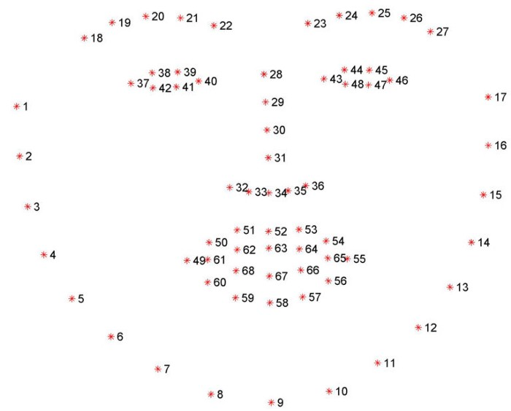

Fig no: Representing the face with 68-(x,y) coordinates.

As we see that the mouth is represented by a set of 20-(x,y) coordinates. So, we have used coordinates 62, 64, 66, and 68 to calculate the distance between then in the same way as EAR Calculation.

On the purpose of reducing the errors, the ratio has to be calculated with ratio values of both eyes as average ratio value. If the average ratio is increased specific predefined value that given by the system, blinking has to be detected. Whenever the duration of the blinking is extending the specified duration, it is going to be detected as drowsiness and should turn on the alarm or send an alert to the user.

Other than that, there is a process to detect the drowsiness of the driver to pretend from the accident rate and it observes the specific points around the eye from facial landmarks to detect whether the eyes are opened, closed or blinking. If eyes are closed for a considerable time as specified the system should alert the driver to stay awake. System will consist of multiple stages like image capturing, image processing, expression detection, emotion recognition, eye blinking detection, analysis of the risk probability, selection and passing the appropriate voice alert etc.

**Emotion Recognition**

A Convolutional Neural Network (CNN) is been proposed in this system to recognise emotions such as surprised, happy, sad, angry, fear etc. The work of emotion recognition is that it can give the mood in which the driver is going through when he is feeling drowsy.

The emotion detection system is based on Convolution Neural Network with a different set of processes and layers, accepting the pre-processing data from the model to determine the emotion of the driver.

The input and hidden layers utilize ReLu as activation function whereas the output layer uses softmax as activation function. After training the model and saving it for the detection system, we define some of the most common moods that human beings experience. Moods such as happy, surprised, fearful, neutral, disgusted, etc are been incorporated in the model.

This detection is run simultaneously with the drowsiness detection system to let the driver know in what instances is he going through the drowsiness.

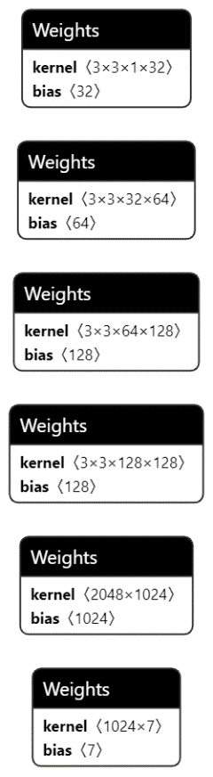

Fig: Deep Learning model visualisation

**Conclusion**

System is built to be a solution for a common problem of fatal road accidents. It has developed using python programming language and OpenCV is used for real time video capturing.

Camera and an audio player or speaker should be used to implement the system as hardware objects in order to get input for and play output from the system. In designing phase, Tensorflow, Keras and also Haar cascade classifiers to specify the emotions. Kaggle emotion detection dataset that consists of 48×48-pixel grayscale images of faces were used to train the system. Drowsiness detection is done by using shape predictor 68 face landmarks.

By the end of this project we were able to implement a system to reduce the risk of happening road accidents due to human (motorists) emotions and drowsiness. It does not require much hardware equipment other than a camera to capture live video.

It is better to have a camera with good quality to get videos with high resolution in order to detect the emotions with higher accuracy. For that case the requirement of the capacity and the computational power will be increased.

Environmental dependencies such as light, weather etc. will also can be an effect to the system for reducing its performance. When there is low light surrounding, the camera may not be capable of capturing the real time video and it may cause the system to stop working.

This situation widely will take place at night time when the system is mostly required since motorists usually tend to feel sleepy while driving at night.

Other than the above-mentioned problems, there are some effects for the system to be implemented accurately with respect to the user. Nowadays most of the drivers are used to having sunglasses or some other vision protection items while driving. This can cause a big issue to the work system in proper manner since it is a huge barrier for reading specific points on the face to detect eye landmarks and expressions.

Another dependency for the accuracy of the system can classify as the style of the face. That means, the natural human faces are different from one another. Some are different from shape when some are from colour. There are some people who have closed eyelids even when they open their eyes (Ex: Chinese people). With these types of users, the system is calculating the average ratio using eye landmarks and may bring an output as the eye is closed if the defined conditions of the system are satisfied.

Face covering is another difficulty for detecting the human facial expressions since it covers all the required points on face for the detection process. Hence the recognition of emotions and drowsiness is problematic.

There are some other factors which can affect the system performance such as makeup, hairstyles that cover the eyes or part of the face, wearing caps and hats or scarves etc.

**REFERENCE**

[1] Sunagawa, Mika, et al. "Comprehensive drowsiness level detection model combining multimodal information." IEEE Sensors Journal 20.7 (2019): 3709-3717.

[2] You, Feng, et al. "A real-time driving drowsiness detection algorithm with individual differences consideration." Ieee Access 7 (2019): 179396-179408.

[3] Ramzan, Muhammad, et al. "A survey on state-of-the-art drowsiness detection techniques." IEEE Access 7 (2019): 61904-61919.

[4] Fujiwara, Koichi, et al. "Heart rate variability-based driver drowsiness detection and its validation with EEG." IEEE Transactions on Biomedical Engineering 66.6 (2018): 1769-1778.

[5] Guede-Fernandez, Federico, et al. "Driver drowsiness detection based on respiratory signal analysis." IEEE access 7 (2019): 81826-81838.

[6] Esteves, Telma, et al. "AUTOMOTIVE: A case study on AUTOmatic multiMOdal drowsiness detecTIon for smart VEhicles." IEEE Access 9 (2021): 153678-153700.

[7] Tanveer, M. Asjid, et al. "Enhanced drowsiness detection using deep learning: an fNIRS study." IEEE access 7 (2019): 137920-137929.

[8] Altameem, Ayman, et al. "Early Identification and Detection of Driver Drowsiness by Hybrid Machine Learning." IEEE Access 9 (2021): 162805-162819.

[9] Paulo, Joao Ruivo, Gabriel Pires, and Urbano J. Nunes. "Cross-subject zero calibration driver’s drowsiness detection: Exploring spatiotemporal image encoding of EEG signals for convolutional neural network classification." IEEE transactions on neural systems and rehabilitation engineering 29 (2021): 905-915.

[10] Zhang, Chao, et al. "Driver drowsiness detection using multi-channel second order blind identifications." IEEE Access 7 (2019): 11829-11843.

[11] Alkinani, Monagi H., Wazir Zada Khan, and Quratulain Arshad. "Detecting human driver inattentive and aggressive driving behavior using deep learning: recent advances, requirements and open challenges." Ieee Access 8 (2020): 105008-105030.

[12] Ngxande, Mkhuseli, Jules-Raymond Tapamo, and Michael Burke. "Bias remediation in driver drowsiness detection systems using generative adversarial networks." IEEE Access 8 (2020): 55592-55601.

[13] Zhang, Wei, Bo Cheng, and Yingzi Lin. "Driver drowsiness recognition based on computer vision technology." Tsinghua Science and Technology 17.3 (2012): 354-362.

[14] Deng, Wanghua, and Ruoxue Wu. "Real-time driver-drowsiness detection system using facial features." Ieee Access 7 (2019): 118727-118738.

[15] Fan, Xin-An, Lu-Zheng Bi, and Zhi-Long Chen. "Using EEG to detect drivers' emotion with Bayesian Networks." 2010 International Conference on Machine Learning and Cybernetics. Vol. 3. IEEE, 2010.

[16] Hayashi, Hiroaki, Mitsuhiro Kamezaki, and Shigeki Sugano. "Toward Health–Related Accident Prevention: Symptom Detection and Intervention Based on Driver Monitoring and Verbal Interaction." IEEE Open Journal of Intelligent Transportation Systems 2 (2021): 240-253.

[17] Savaş, Burcu Kir, and Yaşar Becerikli. "Real time driver fatigue detection system based on multi-task ConNN." Ieee Access 8 (2020): 12491-12498.

[18] Shen, Jianhao, et al. "Nighttime driving safety improvement via image enhancement for driver face detection." IEEE Access 6 (2018): 45625-45634.

[19] Ling, Yancheng, et al. "Driver eye location and state estimation based on a robust model and data augmentation." IEEE Access 9 (2021): 67219-67231.

[20] Agrawal, Urvashi, Shubhangi Giripunje, and Preeti Bajaj. "Emotion and gesture recognition with soft computing tool for drivers assistance system in human centered transportation." 2013 IEEE International Conference on Systems, Man, and Cybernetics. IEEE, 2013.