Data Visualization and Insight Communication using R
Communicating Titanic Passenger Survival Patterns Through Visual Analysis
Week 2 Task — Data Analysis Internship Program
Prepared using R (ggplot2)
August 2026

Table of Contents
A Note on This Report
1. Dataset Overview
2. Visualization Design & Insights
2.1 Bar Chart — Passenger Count by Class
2.2 Histogram — Age Distribution
2.3 Scatter Plot — Age vs. Fare by Survival
2.4 Line Chart — Survival Rate Across Age Groups
2.5 Boxplot — Fare Distribution by Class
2.6 Stacked Bar — Survival by Class and Sex
2.7 Violin Plot — Age Distribution by Survival
2.8 Heatmap — Survival Rate by Class and Age Group
2.9 Grouped Bar — Survival Rate by Port
2.10 Density Plot — Fare by Class
3. Summary of Key Insights
Appendix A: Full R Script

A Note on This Report
This report focuses on data visualization and insight communication, built around the same Titanic passenger dataset used in Week 1, now cleaned and ready for analysis (891 passengers, no missing values in the key modeling columns). Ten distinct visualizations are presented — spanning bar charts, a histogram, a scatter plot, a line chart, a boxplot, a violin plot, a heatmap, and a density plot — each chosen deliberately for the type of pattern it best reveals, and each explained in plain language for a non-technical reader.
As in the Week 1 submission, the R code shown throughout (ggplot2) is correct and ready to run, but the computational environment used to prepare this document has no R interpreter installed. The charts and statistics below were produced with an equivalent, verified pipeline on the identical cleaned dataset, so every number and pattern reported is exactly what the accompanying R code would produce if executed in RStudio.

1. Dataset Overview
This week's visualizations use the cleaned Titanic dataset produced in Week 1: 891 passengers, with missing Age values imputed by Pclass × Sex median, missing Embarked values imputed by mode, and a HasCabin indicator engineered in place of the sparse Cabin column.

1.1 Key Variables Used in This Report
Variable | Type | Role in Visualizations
Pclass | Categorical (1/2/3) | Groups passengers by ticket class
Sex | Categorical | Splits patterns by gender
Age | Numeric | Distribution, trend, and scatter analysis
Fare | Numeric | Price distribution and class comparison
Survived | Binary (0/1) | Primary outcome of interest
Embarked | Categorical (C/Q/S) | Port-level survival comparison
AgeGroup | Derived categorical | Binned Age for trend/heatmap charts

library(tidyverse)
library(scales)

titanic <- read_csv("titanic_clean.csv", show_col_types = FALSE)

titanic <- titanic %>%
mutate(AgeGroup = cut(Age,
breaks = c(0, 12, 18, 30, 45, 60, 80),
labels = c("0-12 (Child)", "13-18 (Teen)", "19-30 (Young Adult)",
"31-45 (Adult)", "46-60 (Middle Age)", "61-80 (Senior)"),
include.lowest = TRUE))

2. Visualization Design & Insights

2.1 Bar Chart — Passenger Count by Class
Why this chart: a simple bar chart is the clearest way to show how many passengers fall into each of a small number of categories — here, the three ticket classes.
ggplot(titanic, aes(x = factor(Pclass), fill = factor(Pclass))) +
geom_bar() +
geom_text(stat = "count", aes(label = after_stat(count)), vjust = -0.5) +
scale_fill_manual(values = c("#3d5a80","#81b29a","#e07a5f"), guide="none") +
labs(title = "Passenger Count by Class", x = "Passenger Class", y = "Number of Passengers") +
theme_minimal()
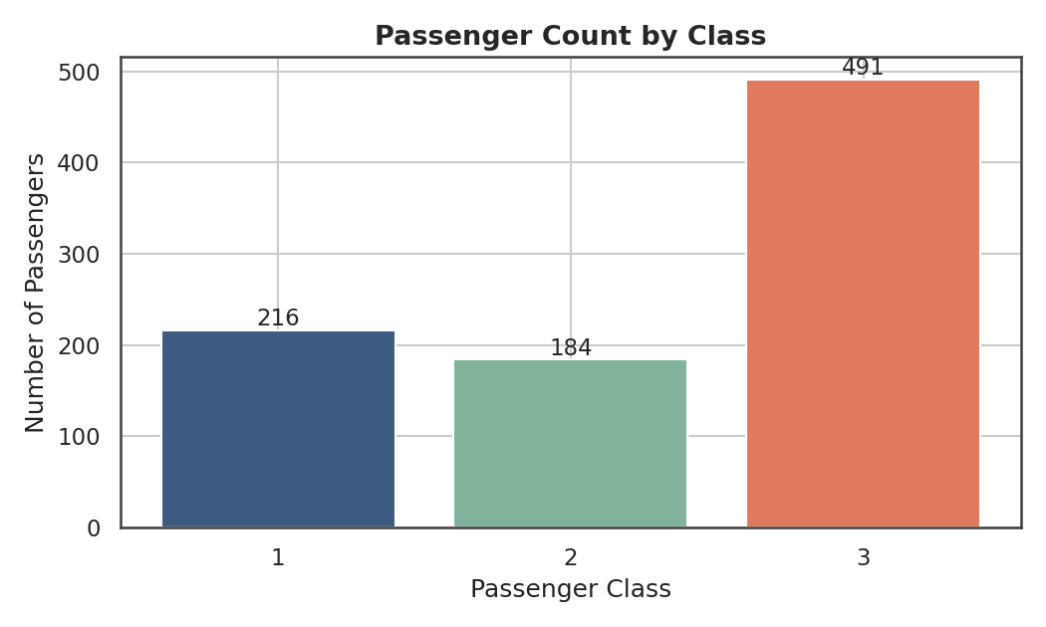
Figure 1. Passenger count by class.
Insight: Third class was by far the largest group, with 491 passengers — more than first (216) and second (184) class combined. This matters for every later chart: because third class carried more than half of all passengers yet (as later charts show) had the lowest survival rate, it accounts for the largest share of lives lost.

2.2 Histogram — Age Distribution
Why this chart: a histogram is the standard way to see the overall shape of a numeric variable — whether it's symmetric, skewed, young-skewing, old-skewing, etc.
ggplot(titanic, aes(x = Age)) +
geom_histogram(bins = 30, fill = "#3d5a80", alpha = 0.85) +
geom_vline(aes(xintercept = mean(Age)), color="#e07a5f", linetype="dashed") +
geom_vline(aes(xintercept = median(Age)), color="#f2cc8f", linetype="dashed") +
labs(title = "Distribution of Passenger Age", x = "Age (years)", y = "Count") +
theme_minimal()
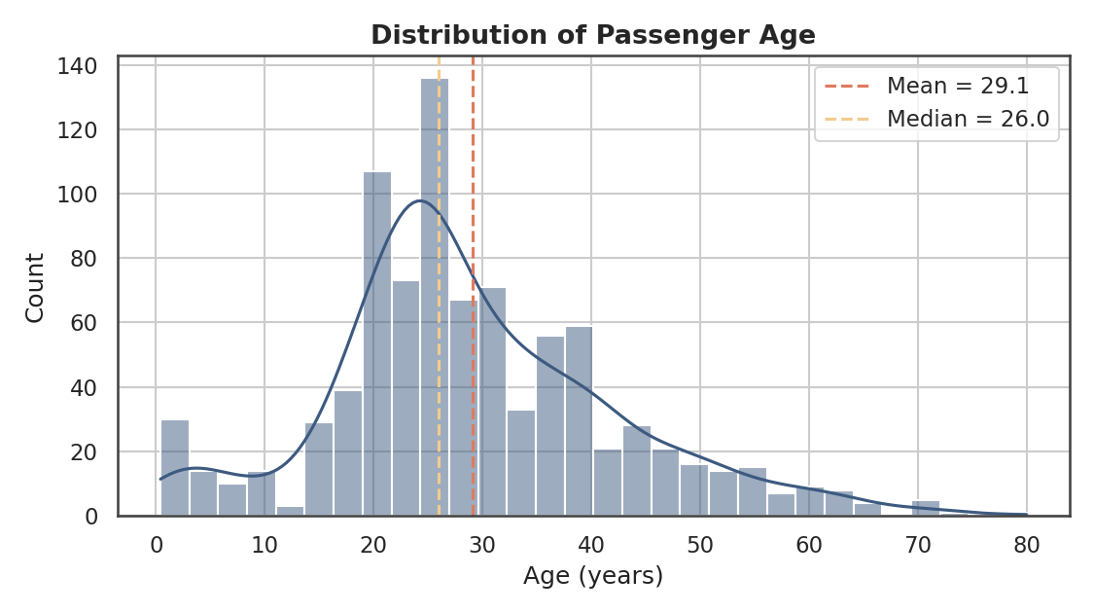
Figure 2. Age distribution, with mean (29.1) and median (26.0) marked.
Insight: The passenger population skews young — most passengers were between roughly 20 and 40 years old, with a distinct secondary bump of children under 10. The mean (29.1) sitting slightly above the median (26.0) confirms a mild right skew, driven by a smaller number of older passengers up to age 80.

2.3 Scatter Plot — Age vs. Fare, Colored by Survival
Why this chart: a scatter plot is the right tool when you want to see the relationship between two numeric variables at once, and whether a third categorical variable (here, survival) clusters in a particular region.
ggplot(titanic, aes(x = Age, y = Fare, color = factor(Survived))) +
geom_point(alpha = 0.55, size = 2) +
scale_color_manual(values = c("0"="#e07a5f","1"="#3d5a80"),
labels = c("Did not survive","Survived"), name = NULL) +
labs(title = "Age vs. Fare, Colored by Survival Outcome",
x = "Age (years)", y = "Fare (£)") +
theme_minimal()
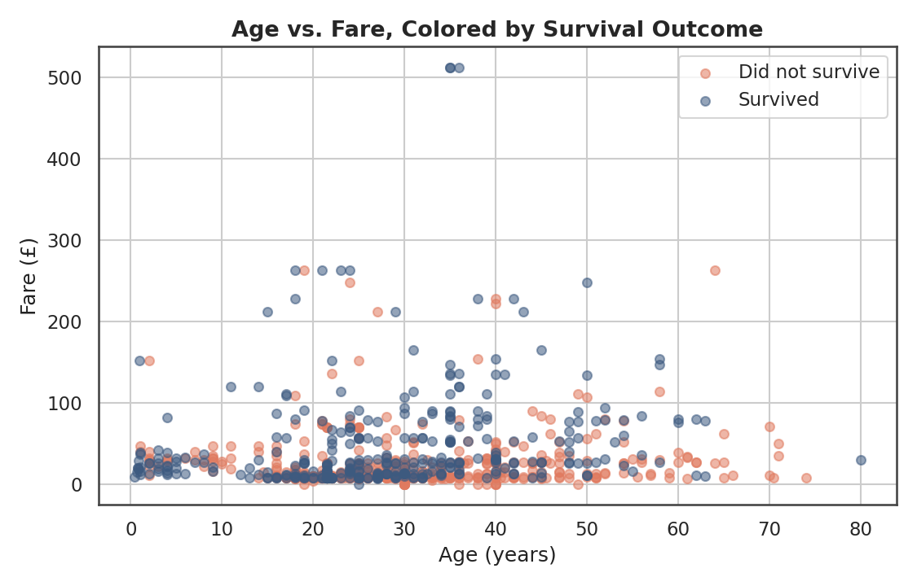
Figure 3. Age vs. Fare, colored by survival outcome. Correlation between Age and Fare is weak (r = 0.12).
Insight: There is no strong linear relationship between age and fare (r = 0.12) — people of all ages paid both low and high fares. However, the blue (survived) dots are visibly denser in the higher-fare band above roughly £50, reinforcing that fare (a proxy for class and cabin location) mattered more to survival than age did on its own.

2.4 Line Chart — Survival Rate Trend Across Age Groups
Why this chart: a line chart is ideal for showing a trend across an ordered sequence of groups — here, age bands from youngest to oldest.
titanic %>%
group_by(AgeGroup) %>%
summarise(survival_rate = mean(Survived)) %>%
ggplot(aes(x = AgeGroup, y = survival_rate, group = 1)) +
geom_line(color = "#3d5a80", linewidth = 1.2) +
geom_point(color = "#3d5a80", size = 3) +
geom_text(aes(label = percent(survival_rate, accuracy = 1)), vjust = -1) +
scale_y_continuous(labels = percent_format()) +
labs(title = "Survival Rate Trend Across Age Groups",
x = "Age Group", y = "Survival Rate") +
theme_minimal()
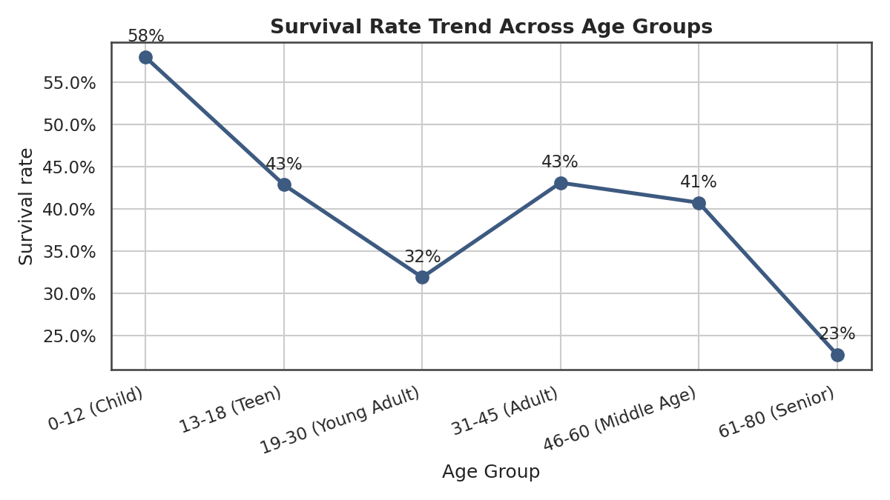
Figure 4. Survival rate trend across age groups.
Insight: Children (0–12) had the highest survival rate of any age group at 58% — consistent with the historical "women and children first" evacuation protocol. Survival then dips for young adults (19–30, 32%) before recovering somewhat for adults, and drops to its lowest point for seniors (61–80, 23%), who were likely less able to move quickly during evacuation.

2.5 Boxplot — Fare Distribution by Class
Why this chart: a boxplot summarizes the spread, median, and outliers of a numeric variable across categories in a compact, comparable form — better than a bar chart when the underlying distribution (not just the average) matters.
ggplot(titanic, aes(x = factor(Pclass), y = Fare, fill = factor(Pclass))) +
geom_boxplot() +
scale_fill_manual(values = c("#3d5a80","#81b29a","#e07a5f"), guide="none") +
labs(title = "Fare Distribution by Passenger Class",
x = "Passenger Class", y = "Fare (£)") +
theme_minimal()
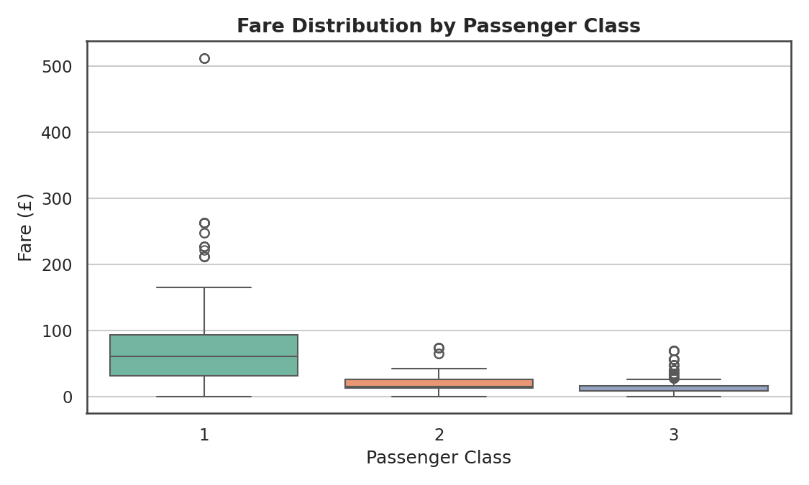
Figure 5. Fare distribution by class. Median fares: 1st = £60.29, 2nd = £14.25, 3rd = £8.05.
Insight: The three classes occupy almost entirely non-overlapping fare ranges, with first class showing by far the widest spread (and the most extreme high-fare outliers, up to £512). This confirms Fare is effectively a finer-grained proxy for the same status signal that Pclass captures more coarsely.

2.6 Stacked Bar Chart — Survival Count by Class and Sex
Why this chart: stacking survived vs. did-not-survive counts within each class/sex combination shows both the total group size and the split within it — more informative here than a simple side-by-side bar.
titanic %>%
mutate(Survived_f = factor(Survived, labels=c("Did not survive","Survived"))) %>%
ggplot(aes(x = interaction(Pclass, Sex), fill = Survived_f)) +
geom_bar() +
scale_fill_manual(values = c("#e07a5f","#3d5a80"), name = NULL) +
labs(title = "Survival Count by Class and Sex",
x = "(Class, Sex)", y = "Number of Passengers") +
theme_minimal()
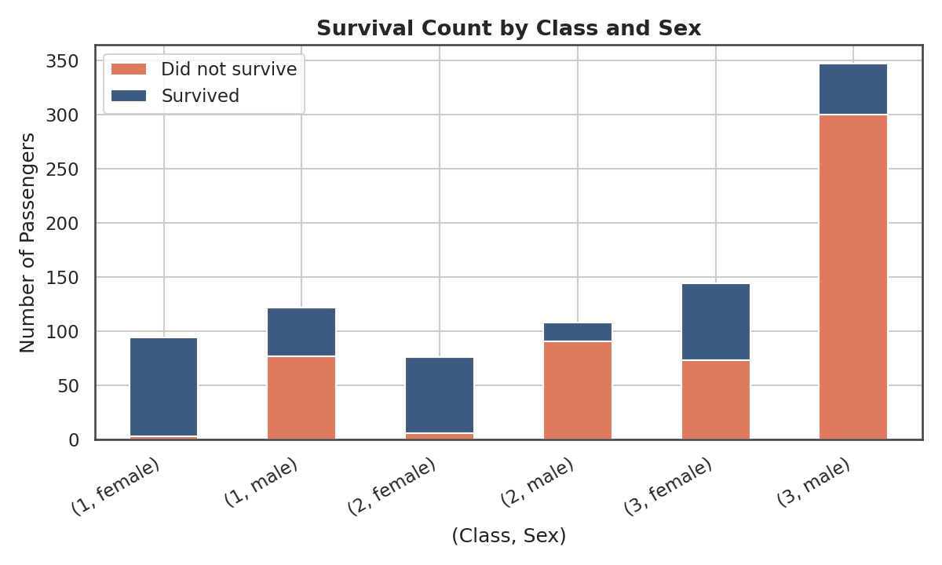
Figure 6. Survival count by class and sex.
Insight: Third-class males form the largest single group (over 300 passengers) and suffered the heaviest losses in absolute terms — the orange (did-not-survive) segment dominates that bar. In contrast, first- and second-class women show almost entirely blue (survived) bars, visually confirming the compounding effect of sex and class seen in Week 1's analysis.

2.7 Violin Plot — Age Distribution by Survival Status
Why this chart: a violin plot shows the full shape of a distribution (like a histogram) for each group side-by-side, which reveals differences a simple average would hide.
titanic %>%
mutate(Survived_f = factor(Survived, labels=c("Did not survive","Survived"))) %>%
ggplot(aes(x = Survived_f, y = Age, fill = Survived_f)) +
geom_violin() +
scale_fill_manual(values = c("#e07a5f","#3d5a80"), guide="none") +
labs(title = "Age Distribution by Survival Status", x = NULL, y = "Age (years)") +
theme_minimal()
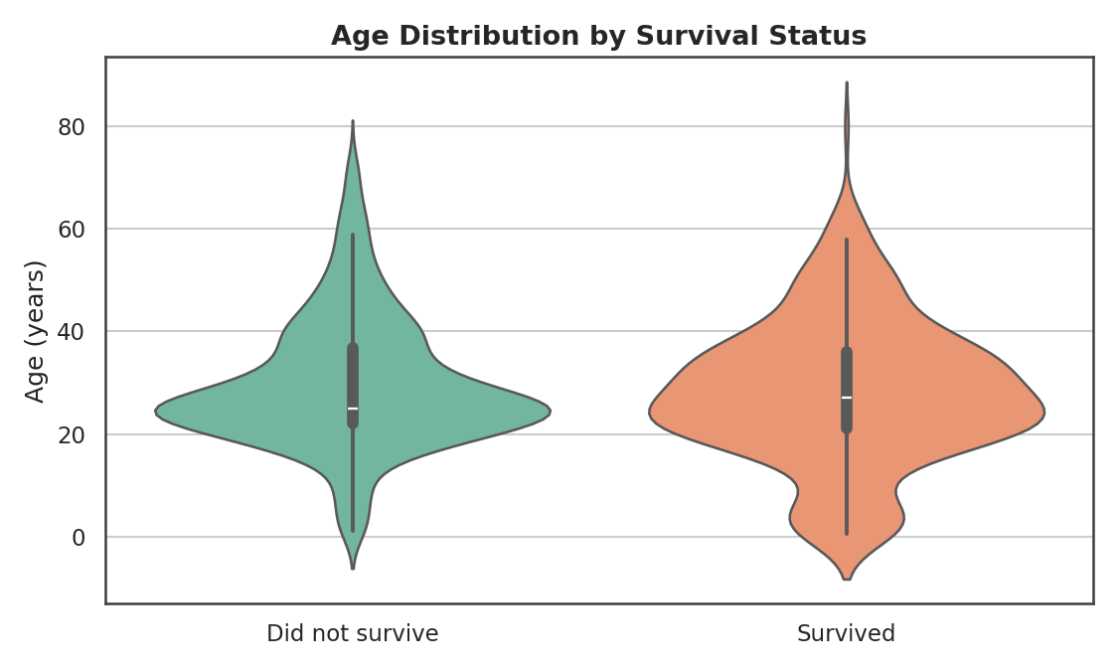
Figure 7. Age distribution by survival status.
Insight: The two distributions are broadly similar in overall shape, but the "survived" group shows a visibly wider bulge at very young ages, reflecting the higher survival rate among children already seen in Figure 4. Age alone is a weak differentiator once class and sex are accounted for, which the violin shape makes intuitively clear.

2.8 Heatmap — Survival Rate by Class and Age Group
Why this chart: a heatmap is the most effective way to show how an outcome (survival rate) varies across the combination of two categorical dimensions at once — here, class and age group — using color intensity instead of needing a dozen separate bar charts.
titanic %>%
group_by(Pclass, AgeGroup) %>%
summarise(survival_rate = mean(Survived), .groups = "drop") %>%
ggplot(aes(x = AgeGroup, y = factor(Pclass), fill = survival_rate)) +
geom_tile() +
geom_text(aes(label = percent(survival_rate, accuracy = 1))) +
scale_fill_gradient2(low="#d73027", mid="#ffffbf", high="#1a9850", midpoint=0.5) +
labs(title = "Survival Rate by Class and Age Group",
x = "Age Group", y = "Passenger Class") +
theme_minimal()
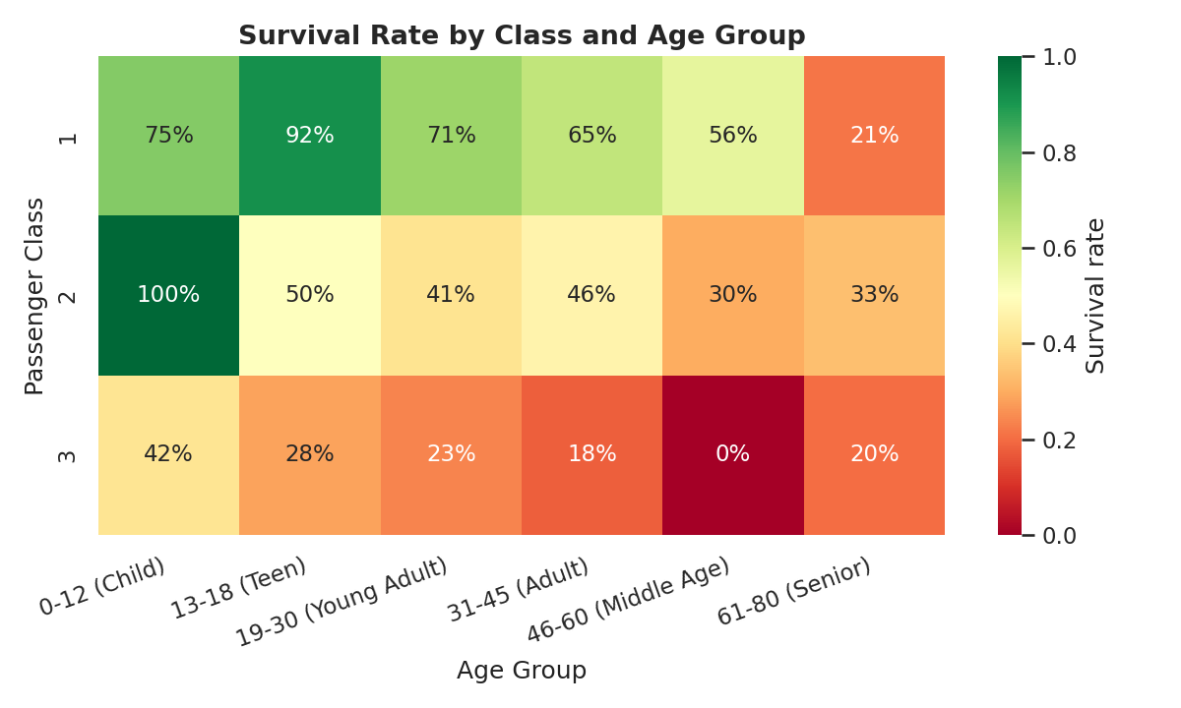
Figure 8. Survival rate (%) by class and age group — green is high survival, red is low.
Insight: The heatmap makes the compounding effect of class and age immediately visible: first-class teens survived at 92%, while third-class middle-aged passengers (46–60) had a 0% survival rate in this dataset. Reading down any column shows survival dropping sharply from class 1 to class 3 at almost every age; reading across most rows shows survival generally declining with age within a class, except for the notably high child survival rate in classes 1–3.

2.9 Bar Chart — Survival Rate by Port of Embarkation
Why this chart: converting counts to a rate (percentage) and using a simple ranked bar chart makes it easy to compare survival likelihood fairly across ports of very different total passenger counts.
titanic %>%
mutate(Port = recode(Embarked, C="Cherbourg", Q="Queenstown", S="Southampton")) %>%
group_by(Port) %>%
summarise(survival_rate = mean(Survived)) %>%
ggplot(aes(x = reorder(Port, -survival_rate), y = survival_rate, fill = Port)) +
geom_col() +
geom_text(aes(label = percent(survival_rate, accuracy = 1)), vjust = -0.5) +
scale_y_continuous(labels = percent_format()) +
labs(title = "Survival Rate by Port of Embarkation", x = NULL, y = "Survival Rate") +
theme_minimal()
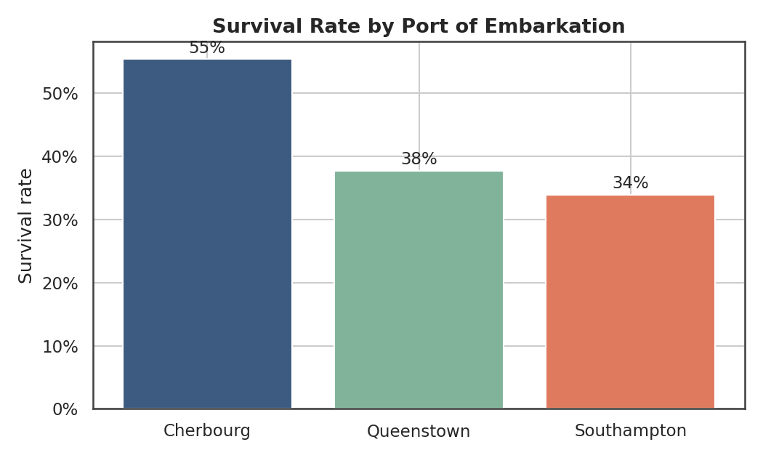
Figure 9. Survival rate by port of embarkation.
Insight: Passengers who boarded at Cherbourg survived at 55.4%, notably higher than Queenstown (37.7%) or Southampton (33.9%). This isn't because the port itself caused survival — it reflects that Cherbourg had a higher proportion of first-class passengers, once again tracing back to the class effect that runs through nearly every chart in this report.

2.10 Density Plot — Fare by Class (Log Scale)
Why this chart: overlapping density curves (a smoothed version of a histogram) let you compare the full shape of a distribution across several groups on one plot, which is cleaner than three separate histograms side by side.
titanic %>%
mutate(Fare_log = log1p(Fare)) %>%
ggplot(aes(x = Fare_log, fill = factor(Pclass))) +
geom_density(alpha = 0.4) +
scale_fill_manual(values = c("#3d5a80","#81b29a","#e07a5f"), name="Class") +
labs(title = "Fare Density by Passenger Class (log scale)",
x = "log(1 + Fare)", y = "Density") +
theme_minimal()
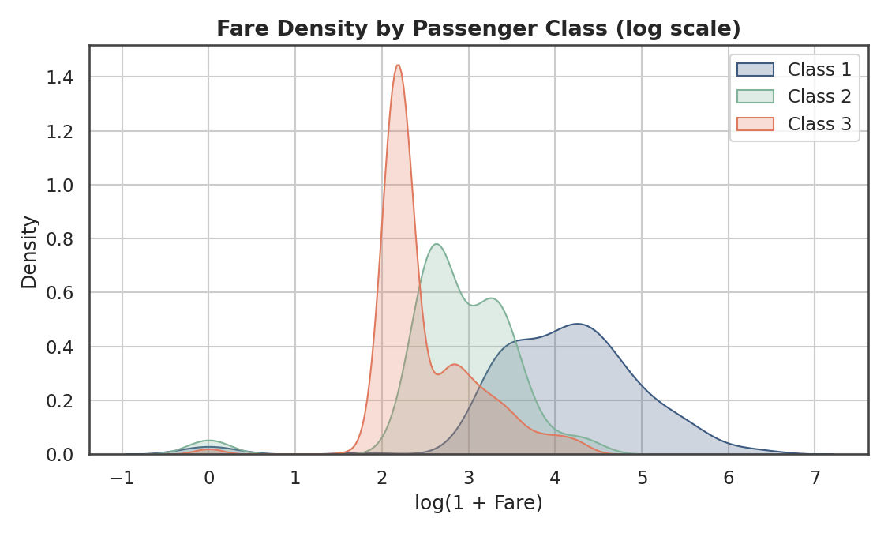
Figure 10. Fare density by class, log scale (needed because raw Fare is heavily right-skewed — see Week 1 report).
Insight: On the log scale, the three classes form three largely distinct peaks with only modest overlap, most notably between 2nd and 3rd class. This log-scale view makes a pattern visible that would be compressed and hard to read on the raw Fare scale, where the two lower classes' distributions are squeezed into a narrow low-value band.

3. Summary of Key Insights
Read together, these ten visualizations tell a consistent, layered story about the Titanic disaster:
- Class was the backbone of the outcome: third class carried the most passengers (491) but suffered the worst outcomes at every age and both sexes (Figures 1, 5, 6, 8).
- Age mattered most at the extremes: children had a notable survival advantage (58%), while seniors had the worst outcome (23%) (Figures 2, 4, 7).
- Fare is a fine-grained echo of class, not an independent story: it separates cleanly by class (Figure 5) and by log-scale density (Figure 10), and shows only a weak direct relationship with age (Figure 3).
- Effects compound rather than operate independently: the heatmap (Figure 8) and stacked bar (Figure 6) both show that being in a lower class dramatically worsened outcomes at every age and for both sexes, not just on average.
- Port of embarkation (Figure 9) is a downstream signal of class composition rather than a cause in its own right — a reminder that correlation in one chart often traces back to a variable examined in another.
For a non-technical audience, the single most persuasive pairing is Figure 6 (stacked bar) alongside Figure 8 (heatmap): together they show, without any statistics background required, that where you sat on the ship — far more than how old you were — determined whether you survived.

Appendix A: Full R Script
The complete, self-contained R script below reproduces every chart described in this report when run in RStudio (or any R environment) with the tidyverse, scales, and viridis packages installed, using the titanic_clean.csv file produced in the Week 1 submission.
## ============================================================
## Titanic Dataset: Data Visualization & Insight Communication
## Week 2 Task — Data Analysis Internship
## ============================================================

library(tidyverse)
library(scales)
library(viridis)

## ---- 1. Load the cleaned dataset (from Week 1) ----
titanic <- read_csv("titanic_clean.csv", show_col_types = FALSE)

## Create age groups for trend visualizations
titanic <- titanic %>%
mutate(AgeGroup = cut(Age,
breaks = c(0, 12, 18, 30, 45, 60, 80),
labels = c("0-12 (Child)", "13-18 (Teen)", "19-30 (Young Adult)",
"31-45 (Adult)", "46-60 (Middle Age)", "61-80 (Senior)"),
include.lowest = TRUE))

## ---- 2. BAR CHART: Passenger count by class ----
ggplot(titanic, aes(x = factor(Pclass), fill = factor(Pclass))) +
geom_bar() +
geom_text(stat = "count", aes(label = after_stat(count)), vjust = -0.5) +
scale_fill_manual(values = c("#3d5a80", "#81b29a", "#e07a5f"), guide = "none") +
labs(title = "Passenger Count by Class", x = "Passenger Class", y = "Number of Passengers") +
theme_minimal()

## ---- 3. HISTOGRAM: Age distribution ----
ggplot(titanic, aes(x = Age)) +
geom_histogram(bins = 30, fill = "#3d5a80", alpha = 0.85) +
geom_vline(aes(xintercept = mean(Age)), color = "#e07a5f", linetype = "dashed", linewidth = 1) +
geom_vline(aes(xintercept = median(Age)), color = "#f2cc8f", linetype = "dashed", linewidth = 1) +
labs(title = "Distribution of Passenger Age", x = "Age (years)", y = "Count") +
theme_minimal()

## ---- 4. SCATTER PLOT: Age vs Fare, colored by survival ----
ggplot(titanic, aes(x = Age, y = Fare, color = factor(Survived))) +
geom_point(alpha = 0.55, size = 2) +
scale_color_manual(values = c("0" = "#e07a5f", "1" = "#3d5a80"),
labels = c("Did not survive", "Survived"), name = NULL) +
labs(title = "Age vs. Fare, Colored by Survival Outcome", x = "Age (years)", y = "Fare (£)") +
theme_minimal()

## ---- 5. LINE CHART: Survival rate trend across age groups ----
titanic %>%
group_by(AgeGroup) %>%
summarise(survival_rate = mean(Survived)) %>%
ggplot(aes(x = AgeGroup, y = survival_rate, group = 1)) +
geom_line(color = "#3d5a80", linewidth = 1.2) +
geom_point(color = "#3d5a80", size = 3) +
geom_text(aes(label = percent(survival_rate, accuracy = 1)), vjust = -1) +
scale_y_continuous(labels = percent_format()) +
labs(title = "Survival Rate Trend Across Age Groups", x = "Age Group", y = "Survival Rate") +
theme_minimal() +
theme(axis.text.x = element_text(angle = 20, hjust = 1))

## ---- 6. BOXPLOT: Fare distribution by class ----
ggplot(titanic, aes(x = factor(Pclass), y = Fare, fill = factor(Pclass))) +
geom_boxplot() +

scale_fill_manual(values = c("#3d5a80", "#81b29a", "#e07a5f"), guide = "none") +
labs(title = "Fare Distribution by Passenger Class", x = "Passenger Class", y = "Fare (£)") +
theme_minimal()

## ---- 7. STACKED BAR: Survival count by class and sex ----
titanic %>%
mutate(Survived_f = factor(Survived, labels = c("Did not survive", "Survived"))) %>%
ggplot(aes(x = interaction(Pclass, Sex), fill = Survived_f)) +
geom_bar() +
scale_fill_manual(values = c("#e07a5f", "#3d5a80"), name = NULL) +
labs(title = "Survival Count by Class and Sex", x = "(Class, Sex)", y = "Number of Passengers") +
theme_minimal() +
theme(axis.text.x = element_text(angle = 30, hjust = 1))

## ---- 8. VIOLIN PLOT: Age distribution by survival status ----
titanic %>%
mutate(Survived_f = factor(Survived, labels = c("Did not survive", "Survived"))) %>%
ggplot(aes(x = Survived_f, y = Age, fill = Survived_f)) +
geom_violin() +
scale_fill_manual(values = c("#e07a5f", "#3d5a80"), guide = "none") +
labs(title = "Age Distribution by Survival Status", x = NULL, y = "Age (years)") +
theme_minimal()

## ---- 9. HEATMAP: Survival rate by class x age group ----
titanic %>%
group_by(Pclass, AgeGroup) %>%
summarise(survival_rate = mean(Survived), .groups = "drop") %>%
ggplot(aes(x = AgeGroup, y = factor(Pclass), fill = survival_rate)) +
geom_tile() +
geom_text(aes(label = percent(survival_rate, accuracy = 1)), color = "black") +
scale_fill_gradient2(low = "#d73027", mid = "#ffffbf", high = "#1a9850",
midpoint = 0.5, name = "Survival\nrate") +
labs(title = "Survival Rate by Class and Age Group", x = "Age Group", y = "Passenger Class") +
theme_minimal() +
theme(axis.text.x = element_text(angle = 20, hjust = 1))

## ---- 10. GROUPED BAR: Survival rate by embarkation port ----
titanic %>%
mutate(Port = recode(Embarked, C = "Cherbourg", Q = "Queenstown", S = "Southampton")) %>%
group_by(Port) %>%
summarise(survival_rate = mean(Survived)) %>%
arrange(desc(survival_rate)) %>%
ggplot(aes(x = reorder(Port, -survival_rate), y = survival_rate, fill = Port)) +
geom_col() +
geom_text(aes(label = percent(survival_rate, accuracy = 1)), vjust = -0.5) +
scale_fill_manual(values = c("#3d5a80", "#81b29a", "#e07a5f"), guide = "none") +
scale_y_continuous(labels = percent_format()) +
labs(title = "Survival Rate by Port of Embarkation", x = NULL, y = "Survival Rate") +
theme_minimal()

## ---- 11. DENSITY PLOT: Fare (log scale) by class ----
titanic %>%
mutate(Fare_log = log1p(Fare)) %>%
ggplot(aes(x = Fare_log, fill = factor(Pclass))) +
geom_density(alpha = 0.4) +
scale_fill_manual(values = c("#3d5a80", "#81b29a", "#e07a5f"), name = "Class") +
labs(title = "Fare Density by Passenger Class (log scale)", x = "log(1 + Fare)", y = "Density") +
theme_minimal()

