DevOps Assignment: End-to-End Infrastructure as Code with Terraform & AWS
Name Vamsi Krishna Adusumalli
GitHub Repository: https://github.com/vamsi462/Terraform-AWS-Deployment-Assignment
AWS Region: ap-south-1 (Mumbai)
1. Remote State Setup & CLI Installation
a. Created an S3 bucket named vamsi-terraform-state-462 in the ap-south-1 region using the AWS CLI. This moves the Terraform state file off my local laptop and keeps it safe in the cloud.
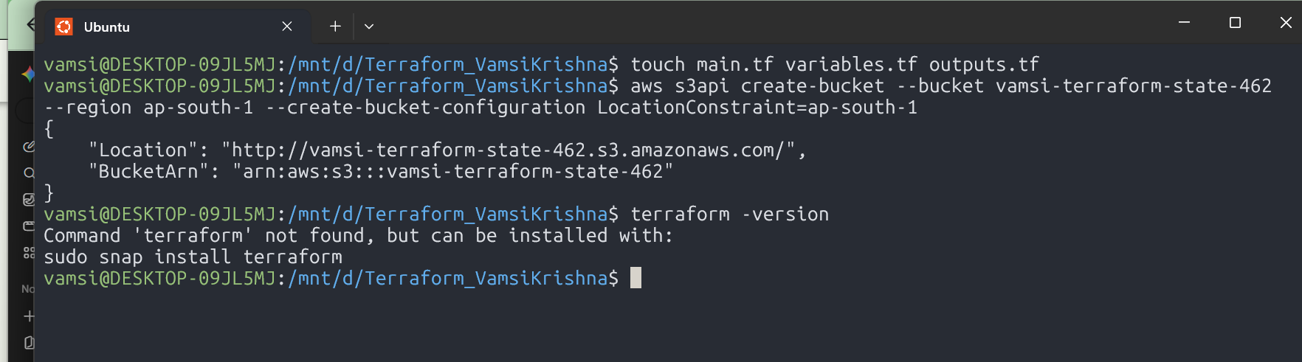
b. Installed Terraform v1.16.4 on Ubuntu WSL2 using the HashiCorp package repo and verified the binary runs cleanly.
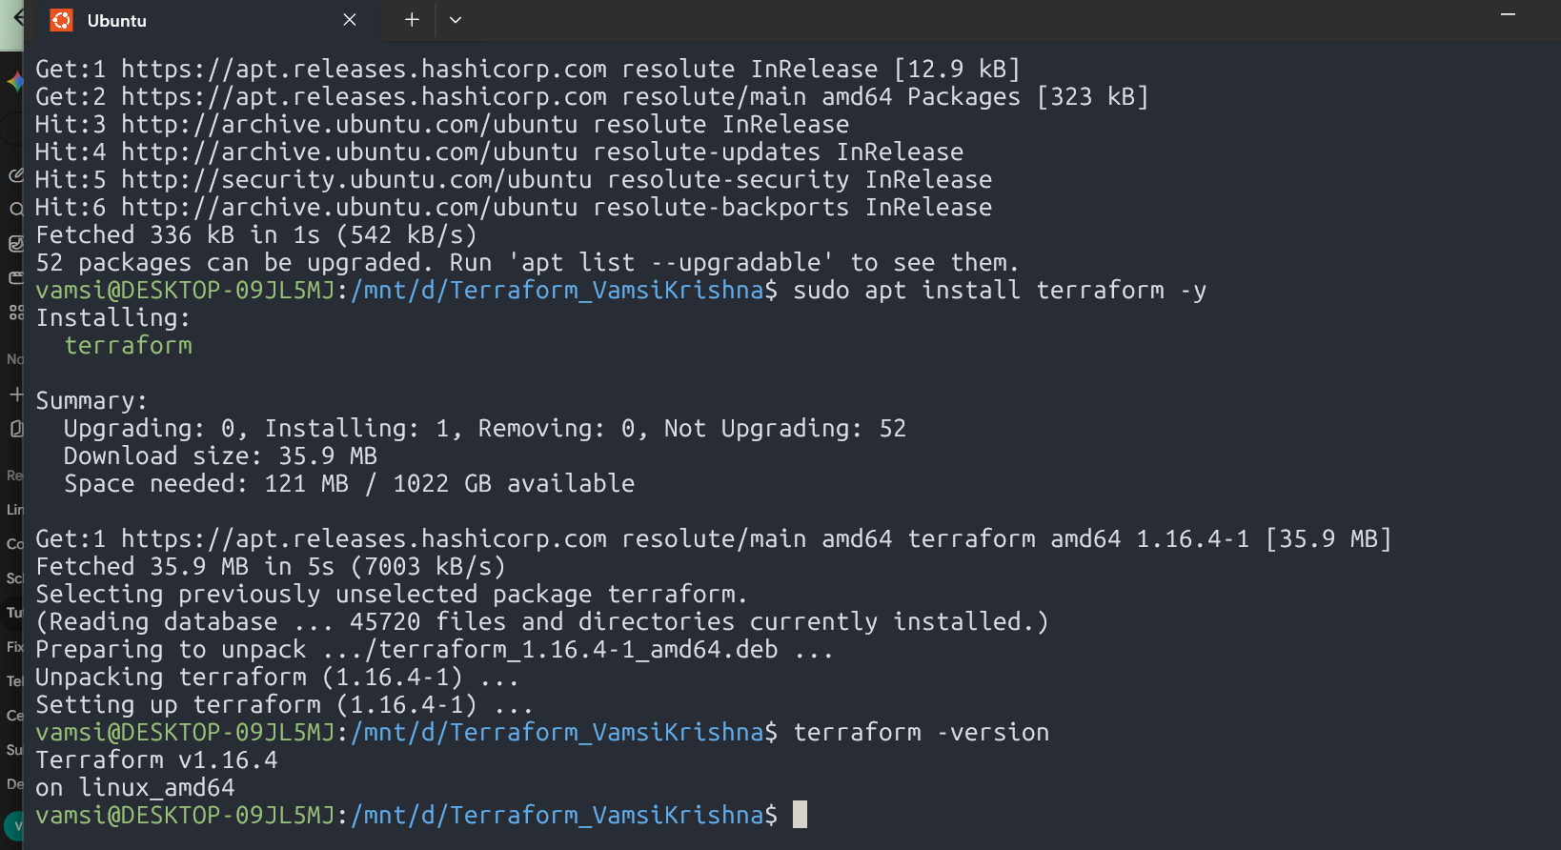
c. Initialized the directory with terraform init. It connected straight to the new S3 bucket for remote state and pulled down AWS provider version 5.100.0.

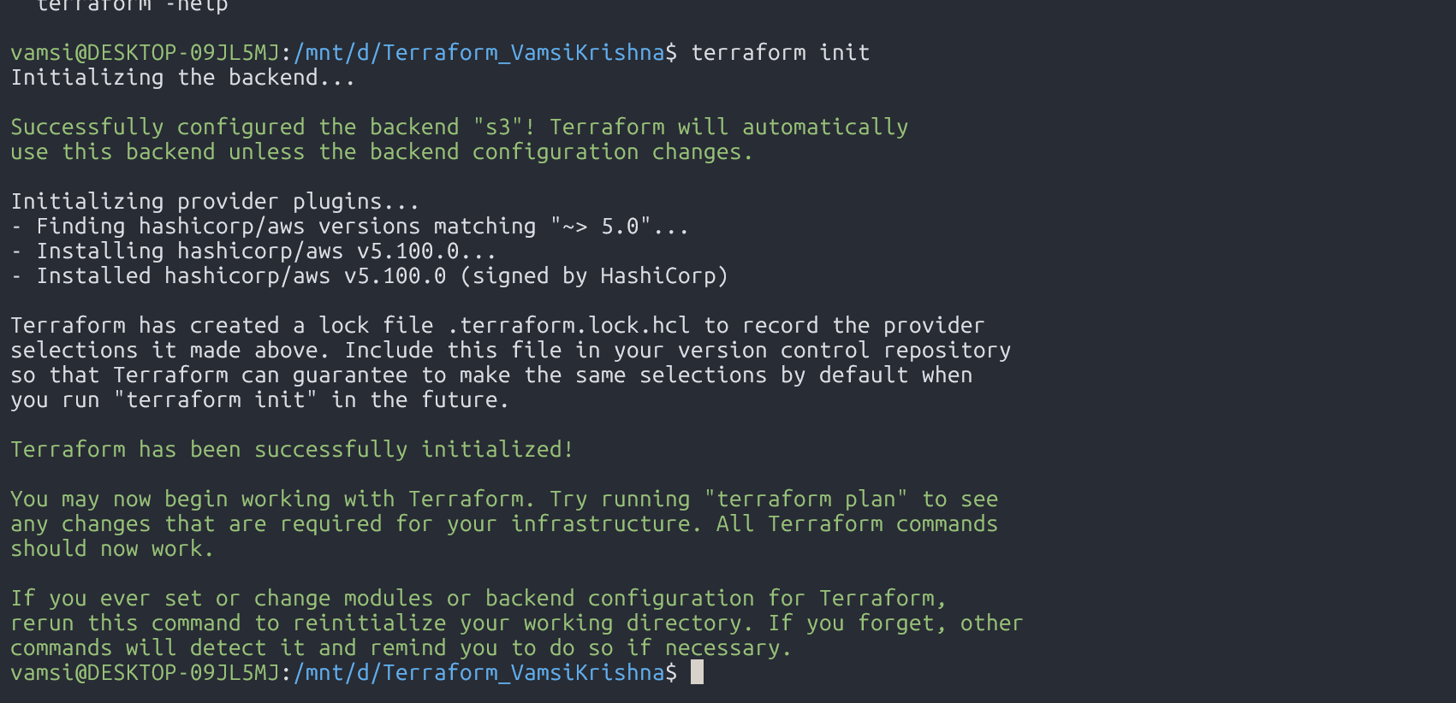
2. Part 1: Single EC2 Deployment
a. Ran terraform plan to preview the build. It generated a clean dry-run showing the single EC2 instance and its security groups ready to deploy.
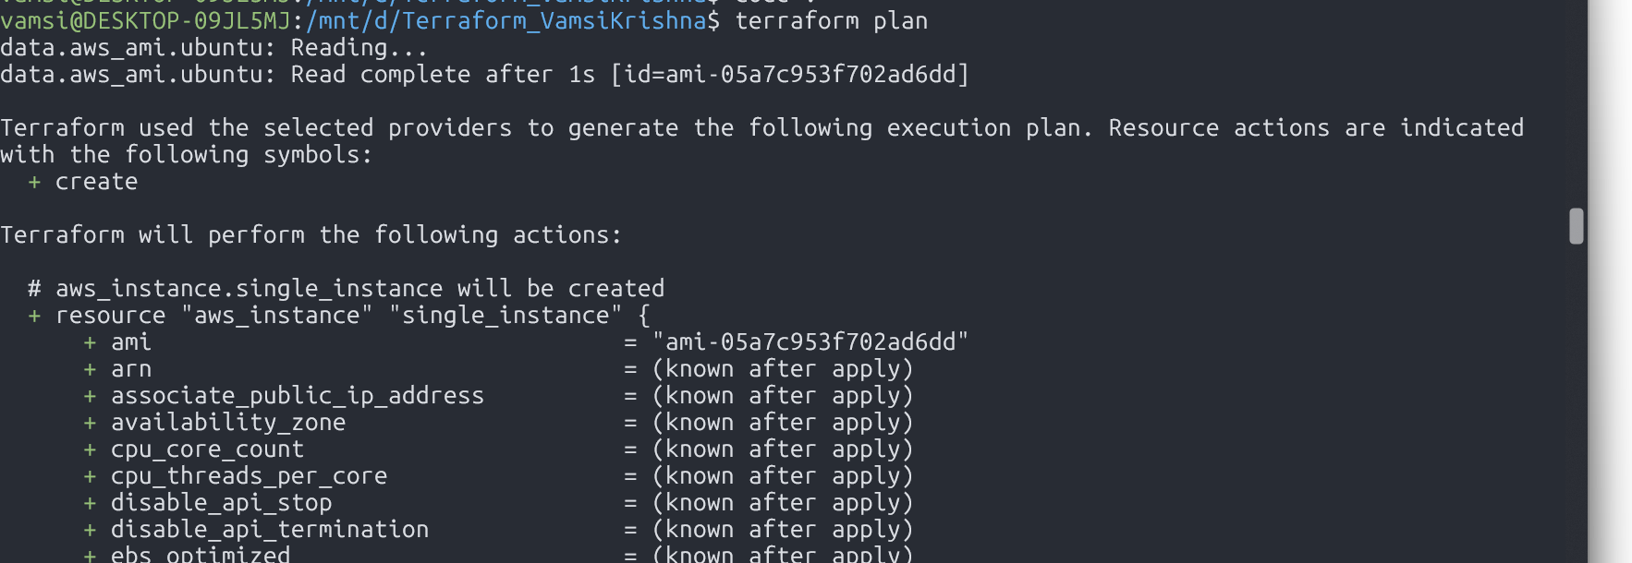
b. Tested an in-place state update by tweaking resource tags to "Assignment-Part1". Terraform updated the tag on the live instance without terminating the server.
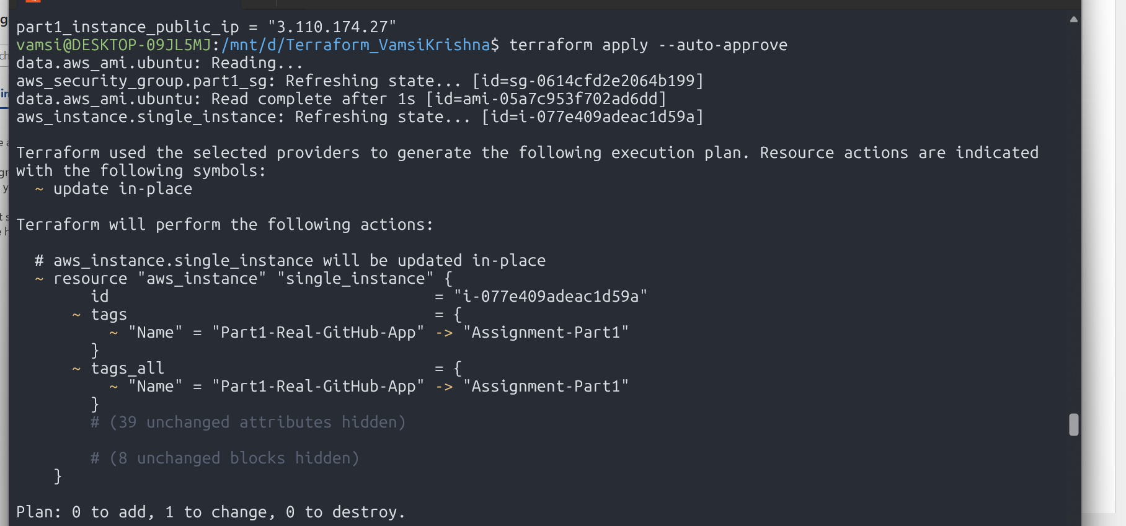
c. Applied the configuration to provision the server at public IP 16.4.42.137. The user-data script handled installing Node.js, Python, and pulling the project code automatically.
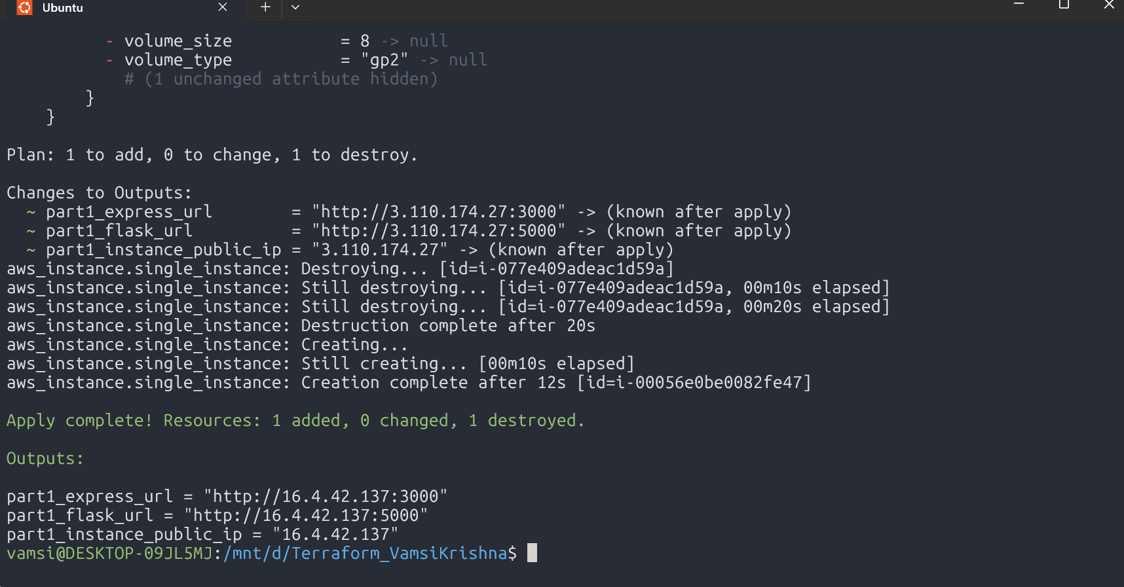
d. Opened http://16.4.42.137:3000 in the browser and submitted a test record. Express caught the submission and relayed it to Flask on local port 5000, returning a successful confirmation for Item ID

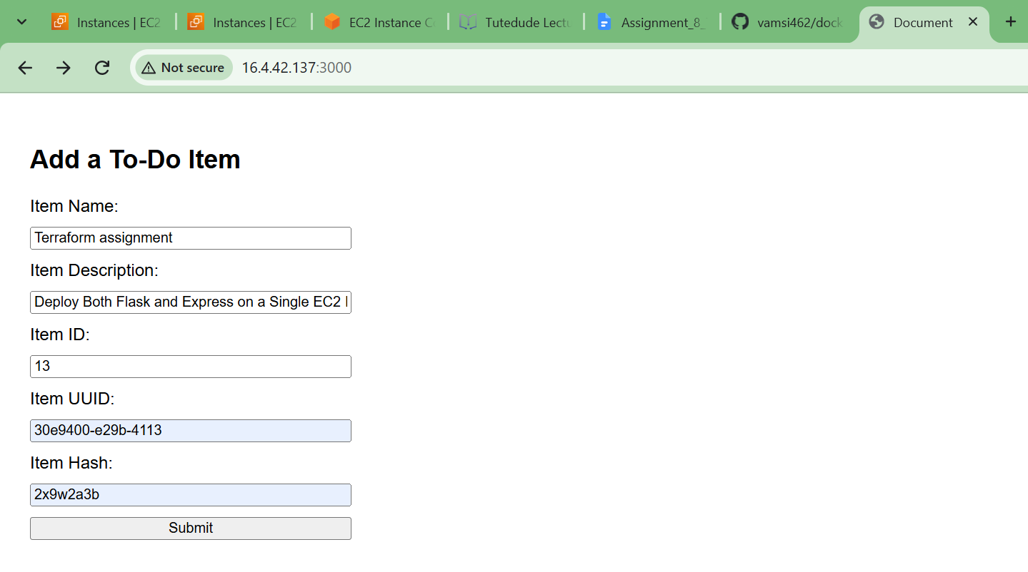

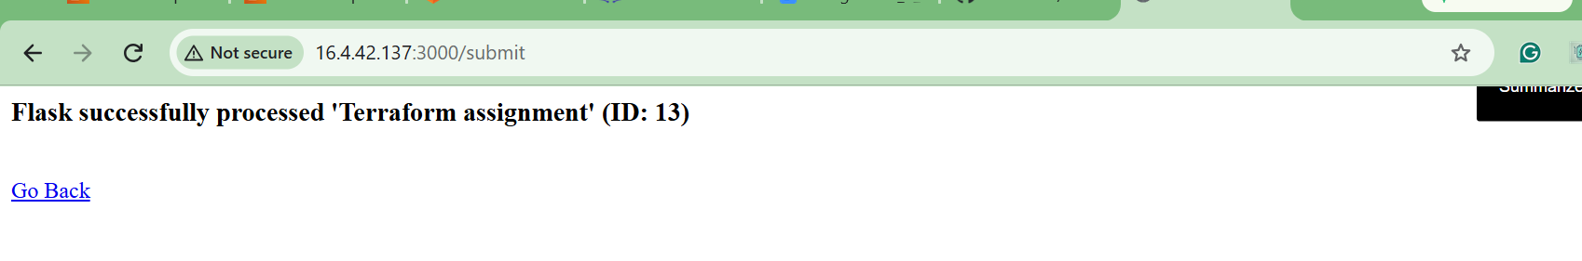
3. Part 2: Decoupled Multi-Server Deployment
a. Switched over to the part2-multi-server folder and re-initialized the working directory against the existing S3 backend.
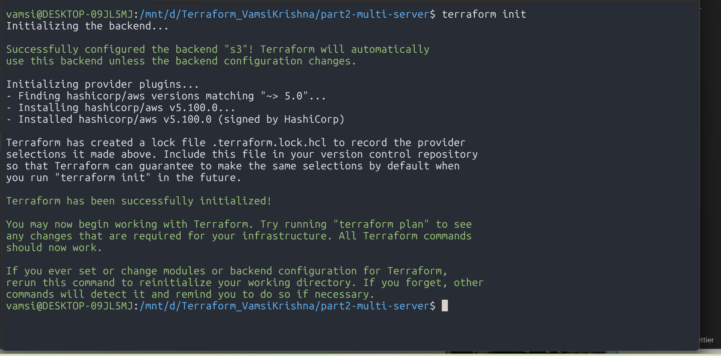
b. Ran terraform plan and saw Terraform pick up the changes—marking the old single server for deletion while preparing two separate instances for Flask and Express.
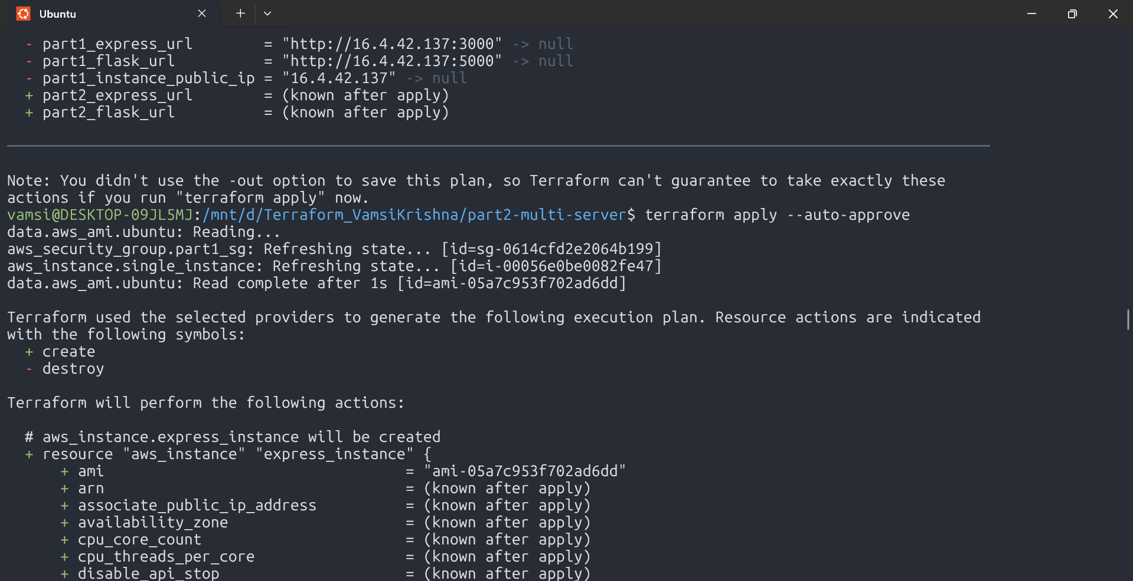
c. Executed terraform apply. The monolith was torn down and two new instances spun up: Express at 3.110.136.224:3000 and Flask at 65.0.199.125:5000.
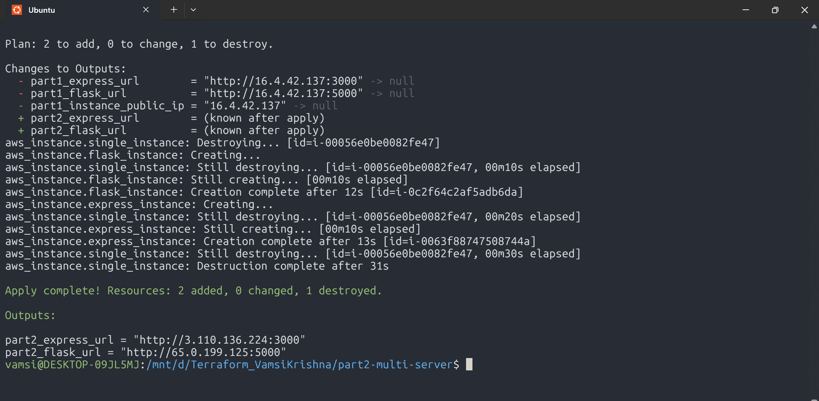

d. Loaded the new Express URL in the browser and submitted Item ID 15. Express routed the payload across the public network to Flask's independent IP, verifying cross-instance connectivity and open port 5000 security group rules.

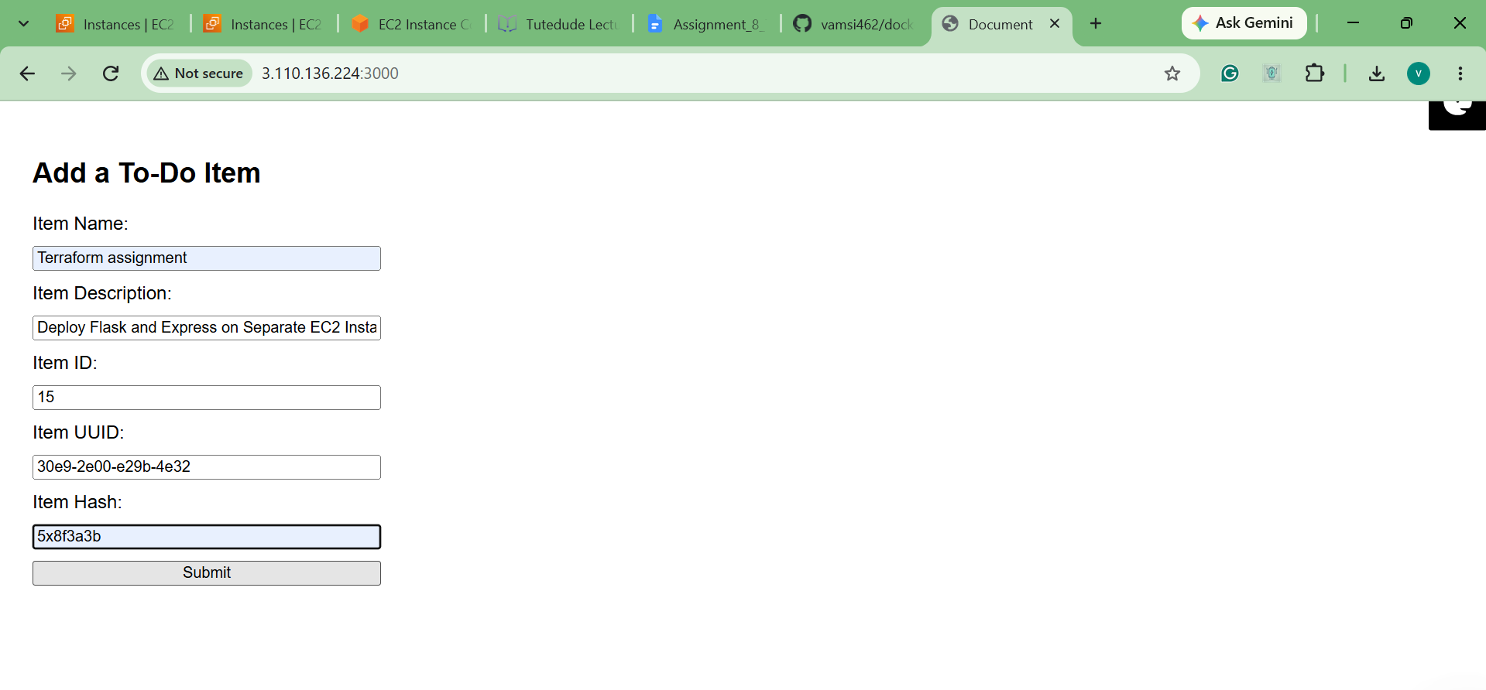
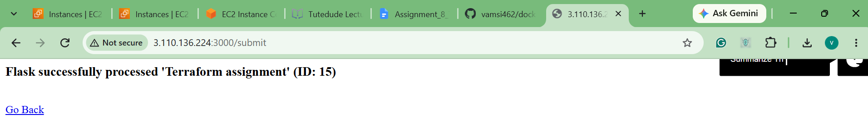
4. Part 3: Containerization & AWS ECR Setup
a. Initialized the part3-ecs directory with terraform init, linking to remote state and pulling down provider v6.66.0.
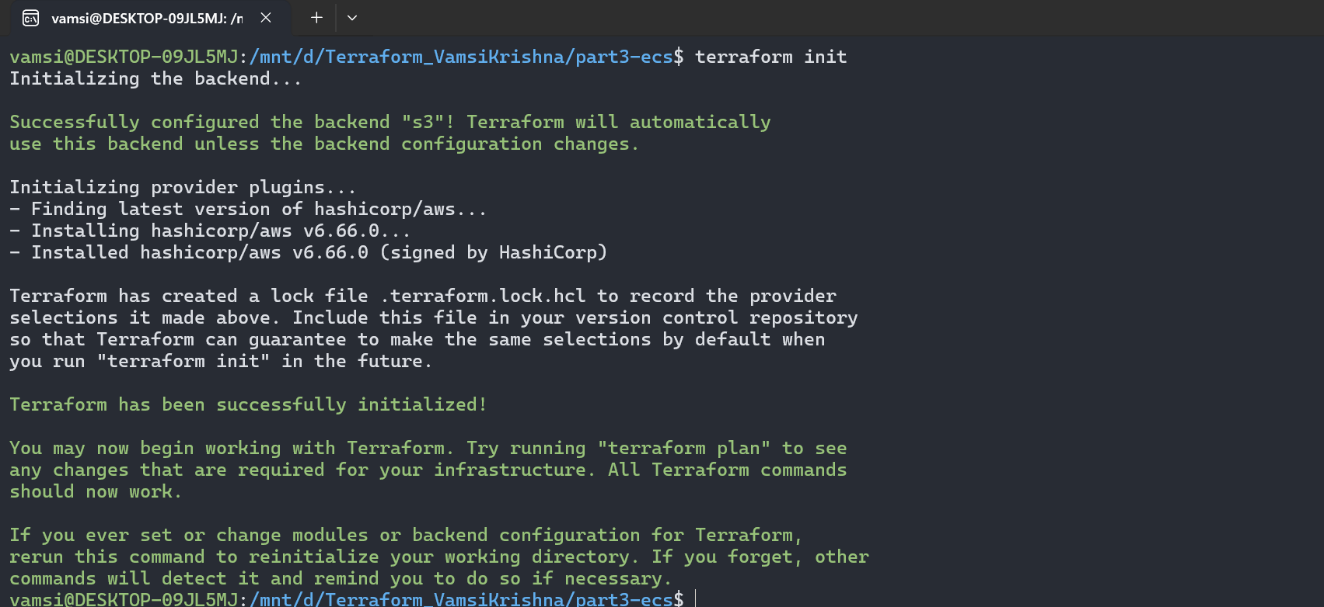
b.Applied the base configuration to decommission the Part 2 EC2 instances and set up two ECR repositories: flask-backend-repo and express-frontend-repo.
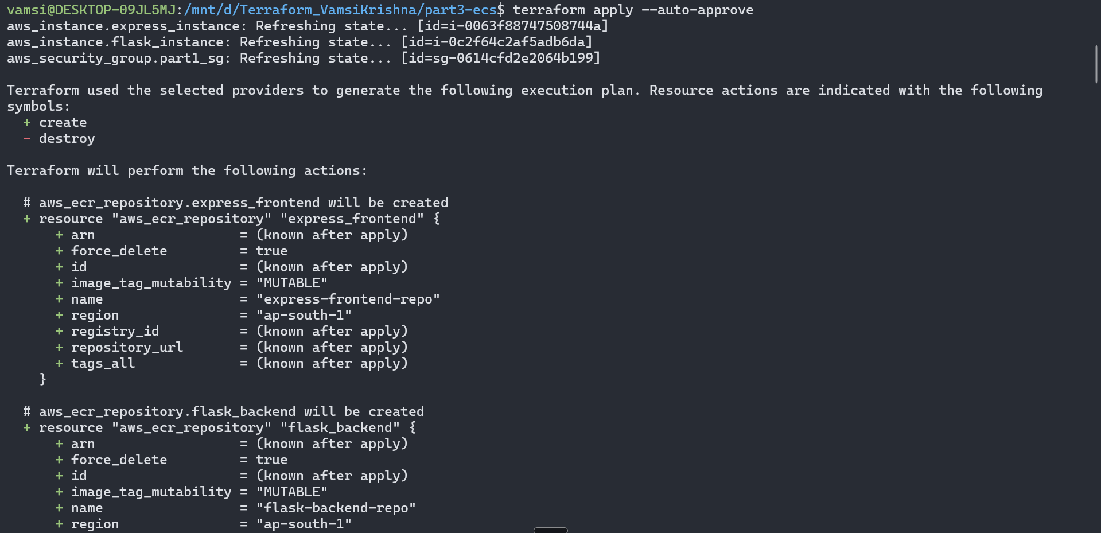
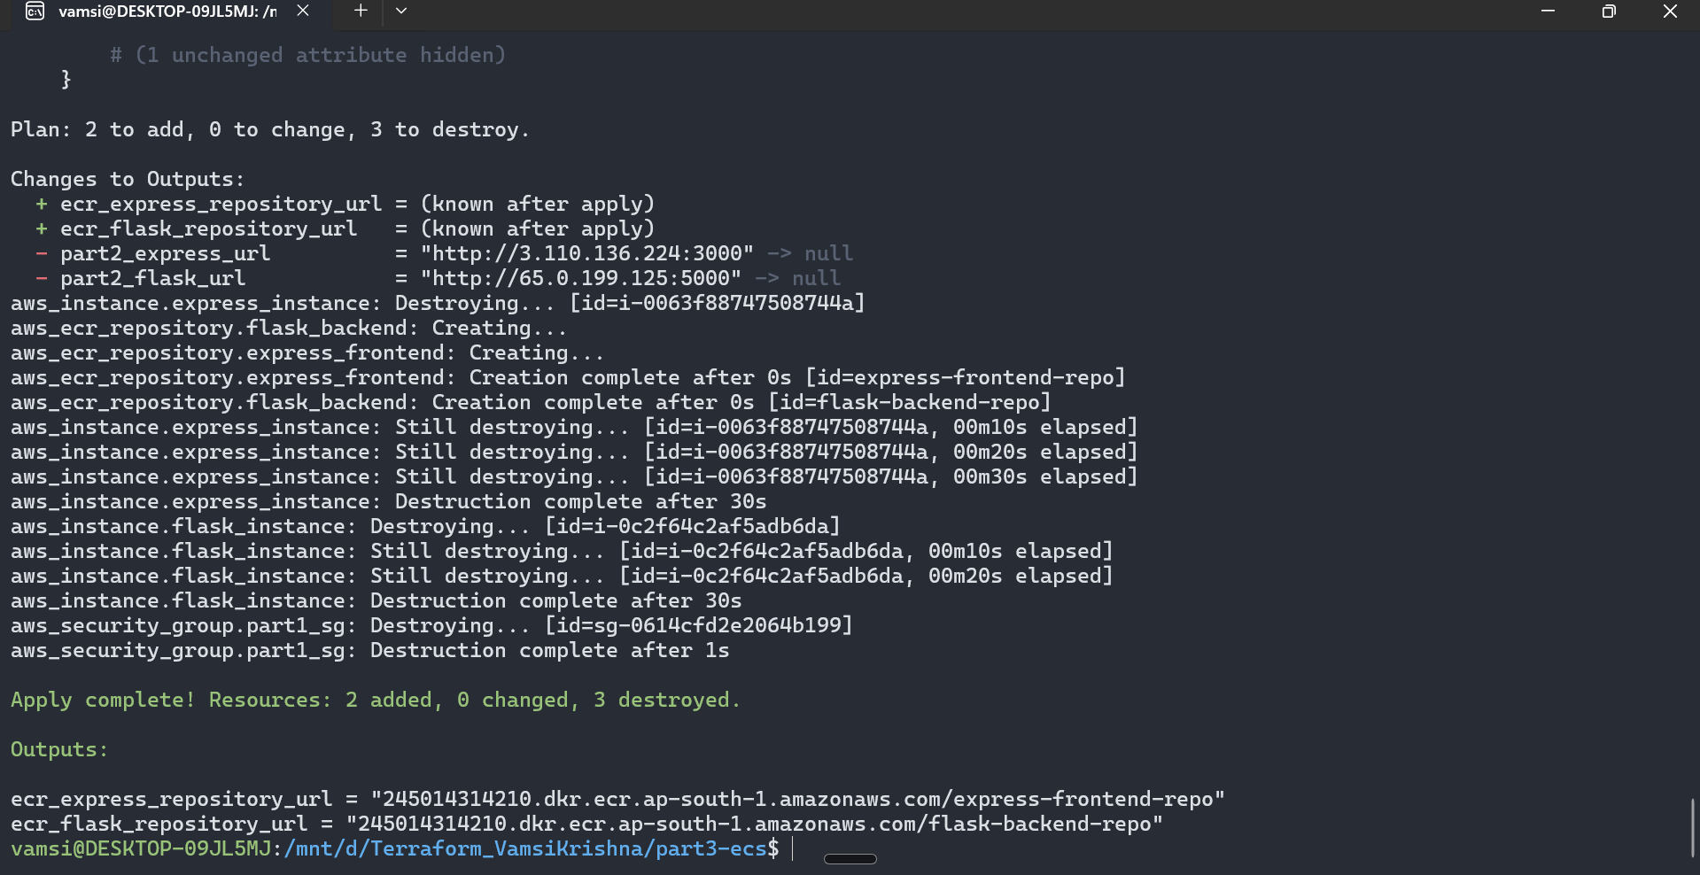
c. Authenticated the local Docker client to the ECR registry via aws ecr get-login-password, getting back Login Succeeded.
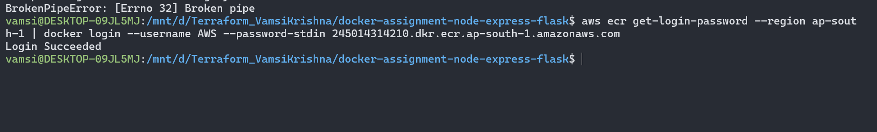
d. Built the backend container off python:3.8-slim-buster, tagged it, and pushed the image layers to ECR
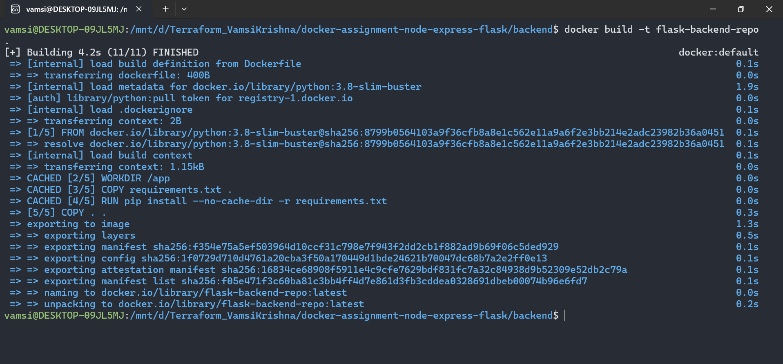
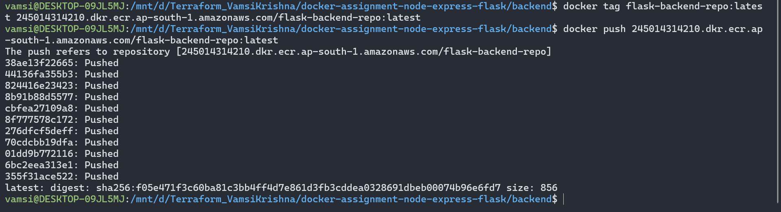
e. Built the frontend container using node:18-alpine, tagged it with the ECR endpoint, and pushed it to AWS.
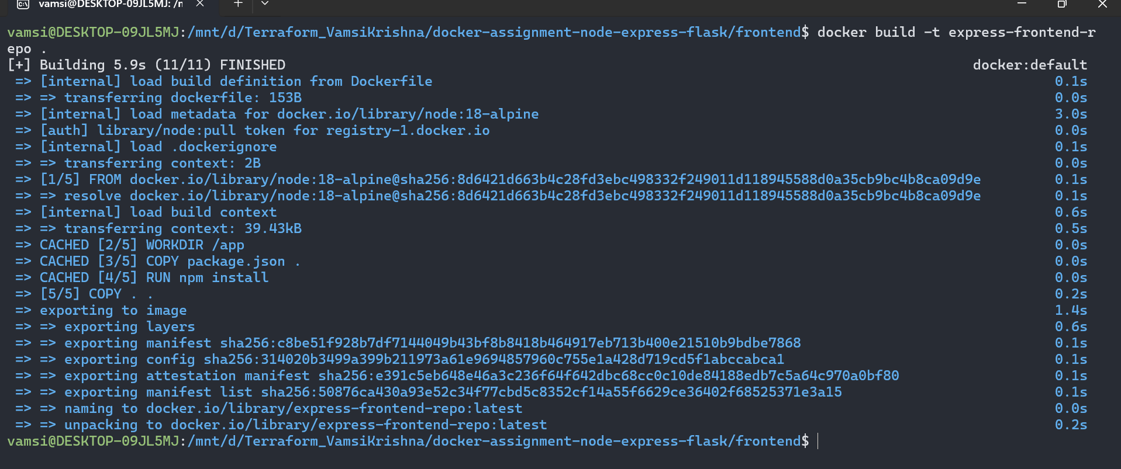

f. Tested both containers locally before cloud deployment. Started them with docker run using host.docker.internal for container communication, then submitted Item ID 19 on localhost:3000 to verify runtime behaviour.
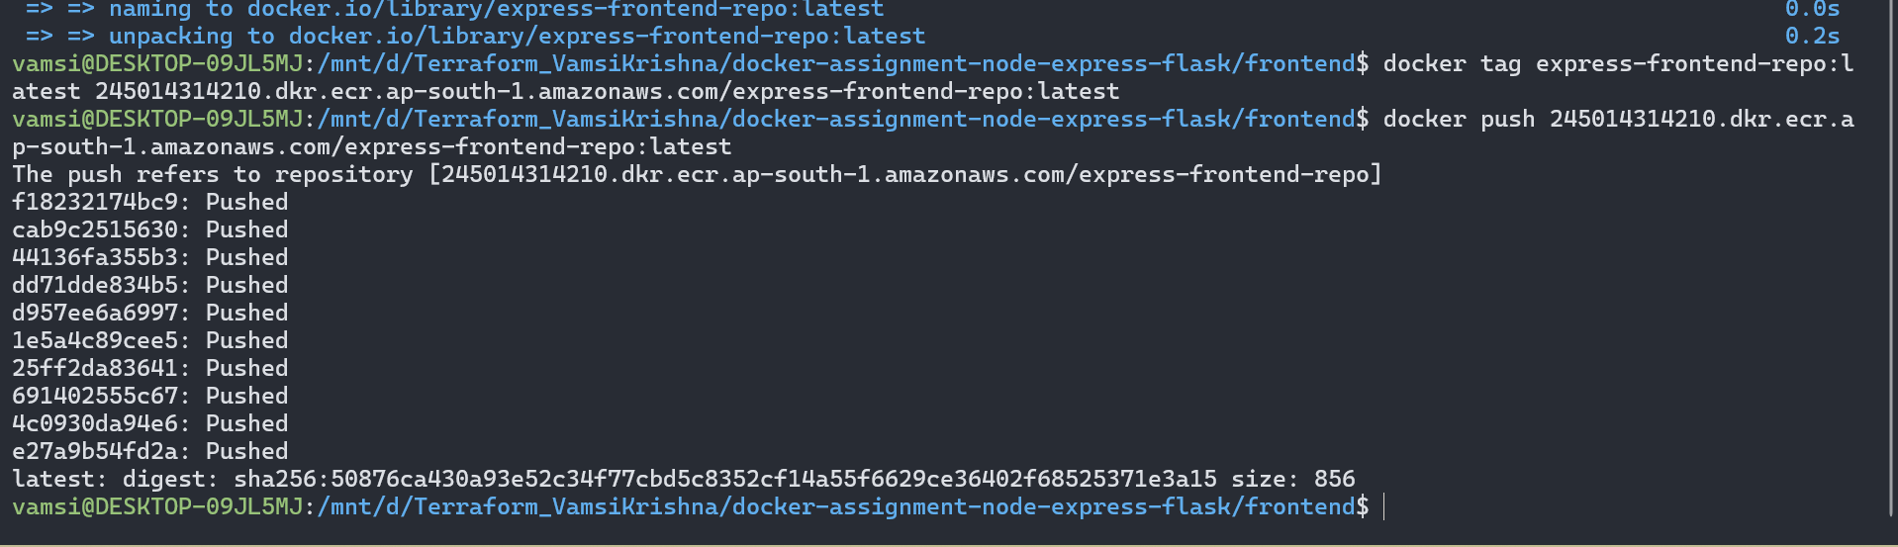
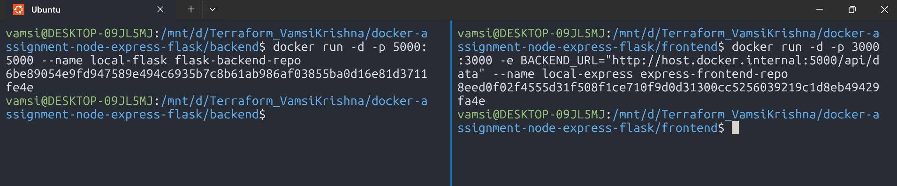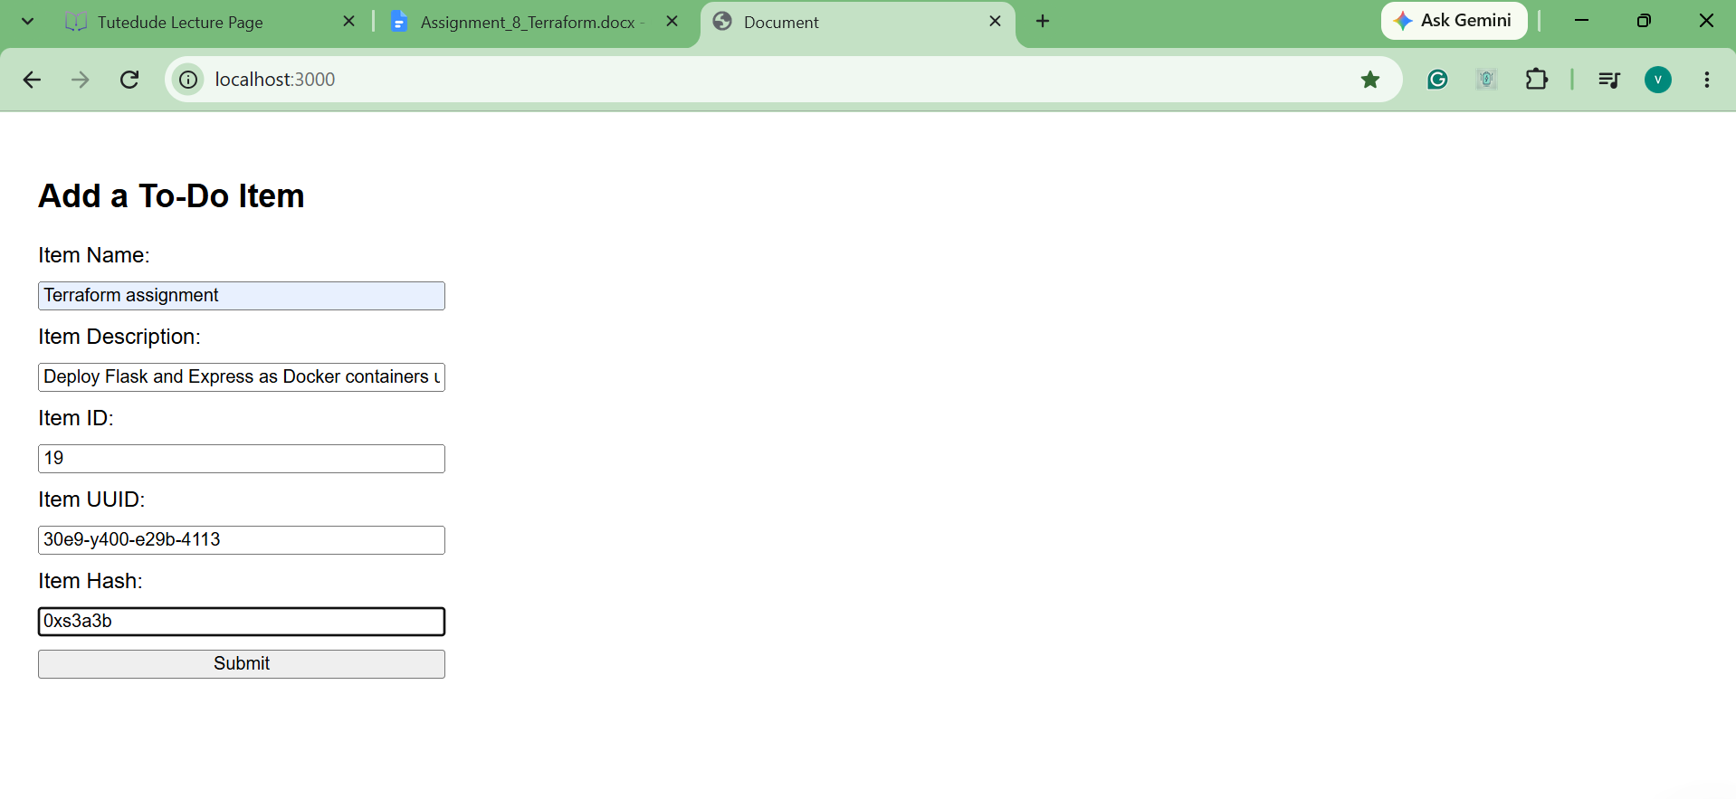
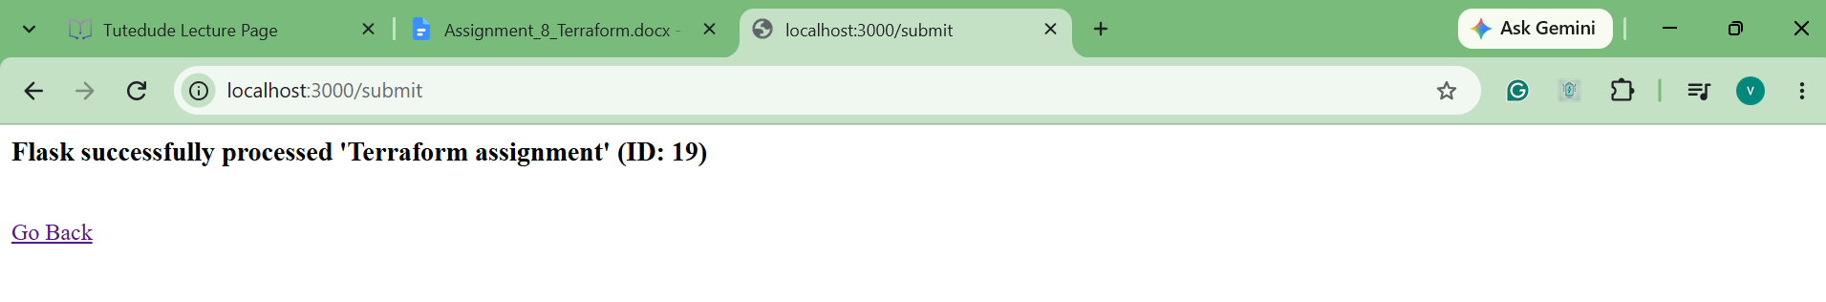

5. Part 3: Custom VPC, ECS Fargate & ALB
a. Applied vpc.tf to build a dedicated network. It provisioned a custom VPC (10.0.0.0/16), an Internet Gateway, route tables, and two public subnets across availability zones ap-south-1a and ap-south-1b.
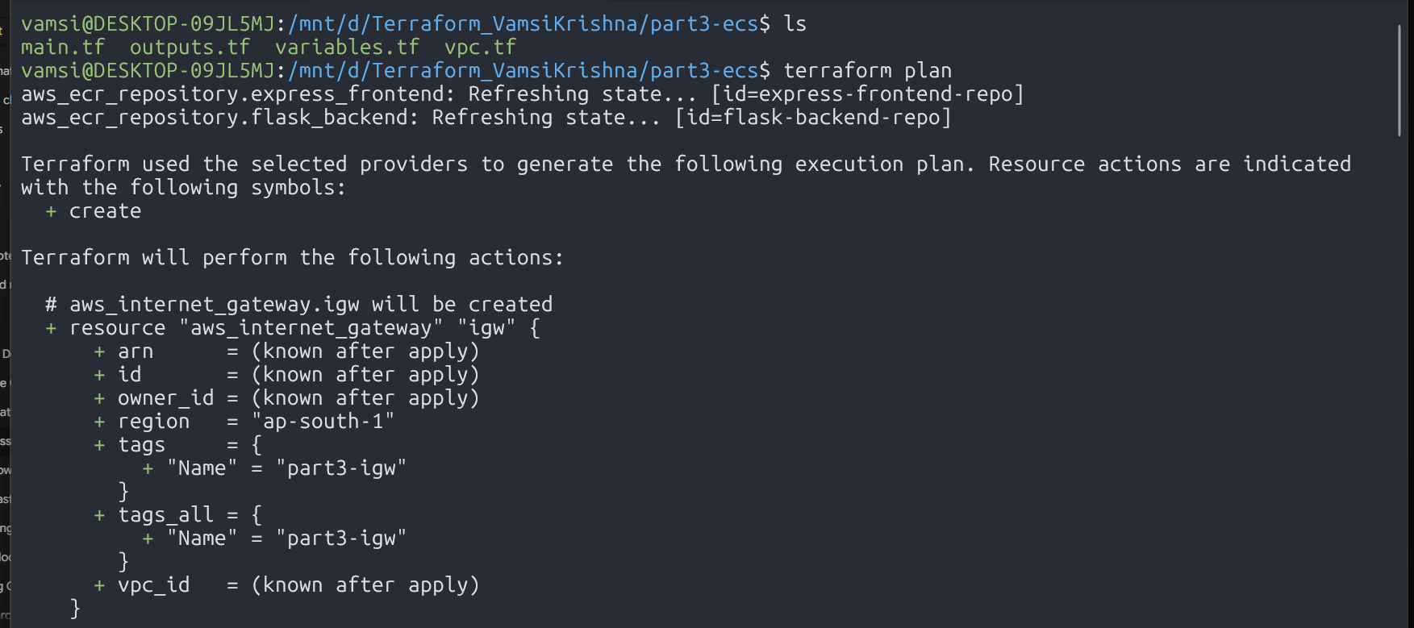
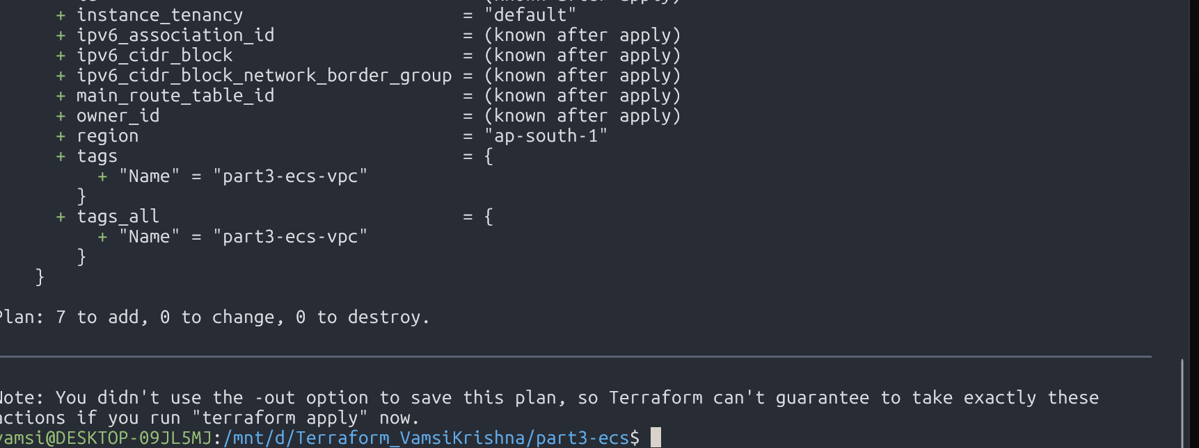

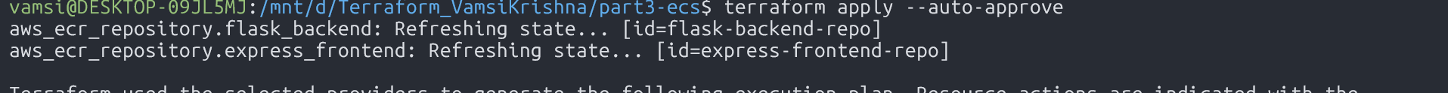
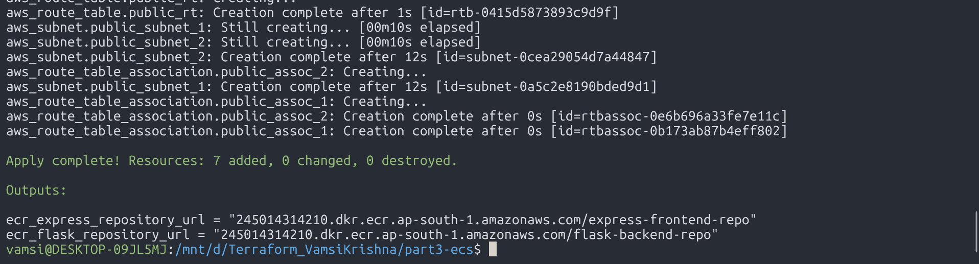

b.Checked the VPC Resource Map in the AWS Management Console to visually confirm the subnet routing and Internet Gateway associations.
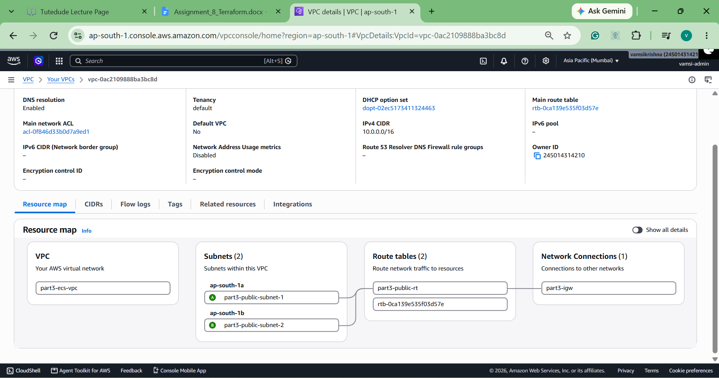
c. Opened the Load Balancer link (http://part3-alb-435958291.ap-south-1.elb.amazonaws.com) in the browser and submitted test Item 21. The load balancer successfully split the traffic, sending the normal web requests to Express and the backend data requests to Flask.
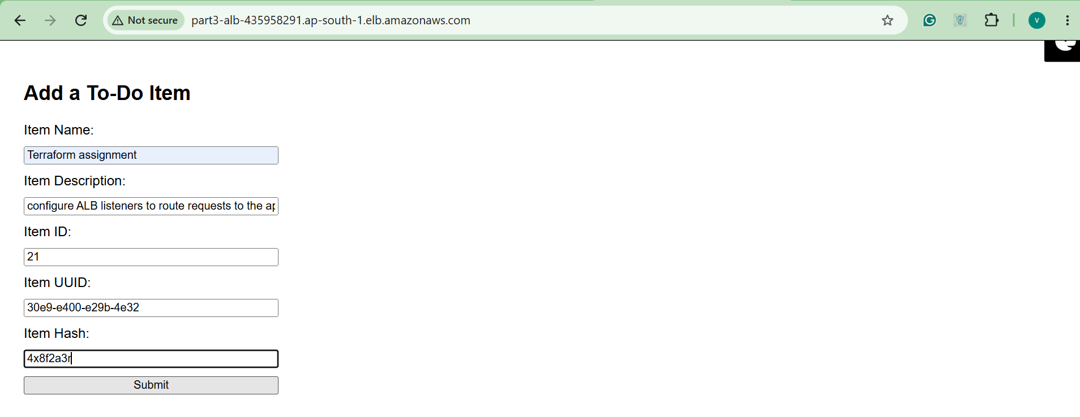
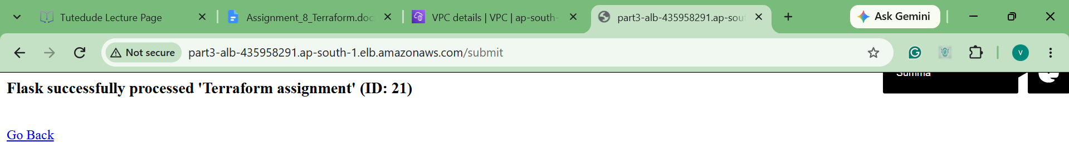

Commands Summary
S3 Remote State:
aws s3api create-bucket --bucket vamsi-terraform-state-462 --region ap-south-1 --create-bucket-configuration LocationConstraint=ap-south-1
Terraform Workflow:
terraform init
terraform plan
terraform apply --auto-approve
terraform destroy --auto-approve

ECR Authentication:
aws ecr get-login-password --region ap-south-1 | docker login –username AWS --password-stdin 245014314210.dkr.ecr.ap-south-1.amazonaws.com
Docker Build & Push (Flask Backend):
cd backend
docker build -t flask-backend-repo .
docker tag flask-backend-repo:latest 245014314210.dkr.ecr.ap-south-1.amazonaws.com/flask-backend-repo:latest
docker push 245014314210.dkr.ecr.ap-south-1.amazonaws.com/flask-backend-repo:latest

cd ../frontend
docker build -t express-frontend-repo .
docker tag express-frontend-repo:latest 245014314210.dkr.ecr.ap-south-1.amazonaws.com/express-frontend-repo:latest
docker push 245014314210.dkr.ecr.ap-south-1.amazonaws.com/express-frontend-repo:latest
Docker Build & Push (Express Frontend):

docker run -d -p 5000:5000 --name local-flask flask-backend-repo
docker run -d -p 3000:3000 -e BACKEND_URL="http://host.docker.internal:5000/api/data" --name local-express express-frontend-repo
docker stop local-flask local-express
docker rm local-flask local-express
Local Container Verification:

Terraform Configuration Structure
- part1-single-server/
  - main.tf: Configures the AWS provider, S3 backend block, and provisions the single EC2 instance with user data running both Node and Python.
  - variables.tf: Declares the AWS region, AMI IDs, and instance sizing defaults.
  - outputs.tf: Exports the single public IP and application URLs for quick testing.
- part2-multi-server/
  - main.tf: Splits the monolith into two standalone EC2 instances, defining unique security groups and injecting the backend instance's public IP as an environment variable into the frontend.
  - variables.tf & outputs.tf: Tracks separate instance configurations and exposes dedicated output endpoints for both servers.
- part3-ecs/
  - main.tf: Configures the S3 state backend and sets up the two ECR repositories for container image storage.
  - vpc.tf: Builds the custom network from scratch, defining the VPC CIDR, Internet Gateway, route table associations, and two public subnets across distinct Availability Zones.
  - alb.tf: Provisions the Application Load Balancer, sets up security groups for ports 80, 3000, and 5000, creates target groups, and configures listener rules to direct root traffic to Express and /api/* to Flask.
  - ecs.tf: Sets up the ECS cluster, IAM execution roles, Fargate task definitions for both containers, and defines the two ECS services connected to their target groups.
  - outputs.tf: Exposes the public ALB DNS name and ECR repository endpoints.

