Name: Vamsi Krishna Adusumalli
GitHub URL: https://github.com/vamsi462/aws-ec2-ecs-vpc-deployments.git
Task 1 App URL: http://3.110.191.250:3000
Task 2 App URL (Two EC2s):http://15.252.243.208:3000
Task 3 App URL (ECS & Custom VPC): http://35.154.176.19:3000

Task 1: Single EC2 Instance Deployment
Creating the IAM User Instead of using my root AWS account, I created a new IAM user named vamsi-admin and gave it AdministratorAccess. This is a better practice for security.
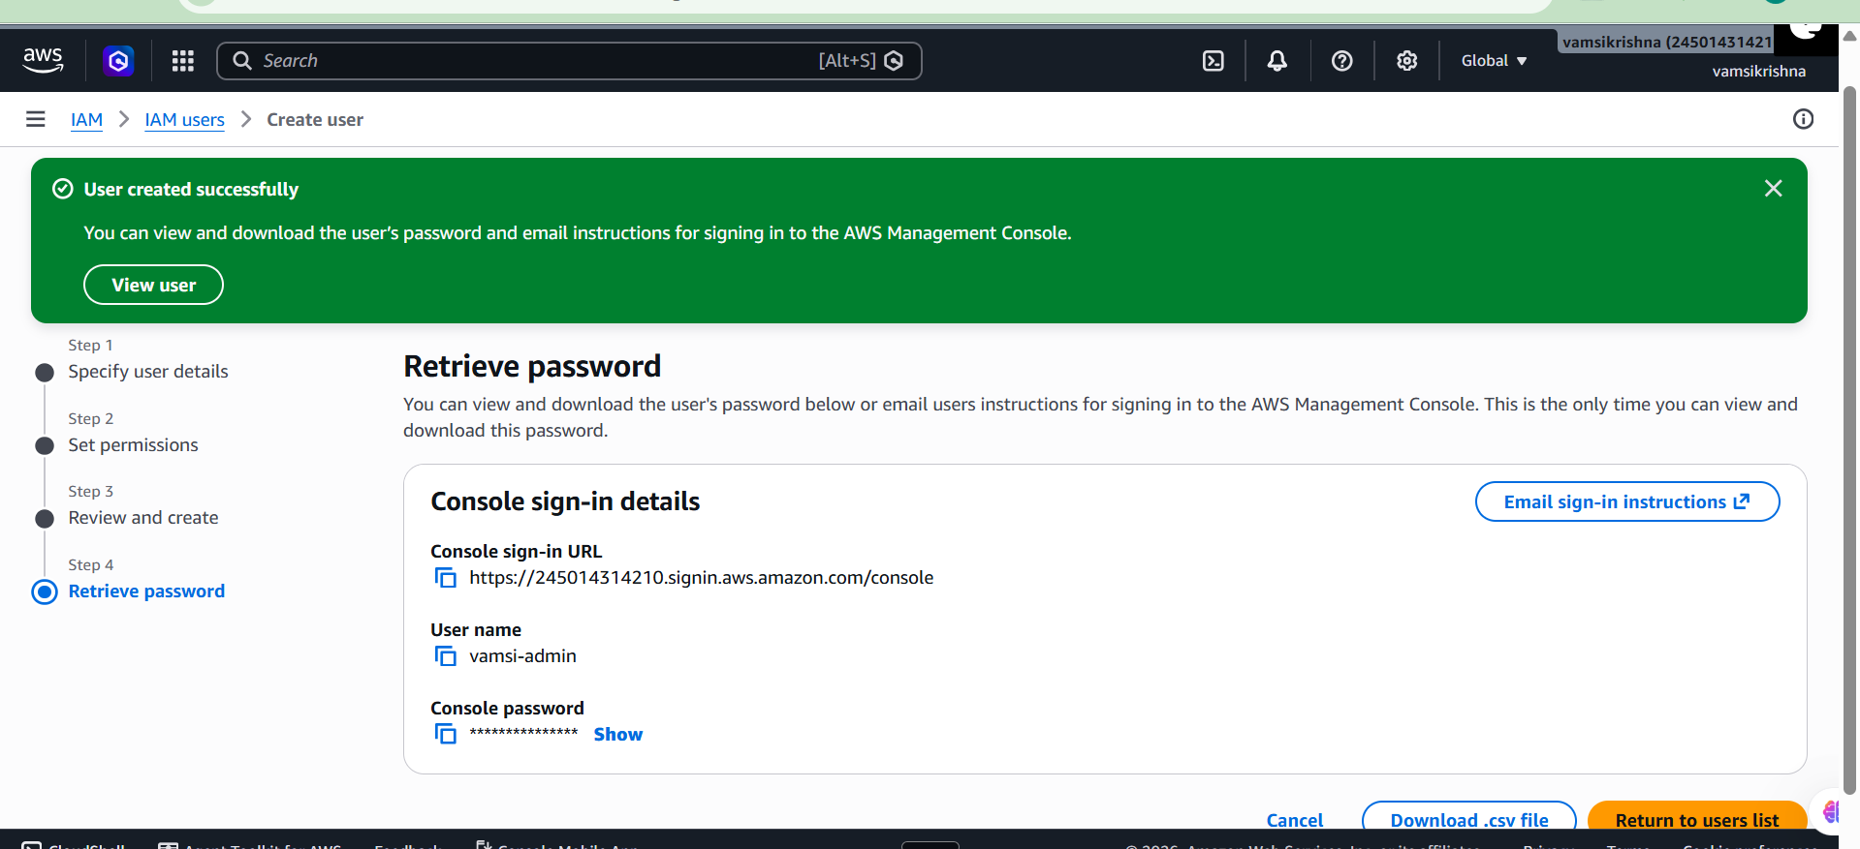
Launching the EC2 Server
I launched a new EC2 instance using Ubuntu 24.04. I selected the t3.micro instance type because it falls under the AWS free tier. I also created a new key pair called vamsi-ec2-key to securely log in.
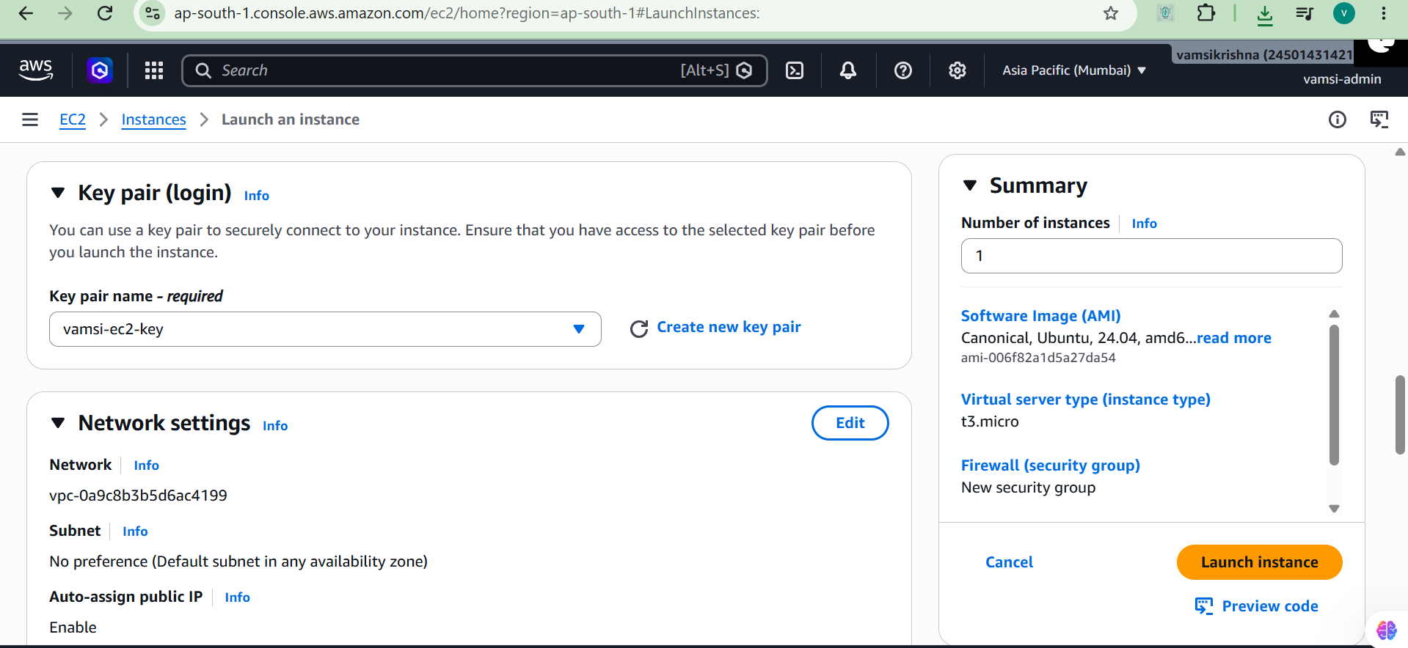

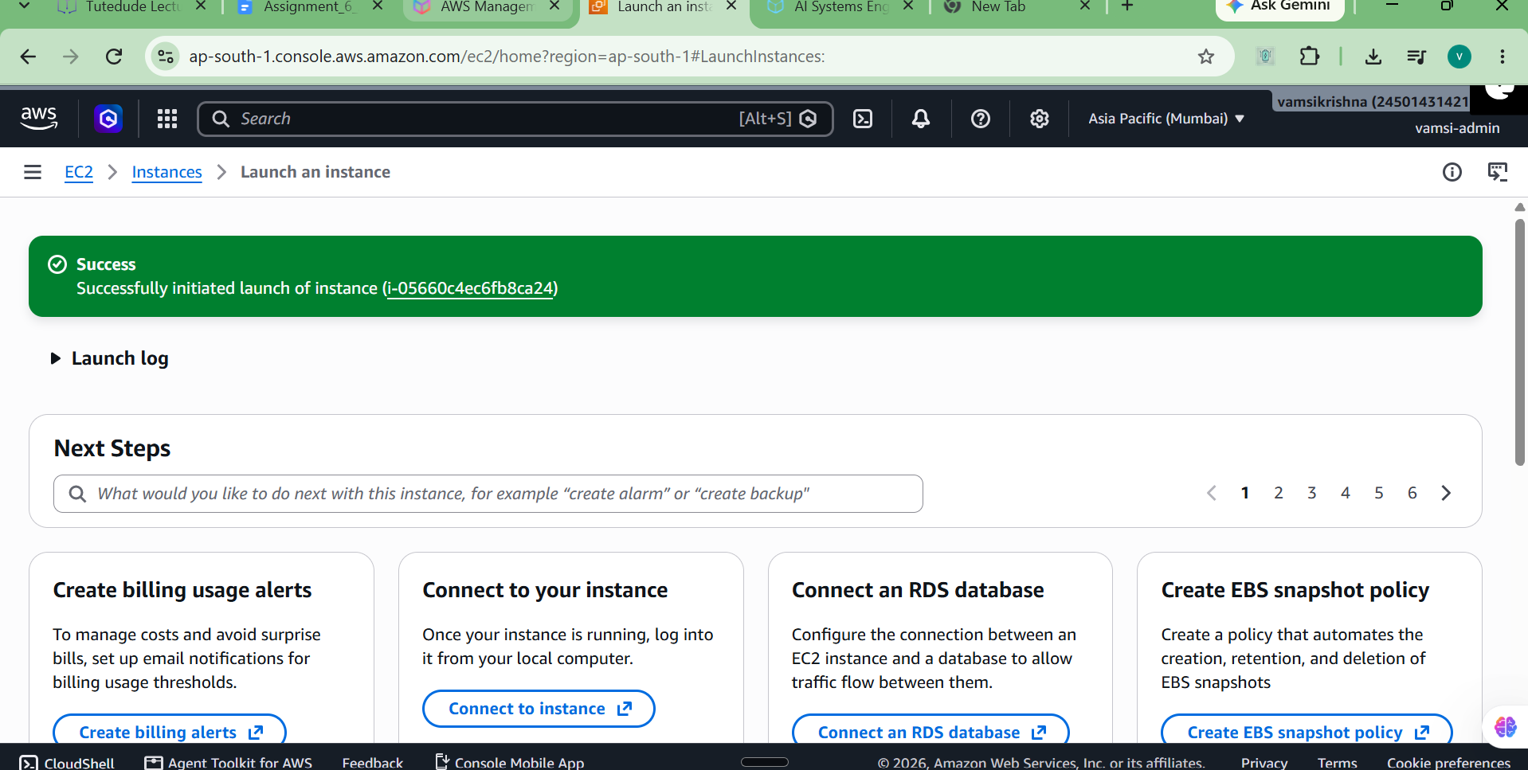
Opening Ports in Security Groups To make the application accessible from the internet, I had to edit the inbound rules. I added Custom TCP rules to open port 5000 for my Flask backend and port 3000 for my Node.js frontend, allowing traffic from anywhere (0.0.0.0/0).
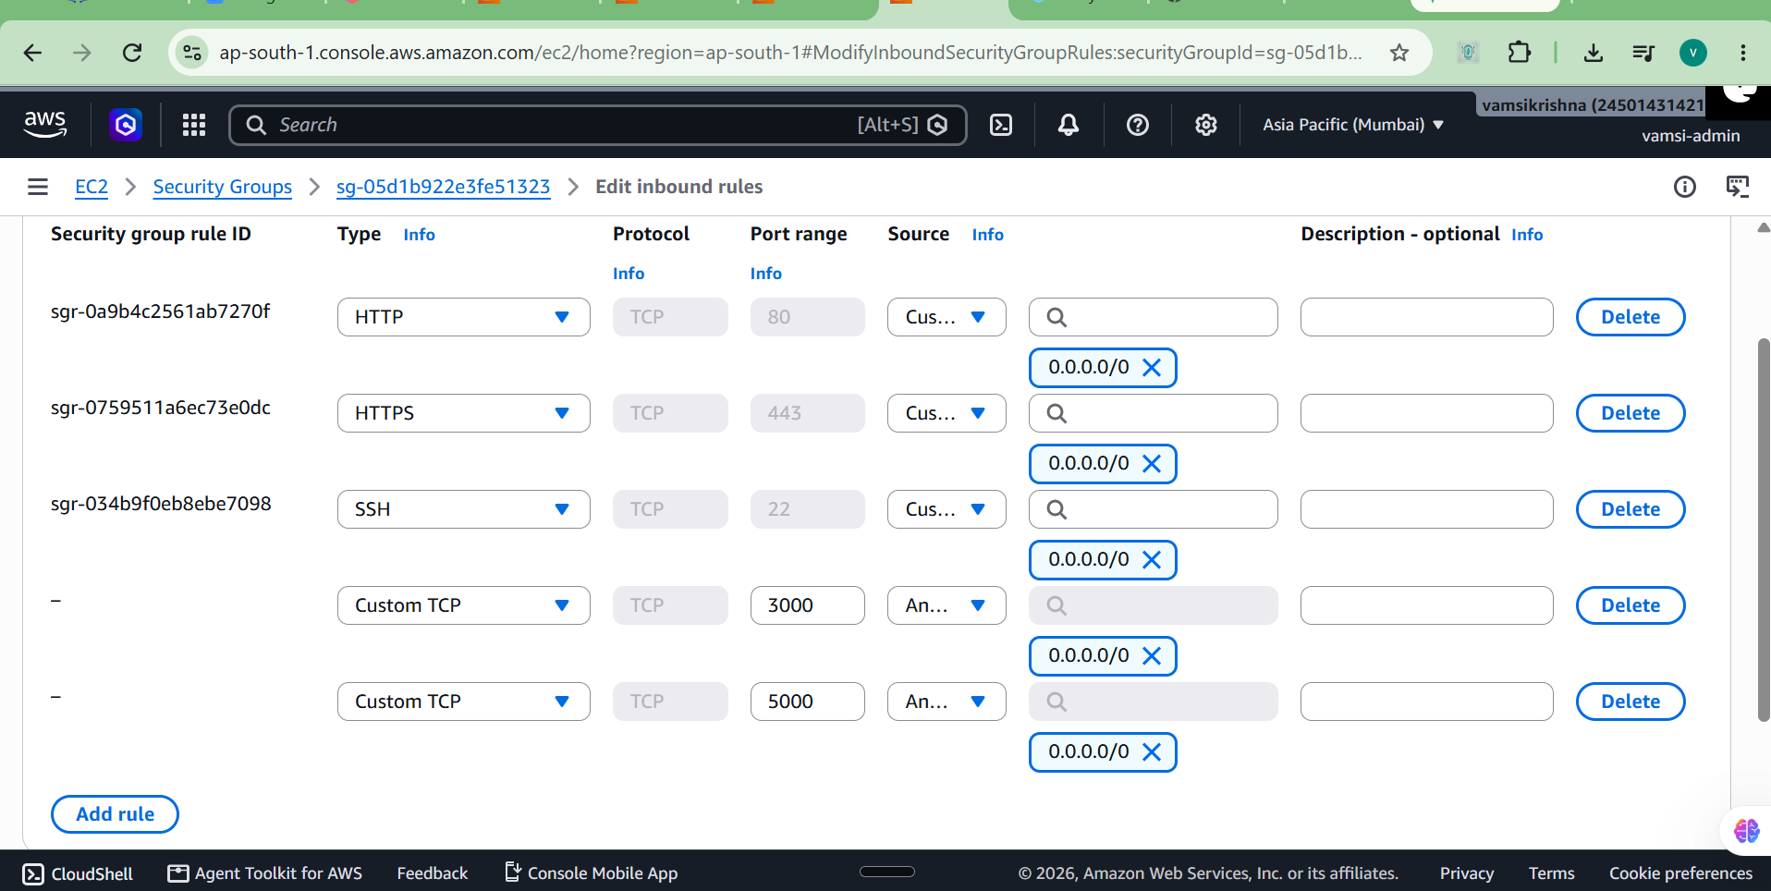
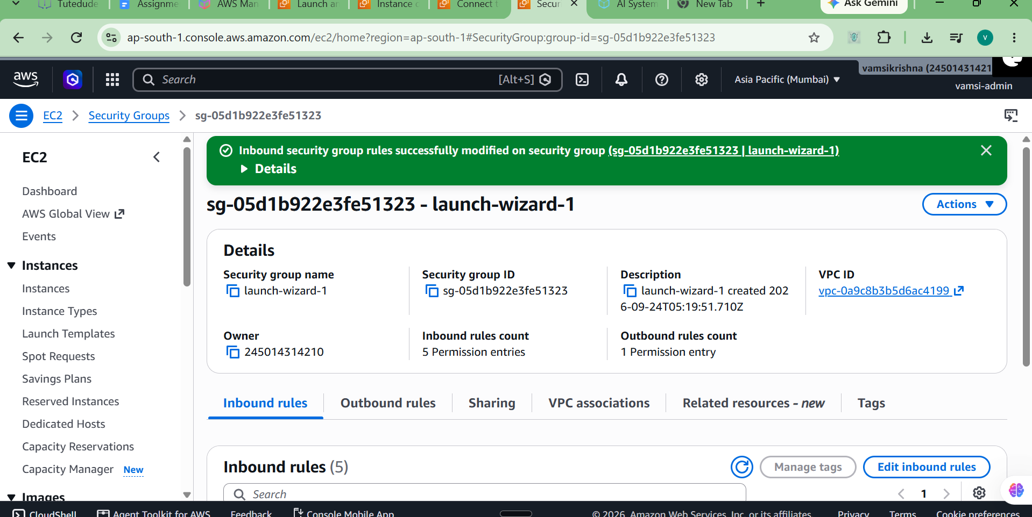
Connecting to the Server I used the EC2 Instance Connect feature directly in the AWS console to connect to my server terminal using the public IP 3.110.191.250.
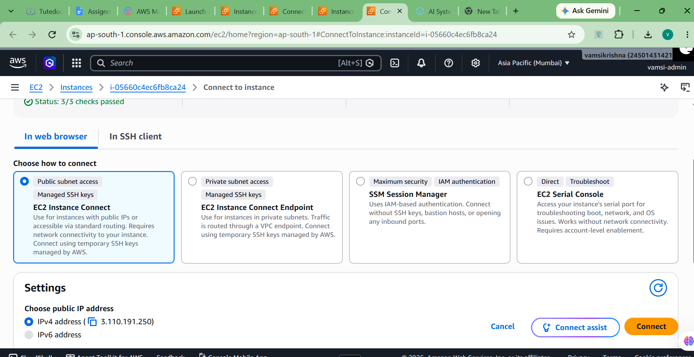
Installing Software Dependencies
Once inside the server, my first step was running sudo apt update to update the package lists. After that, I installed git, nodejs, npm, and python3-venv so I could run my project files. 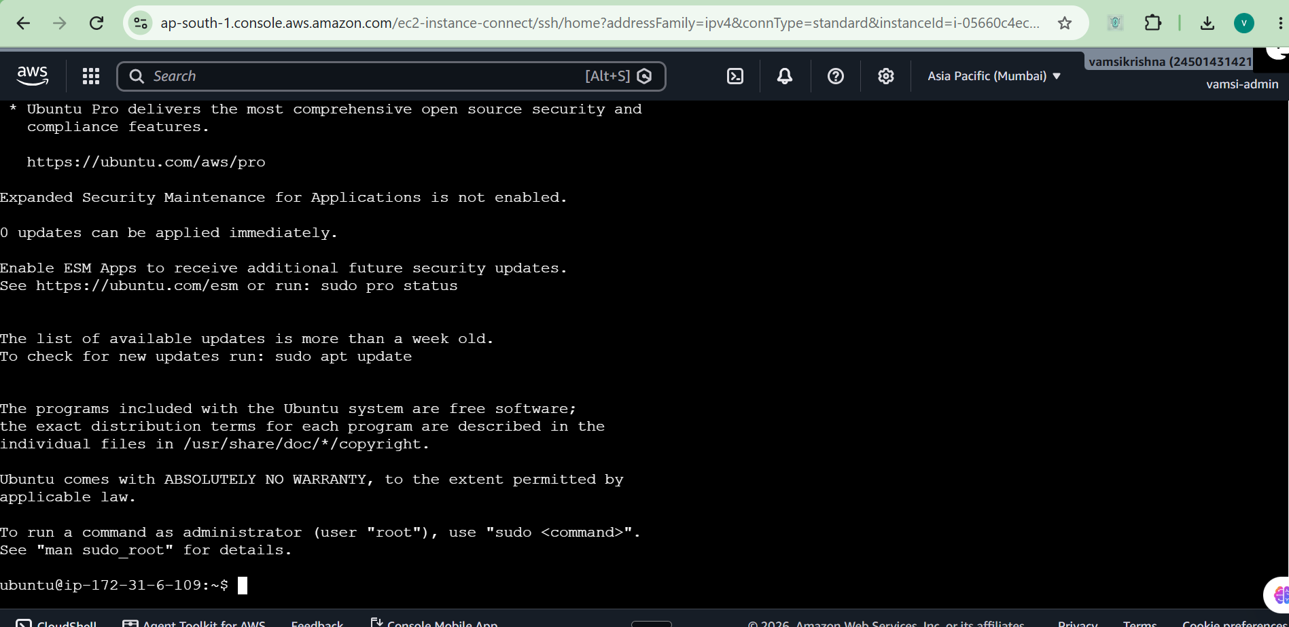
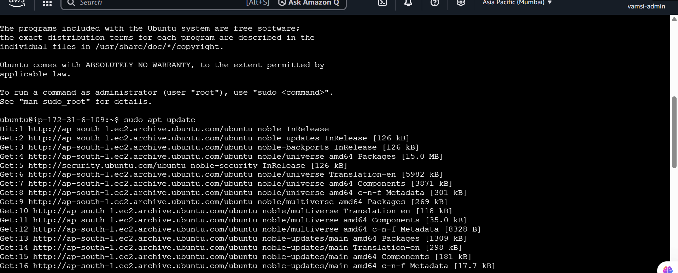
Running the Flask Backend
I learned that Ubuntu 24.04 gives an environment error if you try to install python packages globally. To fix this, I created a virtual environment using python3 -m venv venv. I activated it, installed the requirements, and then used the nohup command to run the backend in the background so it wouldn't stop when I closed the terminal.
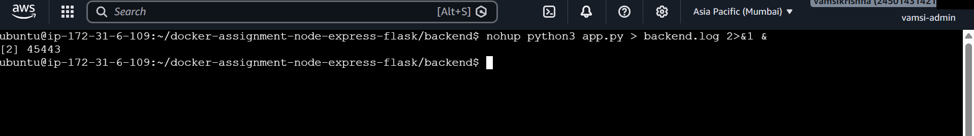
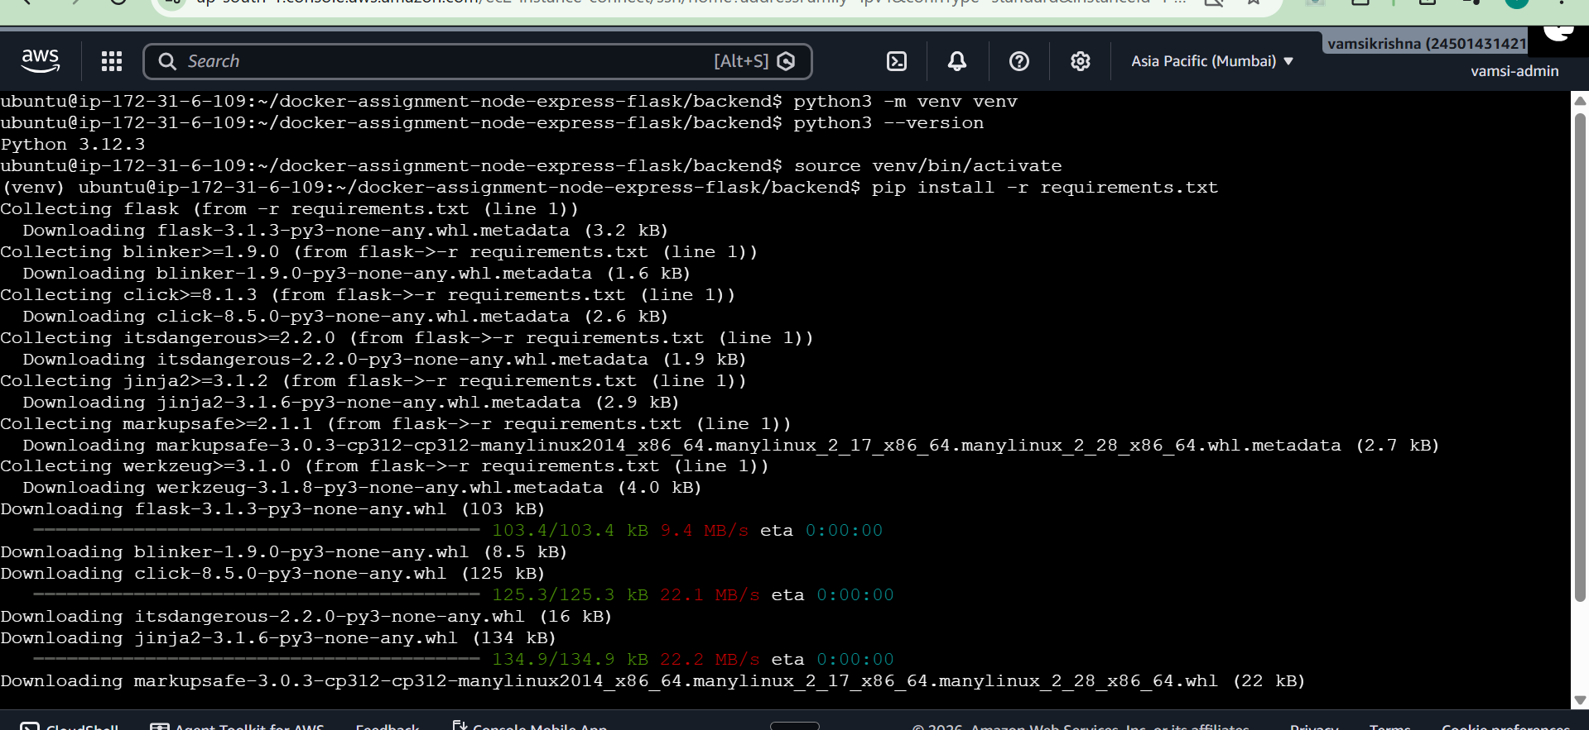

Running the Node Frontend and Fixing an Error I ran into a small error here. I tried to start the frontend using node index.js, but it crashed with a MODULE_NOT_FOUND error. I used the ls command to check the folder and realized the main file was actually named server.js. I updated my command to nohup node server.js > frontend.log 2>&1 & and it started successfully in the background.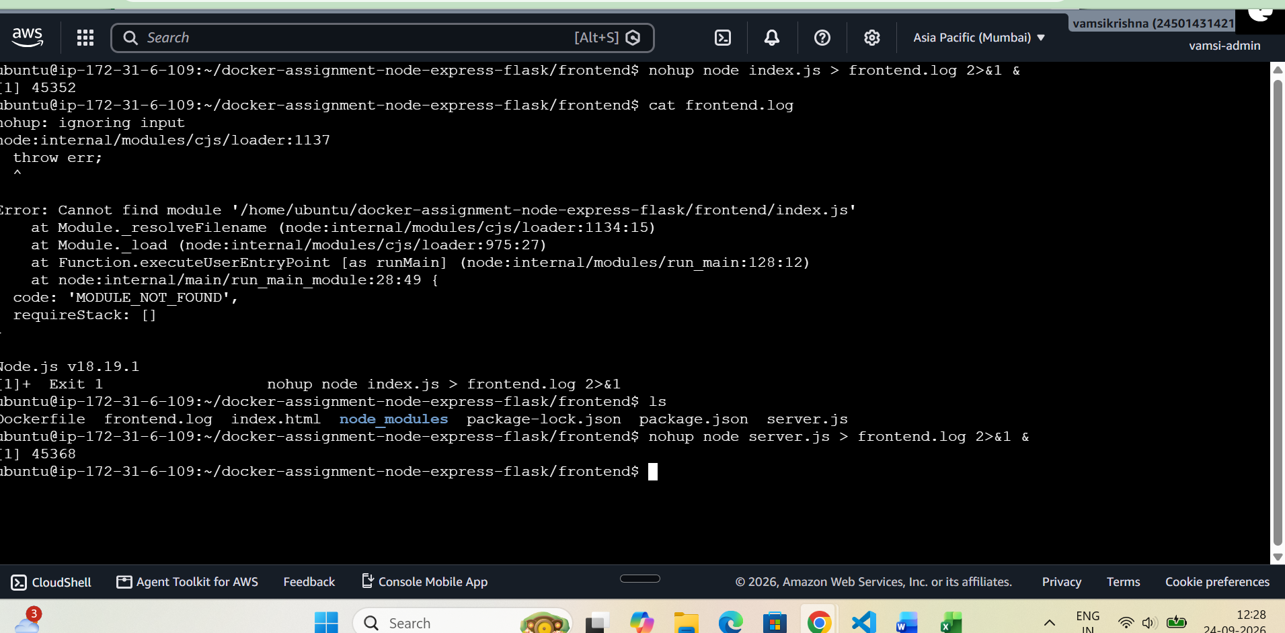

Testing the Application
I opened my browser and went to http://3.110.191.250:3000. The frontend loaded fine. To make sure it was actually connected to the backend, I typed "AWS assignment" in the form and submitted it.
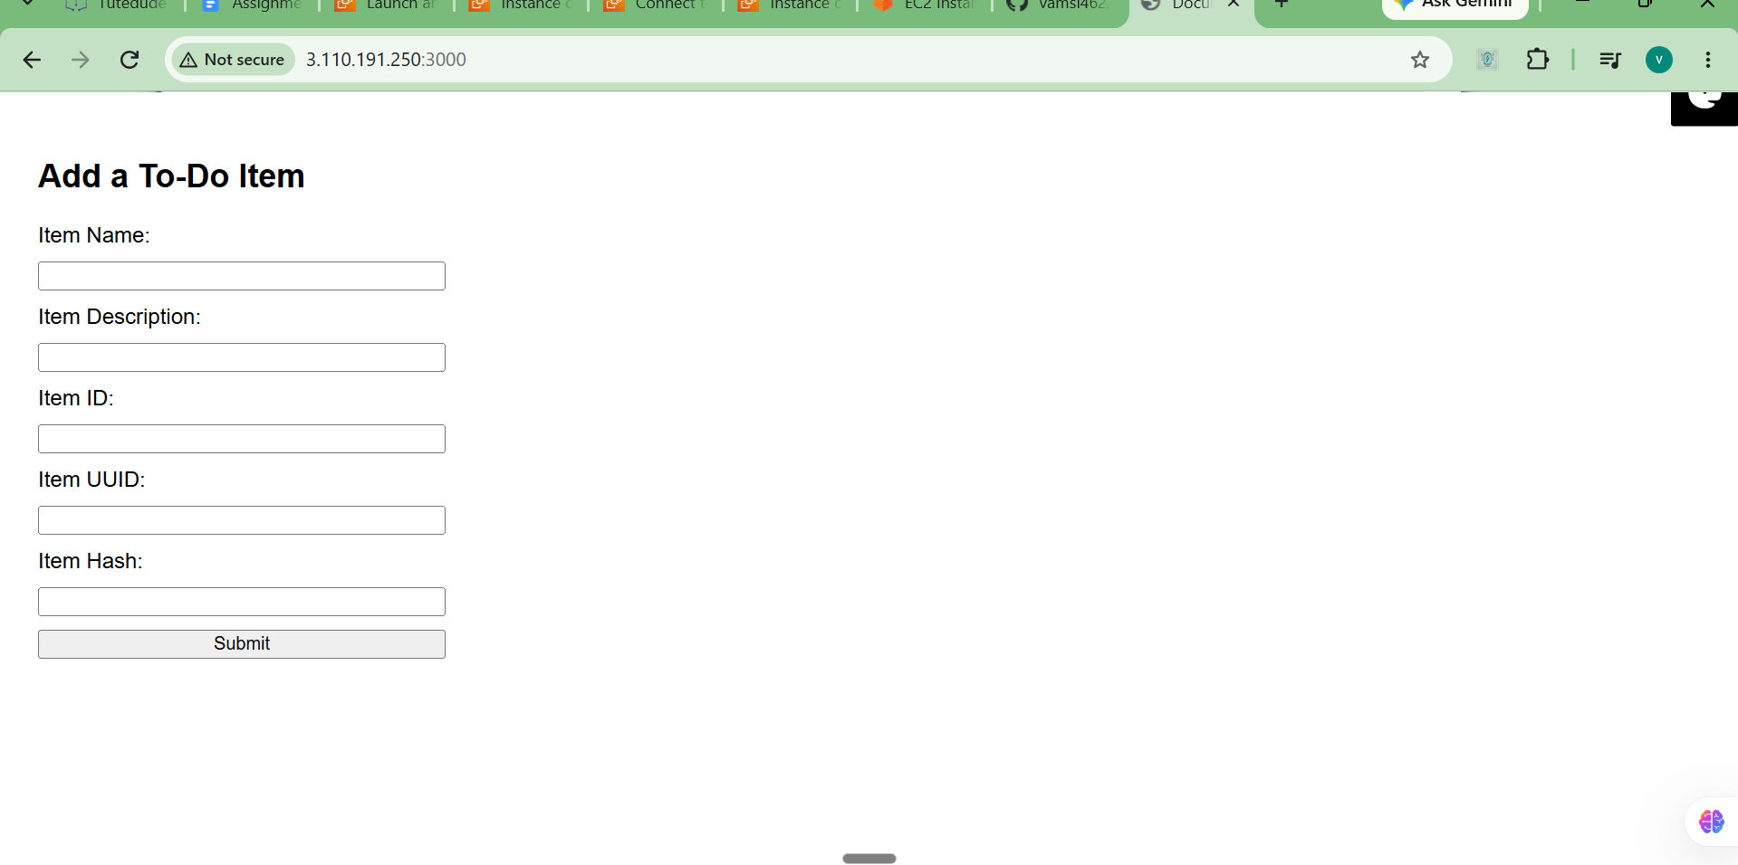
The form submission was successful. The Flask backend received the data and returned a page showing the ID, proving that both the frontend and backend are working together on the single EC2 instance.
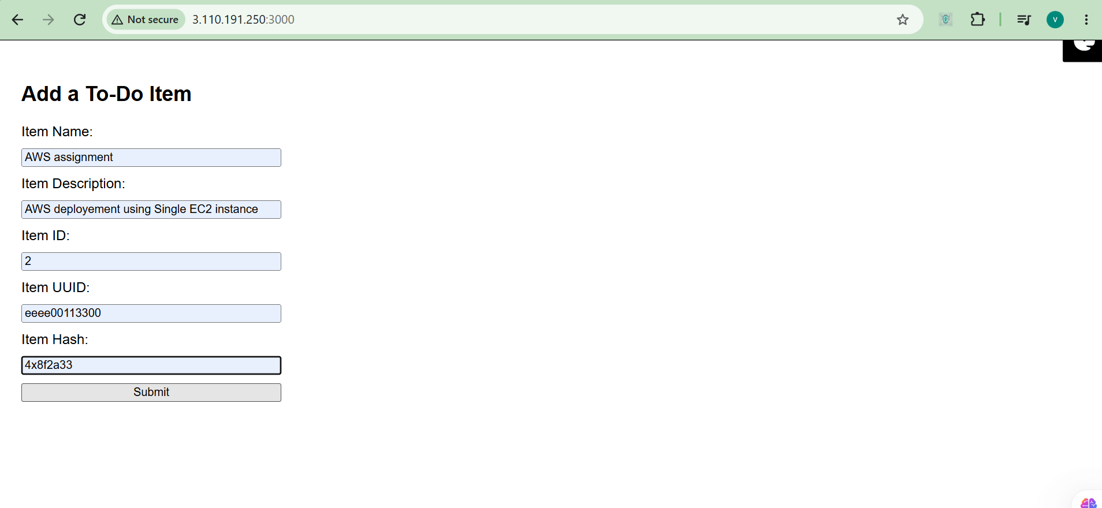
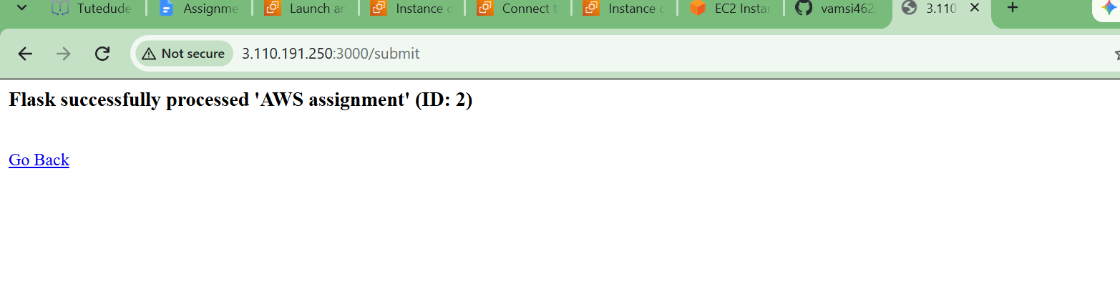

Task 2: Two-Tier Architecture (Separate EC2 Instances)
Stopping the First Server & Launching the New Infrastructure
To start splitting the frontend and backend for the second task, I first stopped my task1-single-ec2 instance in the dashboard so I wouldn't waste my AWS Free Tier hours running extra servers. Once that was off, I launched two new Ubuntu 24.04 t3.micro instances and named them task2-backend-ec2 and task2-frontend-ec2.
For the backend server, I edited the inbound rules to only allow Custom TCP traffic on port 5000. For the frontend server, I made a rule to allow Custom TCP on port 3000.
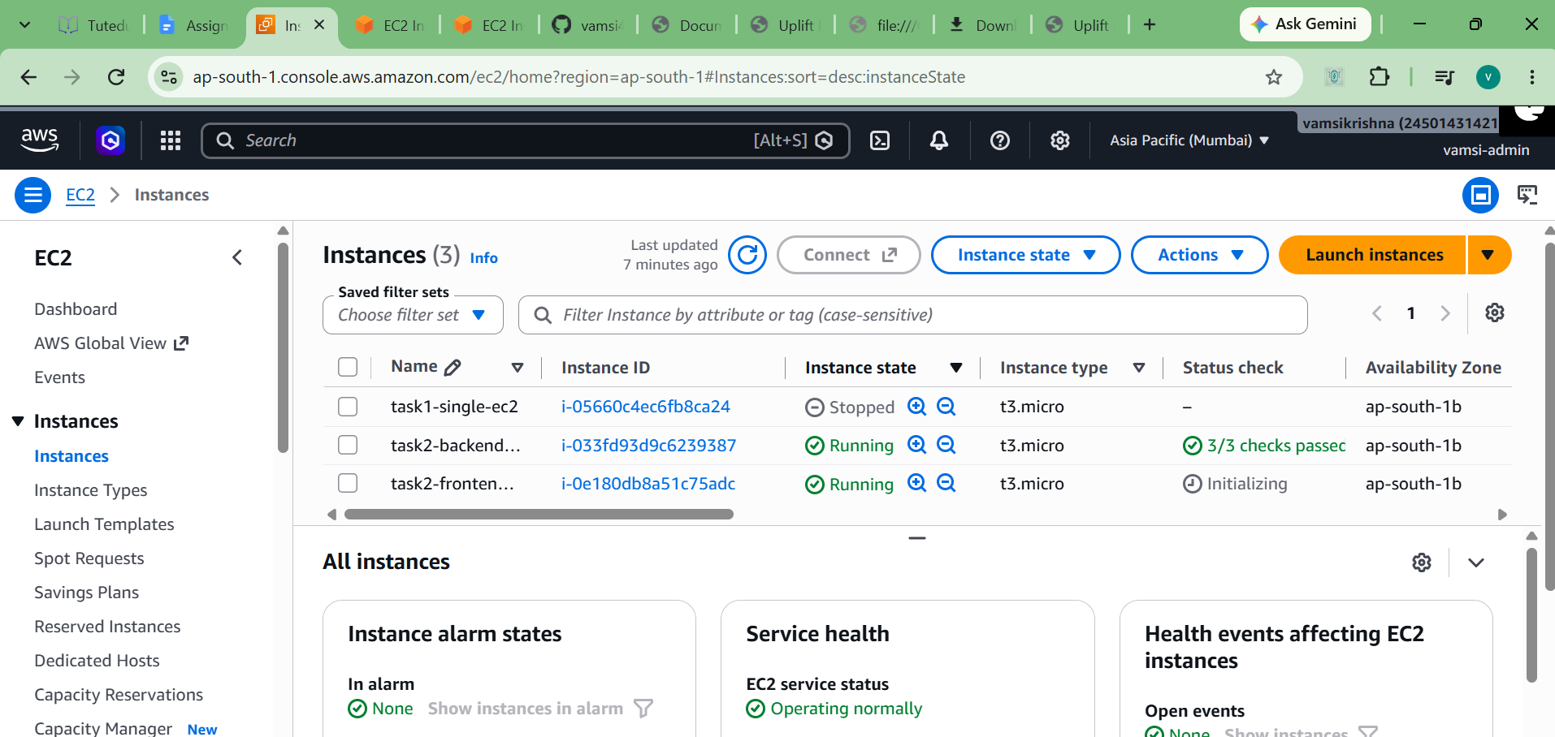

Deploying the Backend First I connected to the task2-backend-ec2 terminal using EC2 Instance Connect. Just like before, I updated the system, installed python3-venv, cloned my git repository, and set up the virtual environment. I ran pip install -r requirements.txt and then started the server in the background using nohup python3 app.py > backend.log 2>&1 &.
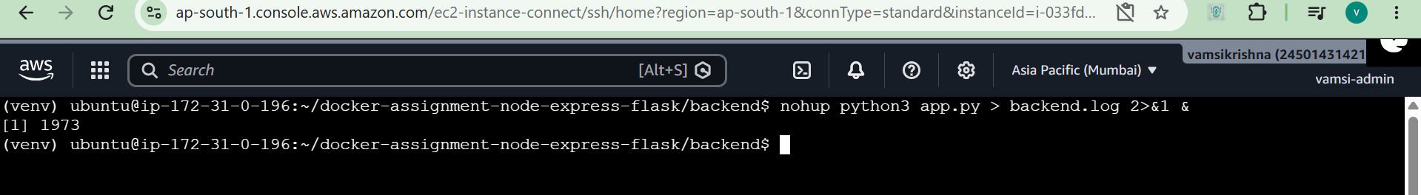
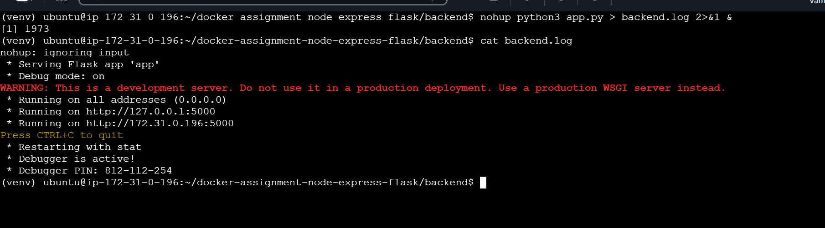

I wanted to know the backend was working completely on its own so I went to http://65.0.61.115:5000/api/data in my browser. It showed a "Method Not Allowed" error, which actually meant it was working—it just blocks standard browser views because it only accepts POST requests! So, I used Postman. I sent a POST request to the backend IP with a JSON body containing a test item name, description, ID, UUID, and hash. It successfully returned a 200 OK status with the success message from Flask.

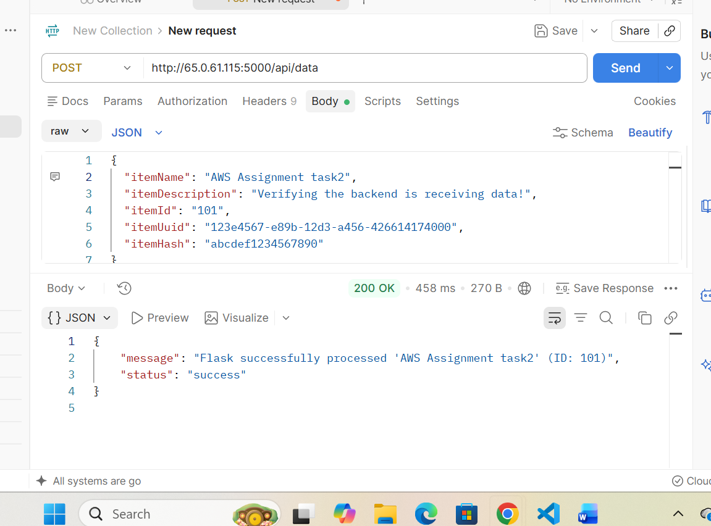

Now that the backend was ready, I connected to the task2-frontend-ec2 terminal. I installed Node.js and NPM, cloned the code, and ran npm install. The most important step here was linking them together. Instead of pointing the frontend to localhost, I exported the backend's public IP address as an environment variable by running: export BACKEND_URL=http://65.0.61.115:5000/api/data. Then I started the frontend with nohup node server.js > frontend.log 2>&1 &.
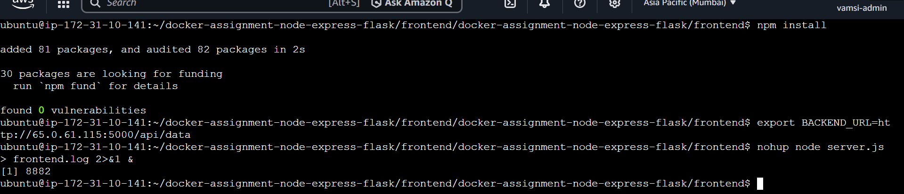

I opened a browser and went to my frontend server's public IP http://15.252.243.208:3000. The web form loaded perfectly. I submitted a test task, and it returned the Flask success message with ID: 5. This proves that the Node.js frontend successfully routed my web request across the internet to the Python Flask backend. 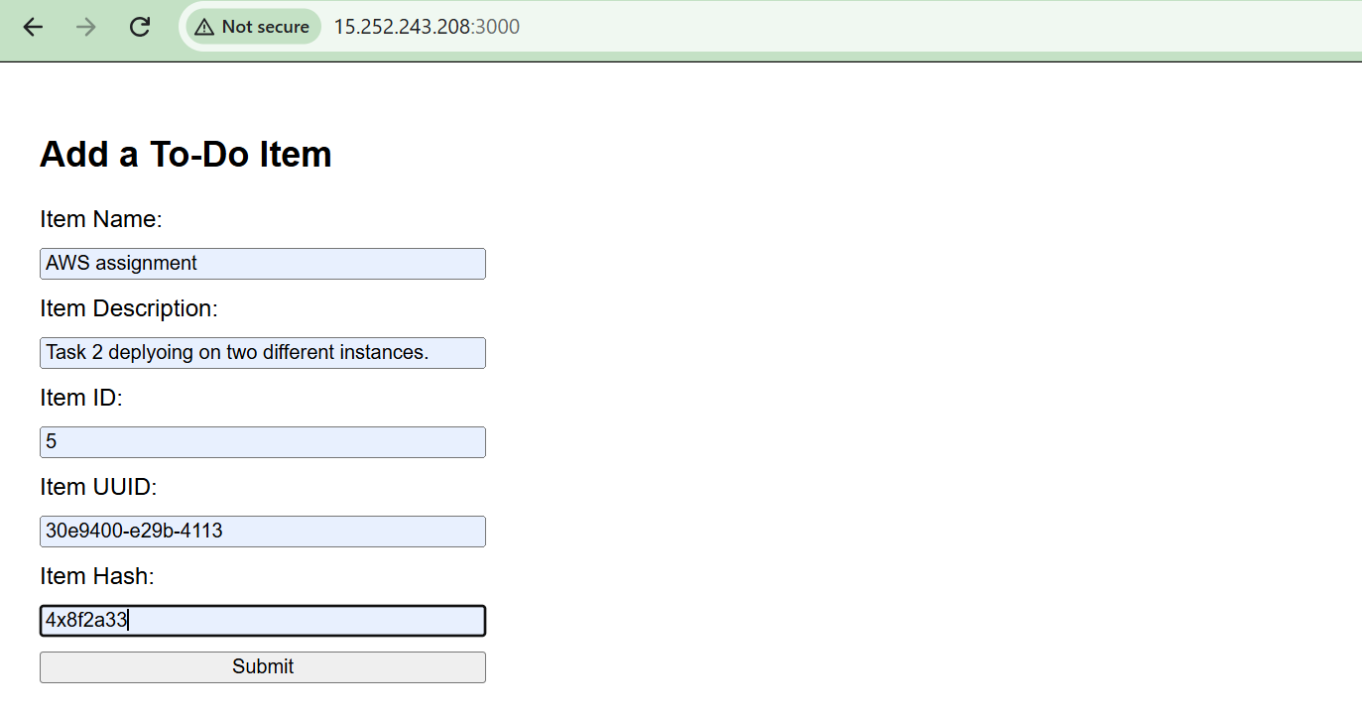
x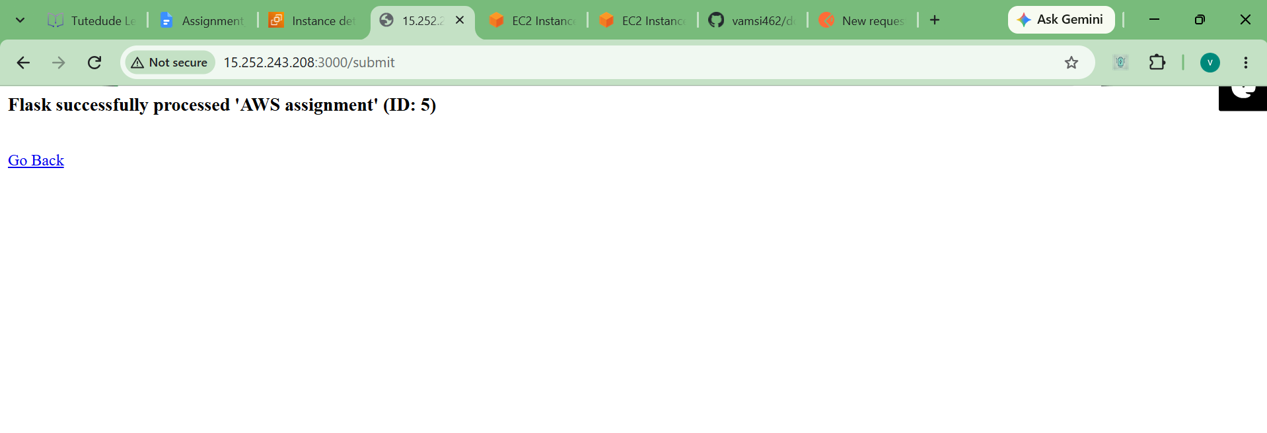

Task 3: Deploying with Docker, ECR, ECS, and Custom VPC
Step 1: Setting up ECR and the Build Server First, I went to Amazon ECR and created two private repositories named express-frontend and flask-backend to store my container images.
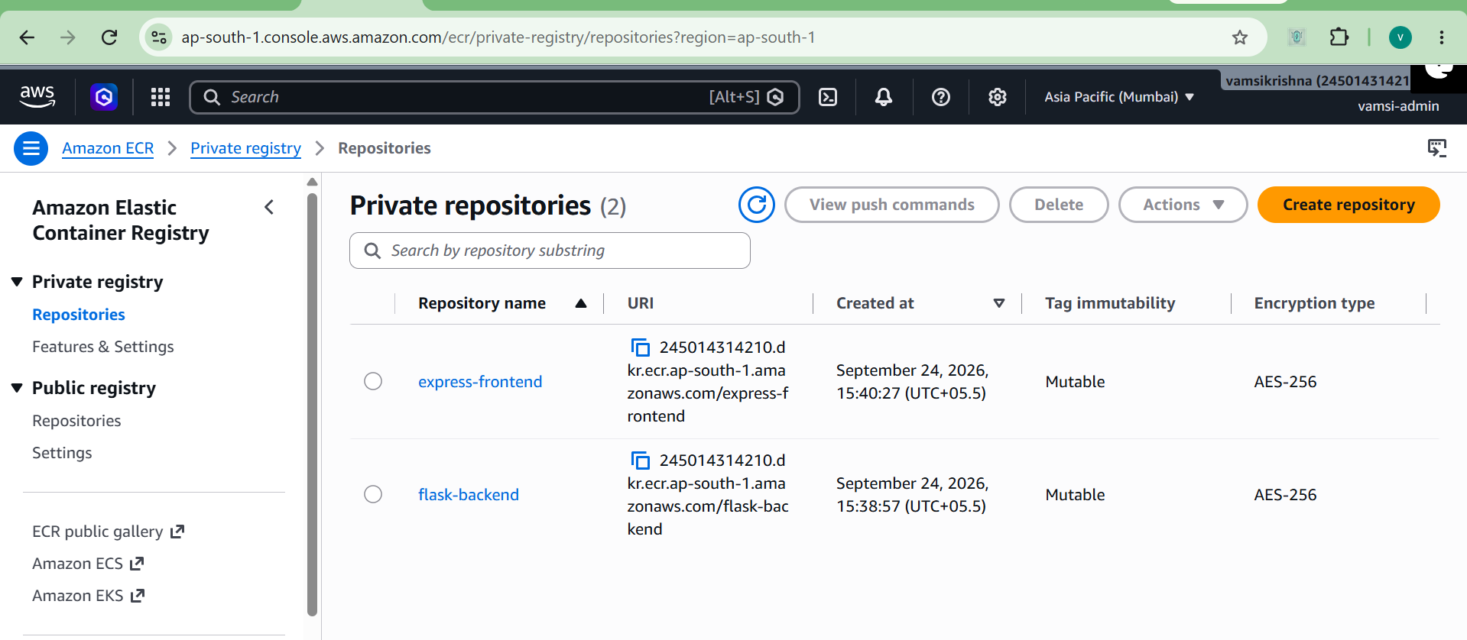

Next, I connected to my EC2 instance to use it as a build server. I installed Docker and unzip. Then, I manually downloaded and installed the AWS CLI so I could push images to my AWS account. Finally, I configured my AWS credentials using aws configure.
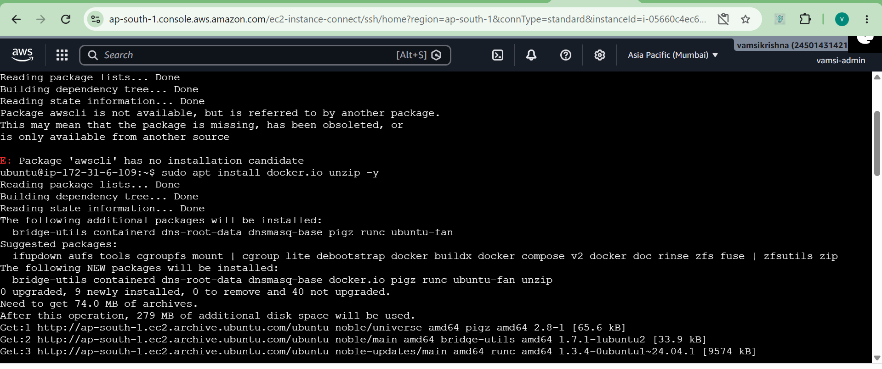
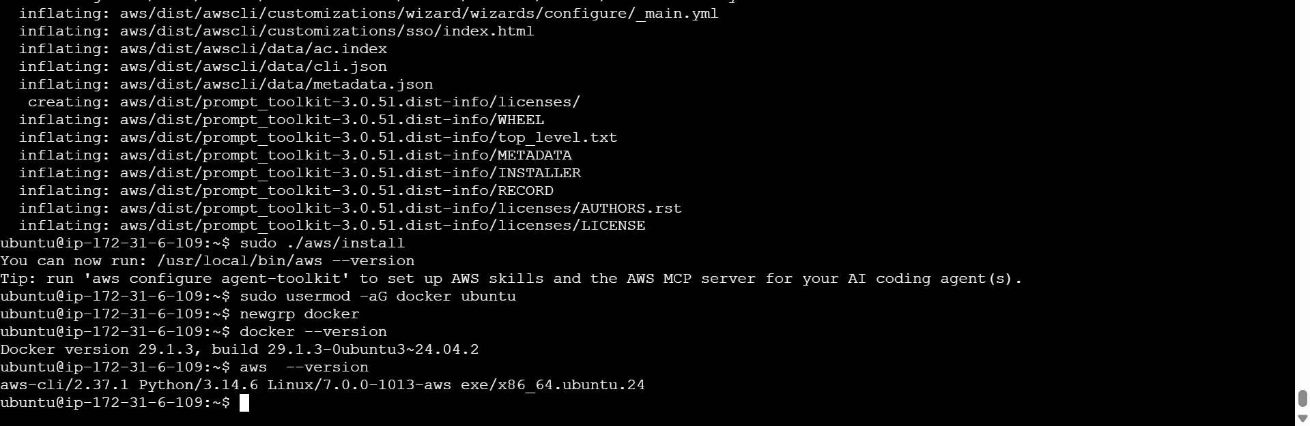
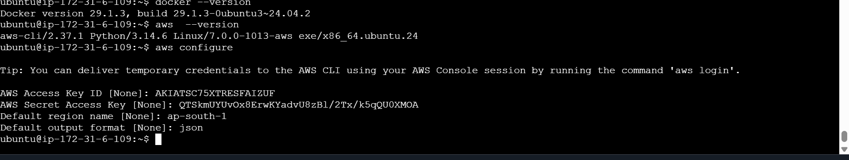

Step 2: Building and Pushing Docker Images I went into the backend folder, built the Docker image, tagged it with my ECR repository URL, and pushed it to AWS.
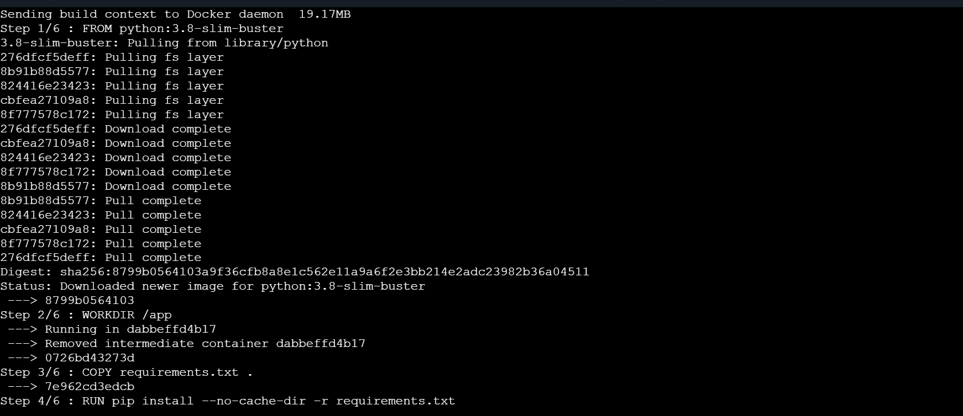
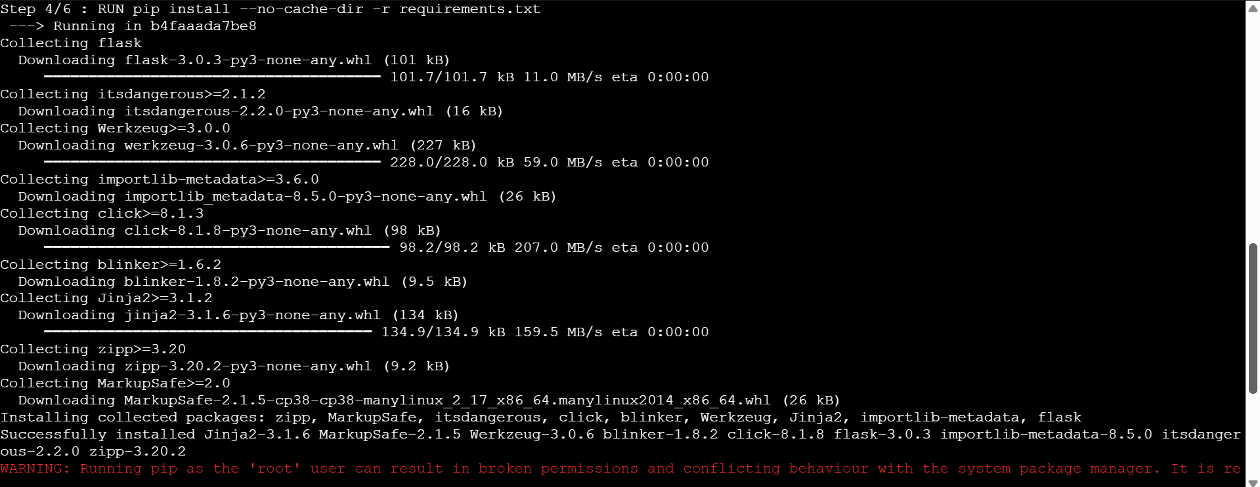
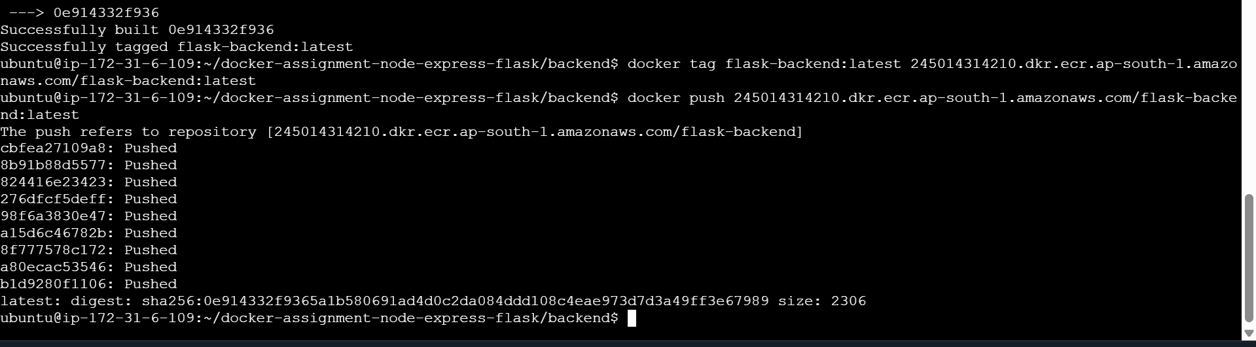
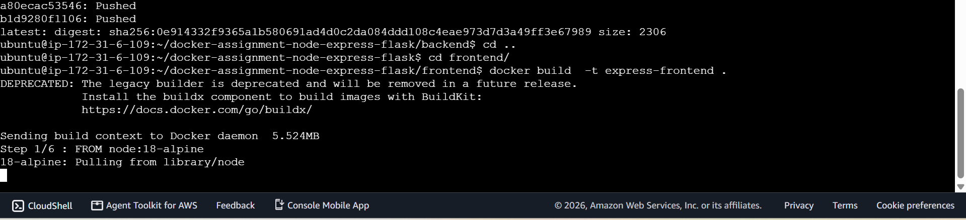
I repeated the exact same process for the frontend folder.
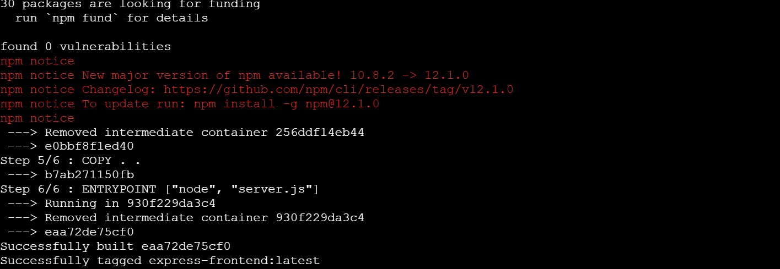
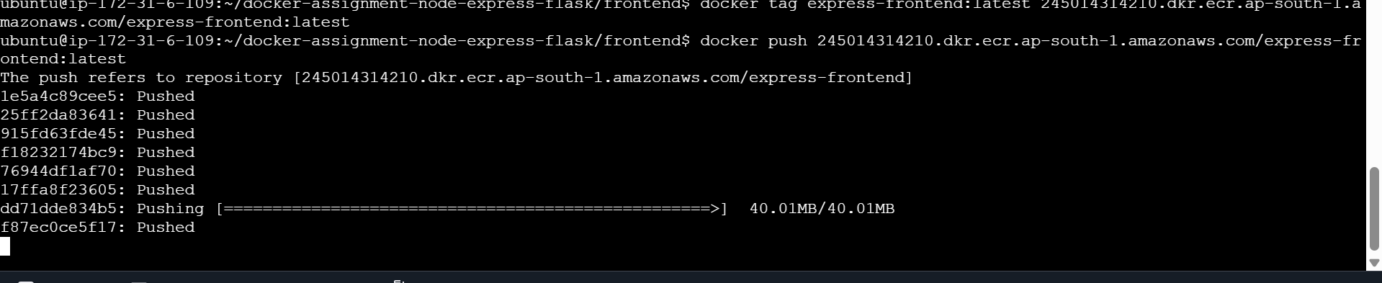
I checked my ECR dashboard to confirm both images were successfully uploaded with their image sizes.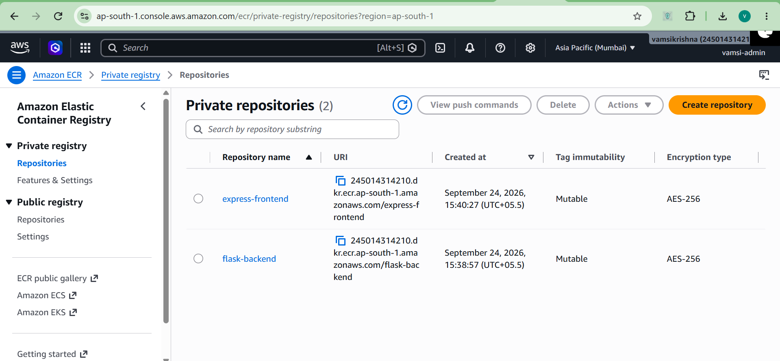
Step 3: Local Docker Testing Before moving to ECS, I tested the containers locally on my EC2 instance using the docker run command. I started the backend on port 5000 and the frontend on port 3000. When I first submitted the form in my browser, I got an error on the screen saying "Frontend works and request was sent! (Flask is offline)."
I realized Docker containers are isolated from each other. The frontend container didn't know where the backend was. To fix this, I stopped the frontend container and ran it again, but this time I used the -e flag to pass the actual EC2 Public IP address to the BACKEND_URL environment variable. After doing that, the form submitted perfectly and returned ID: 7
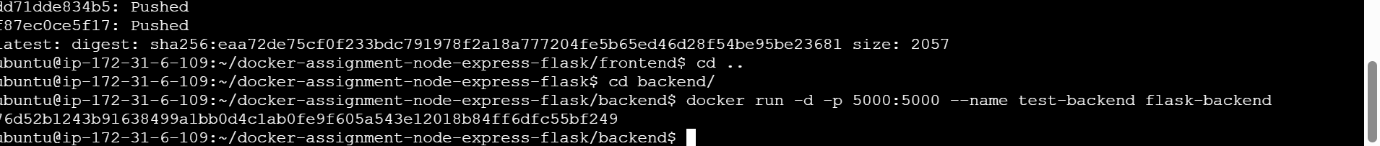
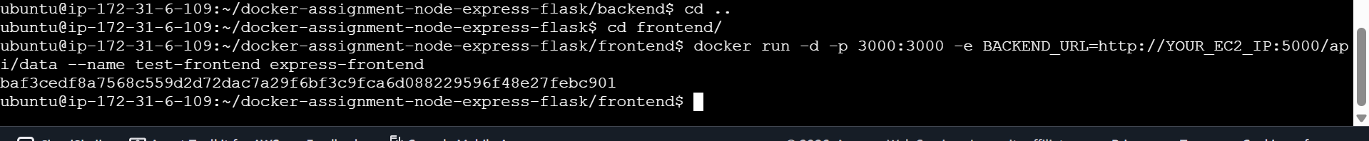
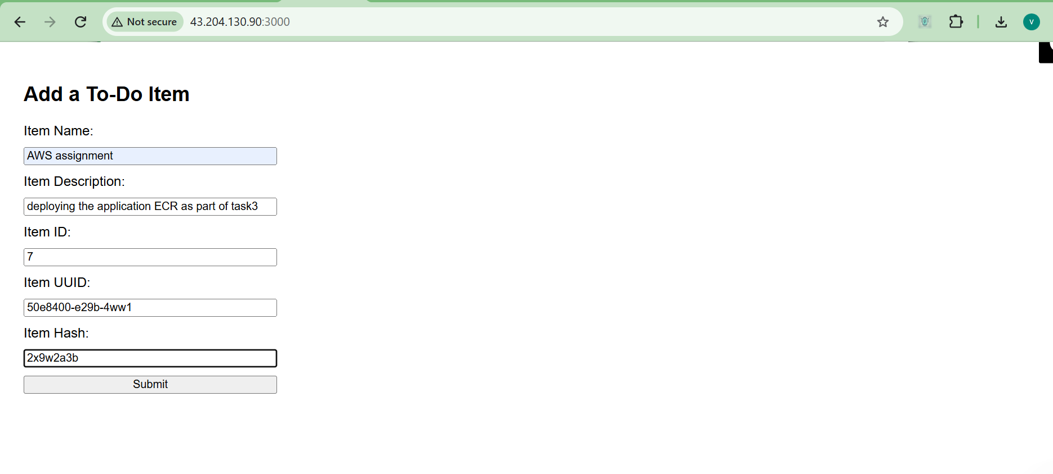
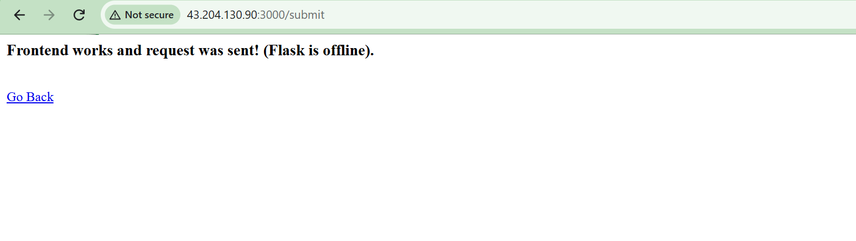
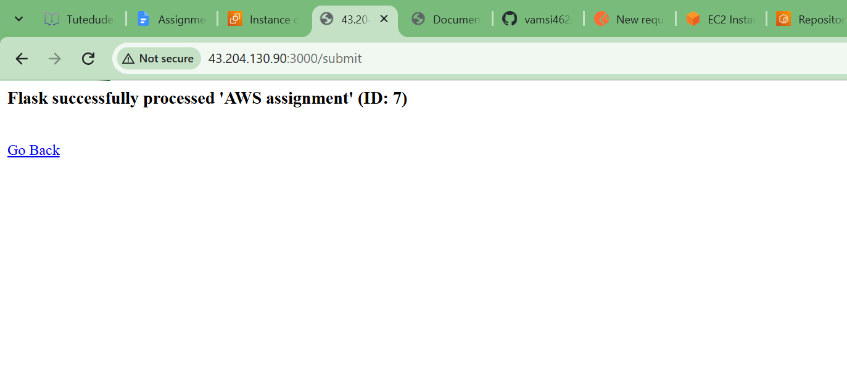
Step 4: Creating the ECS Cluster and Running Tasks Following standard AWS deployment steps, I went to Amazon ECS and created a new Fargate (serverless) cluster named task3-cluster.
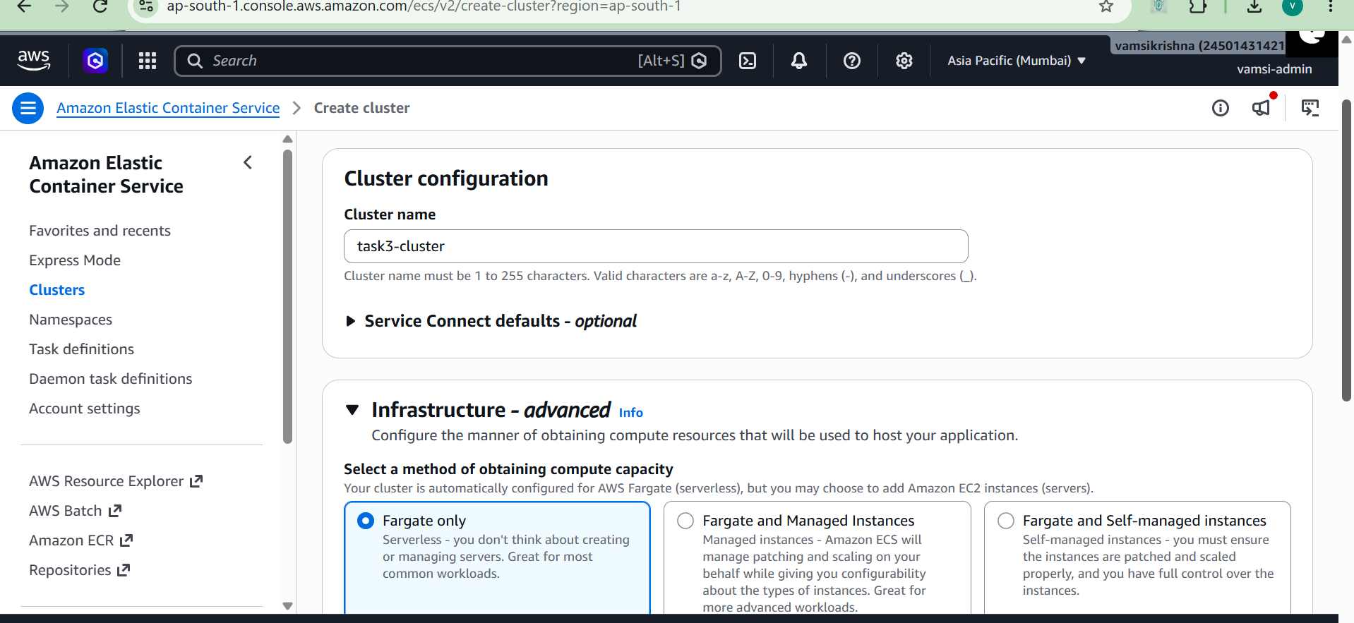
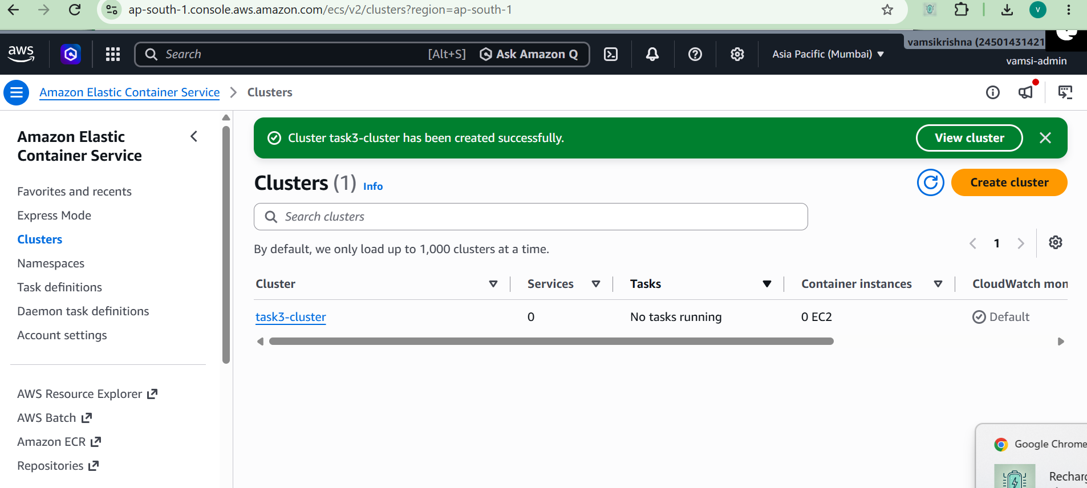

I created a Task Definition for the flask-backend-task using the image URI from ECR. Then, I deployed it to my cluster and waited for the status to show as "Running".
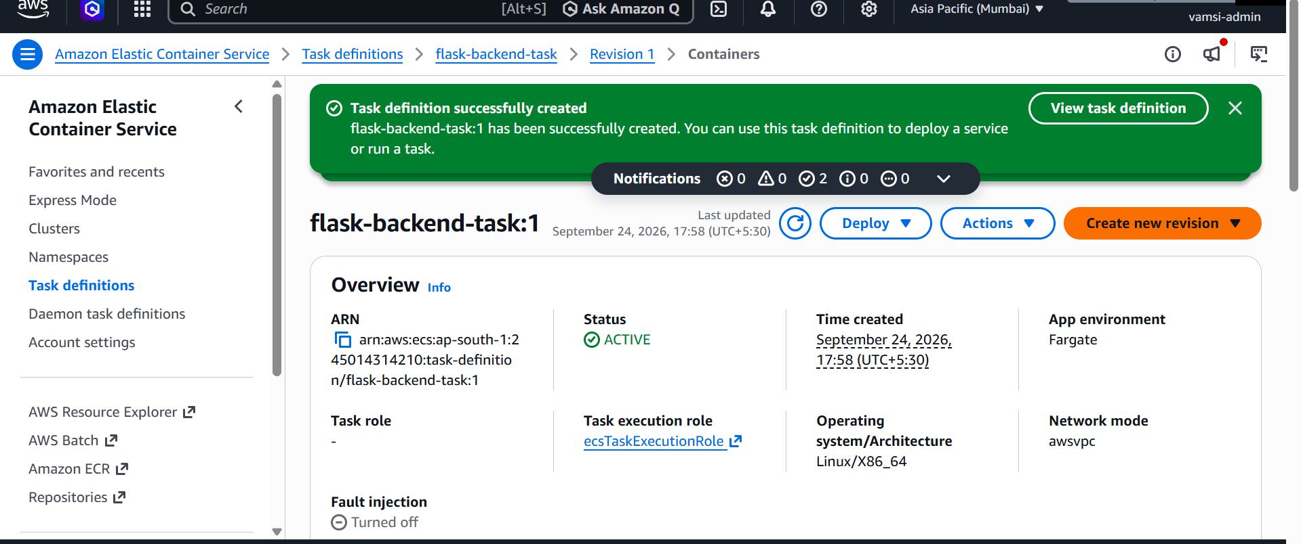
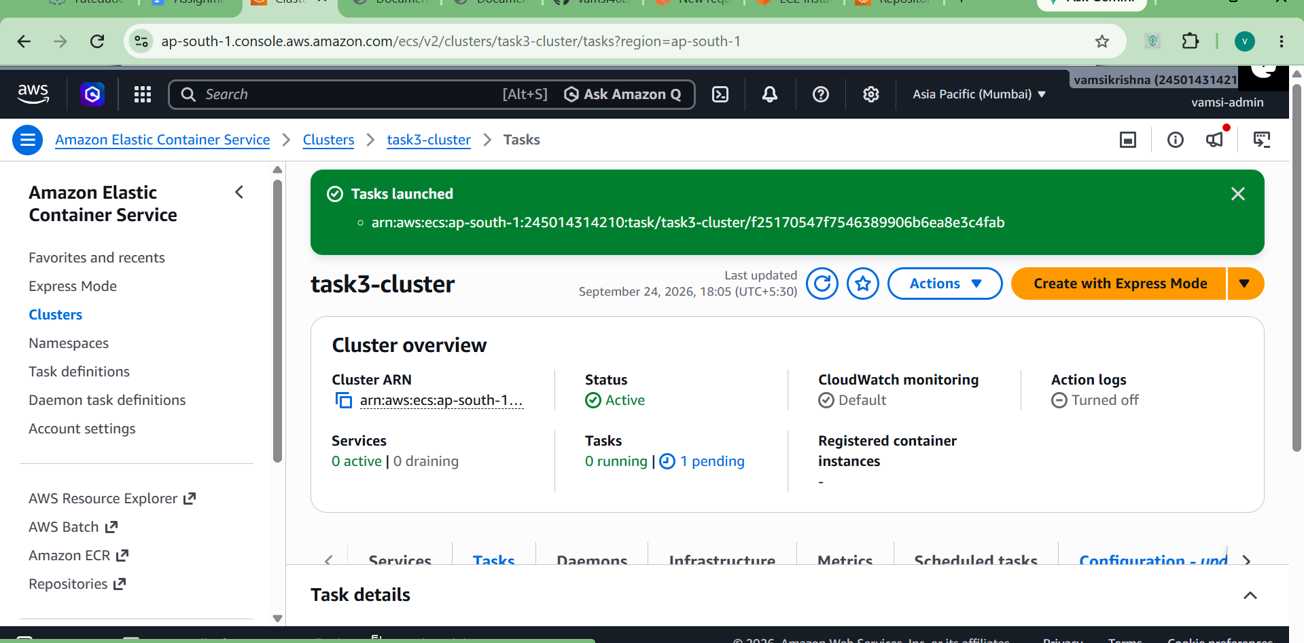
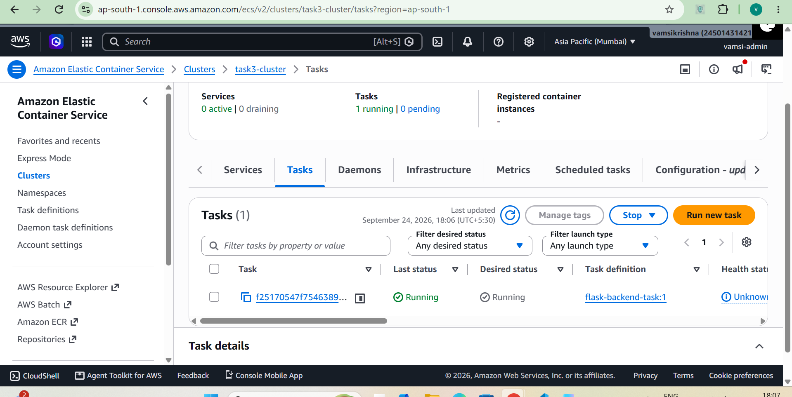
Next, I created the Task Definition for the express-frontend-task. I made sure to add the BACKEND_URL environment variable pointing to the backend's public IP. I deployed it, and soon both tasks were running
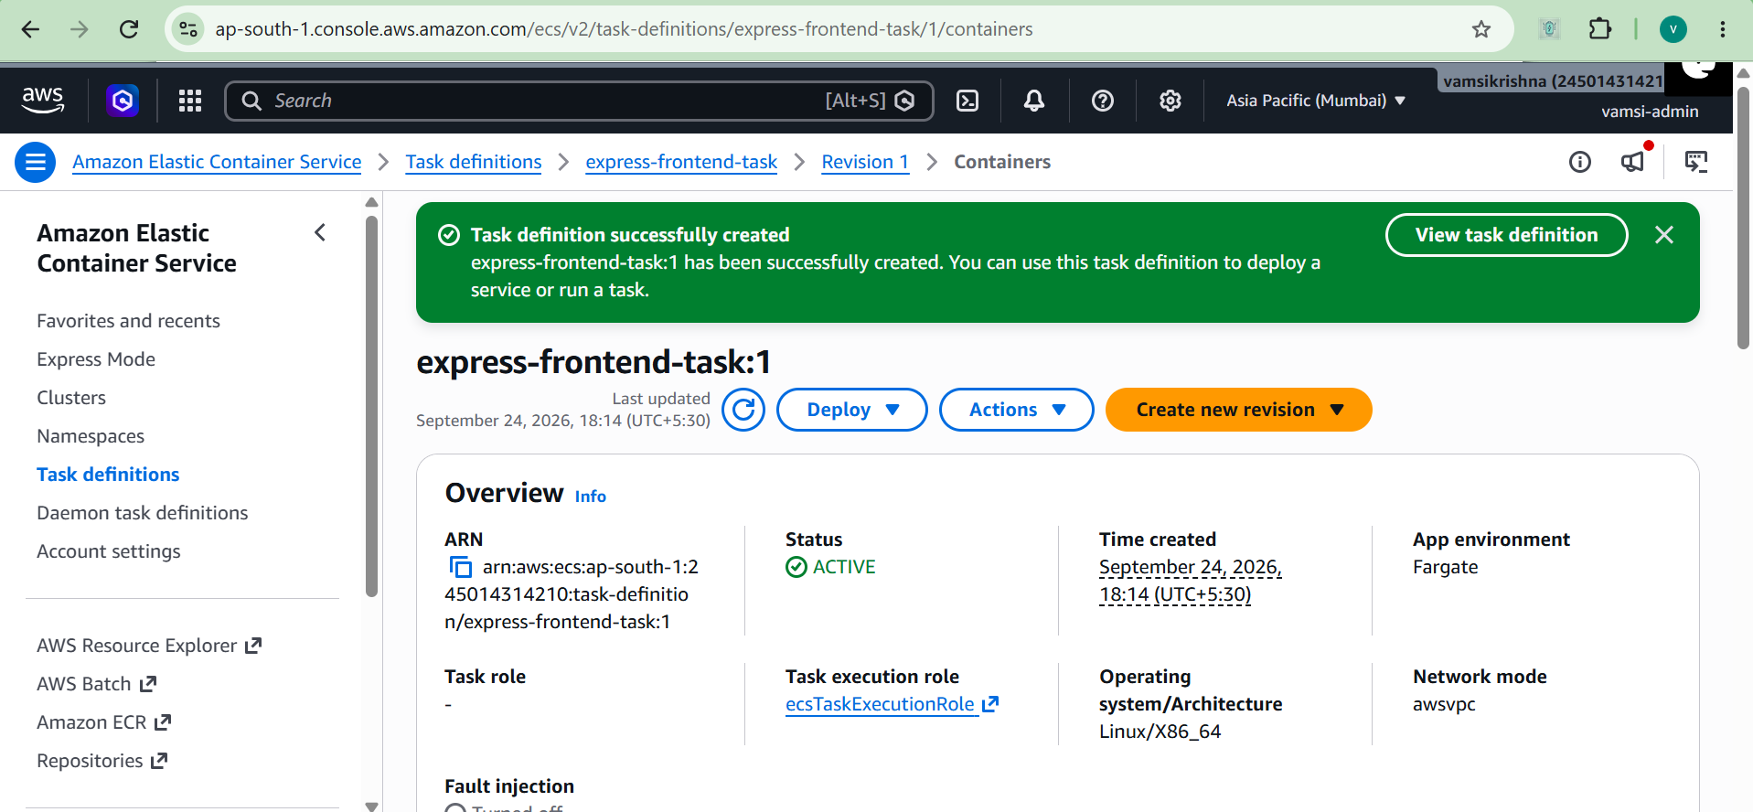
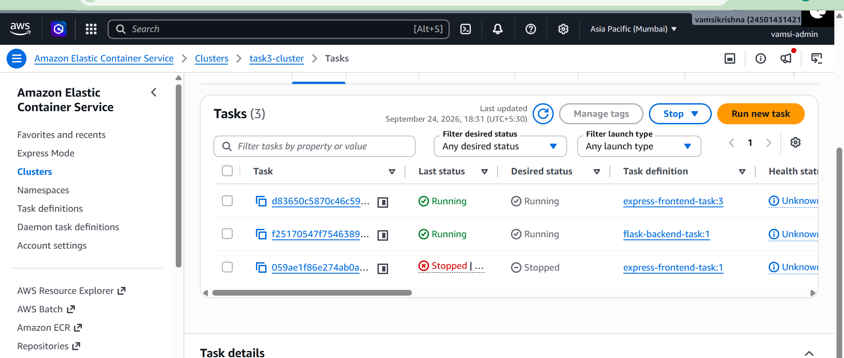
I tested the frontend's public IP in my browser, and it successfully connected to the backend, giving me ID: 9. 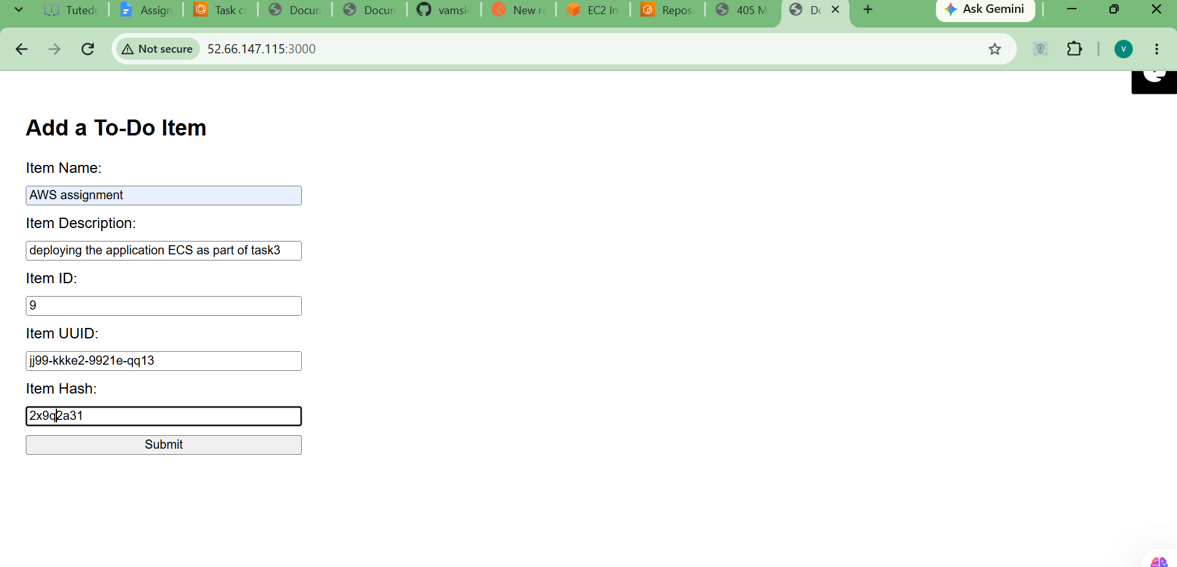
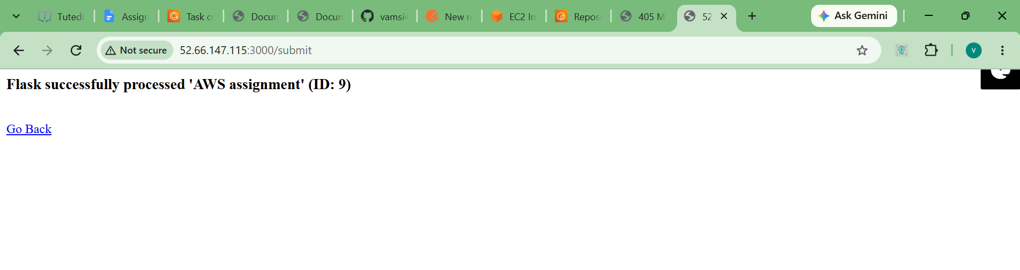
Step 5: Deploying into a Custom VPC The final requirement was to use a custom VPC. I went to the VPC dashboard and created a new one called task3-custom-vpc using the "VPC and more" option so it would automatically create the internet gateway and route tables. 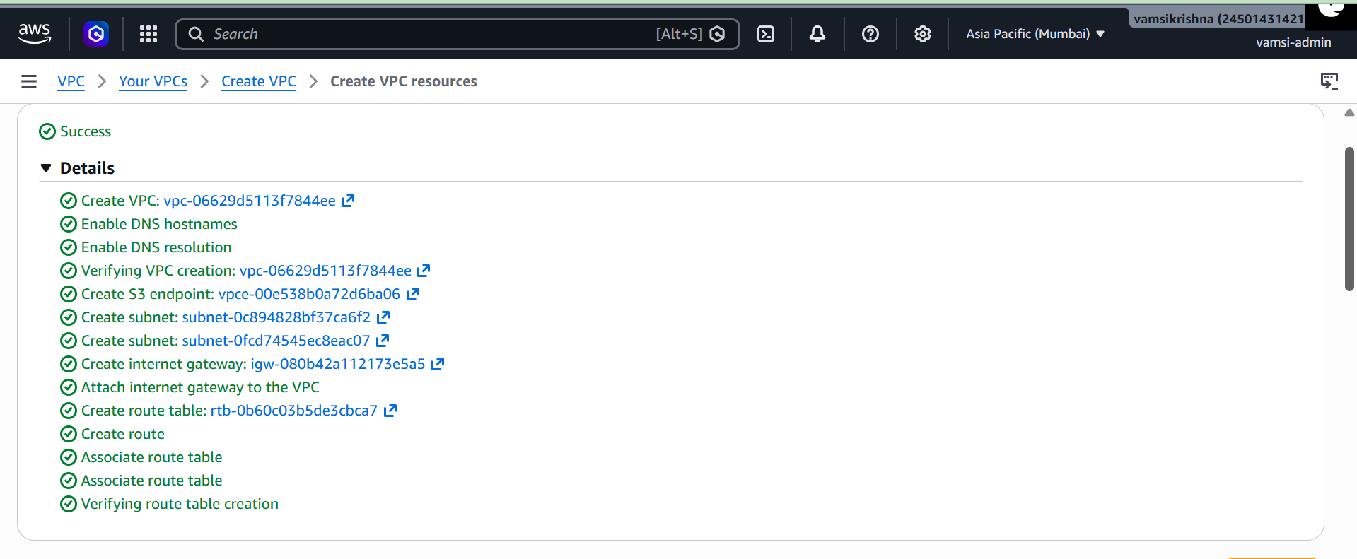
I launched a new backend task, but this time in the Network settings, I selected my new task3-custom-vpc instead of the default one.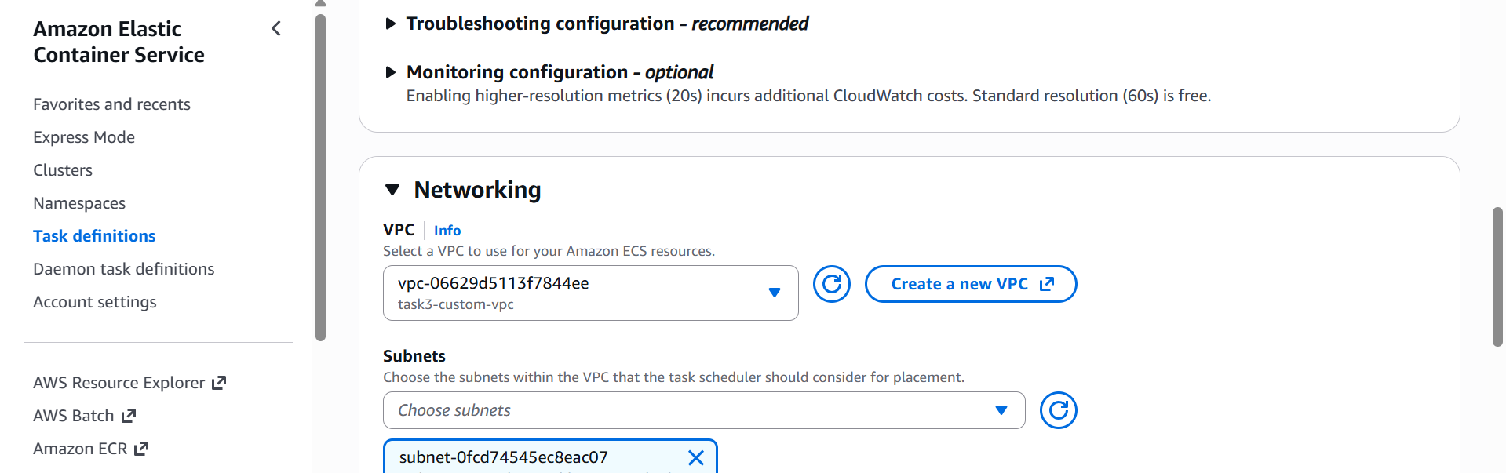
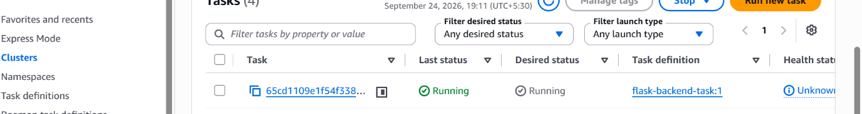
Once the new backend was running, I copied its IP address. I went to my frontend task definition, created a new revision, and updated the BACKEND_URL to match the new IP.

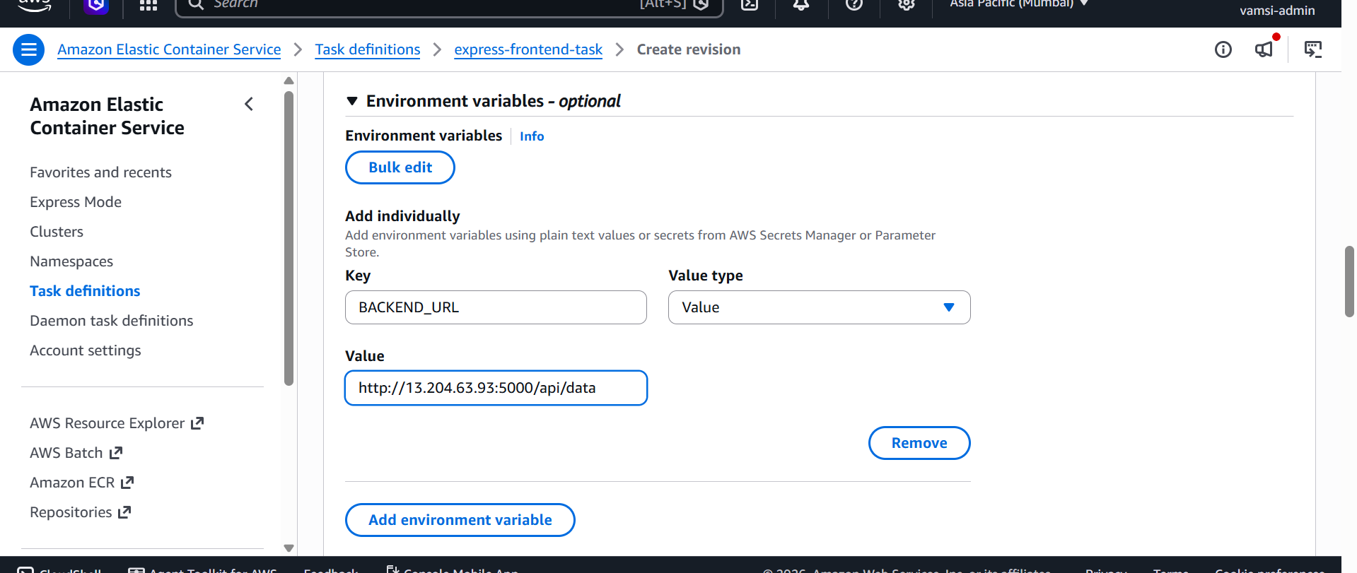

I launched the frontend task into the same task3-custom-vpc. Once everything was running, I did one final test in the browser. It worked perfectly and returned ID: 11, proving the two-tier architecture works inside a custom VPC.
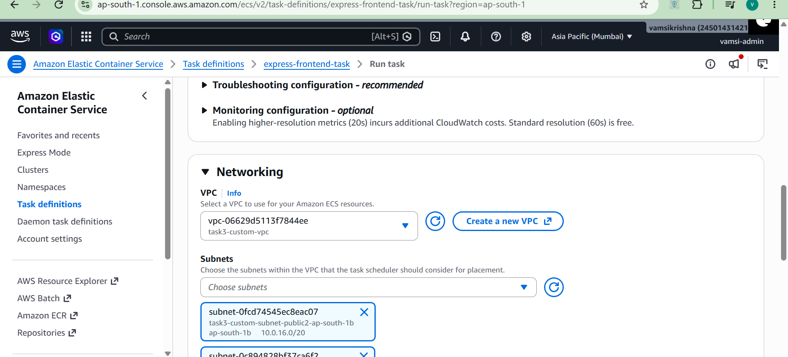

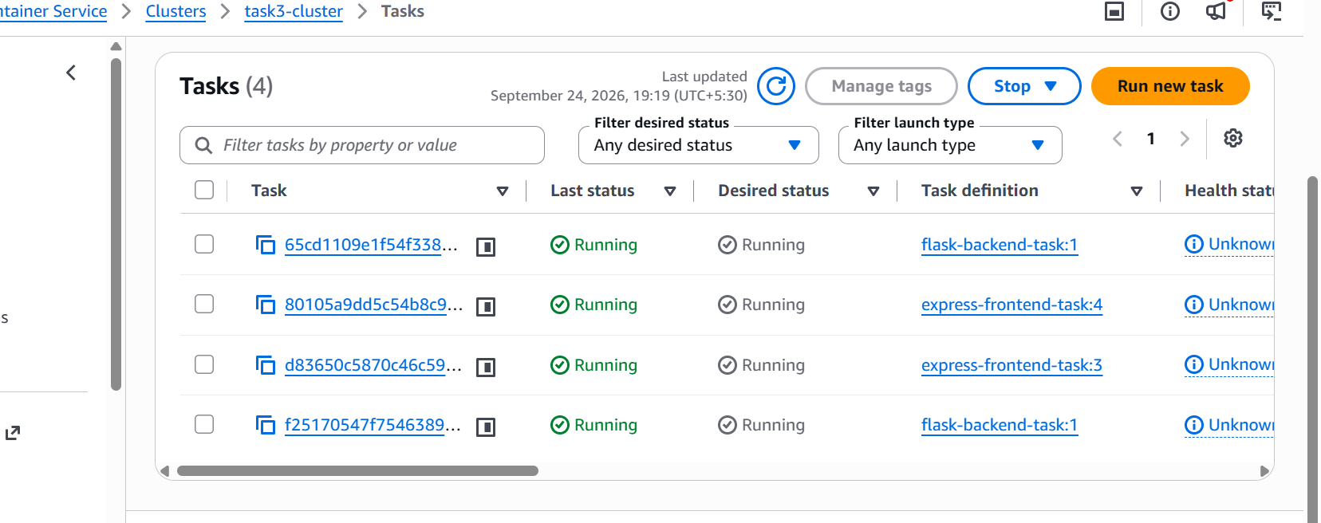
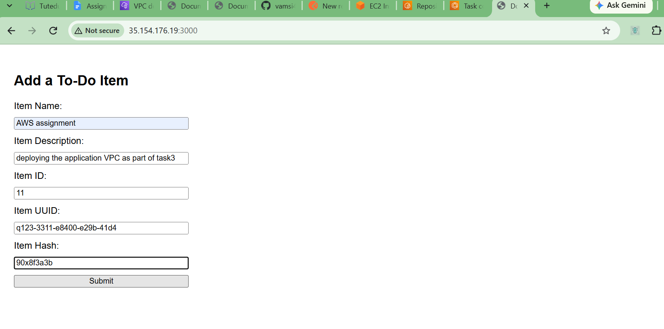
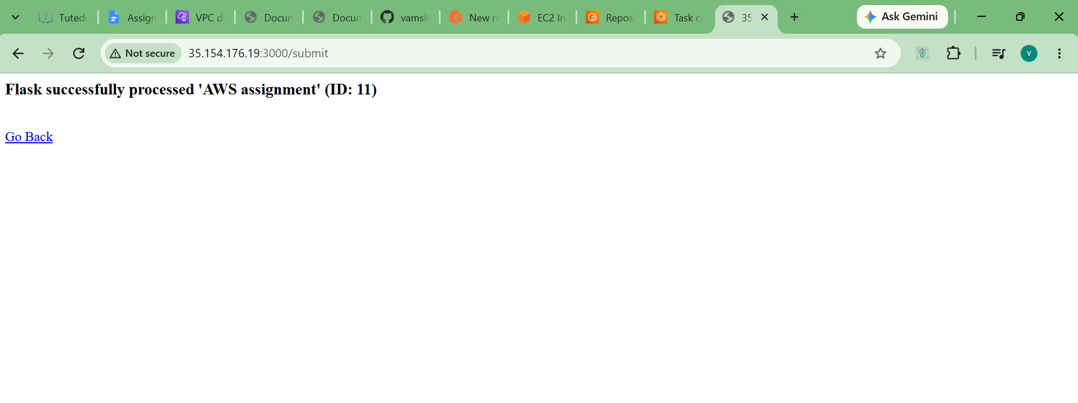

Learnings

What I learned:
- I learned how Docker replaces manually installing software. Packaging the code into images made it much easier to deploy.
- I learned how to use AWS Fargate. It is completely serverless, meaning I did not have to manage EC2 instances to run my containers.
- I learned how VPC networking connects resources. Creating the custom VPC showed me how subnets and security groups control traffic between the internet and my containers.
Errors I faced and how I fixed them:
- AWS CLI Install Error: When I tried to run sudo apt install awscli, Ubuntu said there was no installation candidate. I fixed this by downloading the official zip file directly from AWS using the curl command and running their install script.
- Local Docker Container Communication (Flask is offline): When testing the containers locally on the EC2 instance, the frontend could not reach the backend and showed a "Flask is offline" message. I learned that containers are isolated by default. I fixed it by explicitly passing the correct EC2 public IP into the frontend container using the -e BACKEND_URL=http://YOUR_EC2_IP:5000/api/data flag.
- ECS Task Stopped Error: My frontend container kept crashing right after starting on ECS. I checked the logs and saw a "failed to normalize image reference" error. I realized I accidentally left https:// at the start of my ECR image link. I removed it, saved a new revision, and it worked.

