Date:27/08/2022

C++ programs

1.addition of two numbers.

Code:

#include<iostream>

using namespace std;

int main()

{

int x=5,y=5;

cout<<x+y;

}

Output:

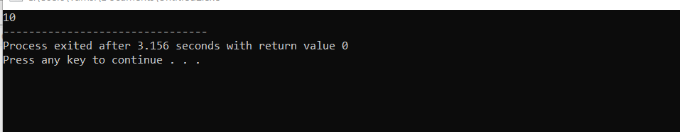

Date:29/08/2022

2.age eligible for voting.

Code:

#include<iostream>

using namespace std;

int main()

{

int age;

cin>>age;

if(age>=18)

{cout<<"eligible";}

else

{cout<<"not";}

}

Output:

18

eligible

--------------------------------

Process exited after 22.13 seconds with return value 0

Press any key to continue . . .

3.switch case:

Code:

#include<iostream>

using namespace std;

float r;

{

cout<<"enter radius";

}

cin>>r;

int exp;

cout>>"enter choice(1)";

cin>>exp;

switch(exp)

{

case 1:

{

cout<<"area of circle"<<3.14\*r\*r;

break;

}

case 2:

{

cout<<"circumference of circle"<<2\*3.14\*r;

break;

}

default:

{

cout<<"enter corret radius value";

break;

}

}

}

Output:

enter radius6

31

4.even or odd number

Code:

#include<iostream>

using namespace std;

int main()

{

int a;

cin>>a;

if(a%2==0)

{

cout<<"even";

}

else

{

cout<<"odd";

}

}

Output:

6

Even