**DATA SCIENCE TOOLBOX: PYTHON PROGRAMMING**

**PROJECT REPORT**

**A Data-Driven Study on Student Mental Health**

Submitted by: Naga Siva Manikanta Sai Vamsi Neerukonda

Registration No:12308365

Section: K23GD

Course Code: INT 375

Under the Guidance of: **Baljinder Kaur (UID:28968)**

Discipline of CSE/IT

Lovely School of Computer Science

Lovely Professional University, Phagwara

---

**CERTIFICATE**

This is to certify that N.sai vamsi, bearing Registration no. 12308365 has completed the INT375 project titled “Unmasking Depression: A Data-Driven Study on Student Mental Health” under my guidance and supervision. To the best of my knowledge, the present work is the result of his/her original development, effort, and study.

**Baljinder Kaur (UID:28968)**

School of Computer Science and Engineering

Lovely Professional University

Phagwara, Punjab.

**DECLARATION**

I, N.sai vamsi, student of BTech under CSE Discipline at Lovely Professional University, Punjab, hereby declare that all the information furnished in this project report is based on my own intensive work and is genuine.

Signature: N.sai vamsi

Registration No. 12308365

---

**ACKNOWLEDGEMENT**

I would like to express my sincere gratitude to my guide, **Baljinder Kaur mam**, for their invaluable guidance, support, and encouragement throughout the completion of this project. Their expertise and constructive feedback greatly contributed to the success of this work.

I also thank Lovely Professional University for providing such a great opportunity to work on this project in the subject DATA SCIENCE TOOLBOX: PYTHON PROGRAMMING with subject code INT 375, and for offering all the necessary resources.

This project titled “Unmasking Depression: A Data-Driven Study on Student Mental Health” has been a deeply insightful experience.

Name: N.sai vamsi

Section: K23GD

Roll No: 47

Reg no: 12308365

**INTRODUCTION**

This project explores the pressing issue of student depression using real-world data and Python-based analysis. The goal is to uncover key patterns, develop a prediction model, and suggest actionable insights that can help institutions enhance student wellness.

---

**SOURCE OF DATASET**

The dataset titled “student_depression_dataset.csv” includes responses collected from students on various academic, emotional, and social indicators. These features help in identifying possible causes and impacts of depression among students.

---

**DATASET PREPROCESSING**

- Dropped irrelevant columns and duplicate records.  
- Encoded categorical variables using Label Encoding.  
- Converted all inputs to a consistent numeric format.  
- Prepared data for visualization and modeling.

---

**OBJECTIVE-BASED ANALYSIS**

**Identify Key Factors Contributing to Depression:**

Investigate and determine the major factors that lead to depression among students based on the dataset.

**Analyze Correlation Between Academic Performance and Mental Health:**

Examine the relationship between students' academic performance and their mental health status.

**Develop and Evaluate Predictive Models:**

Build predictive models to identify students at risk of depression and assess the models' accuracy and performance.

**Create Visualizations Using Matplotlib and Seaborn:**

Utilize Matplotlib and Seaborn libraries to generate insightful visualizations for better understanding and communication of data patterns.

**Evaluate the Impact of Support Mechanisms:**

Analyze how existing mental health support systems affect the mental well-being of students.

**Provide Recommendations for Improvement:**

Suggest actionable recommendations for enhancing mental health support strategies based on the analysis and findings.

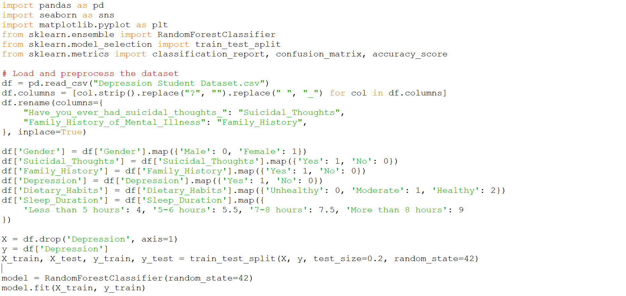

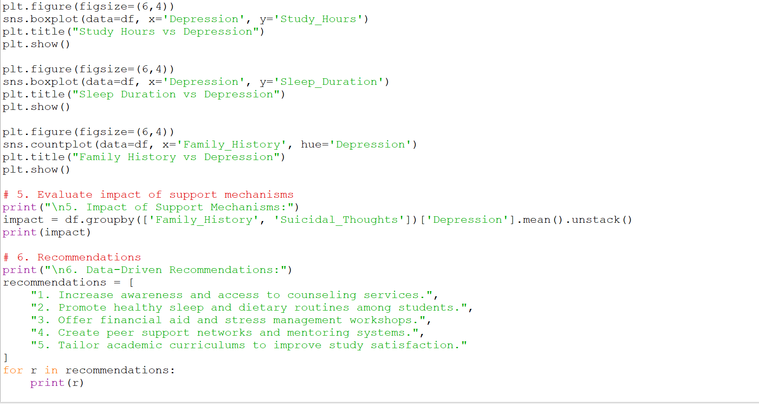

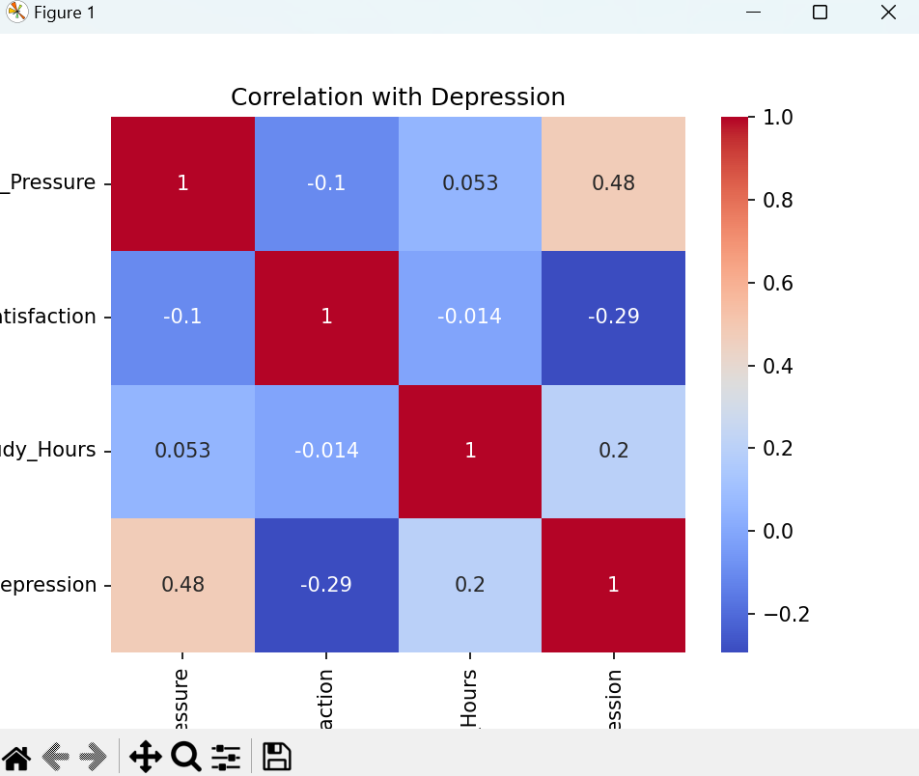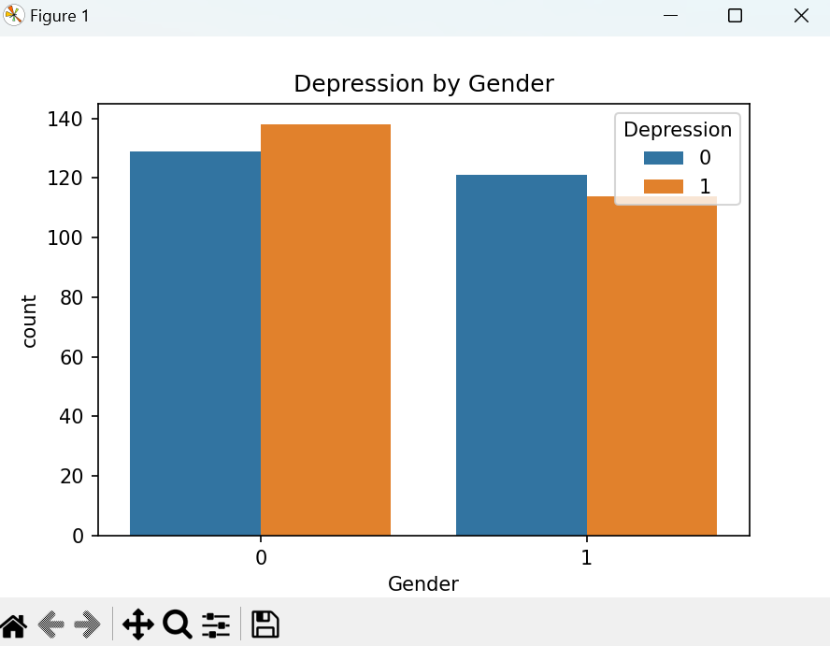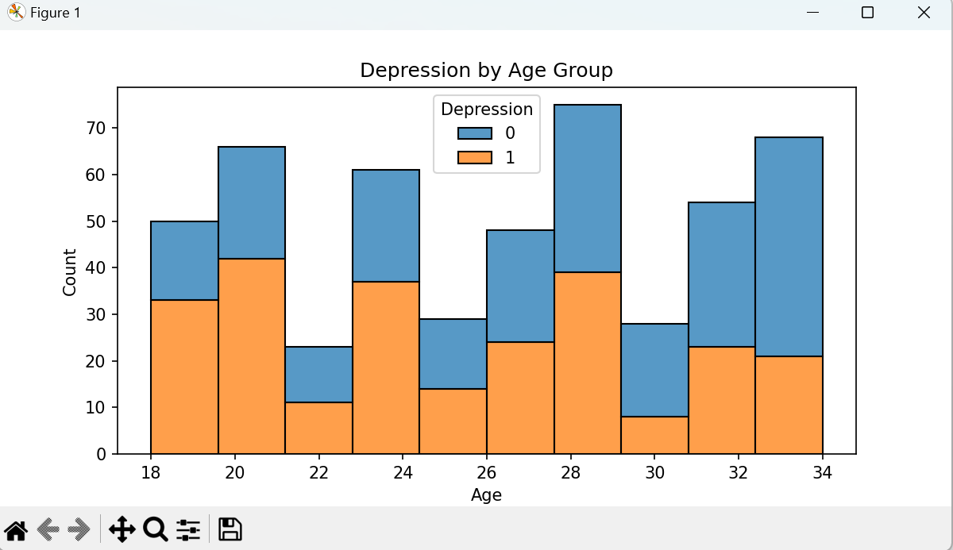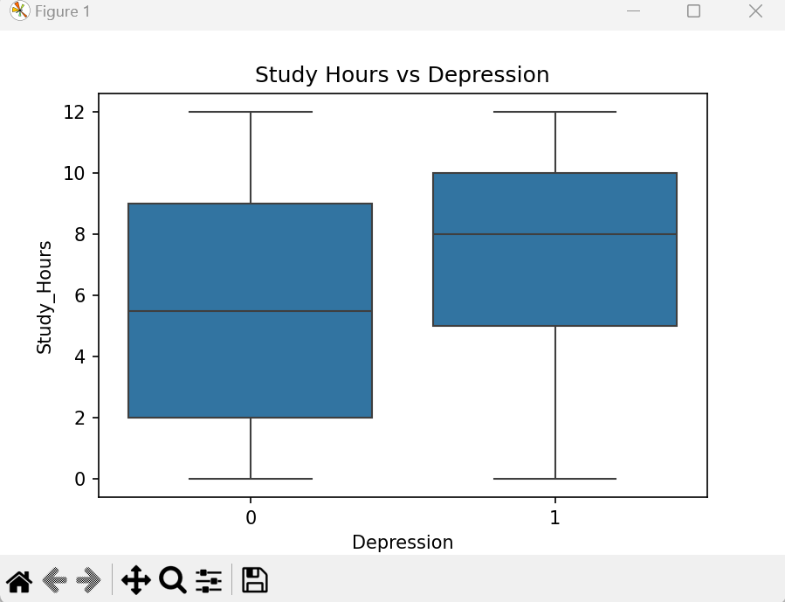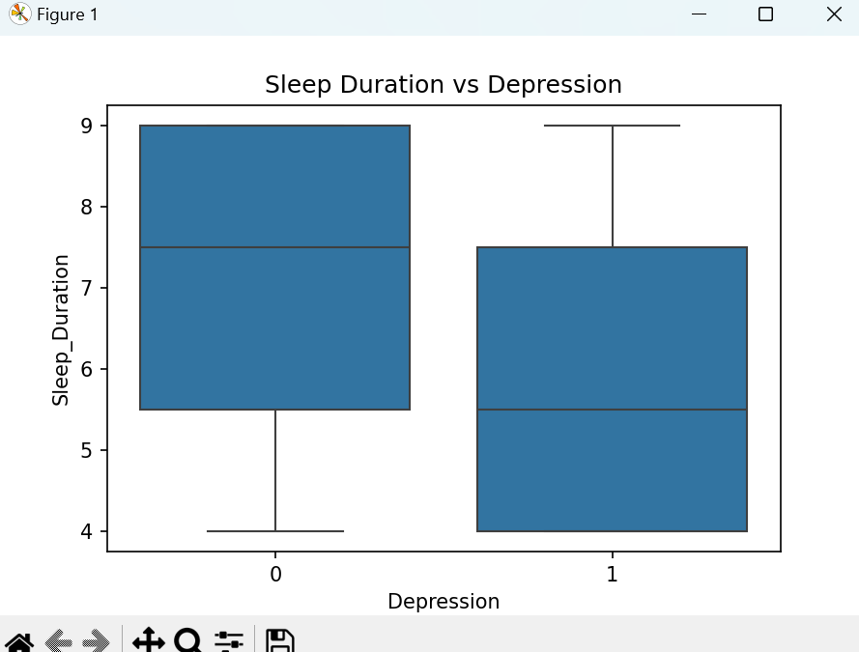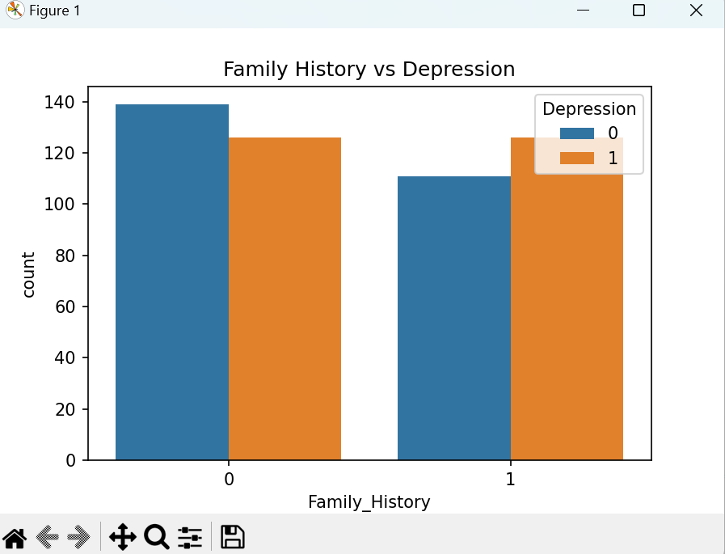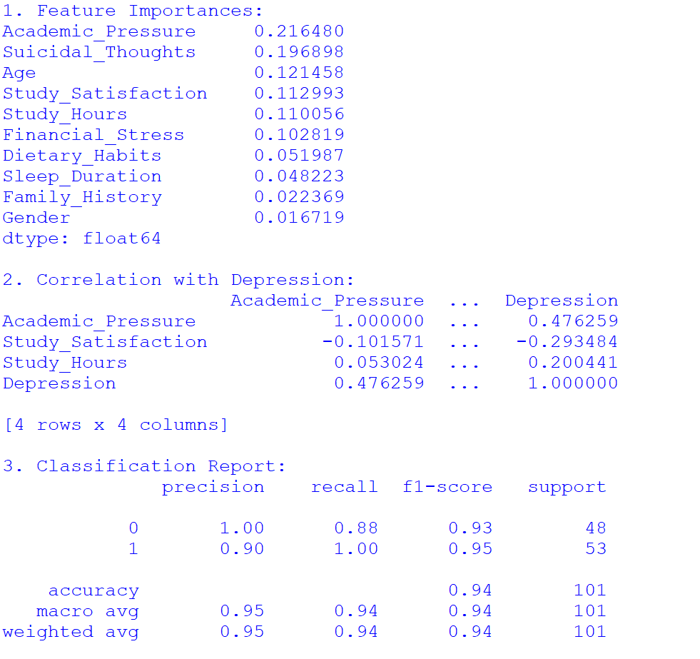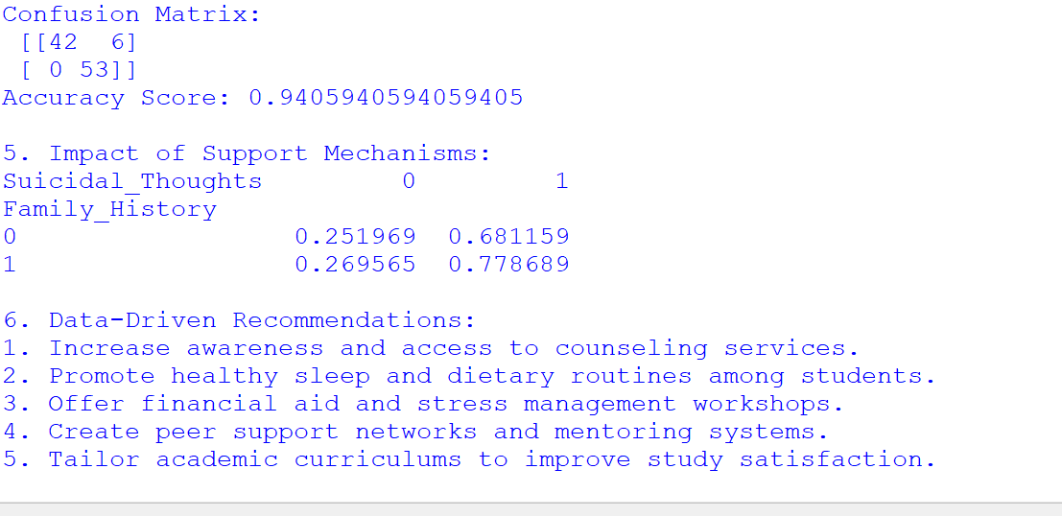

**CONCLUSION**

This analysis revealed deep insights into the mental health challenges faced by students. The correlation and predictive analyses identified academic pressure, suicidal thoughts, and financial stress as major depression indicators. Visualizations reinforced the need for immediate institutional interventions.

Through data-driven insights and machine learning modeling, the project demonstrates how universities can better support student mental health and enhance overall academic outcomes.

---

**FUTURE SCOPE**

- Expand dataset with broader demographic and geographic diversity.  
- Implement advanced models like SVM and deep learning.  
- Integrate real-time analytics for early detection systems in institutions.  
- Partner with mental health professionals to convert insights into action.

---

**REFERENCES**

- Python Libraries Used: Pandas, Seaborn, Matplotlib  
- Dataset Source: student_depression_dataset.csv  
- LinkedIn link : <https://www.linkedin.com/in/1saivamsi/>