**MULTIPLE DISEASE DETECTION (DIABETES, CHRONIC KIDNEY, LEVER DISEASE, BREAST ,SKIN CANCER)**

**OBJECTIVE**

The main objective of this research is to classify the diseases using machine learning by entering features regarding disease, it will predict the patient has disease or not.

**PROBLEM STATEMENT**

The problem statement is to develop a machine learning model that can accurately detect multiple diseases including diabetes, chronic kidney disease, liver disease, and breast, skin cancer. The model should be trained on relevant medical data such as patient demographics, medical history, symptoms, and diagnostic test results. The goal is to create a system that can aid in early disease detection and diagnosis, potentially improving patient outcomes and reducing healthcare costs. The model should also be robust and generalizable, able to perform accurately on new patient data from different populations and geographic regions.

**ABSTRACT**

Globally, there is a substantial unmet need to diagnose various diseases effectively. The complexity of the different disease mechanisms and underlying symptoms of the patient population presents massive challenges to developing the early diagnosis tool and effective treatment. Machine Learning (ML) an area of Artificial Intelligence (AI), enables researchers, physicians, and patients to solve some of these issues. Based on relevant research, this review explains how Machine Learning (ML). Early detection and diagnosis of diseases such as diabetes, chronic kidney disease, liver disease, and breast, skin cancer is crucial for improving patient outcomes and reducing healthcare costs. In recent years, machine learning has emerged as a promising tool for disease detection and diagnosis. In this project, we aim to develop a machine learning model for multiple disease detection, which can aid in early disease diagnosis and treatment. The proposed model will be trained on a large dataset of medical records, which includes patient demographics, medical history, symptoms, and diagnostic test results. The dataset will be carefully curated and pre-processed to ensure high data quality and completeness. We will also incorporate relevant features such as genetic markers and lifestyle factors, which have been shown to influence disease risk.

**Keywords**: Machine Learning, Decision tree, Adaboost , Xgboost and Catboost , CNN and ML techniques, evaluation.

**EXISTING SYSTEM**

The existing system of multiple disease detection using machine learning employs algorithms that can analyze medical data and identify patterns to predict the risk of developing diabetes, chronic kidney disease, liver disease, and breast, skin cancer. This system uses various features such as patient demographics, medical history, symptoms, and laboratory test results to generate accurate predictions. By leveraging machine learning techniques, this system can continuously learn and improve its predictive accuracy, providing early detection and potentially life-saving interventions for patients at risk of developing these diseases.

**Disadvantages:**

* High complexity.
* Time consuming.

**PROPOSED SYSTEM**

The proposed system of multiple disease detection using machine learning involves the development of a model that can accurately detect the presence of four diseases - diabetes, chronic kidney disease, liver disease, and breast, skin cancer - using patient data. The system will use various machine learning algorithms to analyze patient data such as medical history, symptoms, and laboratory test results to identify patterns and predict the likelihood of disease. The system will provide clinicians with accurate and timely information to improve patient outcomes, reduce costs, and optimize healthcare delivery. This will be accomplished through a user-friendly interface and integration with electronic medical records.

**Advantages**:

* Highest accuracy
* Reduces time complexity.
* Easy to use

**PROPOSED METHOD**

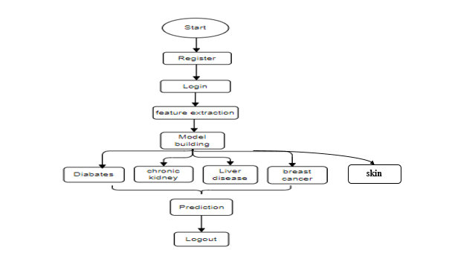

**HARDWARE AND SOFTWARE REQUIREMENTS**

**H/W Configuration:**

Operating system : Windows 7 or 7+

RAM : 8 GB

Hard disc or SSD : More than 500 GB

Processor : Intel 5th generation or high or Ryzen with 8 GB Ram

**S/W Configuration:**

Software’s : Python 3.6 or high version

IDE : PyCharm.

Framework : Flask, pandas, numpy and Scikit-Learn