**TABLE OF CONTENTS**

**SECTION PAGE**

1 Scope 2

1.1 Sitemap 2

2 wireframe 3

2.1 Proposed Technology 3

2.2 Login Page 4

2.3 Home/Dashboard Page 5

2.4 All Networks 6

2.5 All Networks (same page) 7

2.6 Data Management 9

2.7 Assets 10

# Scope

To create a wireframe and site map for Data Management Software (DMS) and to explain a detail description of the page and functionalities within each pages

## Sitemap

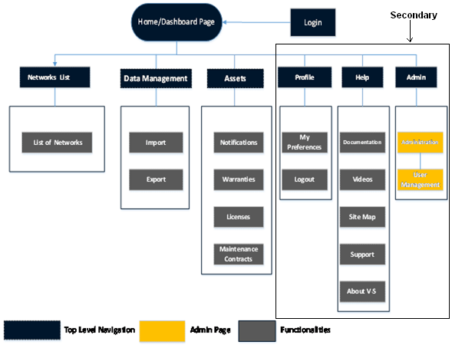

Figure 1: Site Map

# wireframe

Wireframe is a page schematic or screen blueprint, is a visual guide that represents the skeletal framework of a website.

**Site map structure:**

## Proposed Technology

Server: Tomcat

Frame work: Spring Java Framework

Database: MySQL

IDE: Eclipse

GIT:

## Login Page

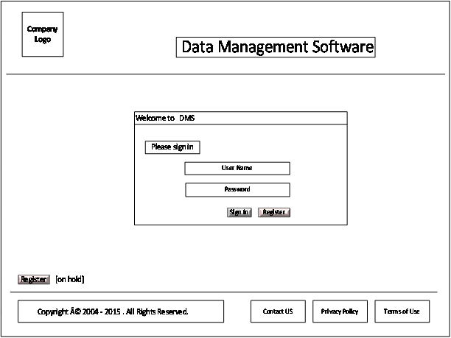

Figure 2: Login page

## Home/Dashboard Page

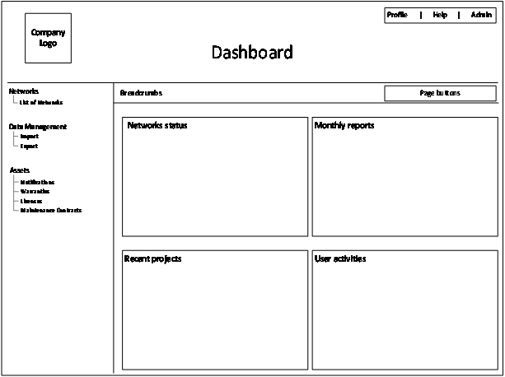

Figure 3: Home/Dashboard page

The user (Admin/Client/Engineer) can click several buttons in the wireframe box to have access according to their permission status. On hover or click over the button: ‘profile’; ‘help’; and ‘admin’ allows pop-up list to appear with list of functionalities dedicated to them.

**All Networks Status:**

It is a wireframe containing status summary of all Network components.

**Monthly Reports:**

The {6} most recently created or generating reports are shown in this wireframe, it allows user to navigate to previous {6} monthly reports. Link is (inactive) greyed out if there are no previous reports.

**Recent Projects:**

The {6} most recently created or current working projects are shown in this wireframe, it allows user to navigate to previous {6} projects. Link is (inactive) greyed out if there are no previous projects.

**User Activities:**

This wireframe allows detailed tracking of user actions such as: which user is connected; which project the user is engaged; and any input provided to the browser (reports, comments, etc).

## All Networks

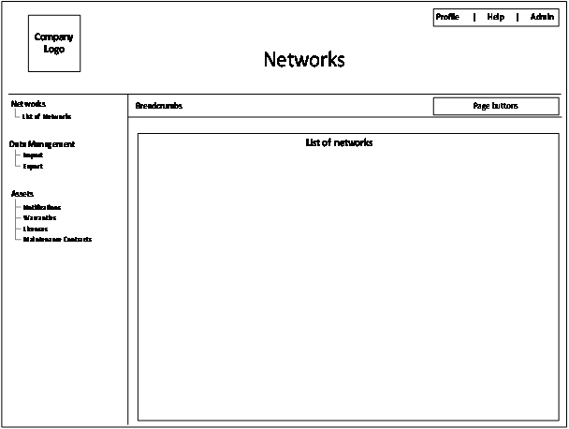

Figure 4: List of all Networks

List of networks div will show all the projects which are associated with network, examples are shown in Example-1 and Example-2

Example-1: List of Network view

|  |  |  |  |  |  |  |
| --- | --- | --- | --- | --- | --- | --- |
| **Ref** | **Name** | **Customer** | **Manager** | **Status** | **Start** | **End** |
|  |  |  |  |  |  |  |

Example-2: List of Network view

|  |  |  |  |  |  |
| --- | --- | --- | --- | --- | --- |
| **Customer:1** | | | | | |
| Ref | Name | Manager | Status | Start | End |
|  |  |  |  |  |  |
| **Customer:2** | | | | | |
| Ref | Name | Manager | Status | Start | End |
|  |  |  |  |  |  |

## All Networks (same page)

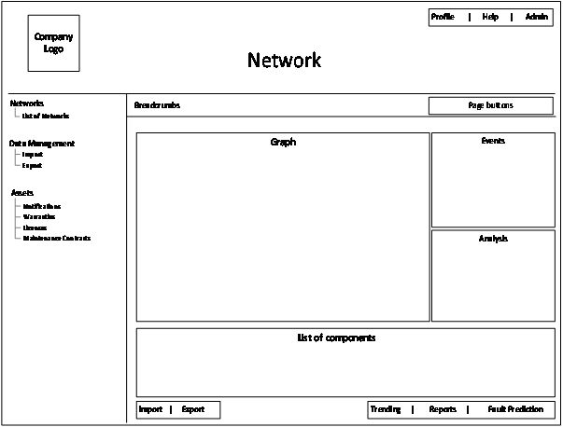

Figure 6: Data Analysis of single component

When user clicks on the project from the list a detail data analysis is shown in the graph div.

**Graph:**

It shows the IR graph of the individual component associated with the network.

**Events:**

It highlights the parameters of the graph such as: line current; start time; end time.

**Reports:**

The corresponding reports (pdf form) of the component are made available to the customer.

**Import:**

The selected data of the individual component can be imported to the database for further analysis.

**Export:**

The selected data of the individual component data from the graph are stored in database for further analysis.

**Trending:**

The component trend at different time is visualised within this wireframe.

**Fault Prediction:**

Fault reports, trend and events.

## Data Management

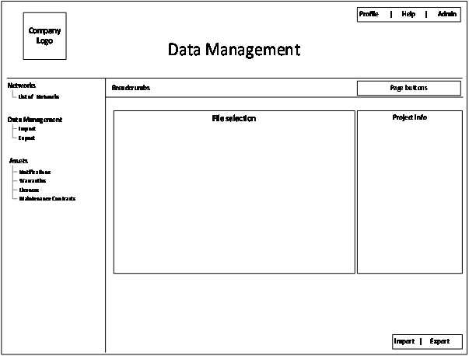

Figure 7: Data Management

The data management of the various files and their associated projects are shown for analysis.

**File Selection:**

Select a data file from the list of files by the user to upload database.

**Project info:**

Pre-filled project info will be displayed on the project info div.

## Assets

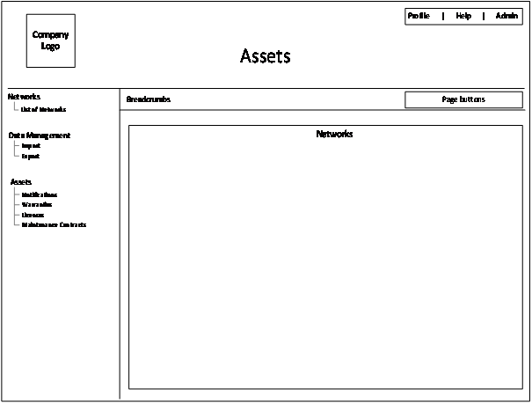

Figure 8: Assets Page

Example-1: Asset page view

|  |  |  |  |  |  |  |  |  |  |
| --- | --- | --- | --- | --- | --- | --- | --- | --- | --- |
| **Ref** | **Name** | **Customer** | **Status** | **Start** | **End** | **License** | **Notification** | **Warranties** | **Maintenance Contracts** |
|  |  |  |  |  |  |  |  |  |  |
|  |  |  |  |  |  |  |  |  |  |