KPI Report and SQL Queries for Skin Kraft Project

# KPI ‘s Requirement

|  |  |
| --- | --- |
| KPI | Value |
| Total Products | 1472 |
| Average Price | $55.58 |
| Average Rank | 4.15 |
| Highest Priced Product | The Concentrate |
| Lowest Priced Product | Nose Strip |
| Most Common Label | Moisturizer |
| Most Common Brand | CLINIQUE |

# Sample SQL Queries and Outputs for KPIs

## Total number of products

SELECT COUNT(*) AS Total_Products FROM cosmetics;

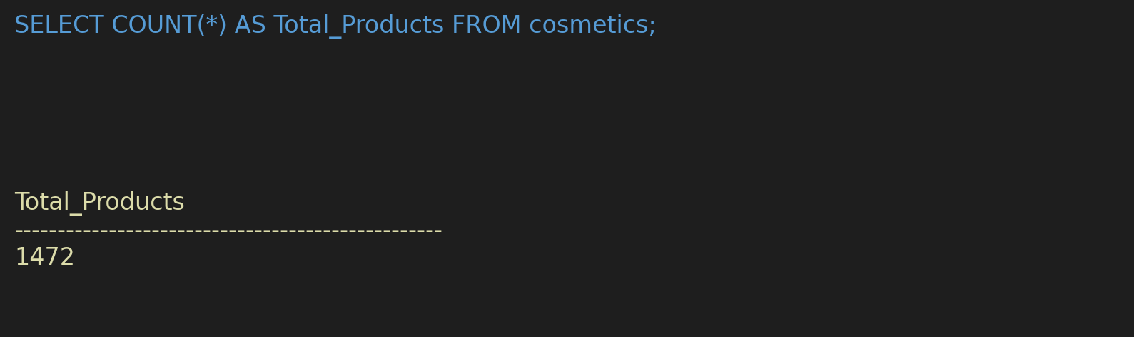

## Average price of products

SELECT AVG(Price) AS Average_Price FROM cosmetics;



## Average rank of products

SELECT AVG(Rank) AS Average_Rank FROM cosmetics;



## Highest priced product

SELECT Name FROM cosmetics ORDER BY Price DESC LIMIT 1;

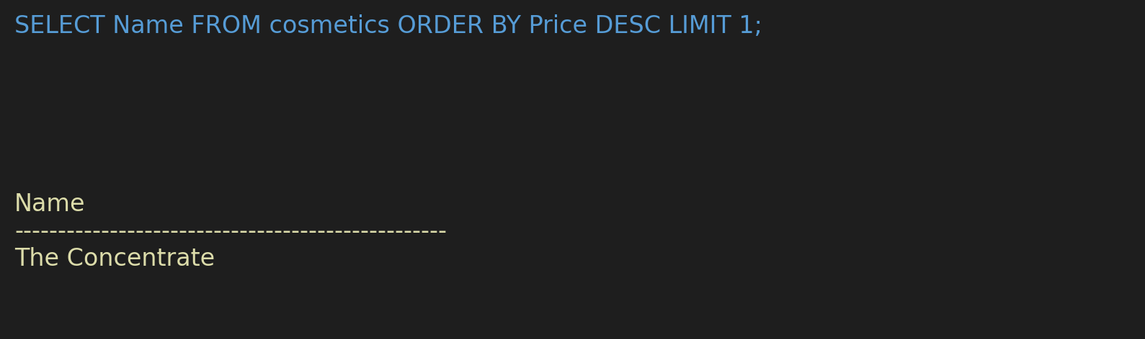

## Lowest priced product

SELECT Name FROM cosmetics ORDER BY Price ASC LIMIT 1;

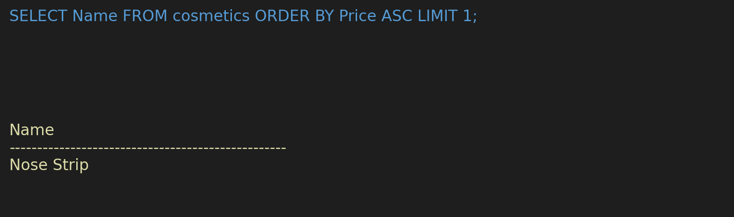

## Most common product label

SELECT Label, COUNT(*) AS Count FROM cosmetics GROUP BY Label ORDER BY Count DESC LIMIT 1;

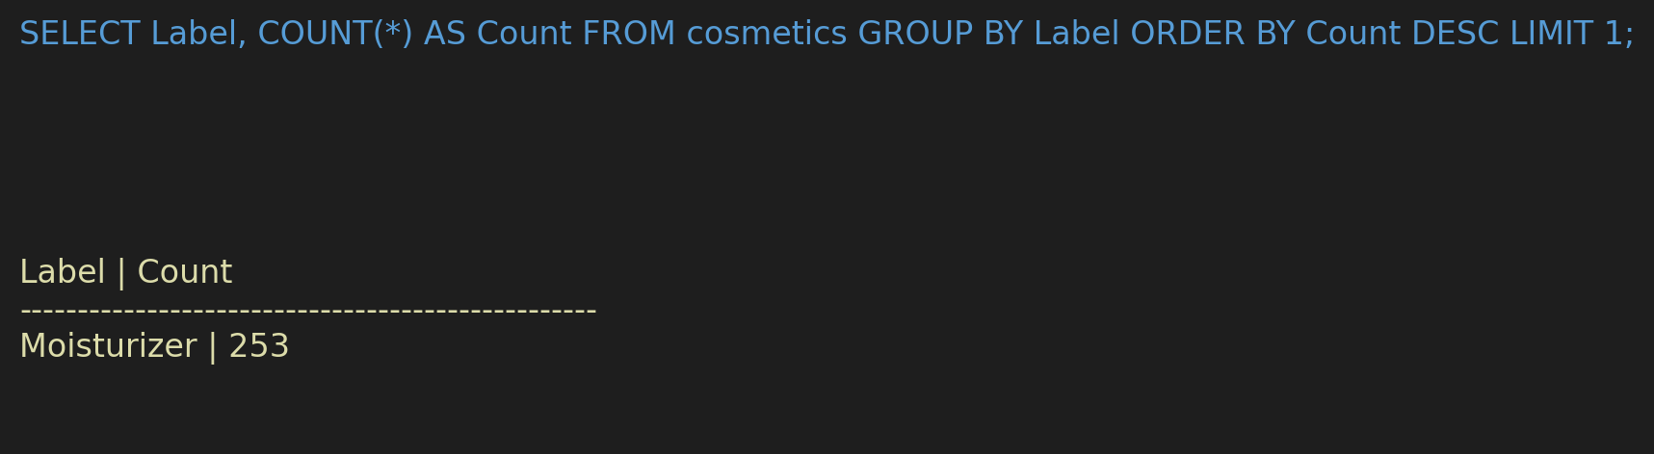

## Most common brand

SELECT Brand, COUNT(*) AS Count FROM cosmetics GROUP BY Brand ORDER BY Count DESC LIMIT 1;

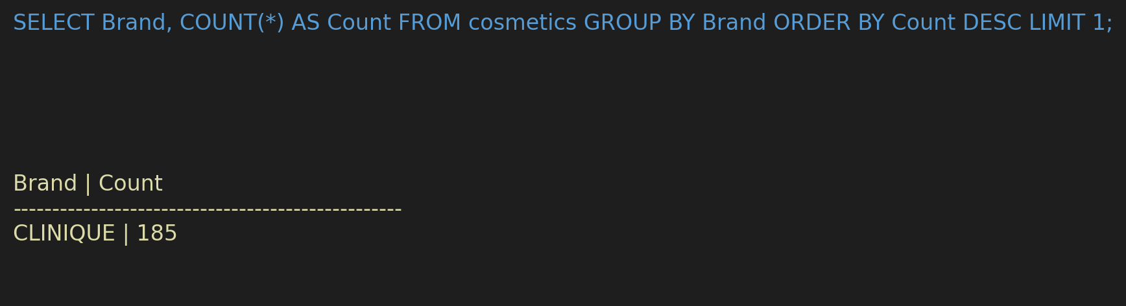

# Project Overview (Skin Kraft)

Client: Skin Kraft, Vedix  
Environment: Excel, MySQL, Python  
Visualization Tool: Power BI  
  
Project Summary:  
Worked on a data analytics project for Skin Kraft, a personalized skincare and haircare brand. The objective was to extract meaningful insights from customer and product data to support business decisions and enhance user experience.

* Used **SQL SERVER** to pull and analyze large datasets from the cosmetics catalog.
* Identified key product metrics like **average price**, **customer rating trends**, and **top-performing brands**.
* Created **Power BI dashboards** to track KPIs and visualize sales patterns, customer preferences, and product success.
* Generated **automated reports** for stakeholders to optimize marketing strategies and product positioning.
* Delivered actionable insights that helped improve customer engagement and product recommendations.

Responsibilities:  
- Pulled large datasets using SQL SERVER and performed ETL tasks.  
- Created Power BI dashboards tracking KPIs like product rank, price trends, and brand-wise performance.  
- Generated reports on product success, user preference, and market penetration.  
- Delivered data-driven insights to stakeholders, aiding strategic decisions.

Customer-Centric Recommendations

1. Segment Customers by Purchase Behavior
2. Optimize Product Recommendations
3. Target Low-Retention Segments
4. Collect and Analyze Feedback Trends
5. Track Location-Based Trends
6. Improve Onboarding for New Customers