**Project Report**

**Computational Thinking and Programming (ECSE105L)**

**Creating Online store using Django**



**Bennett University**

**School of Engineering & Applied Sciences**

**Department of Computer Sciences & Information Technology**

**Submitted by:**

**Fanatic (EB18)**

Vamsi Bitra(E20CSE402)

**Feb202**

**ABSTRACT**

Many instructors have already discovered the fun of teaching programming using the Python programming language. The companies introduced Django, an open source Python web framework that saves you time and makes web development fun. It's aimed at Computer Science instructors who want to teach how to build elegant web applications with minimal fuss. Django follows the Model-View-Controller (MVC) architectural pattern. Its goal is to ease the creation of complex, database-driven websites. Django emphasizes reusability and "pluggability" of components, rapid development, and the principle of DRY (Don't Repeat Yourself). Python is used throughout, even for settings, files, and data models. Topics that will be covered during the workshop include: setup and configuration, template language, and database integration through object-relational mapping. Participants should have some familiarity with Python, HTML and SQL.

Table of Contents

S.NO TITLE

1 Introduction

2 Aim of the Project

2.1 Advantages & Disadvantages

2.2 Future Implementation

3 Software & Hardware Details

4 Data Flow Diagram

5 Implementation

6 Integration and System Testing

7 Conclusion

8 References

# Introduction

Now a day’s all online platform has became famous many of people are interested buying products through online. Based on that my project was created and named online store , It is created by using django . In this project we are using html, sqllite code . The online store is online platform in which a user can create account and they can go through products and if they like they buy and order that products

# Aim of project

To create a online store website by using django

OBJECTIVES

* To make the shopping easier and comfortable

* To serve the customers without wasting their time

* To reach the products to the customer’s address with great care

## Advantages & Disadvantages

**Advantages**

1. convenience of online shopping
2. Online shopping saves time
3. Comparisons
4. Availability of online shop
5. Online tracking
6. Online shopping saves money

**Disadvantages**

1. Delay in delivery
2. Lack of significant discounts in online shops
3. Lack of interactivity in online shopping
4. Lack of shopping experience
5. Lack of close examination in online shopping
6. Frauds in online shopping

## Future Implementation

*Adding cart and address info to store

* Designing the store

* Adding navigation bar

* Adding user settings

* Adding more products to store

*Bringing more sellers

# Software and Hardware details

· **CPU:** 2 x Intel Core 2 (2.66 Ghz, 128K cache)

· **RAM:** 4GB

· **Minimum database space:**10GB

# 

# FlowchartWhatsApp Image 2021-02-14 at 10.03.22.jpeg

# Implementation

Terminal

> pip install django

>django-admin startproject OnlineStore .

>python manage.py runserver

>python manage.py startapp products

Views.py

from django.http import HttpResponse  
from django.shortcuts import render  
  
  
def index(request):  
 return HttpResponse('Hello World')

products/urls.py

from django.urls import path  
from . import views  
  
  
urlpatterns = [  
 path('', views.index)  
]

OnlineStore/urls.py

from django.contrib import admin  
from django.urls import path,include  
  
urlpatterns = [  
 path('admin/', admin.site.urls),  
 path('products/', include('products.urls'))  
]

models.py

from django.db import models  
  
  
class Product(models.Model):  
 name = models.CharField(max_length=255)  
 price = models.FloatField()  
 stock = models.IntegerField()  
 image_url = models.CharField(max_length=2083)

Online store/setting.py

'products.apps.ProductsConfig'

Terminal

>python manage.py makemigrations

>python manage.py migrate

>python manage.py createsuperuser

Username (leave blank to use 'admin'): admin

Email address: [vamsi.b9652@gmail.com](mailto:vamsi.b9652@gmail.com)

Password:

Admin.py

from django.contrib import admin  
from .models import Product  
  
  
class ProductAdmin(admin.ModelAdmin):  
 list_display = ('name', 'price', 'stock')  
  
  
admin.site.register(Product,ProductAdmin)

views.py

from django.http import HttpResponse  
from django.shortcuts import render  
from .models import Product  
  
  
def index(request):  
 products =Product.objects.all()  
 return render(request, 'index.html', {'products': products})

index.html

{% extends 'base.html' %}  
  
{% block content %}  
 <h1>Products</h1>  
 <div class="row">  
 {% for product in products %}  
 <div class="col">  
 <div class="card" style="width: 18rem;">  
 <img src="{{ product.image_url }}" class="card-img-top" alt="...">  
 <div class="card-body">  
 <h5 class="card-title">{{ product.name }}</h5>  
 <p class="card-text">Rs{{ product.price }}</p>  
 <a href="#" class="btn btn-primary">Add to cart</a>  
 </div>  
 </div>  
 </div>  
 {% endfor %}  
 </div>  
{% endblock %}

Base.html

<!doctype html>  
<html lang="en">  
<head>  
 <!-- Required meta tags -->  
 <meta charset="utf-8">  
 <meta name="viewport" content="width=device-width, initial-scale=1">  
  
 <!-- Bootstrap CSS -->  
 <link href="https://cdn.jsdelivr.net/npm/bootstrap@5.0.0-beta2/dist/css/bootstrap.min.css" rel="stylesheet"  
 integrity="sha384-BmbxuPwQa2lc/FVzBcNJ7UAyJxM6wuqIj61tLrc4wSX0szH/Ev+nYRRuWlolflfl" crossorigin="anonymous">  
  
 <title>vamsi online store</title>  
</head>  
<body>  
<nav class="navbar navbar-light bg-light">  
 <div class="container-fluid">  
 <a class="navbar-brand" href="#">OnlineStore</a>  
 </div>  
</nav>  
{% block content %}  
{% endblock %}

# Integration and system testing

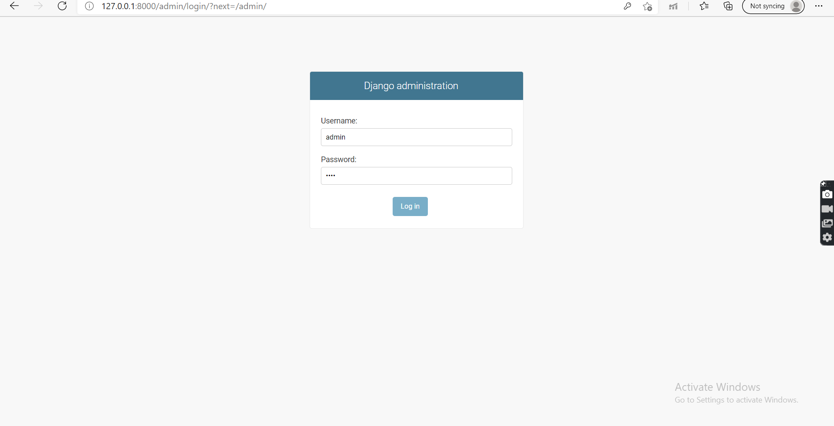

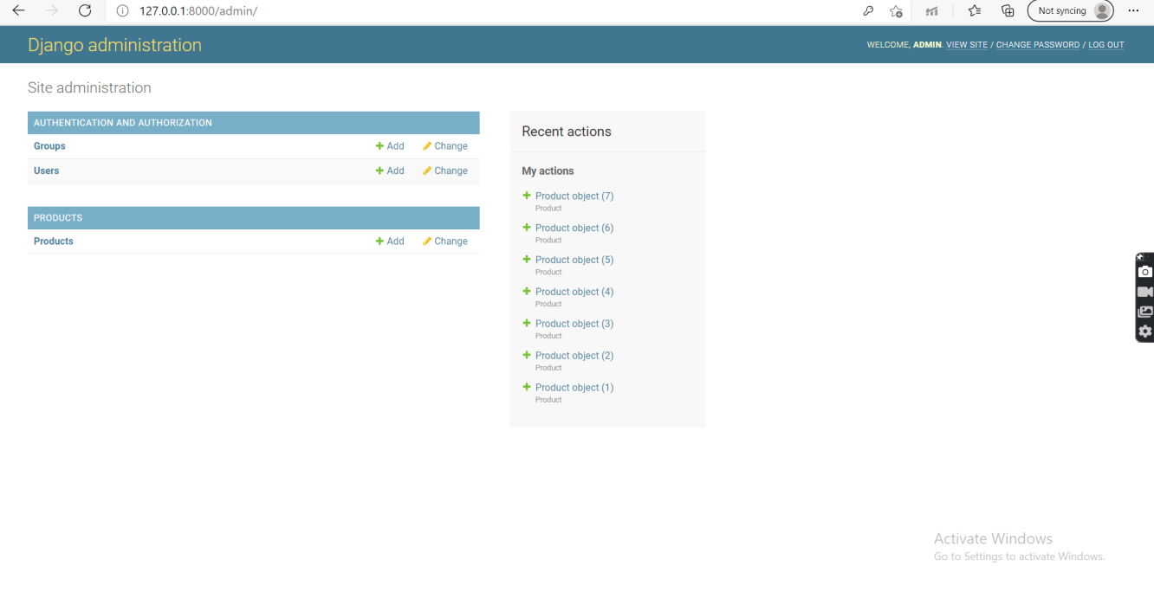

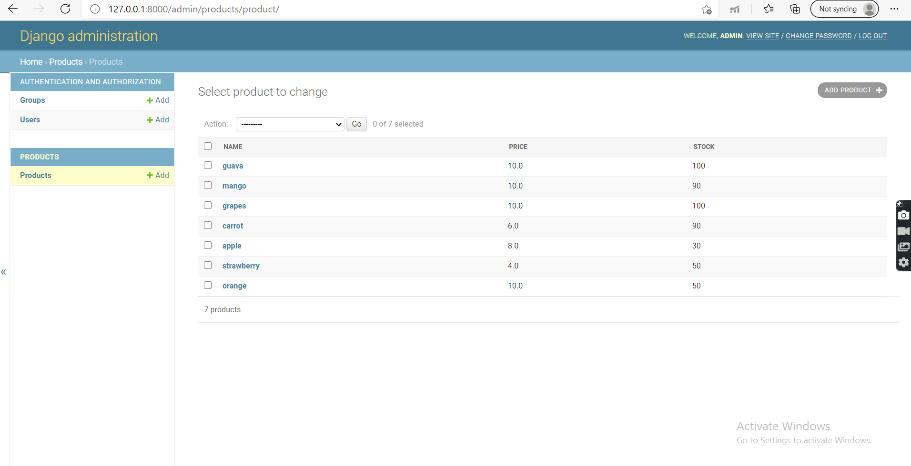

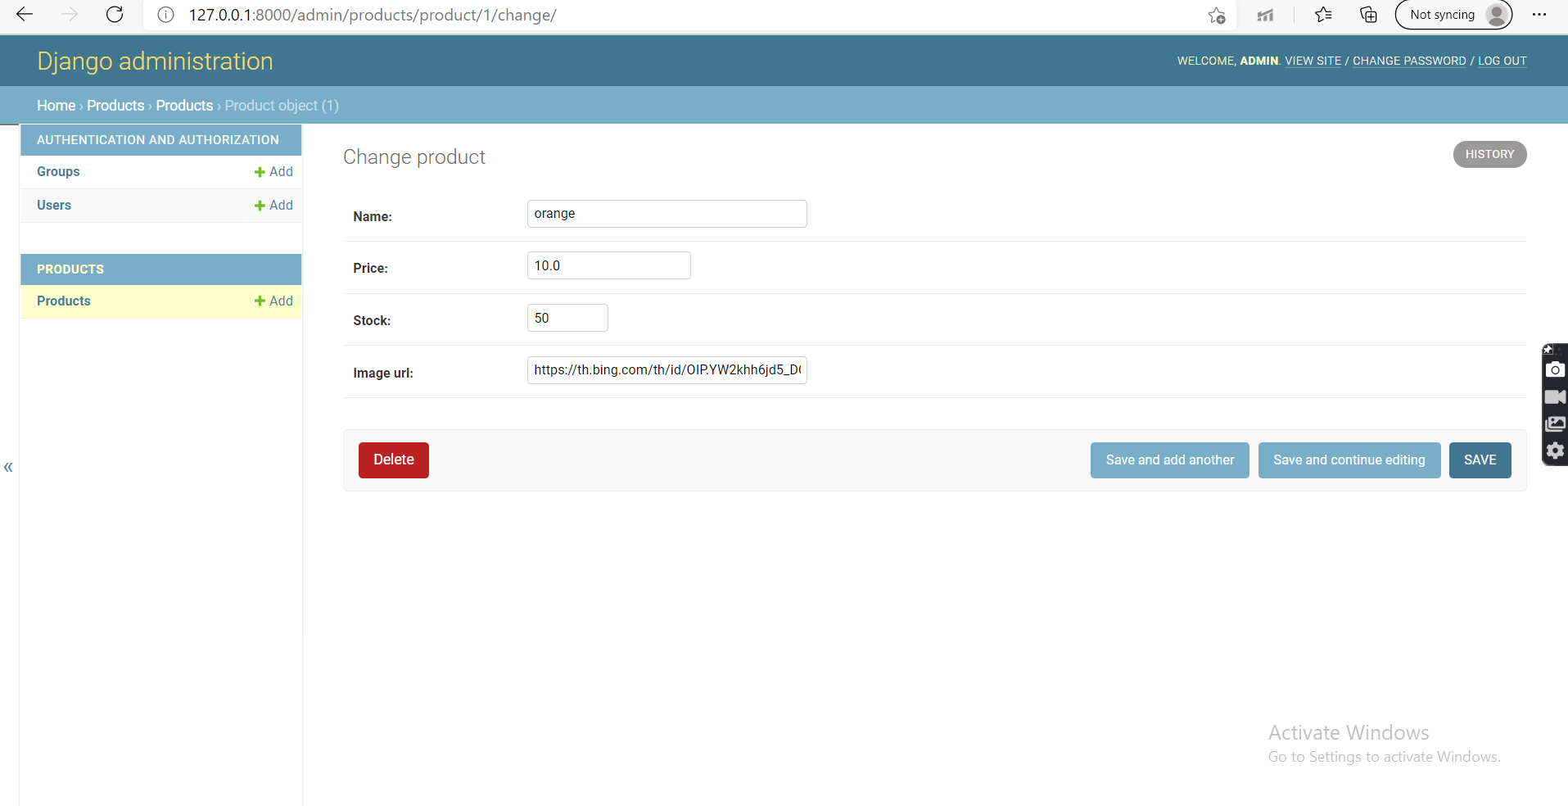

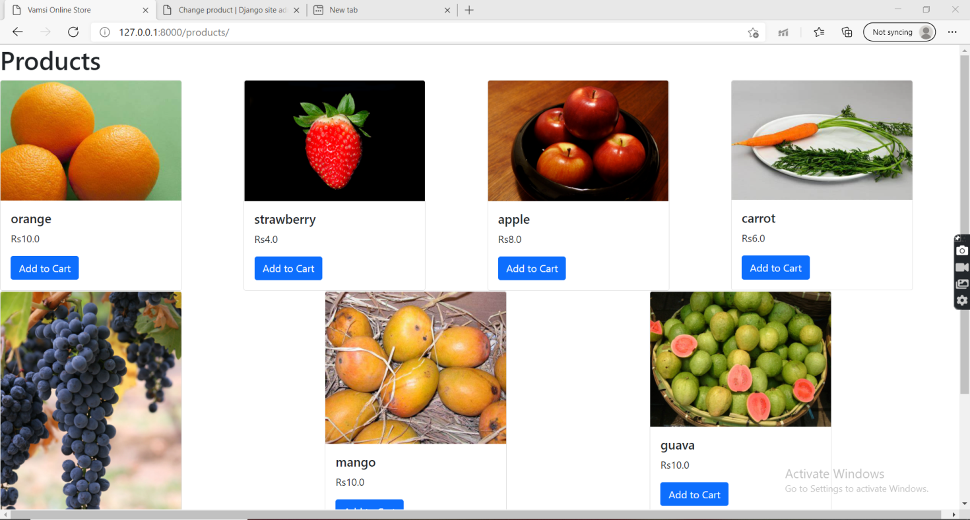

# 7 Conclusion

Technology has made significant progress over the years to provide consumers a better online shopping experience and will continue to do so for years to come.  With the rapid growth of products and brands, people have speculated that online shopping will overtake in-store shopping.  While this has been the case in some areas, there is still demand for brick and mortar stores in market areas where the consumer feels more comfortable seeing and touching the product being bought.  However, the availability of online shopping has produced a more educated consumer that can shop around with relative ease without having to spend a large amount of time.  In exchange, online shopping has opened up doors to many small retailers that would never be in business if they had to incur the high cost of owning a brick and mortar store.  At the end, it has been a win-win situation for both consumer and sellers.

**8 Refrenses**

* Bootstrap
* Django
* Sql lite
* Steps to Create Website with Django | Create Django Website from Scratch (zeolearn.com)

Links

<https://youtu.be/p1t00Ug1W4U>