Phase 0 – Inputs
- Define migration scope, access, tokens, and requirements.
- Generate key pair
- Save Secretes like (GH_PAT, SSH_USER, SSH_PRIVATE_KEY, BBS_TOKEN, BBS_USERNAME & BBS_PASSWORD)
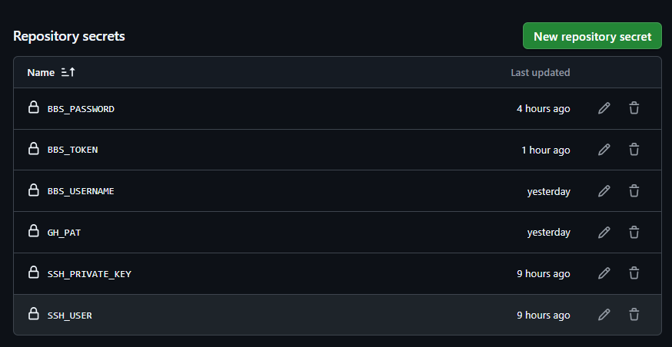
Phase 1 – Repo Inventory
- Collect repo metadata from BBS.
- Pipeline will Export to CSV and store as a pipeline artifact.
- Below is the GitHub Actions Workflow that will generate the repos.csv artifact which can be downloaded. Sample file given below.
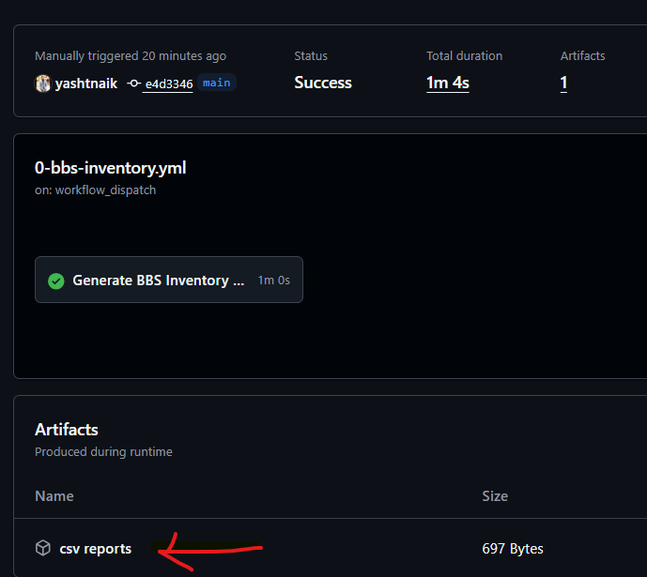
Note - BBS Inventory report works only with Admin password, even with full access PAT Token it fails to generate. Check observations below
Phase 2 – Pre-Validation
- Run checks for any blockers for migration. (Open PRs, Running Build pipelines, Release pipelines etc.)
- This will produce a per-repo report and gate migration based on blockers/warnings.
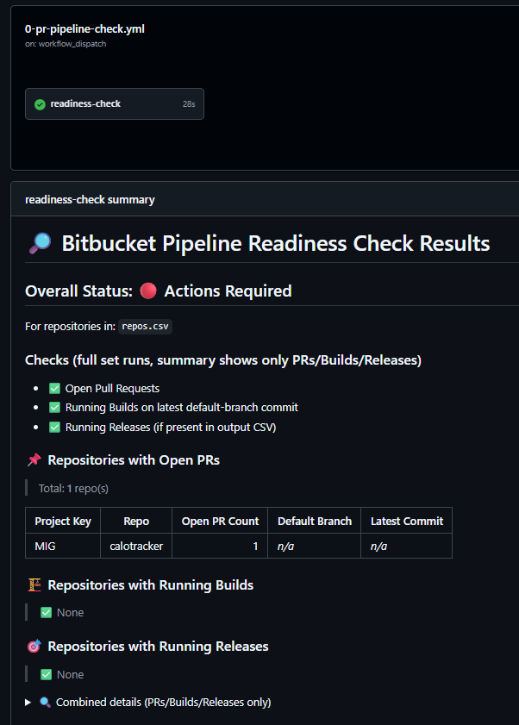
Phase 3 – Migration
- If pre validation goes well, trigger Migration workflow.
- Capture verbose logs and artifacts for each repo.
- Summary will show Successfully, failed etc repos, check the verbose logs in the artifact to identify the failure reason.
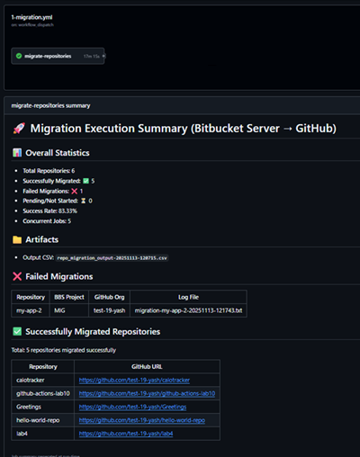
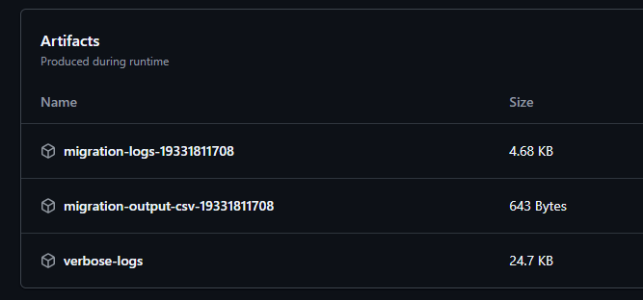
Phase 4 – Post-Validation
- Checks the SHA, Commit counts and branches
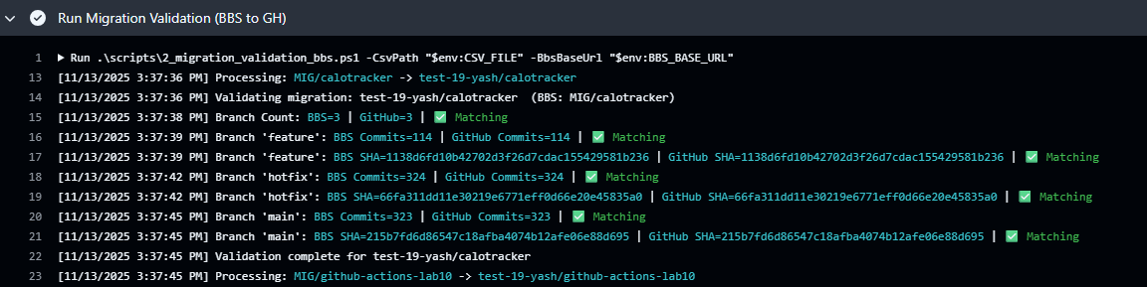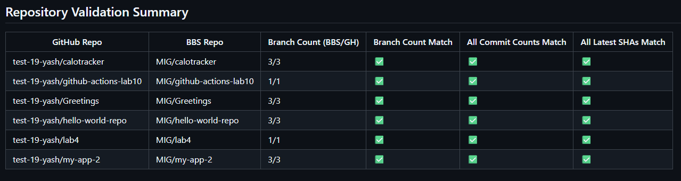
Phase 5: Mannequins reclaim.
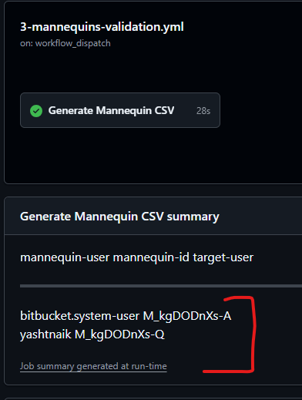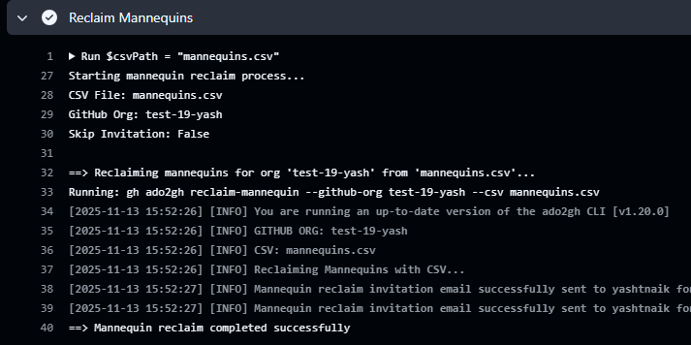

- Update the mannequins.csv and commit back to the repo.
- Then run the reclaim pipeline.

Observations/Note:
- Pipelines are not interconnected; it has the code for it but currently disable.
- BBS Inventory report works only with Admin password, even with full access PAT Token it fails to generate.
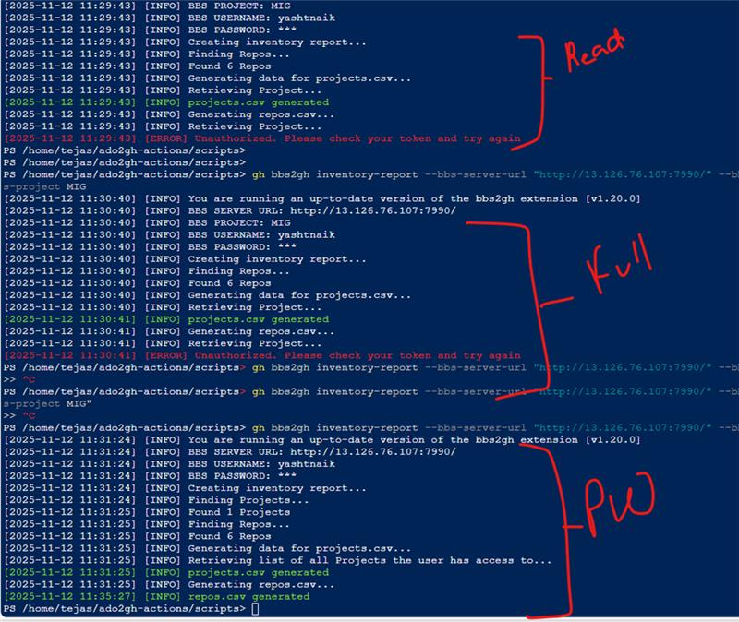

- Validation: BBS_PAT (recommended) — Bitbucket HTTP access token for REST API (Bearer). Create under Profile → HTTP access tokens with read permissions to enumerate PRs/branches/commits
- Repo link https://github.com/yashtnaik/bbs2gh-actions.git

