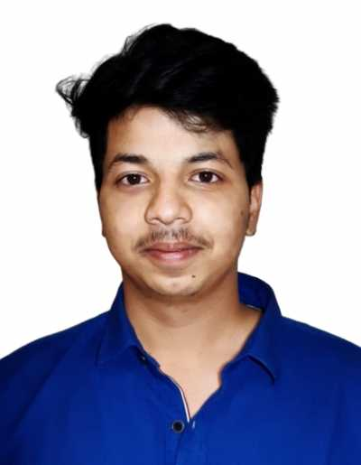

|  |  |
| --- | --- |
| Vamsi Cherukuru  Seeking a position in a competitive environment that would challenge me to push my boundaries and expand my knowledge in this field of computer science. |  |
| EDUCATION  |  |  |  | | --- | --- | --- | | Degree/ Grade | Institution | Score | | B.Tech CSE | Christ(Deemed to Be University) - Bengaluru | 7.71/10 CGPA  [ 7 Semesters ]  65.76% | | Intermediate  ( MPC) | Sri Chaitanya Junior College - Kadapa | 95.2% | | SSC | Nagarjuna E.M High School | 87.4 % |  WORK EXPERIENCEIII Cell, Christ University — *Django Developer*DECEMBER 2020 - PRESENT Database Modelling & Designing for Community Cafe Web application Vidcentum R&D, Hyderabad — *Database Intern*April 2019 - May 2019 Feasibility study of database of OpenEMR software. PROJECTSE-Commerce web app The project was to build an e-commerce web application and to collect user data. This project was done to help a faculty in their Business Psychology research. MOVIE RESERVATION The project was to build a ticket booking web application with authentication OTHER PROJECTS : [**https://github.com/vamsicherukuru?tab=repositories**](https://github.com/vamsicherukuru?tab=repositories) | CONTACT +91 7386867313  [**cvamsifeb21@gmail.com**](mailto:cvamsifeb21@gmail.com)  [**https://www.linkedin.com/in/vamsi-cherukuru-64b59215b/**](https://www.linkedin.com/in/vamsi-cherukuru-64b59215b/) SKILLS  * Full Stack Development:   + HTML/CSS/JS   + DJANGO   + BOOTSTRAP   Deployment:  PythonAnywhere  Heroku   * Java, Python, C#, C * Android App Development  CODING EXPERIENCE [**https://github.com/vamsicherukuru?tab=repositories**](https://github.com/vamsicherukuru?tab=repositories) LANGUAGES English, Telugu, Hindi CERTIFICATIONS  1. Django-python (Udemy) 2. Android App(Internshala) 3. Python for data science (Datacamp)  HOBBIES Cricket, Guitar, Pencil Sketching |