Module-4, Unit-1
Binary Cell and Memory Unit

Question 1: Describe a memory in terms of a basic block diagram.

Solution 1:
A memory is basically comprised of rows (called words) and each row is divided into cells. Each cell can store a bit. Regarding the I/Os, the memory block has the following connections:
- Chip Enable
- Read/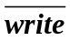
- Address Bus
- Data Bus. .
The figure given below illustrates the basic block diagram of a memory.

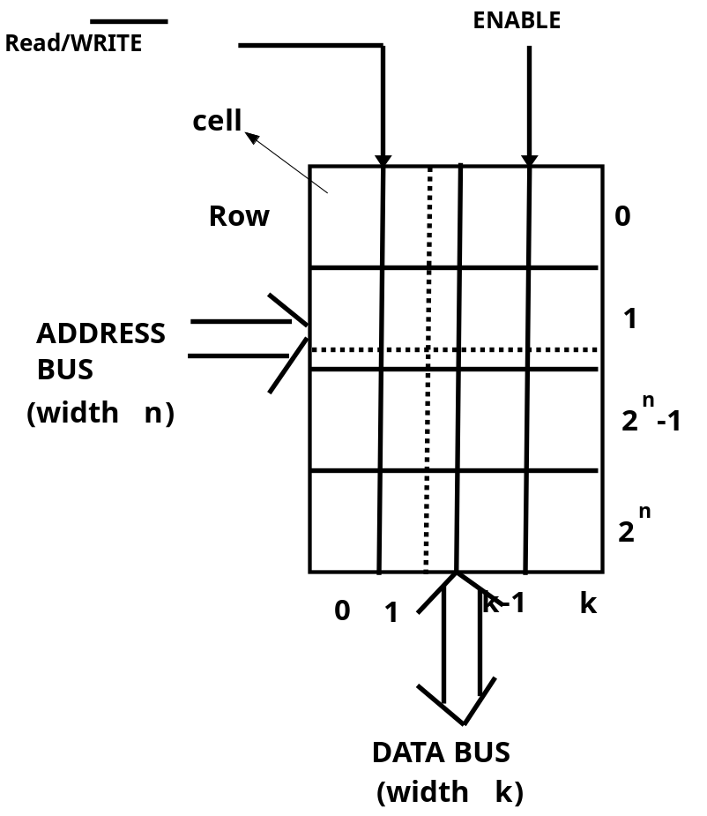
Basic Block diagram of a Memory

The functionalities of the I/O lines are
- Chip Enable: The contents of memory are only accessible (i.e., read or write) when the ‘enable’ signal is set to 1. If it is set to 0 no Read/Write operation can be done on the memory.
- Read/: This signal specifies the type of operation to be done on memory - Read or Write. If the signal is 0, data is written to the memory and if it is 1, data is read from the memory.
- Address Bus: Address Bus is a set of n lines, where 2^{n} is the number of words in the memory. The binary value in the address bus specifies the address of the word on which the I/O operation is done. To elaborate, the binary value in the address bus locates the corresponding word in the memory and its cells can be read (written) if Read/ signal is 1(0). For example, in case of a 4-bit width address bus (n=4), if the value sent is 1111, then the 15th memory word is accessed.
- Data Bus: A row is called a word and the number of cells in a row is called word length. The width of the data bus is k i.e., the word length. Generally speaking, word length depends on the unit of the instruction set and/or hardware of the processor. The data bus contains the data which is either read from the memory or is to be written to the memory for the word which is addressed in the address bus.

Question 2: How can a simple memory cell be designed using a Flip-Flop? Explain its working i.e., reading and writing to the cell.

Solution 2:
Flip-flops are one of the basic circuits that can be used as data storage elements. A flip-flop stores a single bit of data. It has two states based on the values of its outputs—(i) one state represents a "one", generally represented as 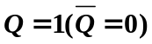and (ii) other represents a "zero", generally represented as 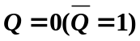. It has a CLOCK input. The flip-flop retains its state and change happens only at the CLOCK edge. Output state is determined based on the input values. Flip-flops generally have two complementary outputs i.e.,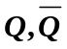. Different types of flip-flops have different inputs. As a flip-flop can retain its state it can serve as a store element and a memory cell can be designed using it. The basic principle to read the flip-flop is to simply probe the value at 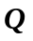(and/or 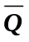) and keep the clock stable. On the other hand, the basic principle to write the flip-flop is to apply the appropriate inputs (depending on the type of flip-flop) and trigger the clock edge.

Here we will explain the concepts using SR flip flop. Truth Table for SR Flip-flop is given below.
Inputs |  | Outputs
S | R | Q
1 | 0 | 1 | 0
0 | 1 | 0 | 1
0 | 0 | Hold
1 | 1 | Not allowed

The figure below shows a memory cell designed using SR Flip-flop.

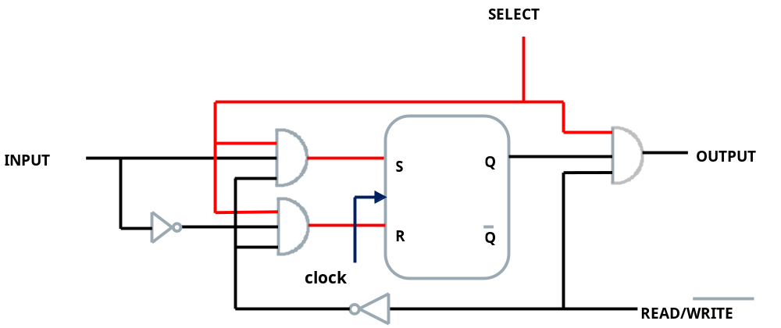

Memory cell designed using SR Flip-flop
The concept of enabling the memory cell (designed using the S-R flip-flop) and read-write is explained using the following figures. In these figure the clock is not explicitly shown to maintain clarity of the figures.

- Memory cell is disabled: No-read/write possible
I/O signal values: Select = 0 , Read/= X , Input = X
SR = 00: Hold, Output = 0 (irrespective of input)

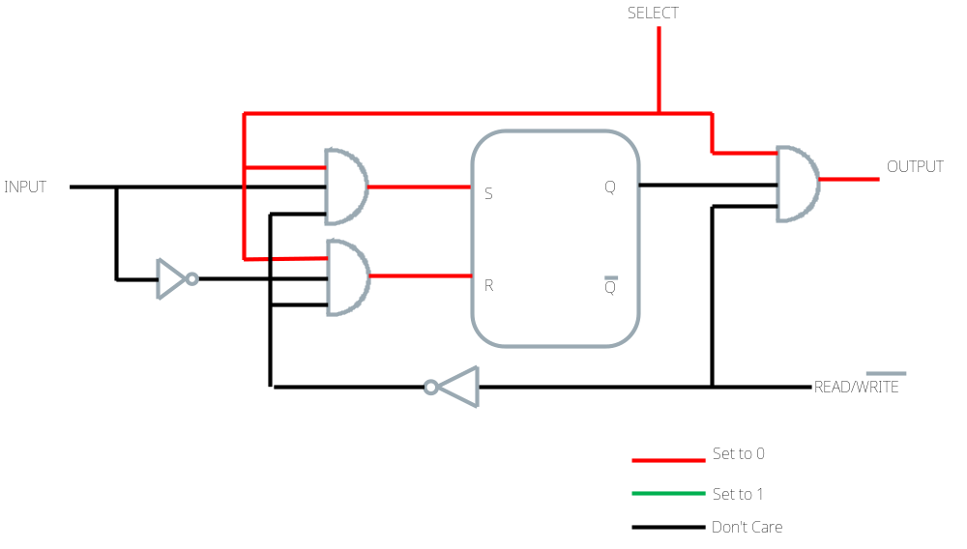

Memory cell is disabled

- Memory cell Read: Memory cell enabled and is being read
I/O signal values: Select = 1, Read/= 1, Input = X
SR = 00: Hold, Output = i.e., Bit stored in flip-flop.

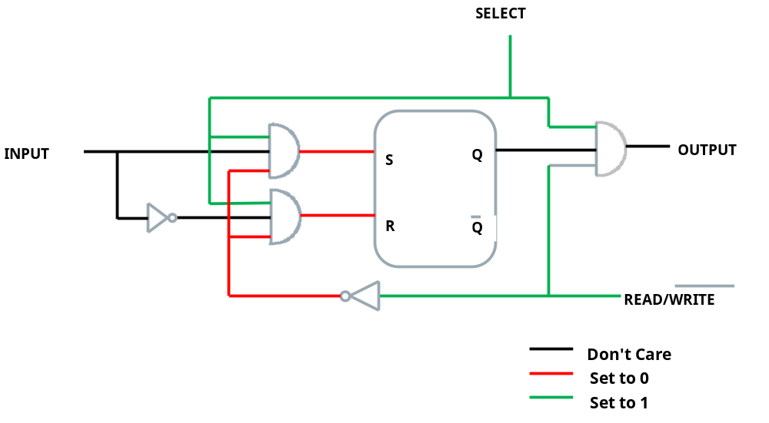
Memory cell Read

- Memory cell write 1: Memory cell enabled and 1 is being written
I/O signal values: Select = 1 , Read/= 0 , Input = 1
SR = 10: Set, Output = =1. Apply clock edge.

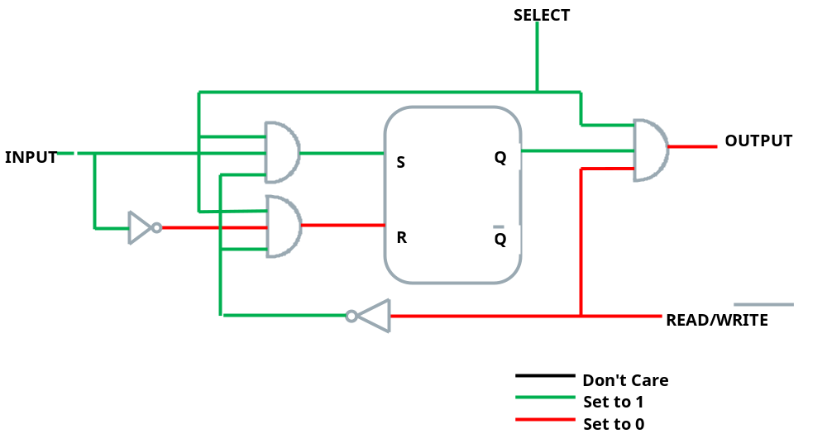

- Memory cell write 1: Memory cell enabled and 0 is being written
I/O signal values: Select = 1 , Read/= 0 , Input = 0
SR = 01: Reset, Output = =0. Apply clock edge..

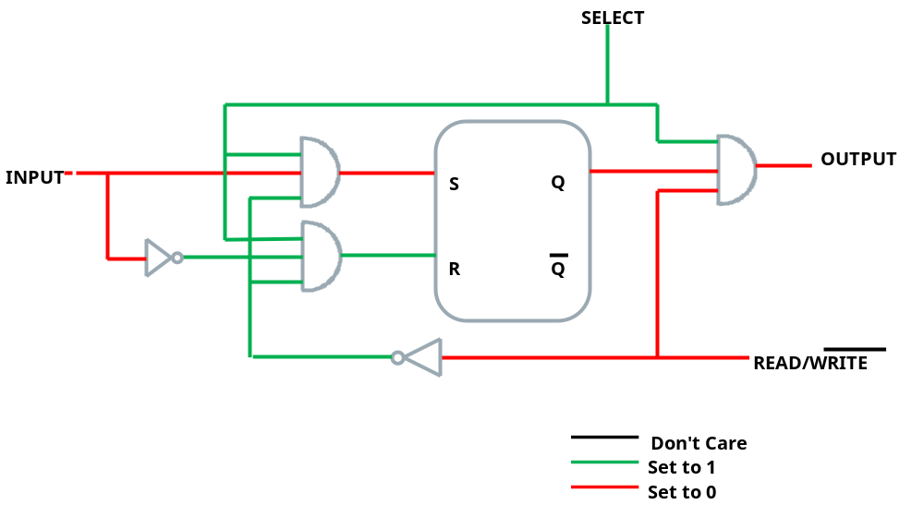

Question 3: Using the basic memory cells design a 4 x 4 memory module.

Solution 3:

- Each word is a combination of k, 1-bit SR flip-flop (called basic block (BC)), where k is the word size. Here k is 4. So each word has 4 BCs.
- n address lines (of the address bus) act as n inputs to a n x 2^{n} decoder. The output lines of the decoder are fed to the select lines of the BCs. Here as we have 4 rows so n=2. A word (i.e., all BCs of that row) is select based on the values of the address lines. To elaborate, based on the values of the address lines, one output line of the decoder is enabled. All BCs connected to that output line are selected. This means that we can perform I/O operations on that word.
- Depending on the value of Read/, Read or Write operation can be performed on each BC of the selected word.
- The memory enable input basically activates/deactivates the memory block.

The figure given below shows the 4 x 4 memory module designed using SR based basic cells.

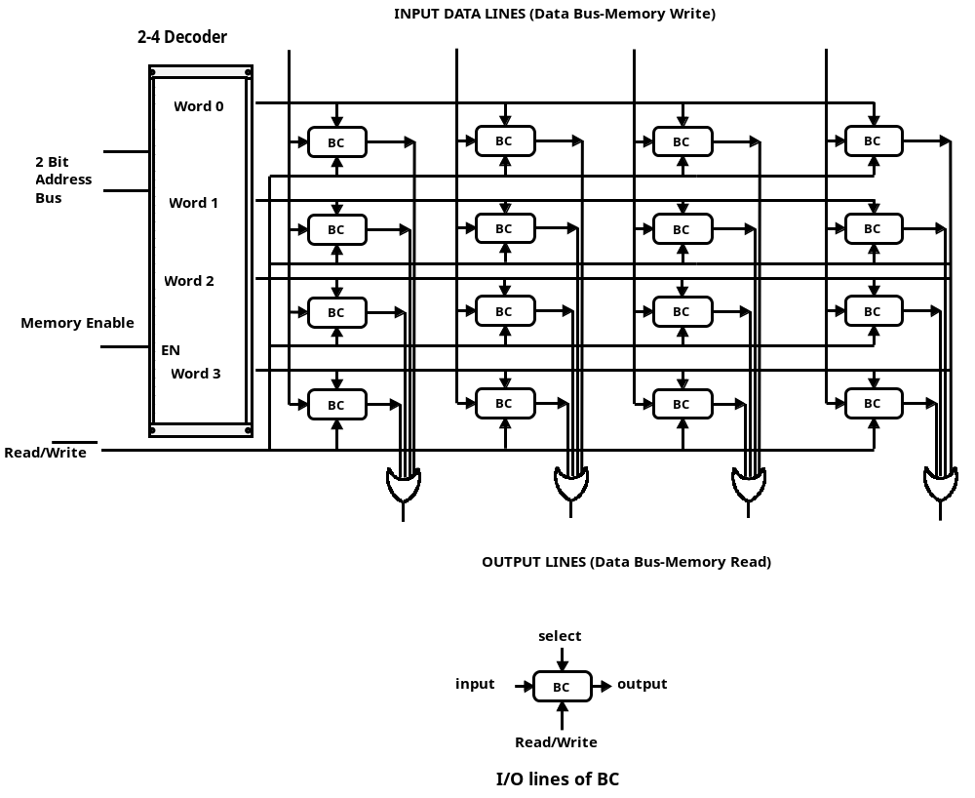

Question 4: We have a memory module of size 1 KiloBytes. What is the size of address and data bus if word size is (i) 8 Bits and (ii) 16 Bits. What would be the changes of the memory module is of 1GigaBytes.

Solution 4:

- We know that 1 KiloBytes is 1024 Bytes. 1024Bytes is 1024 x 8 Bits. So if the word size is 8 bits, then
  - Data bus is of 8 Bits
  - There are 1024 words. To access each word we need an address space of 10 Bits because 2¹⁰=1024. So address bus is of 10 bits.

- We know that 1 KiloBytes is 1024 Bytes. 1024Bytes is 512 x 16 Bits. So if the word size is 16 bits, then
  - Data bus is of 16 Bits
  - There are 512 words. To access each word we need an address space of 9 Bits because 2⁹=512. So address bus is of 9 bits.

- We know that 1 GigaBytes is 1,073,741,824 (2³⁰) Bytes. 1,073,741,824 (2³⁰) Bytes is 1,073,741,824 (2³⁰) x 8 Bits. So if the word size is 8 bits, then
  - Data bus is of 8 Bits
  - There are 1,073,741,824 (2³⁰) words. To access each word we need an address space of 30 Bits because 2³⁰=1,073,741,824. So address bus is of 30 bits.

- We know that 1 GigaBytes is 1,073,741,824 (2³⁰) Bytes. 1,073,741,824 (2³⁰) Bytes is 53, 68,70,912 (2²⁹) x 16 Bits. So if the word size is 16 bits, then
  - Data bus is of 16 Bits
  - There are 53, 68,70,912 (2²⁹) words. To access each we word need an address space of 20 Bits because 2²⁹=53, 68,70,912. So address bus is of 20 bits.

