Module-4, Unit-2
Memory Cell Construction

Question 1: How is memory classified with respect to permanence of storage? Discuss the variants available in each class with the specific to application domains.

Solution 1:
Broadly speaking, memory can be classified into the following classes based on duration of storage:

- Volatile: The state of memory cells (content) are lost or reset when power is removed from the system.
- Non-Volatile: Stores data by permanently enabling or disabling selected transistors, such that memory state is maintained even in absence of power. In this case memory value need to be changed explicitly by employing special techniques.

Volatile memory--RAM
Random access memory (RAM) is used as the scratch pad memory of a computer system. To elaborate, RAM stores input data, program executables, intermediate results obtained by executing the program, and other information temporarily. It can be read and written directly at any location by selecting the address of that location. It is volatile, implying that all data is lost when the power is turned off. Basically there are two types of RAM
- Static RAM (SRAM): It is a semiconductor memory having six transistors and cross coupling inverters (designed using four transistors) stores a bit. It is faster but its area is comparatively larger. So it is used in cache memory.
- Dynamic RAM (DRAM): It is a semiconductor memory having one transistor and a capacitor which stores a bit. DRAM requires frequent refresh of its memory cells. So, it is a bit slower than the SRAM and generates more heat. But its area is much less compared to SRAM and hence used in main memory where more data storage is required.

Non-volatile memory--ROM
Read only memory (ROM) is a memory in computer system which is used to store important programs which need not be changed and contents are to be retained even when power is off. Such programs are generally system software which is required to perform a variety of initialization functions, such as booting up or starting up programs. ROM is non-volatile. Its contents are programmed at the time of manufacture, but in modern ROMs contents may be changed using special circuitry. One of the best example ROM is the Basic Input/output System (BIOS) which loads the operating system when the computer system boots. Other applications include microcontrollers, pre-programmed cartridge etc.

The basic types of RAMs are as follows:
- PROM: Programmable Read Only Memory. It can be programmed only once (during manufacturing) as per user requirements.
- EPROM: Erasable Programmable Read Only Memory. The contents of the memory can be erased and new data can be stored into the memory. The erase operation is performed using strong ultraviolet light. In this case, the whole information present in the ROM is erased.
- EEPROM: Electrically Erasable Programmable Read Only Memory. The erase in EEPROMs is done by applying by special electrical signals (generally higher voltage than the normal operative voltage). So in this type of memory the contents of a particular location can be changed without affecting the contents of other locations.

Question 2: Explain the construction and working of SRAM.

Solution 2:

A typical SRAM cell is made up of six CMOS transistors as shown in the figure below.

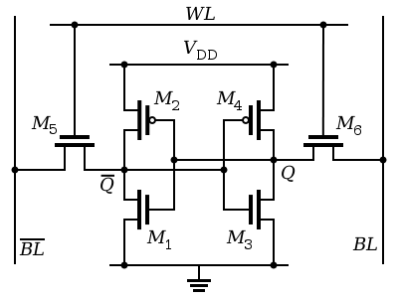

SRAM Cell
Among these six transistors, four transistors (M1, M2, M3, M4) form two cross-coupled inverters. The information bit is stored in these cross-coupled inverters, called storage cell. Two additional transistors (M5, M6) are designed to act as pass transistor logic. These pass transistors control the access to the storage cell during read and write operations. Access to the cell is controlled by the word line (denoted as WL in the figure) which controls the two access transistors M5 and M6. The line WL corresponds to an output of the address decoder and is connected to the gates of M5 and M6. When WL=1, M5 and M6 are conducting and therefore access to cell is granted via lines BL and 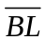 (called bit lines). Lines BL and correspond to data bus. When WL=0, M5 and M6 are non-conducting and therefore BL and get disconnected from the cell.

The inverter based storage cell has two stable states which are used to denote 0 and 1. Now we discuss how read and write operations are carried out in the SRAM. It is assumed that WL=1 as we need access to the cell for read/write operations.

Reading (1)
- The read cycle is started by pre-charging both bit lines to voltage V_{DD}/2 (midrange voltage between logical 1 and 0).
- We are assuming that at present the cell holds logic 1 i.e., BL=1 and =0. The ON and OFF conditions of various transistors in the cross-coupled inverter based cell is shown in the figure below. As M₄ is ON and M₃ is OFF, BL voltage rises. As M₂ is OFF and M₁ is ON, voltage drops. It should be noted that if BL voltage rises, then voltage drops, and vice versa.
- BL and are connected to a sense amplifier. The slight voltage difference between BL and is used to read the cell. In this case as BL rises and falls, logic 1 is read.

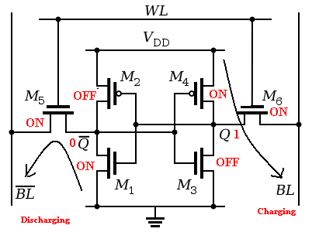
SRAM Reading 1

Reading (0)
- The read cycle is started by pre-charging both bit lines to voltage V_{DD}/2 (midrange voltage between logical 1 and 0).
- We are assuming that at present the cell holds logic 0 i.e., BL=0 and =1. The ON and OFF conditions of various transistors in the cross-coupled inverter based cell is shown in the figure below. As M₄ is OFF and M₃ is ON, BL voltage falls. As M₂ is ON and M₁ is OFF, voltage rises.
- BL and are connected to a sense amplifier. The slight voltage difference between BL and is used to read the cell. In this case as BL falls and rises, logic 0 is read.

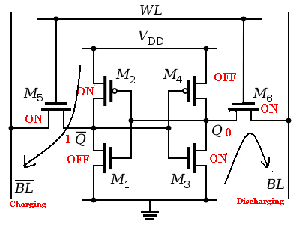

SRAM Reading 0

The start of a write cycle begins by applying the value to be written to the bit lines. The write cycle is optimized by first reading the value in the cell to check whether the value to be written is already the state the cell is in. If not, only then the value is written. This is similar to toggling the state of the cell.

Writing (1)
- We are assuming that at present the cell holds logic 0 i.e., BL=0 and =1. The ON and OFF conditions of various transistors in the cross-coupled inverter based cell is shown in the figure below (top).
- As we wish to write a 1, BL is set to 1 and is set to 0. The voltage at Q is being charged from 0 to V_{DD}, while 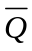is discharged from V_{DD} to 0. The regenerative feedback in the cross-coupled inverter will cause voltage changes on the gates of the transistors which flips their ON/OFF states. This is shown in the figure below (bottom). Once this happens, the cell moves to its new state i.e., logic 1. The reason this works is that the bit line input-drivers are stronger than the transistors in the cell. Thus, bit line input-drivers are able to force the inverters into flipping state (in this case from 0 to 1).

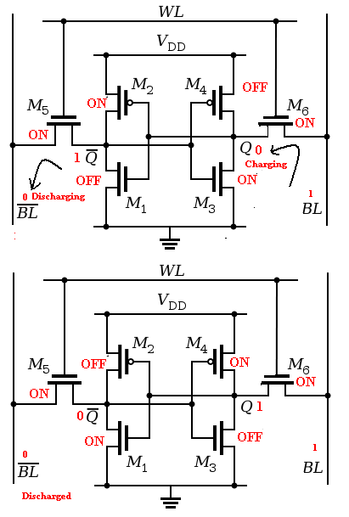
SRAM Writing 1 from 0

Writing (0)
- We are assuming that at present the cell holds logic 1 i.e., BL=1 and =0. The ON and OFF conditions of various transistors in the cross-coupled inverter based cell is shown in the figure below (top).
- As we wish to write a 0, BL is set to 0 and is set to 1. The voltage at Q is discharged down from V_{DD} to 0, while is charged from 0 to V_{DD}. The regenerative feedback in the cross-coupled inverter will cause voltage changes on the gates of the transistors which flips their ON/OFF states. This is shown in the figure below (bottom). Once this happens, the cell moves to its new state i.e., logic 0.

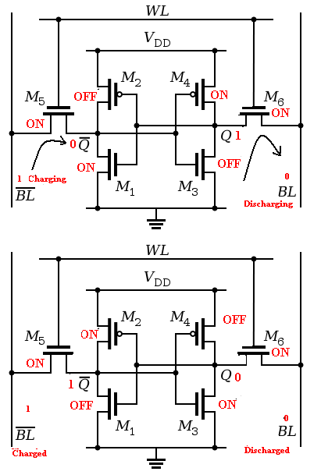
SRAM Writing 0 from 1

Question 3: Explain the construction and working of D-RAM.

Solution 3:

D-RAM is comprised of a single transistor (M_{n}) and a capacitor (C_{s}). Like SRAM it has a word line (denoted as WL) which controls the transistor M_{n} that acts like a pass transistor. It has a bit line denoted as BL. The figure given below shows a typical DRAM.
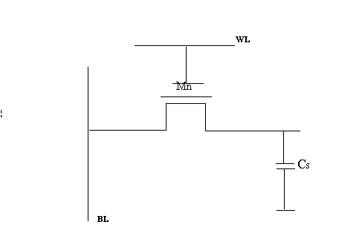

Basic DRAM Cell

Unlike SRAM the charge (i.e., value of the memory cell) is not stored in the gate capacitance of a transistor. The value is stored in the capacitor C_{s}, which is connected to the bit line BL through the pass transistor M_{n}. The cell is selected by setting the word line WL to 1, which connects the capacitor C_{s} to BL.

Now we discuss the read and write operations:

Writing (0)
In this case the storage capacitor is discharged by the following steps
- BL=0
- WL=1, C_{S} is connected to BL. As BL=0 so Cs is dis-charged.
- WL=0, so that Cs is decoupled from BL.

Writing (1)
In this case the storage capacitor is charged by the following steps
- BL=1
- WL=1, C_{S} is connected to BL. As BL=1 so Cs is charged.
- WL=0, so that Cs is decoupled from BL.

Reading (0)
In this case the storage capacitor has discharged. The status of the capacitor is read using the following steps:
- Pre-charge BL to a voltage typically midway between logic 1 and logic 0 e.g., V_{DD}/2.
- WL=1, C_{S} is connected to BL. As “0” is stored in C_{S}, BL voltage changes (drops) slightly.
- Drop is detected by sense amplifier and is denoted as logic 0.
- Write 0. Read is really a read followed by a restoring write.
- WL=0, so that Cs is decoupled from BL.

Reading (1)
In this case the storage capacitor has been charged. The status of the capacitor is read using the following steps:
- Pre-charge BL to a voltage typically midway between logic 1 and logic 0 .e.g., V_{DD}/2
- WL=1, C_{S} is connected to BL. As “1” is stored, BL voltage does not change.
- No change detected by sense amplifier is denoted as logic 1.
- Write 1. Read is really a read followed by a restoring write
- WL=0, so that Cs is decoupled from BL.

Refresh
If left non-accessed, the cells in the DRAM tend to lose the stored charge. So all cells need to be refreshed periodically. Refresh just involves
- A dummy read to every cell.

Question 4: Discuss the pros and cons of S-RAM over D-RAM. Also, highlight the domains where each of these RAMs is suitable.

Solution 4:

The table given below discusses the pros and cons of S-RAM over D-RAM

S.No. | SRAM (Static-RAM) | DRAM (Dynamic-RAM)
1. | Needs 6 transistors for every bit of data stored | Needs a single transistor and 1 capacitor for every bit of data stored
2. | Does not need to be refreshed. | Requires stored value to be periodically refreshed
3. | Faster | Slower due to requirement of periodic refresh
4. | Less power | More Power

Major Domain of Usage
As DRAM is about six times smaller in area compared to SRAM it is cheaper. So DRAM has become one of the most used technologies in computer main memory design despite of being slower and having high power requirement. However, SRAM memory is still used in domains where speed is more important than cost. The major usage of SRAM is in the cache memory of processors. As we know, speed is the first requirement in cache memory. Further, as cache size is not too large (compared to main memory), we can afford to have large area to achieve speed. Also, the low power consumption in SRAM translates to less heat, which is critical as cache is inside the processor.

