Module-3, Unit-3
Memory Unit

Question 1: Given two 1024 x 4 bit RAMs, design a memory of 1024 x 8 bit RAM.
Solution 1: Two 1024 x 4 bit RAMs are organized horizontally to expand them on the word length. The figure given below illustrates the design of 1024 x 8 RAM using 1024 x 4 RAM chips. A common chip (CS) select is given to both the RAM chips. Both the chips are selected when the common CS is high. The 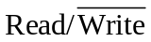 line is also common to both the chips. Also, the address lines (10 Bits) are common. Higher order data bits appear on the output lines of the left chips and lower bits appear on the output of the right chip.

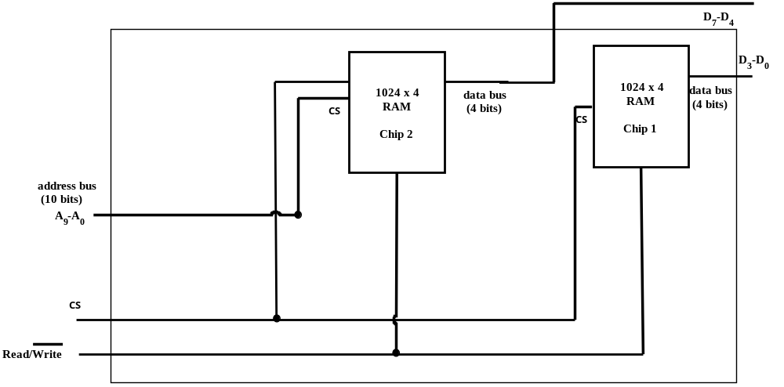 1024 x 8 RAM using 1024 x 4 RAMs

Question 2: Given two 1024 x 4 bit RAM chips, design a memory of size 2048 x 4 bit.
Solution 2: Two 1024 x 4 bit RAMs are organized vertically to expand them on the number of words. The figure given below illustrates the design of 2048 x 4 RAM (called expanded memory) using 1024 x 4 RAM chips. The line is common to both the chips. Each individual RAM chip has address bus of size 10 Bits. As the number of words in the expanded memory is 2048, the address bus is of size 11 Bits. The lower order 10 Bits of the address bus of the expanded memory (A₉-A₀) are connected to the address lines of both the RAM chips. The MSB of the address bus of the expanded memory (A₁₀) is connected to a 2:1 Decoder. The outputs of the Decoder are connected to the chip-select (CS) lines of the memory chips. When A₁₀=0, the words (0-1023) of the RAM chip-1 are selected. This is because the CS line of the top RAM chip is enabled and the bottom RAM chip is disabled. Likewise, when A₁₀=1, the words (1024-2047) of the RAM chip-2 are selected. When A₁₀=0 (A₁₀=1) the data bus of RAM Chip-1 (RAM chip-2) is connected to the data bus of the expanded memory.

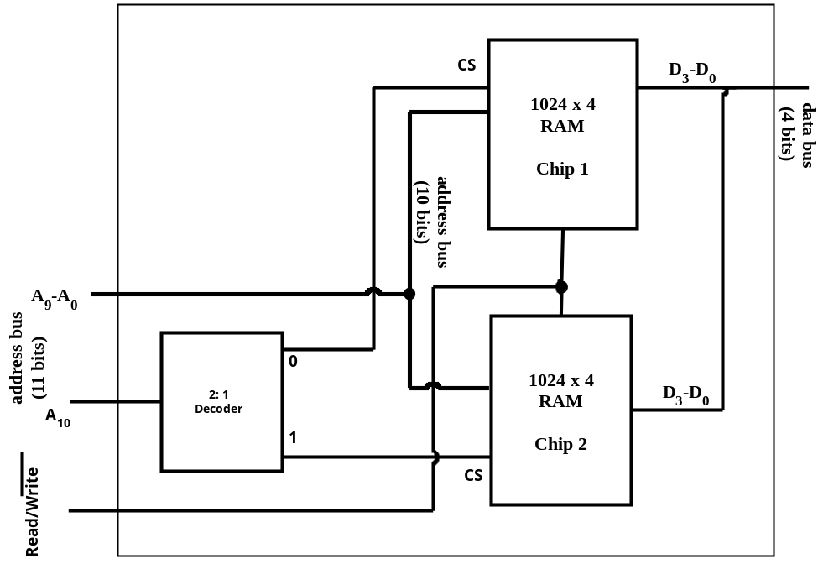
2048 x 4 RAM using 1024 x 4 RAMs
Question 4: The capacity of a main memory is 1 KB (Kilo Byte). Provide the size of Data Bus and Address Bus with proper explanation if the main memory is arranged as:
- Bit Organized
- Byte Organized

Solution 3
Total size of the data is 2 KB =2¹⁰ Bytes (as 1 K Byte = 2¹⁰ Bytes)
So, 1 KB = 8 * 2¹⁰ Bits = 2¹³ Bits.

a) Bit Organized:
Size of data bus is 1 (only one bit at every location in the memory)
No. of addresses=2¹³/1=2¹³.
Therefore size of address bus=13 Bits

b) Byte Organized:
Size of data bus=1*8=8 bits (8 bits at every location in the memory)
No. of addresses=(2¹³)/8=2¹⁰
Size of address bus =10 Bits

Question 4: The capacity of a main memory is 2GB (Giga Byte). Provide the size of Data Bus and Address Bus with proper explanation if the main memory is arranged as:
- Bit Organized
- Byte Organized
- 16 bit in each memory location:
- 32 bit in each memory location:
Solution 4
Total size of the data is 2GB =2³¹ Bytes (as 1 G Byte = 2³⁰ Bytes)
So, 2GB = 8 * 2^³¹ Bits = 2³⁴ Bits.

a) Bit Organized:
Size of data bus is 1 (only one bit at every location in the memory)
No. of addresses=2³⁴/1=2³⁴.
Therefore size of address bus=34 Bits

b) Byte Organized:
Size of data bus=1*8=8 bits (8 bits at every location in the memory)
No. of addresses=(2³⁴)/8=2³¹
Size of address bus =31 Bits

c) Double Byte (16 bit) in each memory location:
Size of data bus=16bits
No. of addresses=(2³⁴)/16=2³⁰
Size of address bus=30 bits.

d)32 bits in each memory location:
Size of data bus=32 bits
No. of addresses=(2³⁴)/32=2²⁹
Size of address bus=29 bits.

