Module-4, Unit-5
Cache Memory

Question 1: Illustrate the concept of memory hierarchy using various storage elements accessed by a processor.
Solution 1: While a program is being executed, efficiency in terms of memory access can be determined by
- Temporal localities: the tendency to reuse recently accessed data items
- Spatial locality: the tendency to reference data items that are close to other recently accessed items.

There are different types of memories in terms of access speed and size. Generally speaking, if the size of memory is large its access time is lower compared to low capacity-high speed memories. Example of former is Main Memory and the later is Cache Memory. Main memory is generally implemented using DRAM (dynamic random access memory), while caches use SRAM (static random access memory). DRAM is less costly per bit in terms of area and hence high capacity memory blocks can be designed using DRAMs. However, its speed is slower compared to SRAM. SRAM’s area is higher and so high capacity design is difficult using this technique. Apart from cache and main memory we have Hard Disks and Tapes whose capacities are in the level of GBs and TBs. Generally, such memories are magnetic and very slow.

A memory hierarchy is basically “multiple levels of memory with different speeds and sizes”. The faster memories are more expensive per bit than the slower memories and thus smaller in capacity. Memory hierarchies use the concept of temporal locality and keeps more recently accessed data items in memories located closer to the processor. Such memories are faster but have low capacity. The idea of spatial locality is used for moving data items to upper levels of the hierarchy i.e., memory that are away from the processor. Such memories are slower but have high capacity.

In other words, Memory Hierarchy creates a virtualization---“memory is as large as the largest level in the hierarchy but, can be accessed as if it was the fastest memory”.

The figure given below illustrates memory hierarchy using various memory types accessed by a processor.
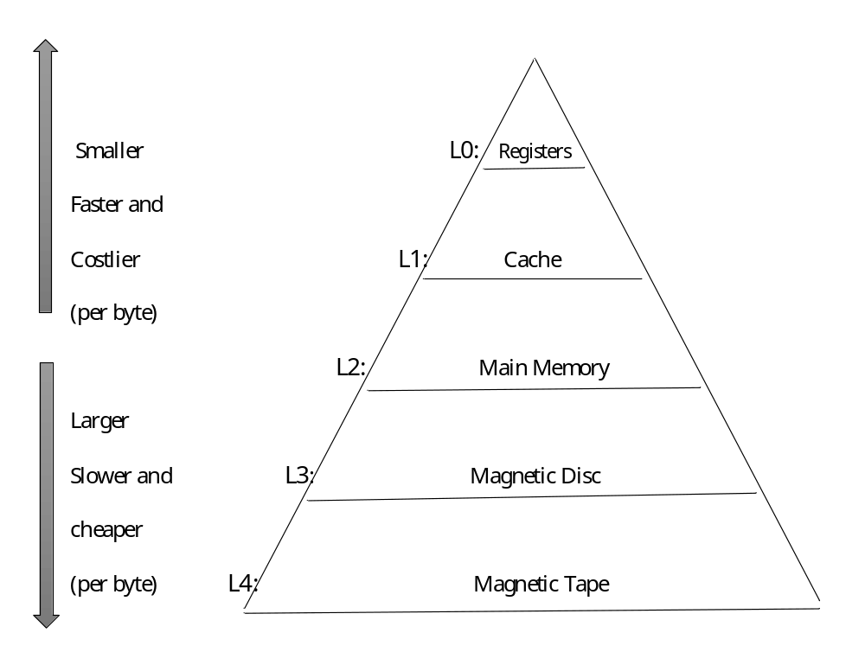

The Memory Hierarchy

The figure given below illustrates how memories at different levels of hierarchy are connected to the processor.
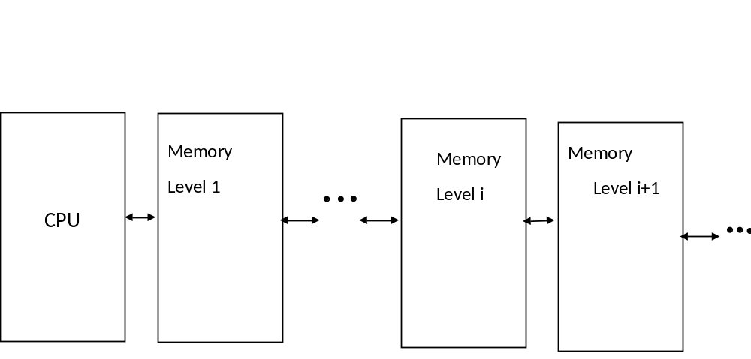 Memory Blocks at different level of Hierarchy and Connection with CPU
Question 2: What is the importance of cache memory? Explain the basic principle of working of cache memory.
Solution 2:
Importance of cache memory:
In memory hierarchy, the cache memory lies in the path between the processor and the main memory. The speeds of the main memory and the CPU vary widely. The CPU clock is very fast, whereas the main memory access time is comparatively slower. Hence, if cache memory is not there, no matter how fast the processor is, the processing speed would be dependent on the speed of the main memory. To address this issue a fast memory called cache having access time much higher than main memory is introduced between the processor and main memory. The cache memory is very expensive and hence is limited in capacity. In modern microprocessors the cache memory is on the processor chip itself.

Working principle of cache memory:
The cache memory is fast and its operating speed is comparable to that of the processor. So if the executing program and the data are in the cache memory, operating speed of the entire system can be increased. However, cache is much smaller in capacity than the main memory. So, the full code and all data cannot be loaded into the cache at an instant. However, still cache memory results in better performance because of a property of computer programs called locality of reference. To elaborate, in almost all computer programs most of their execution time is spent on routines in which instructions are executed repeatedly. Examples include simple loops, nested loops, or procedures that repeatedly call each other etc. In other words, at a given instant the instructions being executed are present in a localized area of the program and the remainder of the program is accessed relatively infrequently. So if a localized set of instructions (i.e., a sub-part of the program) are loaded into the cache at an instance, optimized performance can be achieved.
To summarize, as the cache memory is faster than the main memory, the overall processing speed is increased by making the data and instructions needed in current processing available in the cache.

It must be noted that always the instruction/data being looked for by the processor may not be present in the cache memory. Example includes, moving to a new function, exiting a loop etc. If the data/instruction requested by the processor is present in the cache, this is called a hit. If the data is not found it is called a miss. In case of a miss the required data/instruction is fetched from the main memory to the cache. It may be noted that along with the required data/instruction, other data/instructions in the locality (of the required data/instruction) are also fetched into the cache.

There are three types of cache misses
- Compulsory or Cold: The cache miss occurs as the required instruction/data is not present because, initially the cache is empty.
- Capacity: When a cache miss occurs as the required instruction/data is not present in the cache due to shortage of capacity.
- Conflict: When a cache miss occurs as the required instruction/data is not present in the cache because two blocks are mapped to the same location.

There is a mapping function, which decides where the fetched data/instructions are to be placed in the cache. If locations specified by the mapping function are already filled, one of those has to be chosen for overwriting. The locations marked for overwriting are decided by replacement algorithms. The basic idea is to choose locations, whose data/instructions are not going to be used in recent future. There are a number of replacement algorithms; some of important replacement algorithms are:

- First In First Out (FIFO)
- Least Recently Used (LRU)
- Random

Question 3: Consider a cache memory of size 8 KB and the line size (or block) 64 Bytes. The capacity of the main memory is 16 MB and memory is byte organized. Assume that any block of the main memory can be loaded into any block/line of cache memory (called associative mapping). Give the format of the memory address.

Solution 3:
- Main Memory
  - Let Main memory address (address bus) width be K Bits. So, number of addressable words = 2^{K}
  - Let Block Size = 2w words. Number of blocks in main memory is 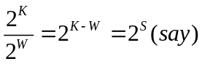
- Cache Memory
  - Let Cache memory address (address bus) width be K1 Bits. So, number of addressable words = 2^{K1}
  - In cache memory, Block size =line size= 2w words. Number of blocks in cache memory is 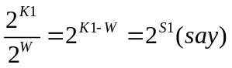

For the memory configuration given in this question
- Main Memory
  - Size of main memory = 16MB =2²⁴ Bytes. Since the memory is Byte organized (i.e., word size is 1 Byte), so memory address width is K=24 Bits. So, number of addressable words = 2²⁴.

  - Block size = 64 Bytes = 2⁶ Bytes; so, W=6. Number of blocks in main memory is 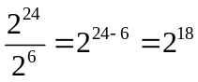; so S=18.

- Cache Memory
  - Size of cache memory = 8 KB =2¹³ Bytes. Since the memory is Byte organized, so cache memory address (address bus) width is K1=13 Bits. So, number of addressable words = 2¹³.

  - Block size = 64 Bytes = 2⁶ Bytes; so, W=6. Number of blocks in cache memory is 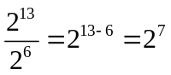; so S1=7.

The figure given below illustrates the mapping of main memory blocks to the cache memory as per fully associative scheme.

Block0
(64 Bytes)
Block1
(64 Bytes)
Block2
(64 Bytes)
………….
Block 2¹⁸-1
(64 Bytes)

Block 0  (64 Bytes) | TAG | Block 0  (64 Bytes)
Block 1  (64 Bytes) | TAG | Block 1  (64 Bytes)
Block 2  (64 Bytes) | TAG | Block 2  (64 Bytes)
Block 3  (64 Bytes) | TAG | Block 3  (64 Bytes)
 | ..............
Block 2⁷-1  (64 Bytes) | TAG | Block 2⁷-1  (64 Bytes)

Main memory Cache memory

Fully associative cache mapping

In associative mapping a main memory block can be placed anywhere in the cache. When a main memory address is generated it needs to be checked if the word addressed is present in the cache. In this mapping the main memory address is split into two parts Tag and Word. The Tag field uniquely identifies a block of main memory and the Word field indicates the offset of the word being addressed in the block. The figure given below shows how main memory address K is split into TAG address as S and Word address as W.

MSB | LSB
TAG=S | Word=W
Main memory address K is split into S and W
If we look into the figure “fully associative cache mapping” it may be noted that along with each block, there is a TAG associated. The value of the TAG is the address of the block in the main memory that is copied into the corresponding block of the cache memory.
In the example under consideration Main memory address K=24 is split into S and W as shown below.

18 | 6
TAG=S Word=W

Main memory address K=24 is split into S=18 and W=6

When a word in the main memory is to be accessed, the CPU generates the corresponding address (24 Bits). The MSB 18 Bits (i.e., the TAG) of the address is compared simultaneously with all the TAGs of the cache. If there is a match the word being addressed is present in the block whose TAG has matched. The LSB 6 Bits is the offset of the word in that block.

Question 4: Illustrate using a simple example, how cache memory can improve efficiency of program execution based locality of reference.

Question 4:

We will use the following configurations of main memory and cache memory in the example:

- Main Memory (Byte Organized)
    - Main memory size: 512 Bytes=2⁹ Bytes
    - Block Size: 8 Bytes or 23 Bytes. So number of Main Memory blocks 2⁹/2³ = 2⁶=64.

- Cache Memory (Byte Organized)
    - Cache Size: 32 Bytes=2⁵ Bytes
    - Block Size: 8 Bytes or 23 Bytes. So number of Cache Memory blocks 2⁵/2³ = 2²=4.

The cache and the main memory as per these specifications are shown below.

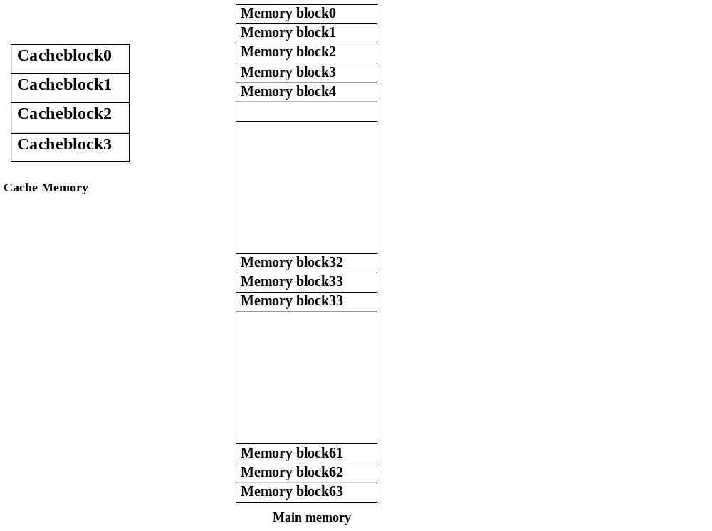
Block diagram of Cache and Main memory as per the specifications

We will use a loop which adds elements of a 1-D array as the example to show that cache memory can improve efficiency of program execution based on locality of reference. The code is given below.
High level code
s = 0;
i = 0;
L: s = s+A[i]; i++;
if (i<n) goto L;

We will consider MIPS instruction set for illustration. Each instruction in MIPS takes 4 Bytes of memory. Hence, two MIPS instructions can be stored in a Block. The equivalent MIPS code for the loop is given below.

Equivalent MIPS CODE
move $s0, $zero move $t0, $zero
L: muli $t1, $t0, 4 add $t1, $t1, $s1 lw $t2, 0($t1)
add $s0, $s0, $t2 add $t0, $t0, 1 blt $t0, $s2, L

The main memory with MIPS code loaded is shown below.

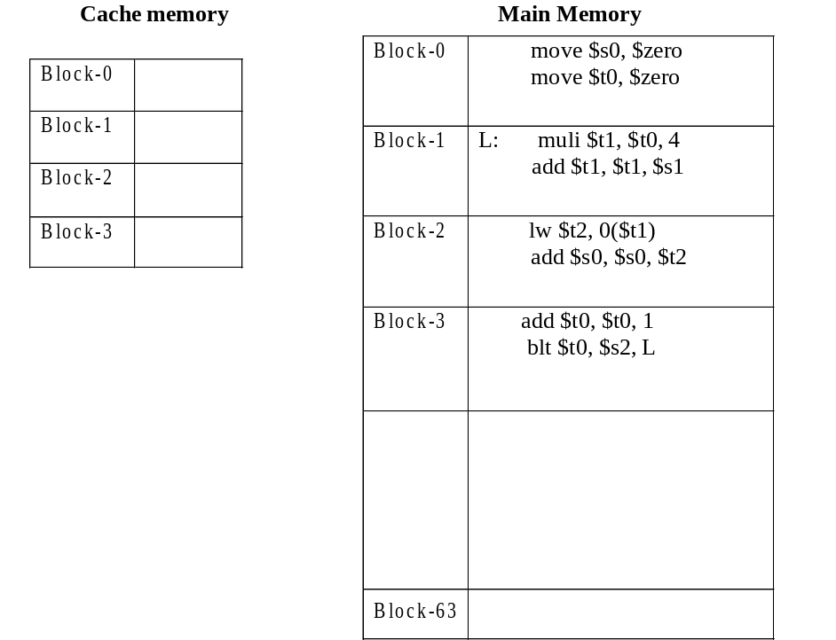
Main memory after loading the program

As it is full associative mapping and number of cache blocks are 4, 64 blocks of main memory can be mapped to any of the 4 cache blocks. In this example, the code occupies only four blocks. So there is no requirement of replacement. We have used a small code in this example as our goal is to show the efficiency of cache due to locality of reference. However, in case of large codes we need block replacement when a new block is to be loaded from main memory to cache and there is no free block in cache.
The sequences of figures given below illustrate the loading of bocks into the cache memory from main memory and then we illustrate the efficiency.
Cache status during program execution:

0 | move $s0, $zero  move $t0, $zero
1
2
3

Hits | 0
Miss | 1

Action: Miss- bring memory block 0 to cache block 0

Executing instruction move $s0, $zero from cache

0 | move $s0, $zero  move $t0, $zero
1
2
3

Hits | 1
Miss | 1

Executing instruction move $t0, $zero from cache

0 | move $s0, $zero move $t0, $zero
1 | L: muli $t1, $t0, 4  add $t1, $t1, $s1
2
3

Hits | 1
Miss | 2

Action: Miss- bring memory block 34 to cache block 1

Executing instruction muli $t1, $t0, 4 from cache
0 | move $s0, $zero move $t0, $zero
1 | L: muli $t1, $t0, 4  add $t1, $t1, $s1
2
3

Hits | 2
Miss | 2

Executing instruction add $t1, $t1, $s1 from cache

0 | move $s0, $zero move $t0, $zero
1 | L: muli $t1, $t0, 4 add $t1, $t1, $s1
2 | lw $t2, 0($t1)  add $s0, $s0, $t2
3

Hits | 2
Miss | 3

Action: Miss- bring memory block 0 to cache block 2
Executing instruction lw $t2, 0($t1) from cache

0 | move $s0, $zero move $t0, $zero
1 | L: muli $t1, $t0, 4 add $t1, $t1, $s1
2 | lw $t2, 0($t1)  add $s0, $s0, $t2
3

Hits | 3
Miss | 3

Executing instruction add $s0, $s0, $t2 from cache

0 | move $s0, $zero move $t0, $zero
1 | L: muli $t1, $t0, 4 add $t1, $t1, $s1
2 | lw $t2, 0($t1) add $s0, $s0, $t2
3 | add $t0, $t0, 1  blt $t0, $s2, L

Hits | 3
Miss | 4

Action: Miss- bring memory block 62 to cache block 3
Executing instruction add $t0, $t0, 1 from cache

0 | move $s0, $zero move $t0, $zero
1 | L: muli $t1, $t0, 4 add $t1, $t1, $s1
2 | lw $t2, 0($t1) add $s0, $s0, $t2
3 | add $t0, $t0, 1  blt $t0, $s2, L

Hits | 4
Miss | 4

Executing instruction blt $t0, $s2, L from cache

0 | move $s0, $zero move $t0, $zero
1 | L: muli $t1, $t0, 4  add $t1, $t1, $s1
2 | lw $t2, 0($t1) add $s0, $s0, $t2
3 | add $t0, $t0, 1 blt $t0, $s2, L

Hits | 5
Miss | 4

Executing instruction muli $t1, $t0, 4 from cache

0 | move $s0, $zero move $t0, $zero
1 | L: muli $t1, $t0, 4  add $t1, $t1, $s1
2 | lw $t2, 0($t1) add $s0, $s0, $t2
3 | add $t0, $t0, 1 blt $t0, $s2, L

Hits | 6
Miss | 4

Executing instruction add $t1, $t1, $s1 from cache

0 | move $s0, $zero move $t0, $zero
1 | L: muli $t1, $t0, 4 add $t1, $t1, $s1
2 | lw $t2, 0($t1)  add $s0, $s0, $t2
3 | add $t0, $t0, 1 blt $t0, $s2, L

Hits | 7
Miss | 4

Executing instruction lw $t2, 0($t1) from cache

0 | move $s0, $zero move $t0, $zero
1 | L: muli $t1, $t0, 4 add $t1, $t1, $s1
2 | lw $t2, 0($t1)  add $s0, $s0, $t2
3 | add $t0, $t0, 1 blt $t0, $s2, L

Hits | 8
Miss | 4

Executing instruction add $s0, $s0, $t2 from cache

0 | move $s0, $zero move $t0, $zero
1 | L: muli $t1, $t0, 4 add $t1, $t1, $s1
2 | lw $t2, 0($t1)  add $s0, $s0, $t2
3 | add $t0, $t0, 1 blt $t0, $s2, L

Hits | 9
Miss | 4

Executing instruction add $t0, $t0, 1 from cache

0 | move $s0, $zero move $t0, $zero
1 | L: muli $t1, $t0, 4 add $t1, $t1, $s1
2 | lw $t2, 0($t1) add $s0, $s0, $t2
3 | add $t0, $t0, 1  blt $t0, $s2, L

Hits | 10
Miss | 4

Executing instruction blt $t0, $s2, L from cache

This way the loop will iterate until t0<s2, where s2=n=100 and t0=i ; so after remaining 98 iterations (with 6 hits in each iterations)

0 | move $s0, $zero move $t0, $zero
1 | L: muli $t1, $t0, 4 add $t1, $t1, $s1
2 | lw $t2, 0($t1) add $s0, $s0, $t2
3 | add $t0, $t0, 1  blt $t0, $s2, L

Hits | 598
Miss | 4

Executing instruction blt $t0, $s2, L from cache
From the analysis we observe that we fetch two instructions (as a block) at a time from main memory to cache memory. Due to locality of reference the instructions being executed after a fetch is the immediate two instructions in sequence (most of the times). So when a new block is fetched, we have one miss but the next instruction is a hit i.e., that instruction can be directly executed from cache. Only in case of the last instruction “blt $t0, $s2, L” the control moves to a new block, however, in this example the required instruction “muli $t1, $t0, 4” is still present resulting in a hit. This result in 10 hits and only 4 misses. In other words, only four times an instruction is to be fetched from main memory to cache and other ten times the instruction is available in cache memory. This happens because while executing a code, generally the control moves within a few instructions (locality) and they are preset in cache. So most of the time the CPU can work successfully by interacting only with the cache (fast memory) and avoiding accessing the (slower) main memory. Further, the above mentioned fact is repeated for n number of iterations further improving the efficiency of cache memory. It may be noted that due to locality of reference, even in the “loop” all instructions are available in the cache.

When the loop is exited, the control will move to a new set of instructions and similar phenomenon occurs because the new set of instructions is also locally binded. However, in some extreme cases such locality does not hold and efficiency of cache is bit compromised.

