Module-4, Unit-6
Mapping Function

Question 1: The blocks of the main memory are copied to the cache when the CPU needs to access some instruction/data (unless it is already there is cache due to some previous fetch). If the block from the main memory can be copied to any free block in cache this is called fully associative mapping. Fully associative mapping seems to be most efficient in terms of usage of the cache memory. Explain using an example the implementation related issues with this mapping.

Solution 1:
We consider the following memory specification in this question. The cache memory is of size 8 KB and the line size (or block) is 64 Bytes. The capacity of the main memory is 16 MB and memory is byte organized. As the mapping is associative, any block of the main memory can be loaded into any block/line of cache memory.

- Main Memory
  - Let Main memory address (address bus) width be K Bits. So, number of addressable words = 2^{K}
  - Let Block Size = 2w words. Number of blocks in main memory is 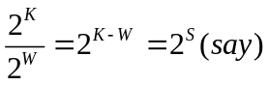
- Cache Memory
  - Let Cache memory address (address bus) width be K1 Bits. So, number of addressable words = 2^{K1}
  - In cache memory, Block size =line size= 2w words. Number of blocks in cache memory is 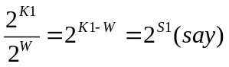.
For the memory configuration considered in the example
- Main Memory
  - Size of main memory = 16MB =2²⁴ Bytes. Since the memory is Byte organized (i.e., word size is 1 Byte), so memory address width is K=24 Bits. So, number of addressable words = 2²⁴.

  - Block size = 64 Bytes = 2⁶ Bytes; so, W=6. Number of blocks in main memory is 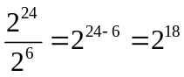; so S=18.
- Cache Memory
  - Size of cache memory = 8 KB =2¹³ Bytes. Since the memory is Byte organized, so cache memory address (address bus) width is K1=13 Bits. So, number of addressable words = 2¹³.

  - Block size = 64 Bytes = 2⁶ Bytes; so, W=6. Number of blocks in cache memory is 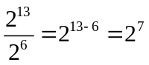; so S1=7.

When a main memory address is generated it needs to be checked if the word addressed is present in the cache. In this mapping the main memory address is split into two parts Tag and Word. The Tag field uniquely identifies a block of main memory and the Word field indicates the offset of the word being addressed in the block. In the example under consideration Main memory address K=24 is split into S and W as shown below.

18 | 6
TAG=S Word=W

Main memory address K=24 is split into S=18 and W=6

The figure given below illustrates cache memory and main memory for the memory being used as example.

Main memory Cache memory
Block0
(64 Bytes)
Block1
(64 Bytes)
Block2
(64 Bytes)
………….
Block 2¹⁸-1
(64 Bytes)

Block 0  (64 Bytes) | TAG (18 Bits) | Block 0  (64 Bytes)
Block 1  (64 Bytes) | TAG (18 Bits) | Block 1  (64 Bytes)
Block 2  (64 Bytes) | TAG (18 Bits) | Block 2  (64 Bytes)
Block 3  (64 Bytes) | TAG (18 Bits) | Block 3  (64 Bytes)
 | ..............
Block 2⁷-1  (64 Bytes) | TAG (18 Bits) | Block 2⁷-1  (64 Bytes)

Fully associative cache mapping

When a word in the main memory is to be accessed, the CPU generates the corresponding address (24 Bits). The required word can be in any block of the cache memory. So, the MSB 18 Bits (i.e., the TAG) of the address is compared simultaneously with all the TAGs of the cache. If there is a match the word being addressed is present in the block whose TAG has matched. The LSB 6 Bits is the offset of the word in that block.

It may be noted that matching the TAG part of the address (generated by CPU) with the TAGs of all the blocks of the cache simultaneously, requires separate comparators for all the blocks of the cache. An n-Bit comparator involves n XOR gates to perform bitwise comparison. Following that, the output of all the XOR gates are fed to an NOR gate. If output of any XOR gate is 1 (i.e., corresponding bit do not match), the NOR gate generates the value 0, implying non-equality. If output of all XOR gates are 0 (i.e., all corresponding bits match), the NOR gate generates the value 1, implying equality. The number of gates required for designing the comparator circuit for associate cache mapping can be derived as follows:

- Number of comparator circuits needed = number of blocks in cache memory

- Number of XOR gates needed = number of bits in tag field * number of blocks in cache memory

- Number of NOR gates are needed = Number of blocks in cache memory

This is a serious implementation issue because of the area overhead of the comparators.

The figure given below illustrates the block diagram for comparing the TAG value of CPU generated address with the TAG of the blocks of the cache memory.
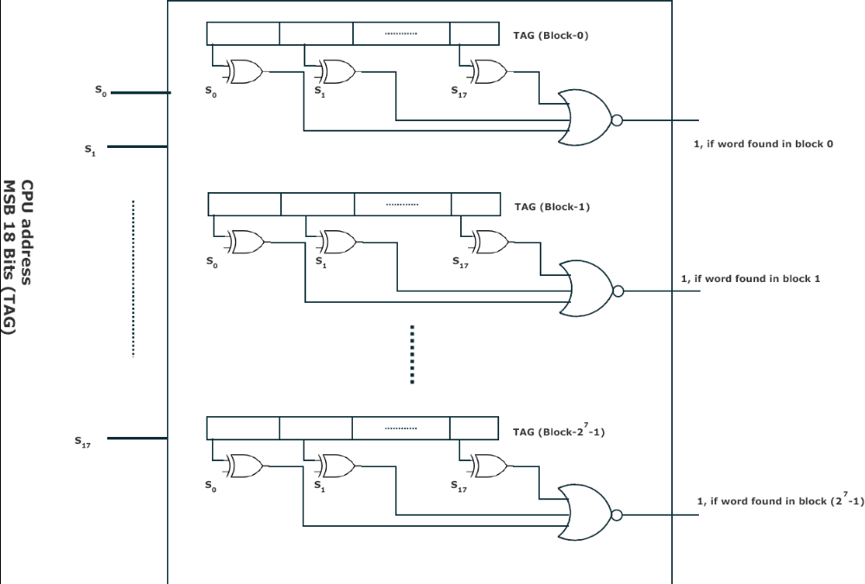

Comparing the TAG value of CPU generated address with the cache memory TAGs

To conclude, associative mapping makes best use of the cache memory as any block of the main memory can be loaded into any block of the cache memory. The major issue with this scheme is the use of “individual comparators for each block in the cache”, resulting is very high area overhead.

Question 2: Although fully associative mapping is most efficient in terms of usage of the cache memory, there are issues with implementation (as identified in last answer). Explain using an example some other alternative cache mapping that addresses this issue. Also highlight the cons of the new mapping.

Solution 2: We consider the following memory specification in this answer (similar to Question 1). The cache memory is of size 8 KB and the line size (or block) is 64 Bytes. The capacity of the main memory is 16 MB and memory is byte organized. Direct mapping is assumed in this case.

- Main Memory
  - Let Main memory address (address bus) width be K Bits. So, number of addressable words = 2^{K}.
  - Let Block Size = 2w words. Number of blocks in main memory is.
- Cache Memory
  - Let Cache memory address (address bus) width be K1 Bits. So, number of addressable words = 2^{K1}
  - In cache memory, Block size =line size= 2w words. Number of blocks in cache memory is .
For the memory configuration considered in the example
- Main Memory

  - Size of main memory = 16MB =2²⁴ Bytes. Since the memory is Byte organized (i.e., word size is 1 Byte), so memory address width is K=24 Bits. So, number of addressable words = 2²⁴.

  - Block size = 64 Bytes = 2⁶ Bytes; so, W=6. Number of blocks in main memory is ; so S=18.
- Cache Memory

  - Size of cache memory = 8 KB =2¹³ Bytes. Since the memory is Byte organized, so cache memory address (address bus) width is K1=13 Bits. So, number of addressable words = 2¹³.

  - Block size = 64 Bytes = 2⁶ Bytes; so, W=6. Number of blocks in cache memory is ; so S1=7.

The simplest way in terms of ease of implementation to map a main memory block to the cache is to assign the cache location based on the address of the main memory. This method is called Direct Mapping, since each main memory block is mapped (directly) to exactly one block in the cache, irrespective of other cache blocks being free. In other words, direct mapping maps each block of main memory into only one possible cache block.

The mapping is expressed as follows:
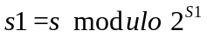
Where,
- s is main memory block number, as per the address generated by the CPU.
- s1 is cache block number, where the corresponding main memory block is to be mapped.
- 2^{S1} is number of blocks in the cache.

When a main memory address is generated it needs to be checked if the word addressed is present in the cache. In this mapping the main memory address is split into three parts TAG, LINE and WORD. The Tag and Line field together identifies a block of main memory and the Word field indicates the offset of the word being addressed in the block. In the example under consideration (Question 1) Main memory address K=24 is split into TAG, LINE and WORD as shown below.

11 | 7 | 6
TAG=S-S1 LINE=S1 Word=W

Main memory address K=24 is split into TAG=11, LINE=7 and WORD=6

To elaborate, the least significant W Bits (of CPU generated address) identifies the word within the block of main memory. The remaining S Bits specify one of the 2s blocks of main memory. The cache has 2^{S1} blocks. The cache logic interprets these S bits as a TAG of S – S1 Bits (most significant portion) and a LINE field of S1 Bits. This LINE field identifies one of the 2^{S1} blocks of the cache. To elaborate, the LINE field identifies the block number of the cache where the corresponding main memory block is present or can be loaded. So the scheme of direct mapping provides a unique location for each block of main memory in the cache. The unique mapping is determined by the “modulo” operation. For example, the 1st block of main memory can be loaded only into the 1st block of the cache; the 2nd block of main memory can be loaded only into the 2nd block of the cache, and so on. Continuing in a similar fashion, (2^{S1} – 1)^{th} block of main memory can be loaded only into the (2^{S1} – 1)^{th} block (last block) of the cache. Following that, the next sequence of main memory blocks are loaded into the cache memory in a modulo fashion i.e., the (2^{S1})^{th} block of main memory can be loaded only into the 1th block of the cache. The figure given below shows the modulo based “mapping of blocks of main memory to blocks of the cache”

Cache Block | Main memory block assigned
0 | 0, 2^{S1}, 2(2^{S1}), … , 2s-2^{S1}
1 | 1, 2^{S1} + 1, 2(2^{S1} ) + 1, … , 2s-2^{S1} + 1
… | …
2^{S1} - 1 | (2^{S1} – 1), 2(2^{S1}) - 1, 3(2^{S1}) - 1, … , 2s - 1
Mapping blocks of main memory to blocks of the cache

A small example is shown in the figure below where the cache has 8 blocks and main memory has 32 blocks. The 3 Bits LSB (S1) of the block address of the main memory (S) determines the block of cache where it is mapped; these 3 LSB Bits comprise the LINE. Since each block of cache memory can be mapped to only one block in the cache memory (which is determined LINE), the TAG of the cache comprises the remaining 2 Bits MSB (S-S1) of the block address of the main memory; these 2 MSB Bits comprise the TAG.
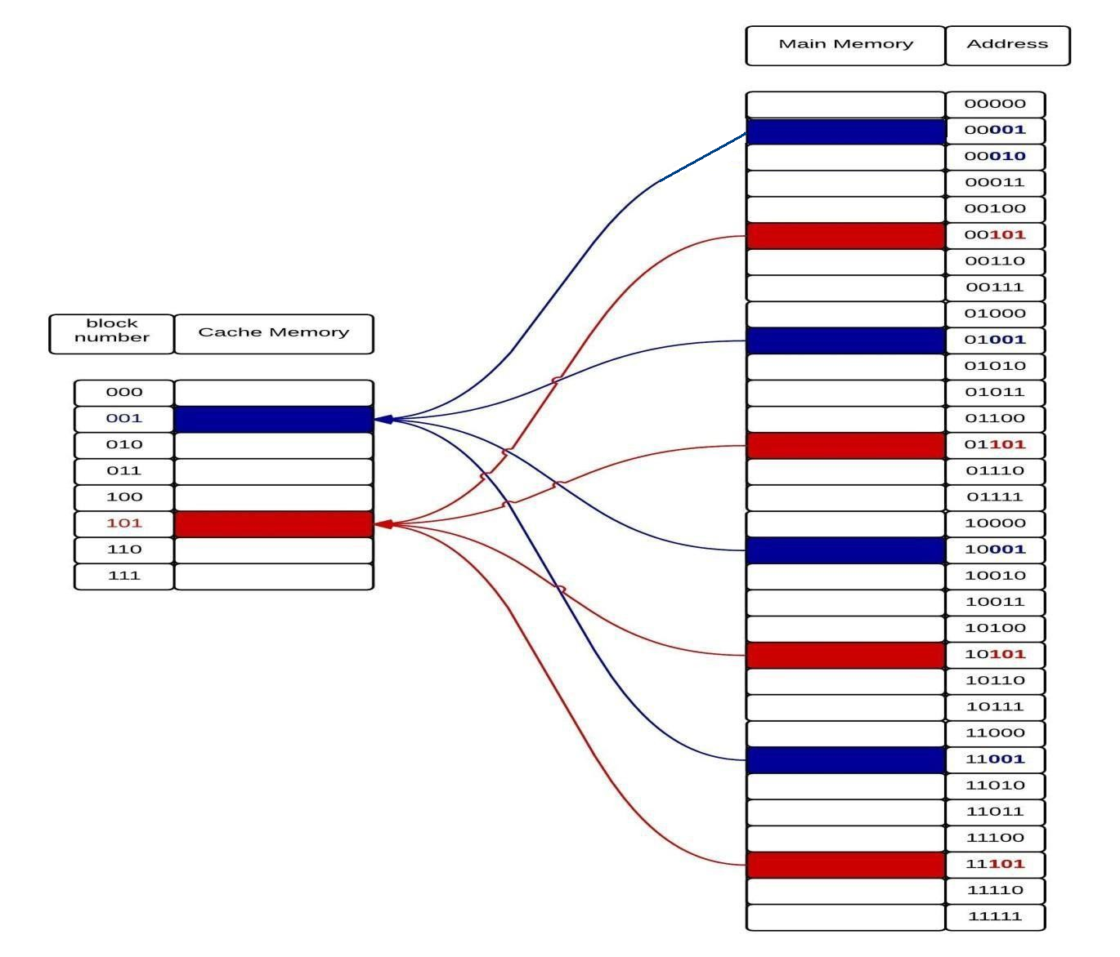

Mapping to main memory blocks to cache blocks under direct-mapping

For example, the 1st (00000), 8th (01000), 16th (10000) and 32nd (11000) main memory blocks can be mapped to 1st block (000) of the cache. As these four blocks cannot be mapped to any other cache blocks, if the 1st main memory block is present in the cache the TAG of the first cache block holds the value 00. Similarly, if the 8th, 16th or 32nd main memory block is present in the cache the TAG of the first cache block holds the value 01, 10 and 11, respectively.

The figure given below illustrates cache memory and main memory for the memory being used as example (Question 1).

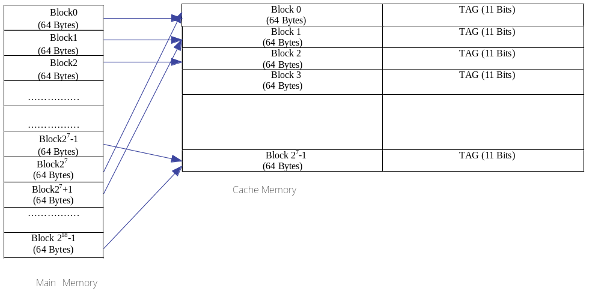Direct cache mapping

When a word in the main memory is to be accessed, the CPU generates the corresponding address k, say (24 Bits). First, the address is divided into WORD (W= 6 Bits LSB), the LINE (7 Bits) and the TAG (11 Bits MSB). The required word can be only in a given block of the cache memory determined by modulo operation. So, the 7 Bits (i.e., the LINE) is used to generate the address of the cache memory block. The corresponding TAG of cache memory is searched for the 11 MSB Bits. If there is a match the word being addressed is present in the block. The 6 Bits (WORD) is the offset of the word in that block.
The figure given below illustrates the block diagram for comparing the TAG value of CPU generated address with the TAG of the cache memory block whose address is given in the LINE field.

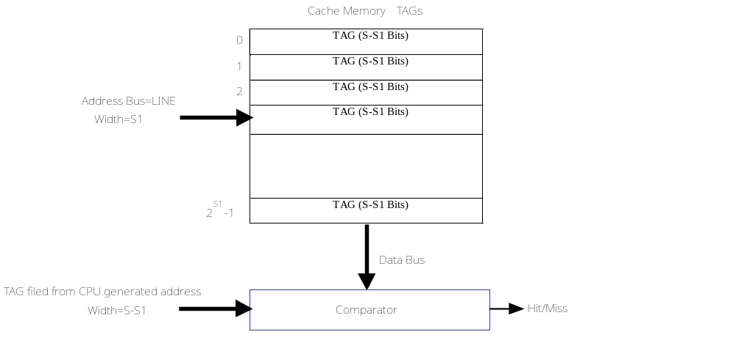
Comparing the TAG value of CPU generated address with the TAG of the cache memory in direct mapping.

Pros of Direct mapping:

This mapping is inexpensive to implement mainly because the area overhead of the comparator logic is very low. As already discussed, in the direct mapping we need a single comparator, which compares the value of the TAG of the cache block selected with the TAG of the address generated by the CPU.

Cons of Direct mapping:
The main disadvantage in direct cache mapping is due to the predetermined location of main memory blocks in the cache memory. Thus, if a program requires words repeatedly from two different blocks that map into the same cache block, then the blocks will be continually swapped into the cache, and the hit ratio will be low; phenomenon known as thrashing. To generalize, if a cache block is already occupied and a new main memory block is to be fetched, which also maps to the same cache block, then the old entry is to be replaced. This holds even if some other cache block was free. This reduces the hit ratio because the replaced block may be required in near future leading to thrashing.

Question 3: Based on the pros and cons of associative mapping versus direct mapping, suggest some hybrid mapping scheme that uses features from both these alternatives. Explain using an example.

Solution 3: We consider the following memory specification in this answer (similar to Question 1). The cache memory is of size 8 KB and the line size (or block) is 64 Bytes. The capacity of the main memory is 16 MB and memory is byte organized. Set associative mapping is assumed in this case, where 4-way set associatively is assumed.
In set-associative mapping the cache blocks are divided into sets. In this approach, a main memory block will always be mapped to a single cache set based on modulo operation. However, within the set, the main block can be placed at any cache block. Therefore direct mapping occurs at the set level and fully associated mapping occurs within a set; so it is a hybrid mapping scheme.

- Main Memory
  - Let Main memory address (address bus) width be K Bits. So, number of addressable words = 2^{K}.
  - Let Block Size = 2w words. Number of blocks in main memory is.
- Cache Memory
  - Let Cache memory address (address bus) width be K1 Bits. So, number of addressable words = 2^{K1}
  - In cache memory, Block size =line size= 2w words. Number of blocks in cache memory is .
  - Let the cache be arranged as L-way set associative i.e., in a set there can be L-blocks. Also, let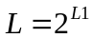. So the number of sets is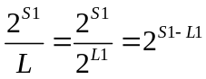.
For the memory configuration considered in the example
- Main Memory

  - Size of main memory = 16MB =2²⁴ Bytes. Since the memory is Byte organized (i.e., word size is 1 Byte), so memory address width is K=24 Bits. So, number of addressable words = 2²⁴.

  - Block size = 64 Bytes = 2⁶ Bytes; so, W=6. Number of blocks in main memory is ; so S=18.
- Cache Memory

  - Size of cache memory = 8 KB =2¹³ Bytes. Since the memory is Byte organized, so cache memory address (address bus) width is K1=13 Bits. So, number of addressable words = 2¹³.

  - Block size = 64 Bytes = 2⁶ Bytes; so, W=6. Number of blocks in cache memory is ; so S1=7.

  - The cache is arranged as 4-way set associative i.e., in a set there are 4-blocks; here L=4 and L1 =2. So the number of sets is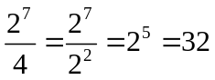.

The set-associate is expressed as follows:
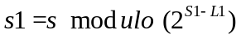
Where,
- s is main memory block number, as per the address generated by the CPU.
- s1 is cache set number, where the corresponding main memory block is to be mapped. In s1 the main memory block can be mapped to any of the L cache blocks.
- S1 is number of blocks in the cache and 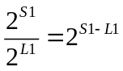 is the number of sets in the cache.
When a main memory address is generated it needs to be checked if the word addressed is present in the cache. In this mapping the main memory address is split into three parts TAG, SET and WORD. The TAG and SET fields together identify a block of main memory and the Word field indicates the offset of the word being addressed in the block. In the example under consideration (Question 1) Main memory address K=24 is split into TAG, SET and WORD as shown below.

13 | 5 | 6
TAG=S-S1+L1 SET=S1-L1 Word=W

Main memory address K=24 is split into TAG=13, SET=5 and WORD=6

To elaborate, the least significant W Bits (of CPU generated address) identifies the word within the block of main memory. The remaining S Bits specify one of the 2s blocks of main memory. The cache has 2^{S1} blocks and 2^{S1-L1} sets. The cache logic interprets these S bits as a TAG of S – S1+L1 Bits (most significant portion) and a SET field of S1-L1 Bits. This SET field identifies one of the 2^{S1-L1} blocks of the cache. To elaborate, the SET field identifies the set number of the cache where the corresponding main memory block is present or can be loaded. Inside the set, the main memory block can be present in any of the cache blocks. The TAG field identifies the exact cache memory block in the set where the main memory block being addressed is loaded. So the scheme of set-associative mapping provides a unique location for each block of main memory in the cache set (similar to direct mapping) but inside the set the mapping is flexible (similar to associative mapping). The unique mapping is determined by the “modulo” operation.

For example, the 1st block of main memory can be loaded only into the 1st set of the cache; the 2nd block of main memory can be loaded only into the 2nd set of the cache, and so on. Continuing in a similar fashion, (2^{S1-L1} – 1)^{th} block of main memory can be loaded only into the (2^{S1-L1} – 1)^{th} set (last set) of the cache. Following that, the next sequence of main memory blocks are loaded into the cache memory in a modulo fashion i.e., the (2^{S1-L1})^{th} block of main memory can be loaded only into the 1th set of the cache. The figure given below shows the modulo based “mapping of blocks of main memory to sets of the cache”

Cache Set | Main memory block assigned
0 | 0, 2 ^{S1-L1}, 2(2 ^{S1-L1}), … , 2s-2 ^{S1-L1}
1 | 1, 2 ^{S1-L1} + 1, 2(2 ^{S1-L1} ) + 1, … , 2s-2 ^{S1-L1}+1 + 1
… | …
2^{S1-L1} - 1 | (2^{S1-L1} – 1), 2(2 ^{S1-L1}) - 1, 3(2 ^{S1-L1}) - 1, … , 2s - 1
Mapping blocks of main memory to blocks of the cache

Now, inside each cache set (say 0) the main memory blocks mapped to that set (0, 2 ^{S1-L1}, 2(2 ^{S1-L1}), … , 2s-2 ^{S1-L1}, for the 0th set) can be placed in any one of the L1 cache blocks.

The figure given below illustrates cache memory and main memory for the memory being used as example (Question 1).
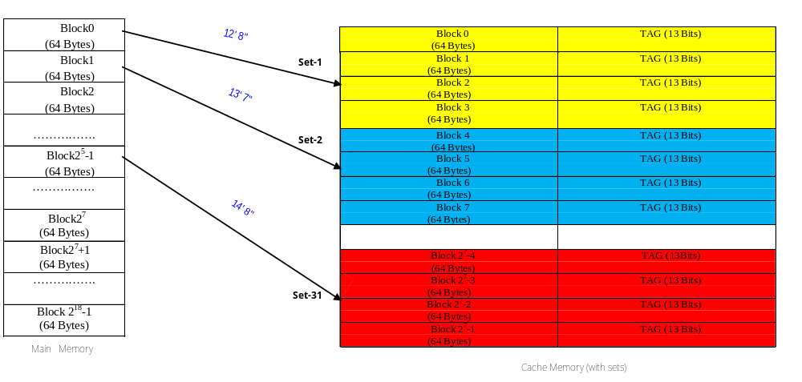 Set-associative cache mapping

When a word in the main memory is to be accessed, the CPU generates the corresponding address k, say (24 Bits). First, the address is divided into WORD (W= 6 Bits LSB), the SET (5 Bits) and the TAG (13 Bits MSB). The required word can be only in a given set of the cache memory determined by modulo operation. So, the 5 Bits (i.e., the SET) is used to generate the address of the cache set. The TAGs of all the cache blocks in the SET are simultaneously searched for the 13 MSB Bits. If there is a match the word being addressed is present in that block of the set. The 6 Bits (WORD) is the offset of the word in that block.
The figure given below illustrates the block diagram for comparing the CPU generated address with the TAG, SET and WORD fields. In the diagram is it assumed that W=000000 (i.e., word being address is the first in the block), SET=00101 (i.e., the block can be present in set 5 of the cache). Now TAGs of all the four blocks in SET 5 will be compared to TAG of memory address (13 Bits). If there is a match the main memory block is present in that block of the cache; else there is a miss and there is a need to fetch from main memory.

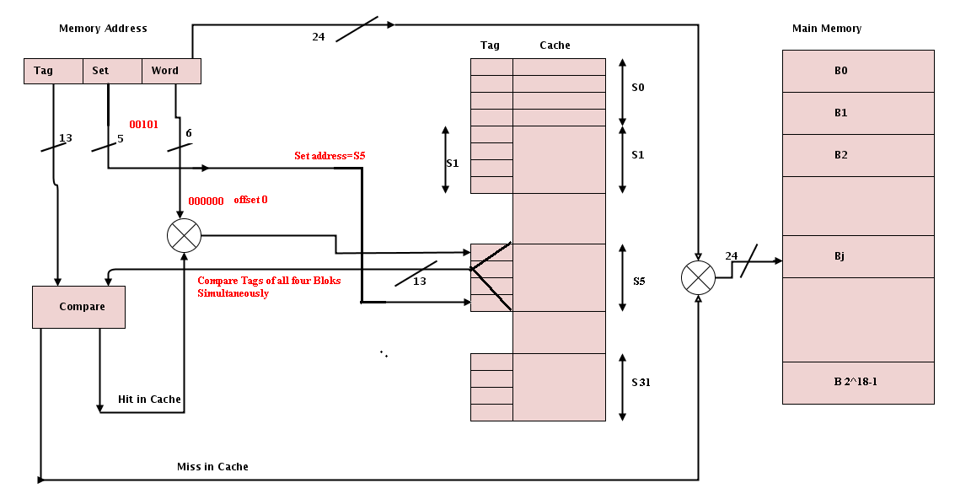
Comparing the CPU generated address with the TAG, SET and WORD fields in set associative mapping.

The number of gates required for designing the comparator circuit for set-associative cache mapping can be derived as follows:

- Number of comparator circuits needed = number of blocks in a set of cache memory
- Number of XOR gates needed = number of bits in tag field * number of blocks
in a set of the cache memory
- Number of NOR gates are needed = Number of blocks in a set of the cache memory

It may be noted as the number of blocks in a set of cache memory is low the area overhead because of the comparators is much lower compared to associative mapping. Also, the issue of a single fixed cache block for a main memory block (direct mapping) is eliminated to an extent. This is because now a main memory block can be mapped to any block in a given set of the cache memory. It may be noted that however, set associative mapping is not as flexible as associative mapping in terms of cache usage because some sets may be over loaded and others may not have many blocks. In other words, in set associative mapping flexibility is only within a set whereas in associative mapping the flexibility is all throughout the cache memory.

Solution 4:

We will use the following configurations of main memory and cache memory in the example:

- Main Memory (Byte Organized)
    - Main memory size: 512 Bytes=2⁹ Bytes
    - Block Size: 8 Bytes or 23 Bytes. So number of Main Memory blocks 2⁹/2³ = 2⁶=64.

- Cache Memory (Byte Organized)
    - Cache Size: 32 Bytes=2⁵ Bytes
    - Block Size: 8 Bytes or 23 Bytes. So number of Cache Memory blocks 2⁵/2³ = 2²=4.

The cache and the main memory as per these specifications are shown below.

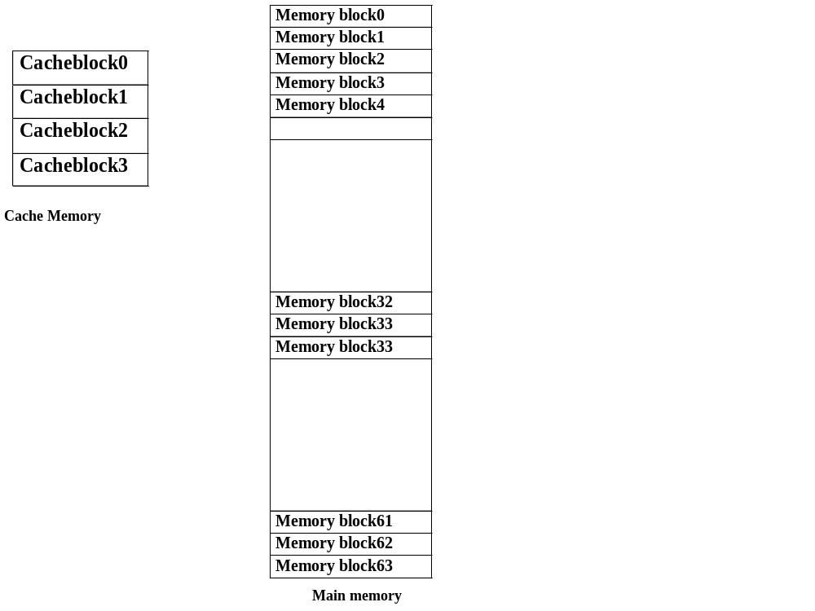Block diagram of Cache and Main memory as per the specifications

We will use a loop which adds elements of a 1-D array as the example to show that cache memory can improve efficiency of program execution based on locality of reference. The code is given below.
High level code
s = 0;
i = 0;
L: s = s+A[i]; i++;
if (i<n) goto L;

We will consider MIPS instruction set for illustration. Each instruction in MIPS takes 4 Bytes of memory. Hence, two MIPS instructions can be stored in a Block. The equivalent MIPS code for the loop is given below.

Equivalent MIPS CODE
move $s0, $zero move $t0, $zero
L: muli $t1, $t0, 4
add $t1, $t1, $s1
lw $t2, 0($t1)
add $s0, $s0, $t2 add $t0, $t0, 1
blt $t0, $s2, L

We will illustrate the performance of cache memory in terms of hit and misses for the code give above for associative and direct mapping polices. As it is full associative mapping and number of cache blocks are 4, 64 blocks of main memory can be mapped to any of the 4 cache blocks. In this example, the code occupies only four blocks. So there is no requirement of replacement. We have used a small code in this example as our goal is to show the efficiency of cache due to mapping scheme and not on replacement policy. However, for completeness we assume FIFO and the replacement scheme for associative mapping.

Fully Associative Cache mapping

The figure given below illustrates the initial content of the cache memory and the main memory. We assume that the program in not located in contiguous memory location of the main memory.

Initial configuration

Cache memory Main Memory

0 | lw $t2,0($t1)  add $s0, $s0,$t2
1 | move $s0,$zero move $t0,$zero
2
3
32
33
34 | L: muli $t1, $t0,4  add $t1, $t1,$s1
35
60
61
62 | add $t0, $t0,1  blt $t0, $s2,L
63

Main memory after loading the program and empty cache memory

As the mapping is associative, any main memory block can be mapped to any cache block. The figures given below show the sequence of cache and main memory configurations while the code is being executed instruction wise. Finally, we will also calculate the hit ratio.

FIFO order
0
0 | move $s0,$zero  move $t0,$zero
1
2
3

Hits | 0
Miss | 1

Action: Miss- bring memory block 1 to cache block 0
Executing instruction move $s0, $zero from cache

FIFO order
0
0 | move $s0,$zero  move $t0,$zero
1
2
3

Hits | 1
Miss | 1

Executing instruction move $t0, $zero from cache

FIFO order
1, 0
0 | move $s0,$zero move $t0,$zero
1 | L: muli $t1, $t0,4  add $t1, $t1,$s1
2
3

Hits | 1
Miss | 2

Action: Miss- bring memory block 34 to cache block 1

Executing instruction muli $t1, $t0, 4 from cache
FIFO order
1, 0
0 | move $s0,$zero move $t0,$zero
1 | L: muli $t1, $t0,4  add $t1, $t1,$s1
2
3

Hits | 2
Miss | 2

Executing instruction add $t1, $t1, $s1from cache

FIFO order
2, 1,0
0 | move $s0,$zero move $t0,$zero
1 | L: muli $t1, $t0,4 add $t1, $t1,$s1
2 | lw $t2, 0($t1)  add $s0, $s0,$t2
3

Hits | 2
Miss | 3

Action: Miss- bring memory block 0 to cache block 2

Executing instruction lw $t2, 0($t1) from cache

FIFO order
2, 1,0
0 | move $s0,$zero move $t0,$zero
1 | L: muli $t1, $t0,4 add $t1, $t1,$s1
2 | lw $t2,0($t1)  add $s0, $s0, $t2
3

Hits | 3
Miss | 3

Executing instruction add $s0, $s0, $t2 from cache

FIFO order
3, 2, 1,0
0 | move $s0,$zero move $t0,$zero
1 | L: muli $t1, $t0,4 add $t1, $t1,$s1
2 | lw $t2,0($t1) add $s0, $s0,$t2
3 | add $t0, $t0,1  blt $t0, $s2,L

Hits | 3
Miss | 4

Action: Miss- bring memory block 62 to cache block 3

Executing instruction add $t0, $t0, 1 from cache

FIFO order
3, 2, 1,0
0 | move $s0,$zero move $t0,$zero
1 | L: muli $t1, $t0,4 add $t1, $t1,$s1
2 | lw $t2,0($t1) add $s0, $s0,$t2
3 | add $t0, $t0,1  blt $t0, $s2,L

Hits | 4
Miss | 4

Executing instruction blt $t0, $s2, L from cache

FIFO order
3, 2, 1,0
0 | move $s0,$zero move $t0,$zero
1 | L: muli $t1, $t0,4  add $t1, $t1,$s1
2 | lw $t2,0($t1) add $s0, $s0,$t2
3 | add $t0, $t0,1 blt $t0, $s2,L

Hits | 5
Miss | 4

Executing instruction muli $t1, $t0, 4 from cache

FIFO order
3, 2, 1,0
0 | move $s0,$zero move $t0,$zero
1 | L: muli $t1, $t0,4  add $t1, $t1,$s1
2 | lw $t2,0($t1) add $s0, $s0,$t2
3 | add $t0, $t0,1 blt $t0, $s2,L

Hits | 6
Miss | 4

Executing instruction add $t1, $t1, $s1 from cache

FIFO order
3, 2, 1,0
0 | move $s0,$zero move $t0,$zero
1 | L: muli $t1, $t0,4 add $t1, $t1,$s1
2 | lw $t2, 0($t1)  add $s0, $s0,$t2
3 | add $t0, $t0,1 blt $t0, $s2,L

Hits | 7
Miss | 4

Executing instruction lw $t2, 0($t1) from cache

FIFO order
3, 2, 1,0
0 | move $s0,$zero move $t0,$zero
1 | L: muli $t1, $t0,4 add $t1, $t1,$s1
2 | lw $t2,0($t1)  add $s0, $s0, $t2
3 | add $t0, $t0,1 blt $t0, $s2,L

Hits | 8
Miss | 4

Executing instruction add $s0, $s0, $t2 from cache

FIFO order
3, 2, 1,0
0 | move $s0,$zero move $t0,$zero
1 | L: muli $t1, $t0,4 add $t1, $t1,$s1
2 | lw $t2,0($t1) add $s0, $s0,$t2
3 | add $t0, $t0,1  blt $t0, $s2,L
Hits | 9
Miss | 4

Executing instruction add $t0, $t0, 1 from cache

FIFO order
3, 2, 1,0
0 | move $s0,$zero move $t0,$zero
1 | L: muli $t1, $t0,4 add $t1, $t1,$s1
2 | lw $t2,0($t1) add $s0, $s0,$t2
3 | add $t0, $t0,1  blt $t0, $s2,L

Hits | 10
Miss | 4

Executing instruction blt $t0, $s2, L from cache

In this manner the loop will iterate until t0<s2, where s2=n=100 and t0=i. So after remaining 98 iterations (with 6 hits in each iterations)

FIFO order
3, 2, 1,0
0 | move $s0,$zero move $t0,$zero
1 | L: muli $t1, $t0,4 add $t1, $t1,$s1
2 | lw $t2,0($t1) add $s0, $s0,$t2
3 | add $t0, $t0,1  blt $t0, $s2,L

Hits | 598
Miss | 4

Executing instruction blt $t0, $s2, L from cache

Finally, the Hit Ratio=hits/ (hits+miss)=598/602=0.99335548=0.99.

Direct Cache mapping

The figure given below illustrates the initial content the main memory and possible mapping of main memory blocks to cache memory blocks. We assume that the program in not located in contiguous memory locations of the main memory. As the mapping is direct the main memory blocks are mapped to cache memory blocks using modulo operation. The main memory block numbers shown in the cache memory represent the cache block whey they can be loaded. For example, block 0 of cache memory can load main memory blocks 0,4,8,12,16,20,24,28,32,36…..60. The block numbers marked in bold in the cache memory correspond to the main memory blocks where the current code being executed is loaded.

Cache memory
(Possible mapping of Main Memory Blocks) Main Memory
0,4,8,12,16,20,24,28,32,36…..60
1,5,9,13,17,21,25,29,33,37….61
2,6,10,14,18,22,26,30,34,……62
3,7,11,14,19,23,27,31,35…….63
0  0 | lw $t2,0($t1)  add $s0, $s0,$t2
1 | move $s0,$zero move $t0,$zero
2
3
32
33
34 | L: muli $t1, $t0,4  add $t1, $t1,$s1
35
60
61
62 | add $t0, $t0,1  blt $t0, $s2,L
63
Initial configuration of Main Memory and possible cache mapping
As the mapping is direct, a main memory block can be mapped to only one cache block (by modulo operation), as shown in the last figure. So, there is no requirement of any block replacement scheme. If the cache block in which the new main memory block being fetched is mapped, the new block replaces the old one.

The figures given below show the sequence of cache and main memory configurations while the code is being executed instruction wise. Finally, we will also calculate the hit ratio.

0
1 | move $s0,$zero  move $t0,$zero
2
3

Hits | 0
Miss | 1

Cache miss for move $s0,$zero instruction

0
1 | move $s0,$zero  move $t0,$zero
2
3

Hits | 1
Miss | 1

Cache hit for move $t0,$zero instruction

0
1 | move $s0,$zero move $t0,$zero
2 | L: muli $t1, $t0,4  add $t1, $t1,$s1
3

Hits | 1
Miss | 2

Cache miss for muli $t1, $t0,4 instruction

0
1 | move $s0,$zero move $t0,$zero
2 | L: muli $t1, $t0,4  add $t1, $t1,$s1
3

Hits | 2
Miss | 2

Cache hit for add $t1, $t1,$s1 instruction

0 | lw $t2,0($t1)  add $s0, $s0,$t2
1 | move $s0,$zero move $t0,$zero
2 | L: muli $t1, $t0,4  add $t1, $t1,$s1
3

Hits | 2
Miss | 3

Cache miss for lw $t2,0($t1) instruction

0 | lw $t2,0($t1)  add $s0, $s0,$t2
1 | move $s0,$zero move $t0,$zero
2 | L: muli $t1, $t0,4  add $t1, $t1,$s1
3

Hits | 3
Miss | 3

Cache hit for add $s0, $s0,$t2 instruction

0 | lw $t2,0($t1)  add $s0, $s0,$t2
1 | move $s0,$zero move $t0,$zero
2 | add $t0, $t0,1  blt $t0, $s2,L
3

Hits | 3
Miss | 4

Cache miss for add $t0, $t0,1 instruction
(Cache block 2 had main memory block 34. Now replaced with main memory block 62)

0 | lw $t2,0($t1)  add $s0, $s0,$t2
1 | move $s0,$zero move $t0,$zero
2 | add $t0, $t0,1  blt $t0, $s2,L
3

Hits | 4
Miss | 4

Cache hit for blt $t0, $s2,L instruction
(END of 1st Iteration)

Next Iteration

0 | lw $t2,0($t1)  add $s0, $s0,$t2
1 | move $s0,$zero move $t0,$zero
2 | L: muli $t1, $t0,4  add $t1, $t1,$s1
3

Hits | 4
Miss | 5

Cache miss for muli $t1, $t0,1 instruction
(Cache block 2 had main memory block 62. Now replaced with main memory block 34)

0 | lw $t2,0($t1)  add $s0, $s0,$t2
1 | move $s0,$zero move $t0,$zero
2 | L: muli $t1, $t0,4  add $t1, $t1,$s1
3

Hits | 5
Miss | 5

Cache hit for add $t1, $t1,$s1 instruction

0 | lw $t2,0($t1)  add $s0, $s0,$t2
1 | move $s0,$zero move $t0,$zero
2 | L: muli $t1, $t0,4  add $t1, $t1,$s1
3

Hits | 6
Miss | 5

Cache hit for lw $t2,0($t1) instruction

0 | lw $t2,0($t1)  add $s0, $s0,$t2
1 | move $s0,$zero move $t0,$zero
2 | L: muli $t1, $t0,4  add $t1, $t1,$s1
3

Hits | 7
Miss | 5

Cache hit for add $s0, $s0,$t2 instruction

0 | lw $t2,0($t1)  add $s0, $s0,$t2
1 | move $s0,$zero move $t0,$zero
2 | L: muli $t1, $t0,4  add $t1, $t1,$s1
3

Hits | 7
Miss | 6

Cache miss for muli $t1, $t0,1 instruction
(Cache block 2 had main memory block 62. Now replaced with main memory block 34)

0 | lw $t2,0($t1)  add $s0, $s0,$t2
1 | move $s0,$zero move $t0,$zero
2 | L: muli $t1, $t0,4  add $t1, $t1,$s1
3

Hits | 8
Miss | 6

Cache hit for add $t1, $t1,$s1 instruction
(end of 2nd Iteration)

After remaining 98 iterations

0 | lw $t2,0($t1)  add $s0, $s0,$t2
1 | move $s0,$zero  move $t0,$zero
2 | add $t0, $t0,1  blt $t0, $s2,L
3

Hits | 202
Miss | 400

Cache hit for blt $t0, $s2,L instruction

Hit Ratio = 400/602=0.66
To conclude, associative mapping makes best use of the cache memory as any block of the main memory can be loaded into any block of the cache memory. So the hit ratio for the example code in case of associative mapping is 0.99. The major issue with this scheme is the use of “individual comparators for each block in the cache”, resulting is very high area overhead. The alternative is direct mapping where the area overhead of the comparator is low. But the space utilization of cache memory not optimized because a main memory block can be mapped to only one cache block based on modulo operation. So the hit ratio for the example code in case of associative mapping is 0.99.

