Module-5, Unit-2
I/O Instructions and Addressing of I/O devices

Question 1: If there are multiple I/O devices, what is the basic technique to address them?

Solution 1:

In general, in a computer system there are multiple I/O devices and each of them is identified by a unique address. When the processor issues an I/O command, the command contains the address of the device that is used by the command. The I/O devices must interpret the address lines to check if the command is for itself. Generally in most of the systems, the processor, main memory and I/O devices share a common bus (data address and control bus).

Two types of addressing are possible:
- Memory-mapped I/O
- Isolated or I/O mapped I/O

Memory-mapped I/O:
In this technique there is a single address space for memory locations and I/O devices.
The processor treats the status and address register of the I/O devices as memory location. If the size of address bus of a processor is n then there are 2^{n} combinations and all together 2^{n} address locations can be addressed with these n address lines. Out of these 2^{n} address locations, some address locations can be used to address I/O devices and other locations are used to address memory locations. Since I/O devices are included in the same memory address space, so the status and address registers of I/O modules are treated as memory location by the processor. Therefore, the same machine instructions are used to access both memory and I/O devices.

Isolated or I/O mapped I/O:
In this scheme, the full range of addresses may be available for both. The address refers to a memory location or an I/O device is specified with the help of a command line. In general, command line 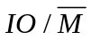is used to identify a memory location or an I/O device. If 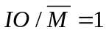, it indicates that the address present in address bus is the address of an I/O device. Otherwise, if 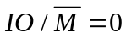, it indicates that the address present in address bus is the address of a memory location. Since full range of address is available for both memory and I/O devices, so, with n address lines, the system may now support both 2^{n} memory locations and 2^{n} I/O addresses.

Question 2: We know that I/O devices vary substantially in their characteristics i.e., data processing rate, data format etc. However, the user does not have to be familiar with the characteristics of physical I/O devices. Instead, the user performs data transfer between the CPU and I/O devices indirectly by using I/O instructions, which are semantically similar to ordinary instructions. Explain using proper examples of I/O instructions, how the CPU communicates with I/O devices.

Solution 2:

There are three basic forms of exchanging data between I/O devices and CPU –

- Programmed I/O

- Interrupt driven I/O

- Direct Memory Access (DMA)

With programmed I/O, the processor executes a program that gives it direct control of the I/O operation, including sensing device status, sending a read or write command, and transferring the data. With interrupt driven I/O, the processor issues on I/O command, continues to execute other instructions, and is interrupted by the I/O module when the I/O module completes its work. In Direct Memory Access (DMA), the I/O module and main memory exchange data directly without CPU involvement. Since, in program I/O the CPU interacts with the I/O devices just in terms of instructions, in this answer we will consider the program I/O based case only. It may be noted that interrupt based I/O and DMA involves extra hardware controllers for I/O management and the CPU only transfers control to those controllers by limited I/O instructions.

The CPU executes a program to communicate with an external device via register(s) called I/O port for programmed I/O. I/O ports are of two types. For the first type, each bit in the port can be individually configured as either input or output. For the second type, all bits in the port can be set up as either all parallel input or output bits. In this answer we consider only the first type of I/O ports.

Each bit of the port can be configured as an input or output by another register called the command (also called control or data direction) register. To elaborate, the port data register contains the actual input or output data. On the other hand, the data direction register is an output register and can be used to configure the bits in the port as inputs or outputs. Each bit in the port can be set up as an input or output by writing a 0 or a 1, respectively in the corresponding bit of the control register. For example, in the figure given below the 8-bit control register is loaded with 34₁₆ and I/O configuration of the port is shown.
To perform data transfer between CPU and I/O device, the CPU executes two instructions.

- First the CPU sends the port configuration data that is required to be loaded in the control register, as per the requirement to configure the Bits of the port as Input or Output. In case of the figure given below, the requirement is to configure 0,1,3,6 and 7 Bits of the port as inputs and 2,4, and 5 Bits as outputs. So, the CPU sends 34₁₆ (i.e., (0011 0100)₂) using an instruction to the control register of the port. Immediate addressing mode can be used to load the required port configuration data (34₁₆ in this example) to the control register.
Let us consider the case for a simple CPU where--“DCR1”, implies Data Control register for Port 1, whose data register is DR1.
So, the instruction LDI DCR1, #34_{H} (load immediate DR1 with 34_{H}) will configure Port 1 as shown in the figure below.

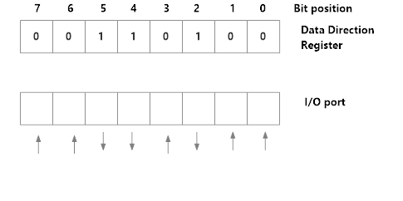
8-bit control register loaded with 34₁₆ and Input / Output configuration of the port

- Next the CPU reads/writes from/to the data register.
Let us consider the case for a simple CPU where--“IN Port 1”, implies contents of Data register for Port 1, is loaded into the Accumulator. It may be noted that if some of the Bit positions of the data register are configured for output they will also be read to the accumulator by the IN instruction; values for such bit positions are to be marked as don’t cares.
So, the instruction “IN Port 1” will load value of register DR1 to accumulator. As Bit positions 2, 4 and 5 are marked for output, values of these Bit positions in accumulator are treated as don’t cares.
Similarly, instruction--“OUT Port 1” implies contents of accumulator will be loaded to Data register for Port 1, which will be sent to the connected output devices. It may be noted that if some of the Bit positions of the data register are configured for input they will also be written by the OUT instruction. It may be noted that this does not create any problem, because when input is to be taken (from an input device) from the port the respective bits in the data register will be written by the input device. In other words, before an IN instruction from the port under question, the bits configured as inputs will be written by the addressed input device(s).

So, the instruction “OUT Port 1” in this example will load value of accumulator to DR1. As Bit positions 2,4 and 5 are marked for output, values of these Bit positions will be loaded to the connected output devices through proper interface.

Question 3: We know that I/O devices vary substantially in their data processing rate. How does the CPU synchronize data transfer with different I/O devices, having different data rates? Explain using the control signals required for the synchronization.

Solution 3:
There are several schemes for handling the timing of data transfer over the I/O bus from CPU to peripheral devices and vice-versa. These can be broadly classified as

- Synchronous bus transfer
- Asynchronous bus transfer

Synchronous Bus

In a synchronous bus as all the devices are synchronized by a common clock, so all devices derive timing information from a common clock line of the bus. A clock pulse on this common clock line defines equal time intervals. In the simplest form of a synchronous bus, each of the clock pulse constitutes a bus cycle during which one unit data transfer can take place.

Let us consider the sequence of control signals for an input (read) operation.

The timing of an input transfer on a synchronous bus is shown in the figure below.

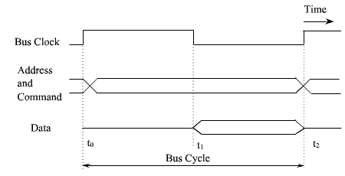
Timing of an input transfer on a synchronous bus

- At time to, the master places the device address on the address lines and sends an appropriate command (read in case of input) on the command lines. In any data transfer operation, one device plays the role of a master, which initiates data transfer by issuing read or write commands on the bus. Normally, the processor acts as the master. The device addressed by the master is referred to as a slave or target device.

- The clock pulse width, 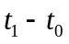, must be longer than the maximum propagation delay between the device and CPU among which data transfer is being done. After decoding the information on address and control lines the slave of that particular address responds at time . The addressed slave device places the required input data on the data line at time .

- At the end of the clock cycle, at time , the master strobes the data on the data lines into its input buffer. The period 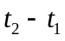 must be greater than the maximum propagation delay on the bus plus the set up time of the input buffer register of the master.

A similar procedure is followed for an output operation. The master places the output data on the data lines when it transmits the address and command information. At time, the addressed device strobes the data lines and load the data into its data buffer.

Multiple Cycle Transfer:

The simple design of device interface by synchronous bus has some limitations.

- A transfer has to be completed within one clock cycle. The clock period, 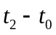, must be long enough to accommodate the slowest device to interface. This forces all devices to operate at the speed of slowest device.
- The processor or the master has no way to determine whether the addressed device has actually responded. It simply assumes that, at , the output data has been received by the device or the input data is available on the data lines.

To solve these problems, most buses incorporate control signals that represent a response from the device. These signals inform the master that the target device has recognized its address and that it is ready to participate in the data transfer operation. They also adjust the duration of the data transfer period to suit the needs of the participating devices. A high frequency clock pulse is used so that a complete data transfer operation span over several clock cycles. The numbers of clock cycles involved can vary from device to device.
An instance of this scheme is shown in the figure given below.

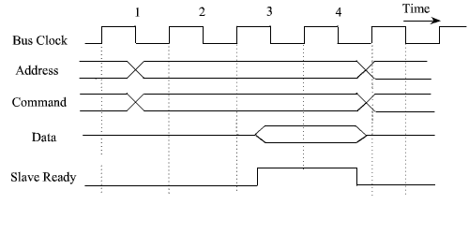
An input transfer using multiple clock cycle

- In clock cycle 1, the master sends address and command on the bus requesting a read operation.

- The target device responded at clock cycle 3 by indicating that it is ready to participate in the data transfer by making the slave ready signal high. Then the target device places the data on the data line.

- The target device is a slower device and it needs two clock cycles to transfer the information. After two clock cycles, that is at clock cycle 5, it pulls down the slave ready signal down.

- When the “slave ready” signal goes down, the master strobes the data from the data bus into its input buffer (not shown in the figure above).

- If the addressed device does not respond at all, the master waits for some predefined maximum number of clock cycles and then aborts the operation.

Asynchronous Bus

In asynchronous mode of transfer, a handshake signal is used between master and slave.

- In asynchronous bus, there is no common clock, and the common clock signal is replaced by two timing control signals, master-ready and slave-ready.

- Master-ready signal is assured by the master to indicate that it is ready for a transaction, and slave-ready signal is a response from the slave.

The handshaking protocol proceeds as follows:

- The master places the address and command information on the bus. Then it indicates to all devices that it has done so by activating the master-ready signal.

- This causes all devices on the bus to decode the address.

- The selected target device performs the required operation and informs the processor (or master) by activating the slave-ready line.

- The master waits for slave-ready to become asserted before it removes its signals from the bus. In case of a read operation, it also strobes the data into its input buffer (not shown in the figure).

The timing of an input data transfer using the handshake scheme is shown in the figure below.

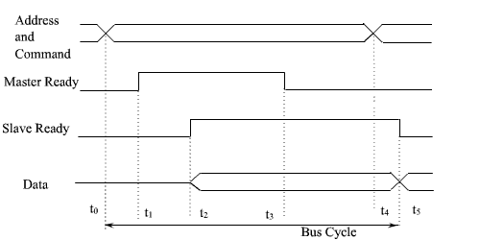
Handshake control of data transfer during an input operation.

The timing of an output operation using handshaking scheme is shown in the figure below.
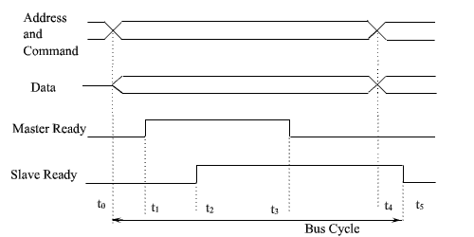
Handshake control of data transfer during an output operation.

- The master places the address and command information on the bus. Also, the data is placed in the data bus. Then it indicates to all devices that it has done so by activating the master-ready signal.

- This causes all devices on the bus to decode the address.

- The selected target device reads the required data and informs the processor (or master) by activating the slave-ready line.

- The master waits for slave-ready to become asserted before it removes its signals from the bus.

Question 4: How the CPU communicates with an external device via one or more registers called I/O ports?

Solution 4:

The CPU can communicate with an external device using I/O ports. Broadly speaking, I/O ports are registers which communicate with peripheral devices mapped to that port. In the simplest designs, each port has two registers—

- Control register or data direction register: It determines the data flow direction (i.e., input or output) for the port it is controlling.

- Data Register: It is responsible for inputting (or outputting) data from (to) the I/O device based on the values of the corresponding control register.

I/O ports are usually of two types

- Type-1 (Bit-serial ports): Each bit in the port can be individually configured either as input or output.

- Type-2 (Parallel ports): Each I/O port (as a whole) may be configured as input or output.

To elaborate, each port can be configured by command or data direction register. The port contains the actual input or output data. The data direction register is an output register and can be used to configure the bits in the ports as input or outputs. In Type-1, each bit in the port can be configured as input or output by writing a 0 or 1 in the corresponding bit of data direction register, respectively. So, the width of the control register is same as that of the data register. In case of Type-2, the port as a whole can be configured as input or output by writing a 0 or 1 in the corresponding bit of data direction register. Each bit of the control register configures an entire port. So, width of the control register is equal to the total number of ports. The two figures given below illustrate Type-1 and Type-2 configuration of the ports.

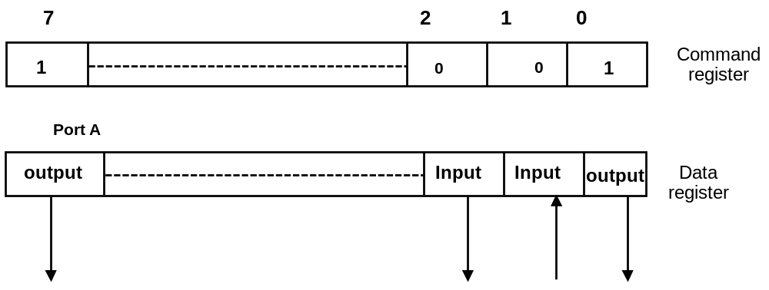

Control and Data Registers for Bit-serial ports

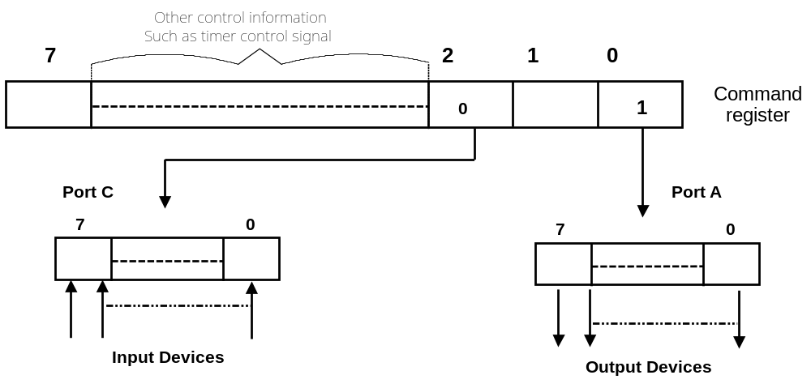
Control and Data Registers for Parallel ports

