Module-5, Unit-2
Programmed I/O

Question 1: Explain how data transfer is performed between CPU and I/O devices using Programmed I/O technique.

Solution 1:

There are three basic forms in which CPU performs I/O operations.
- Programmed I/O
- Interrupt driven I/O
- Direct Memory Access(DMA)
With programmed I/O, the processor executes a program that gives it direct control of the I/O operation, including sensing device status, sending a read or write command, and transferring the data. In this answer we concentrate only on Programmed I/O. The figure given below illustrates the flow of data transfer (input) using Programmed I/O.

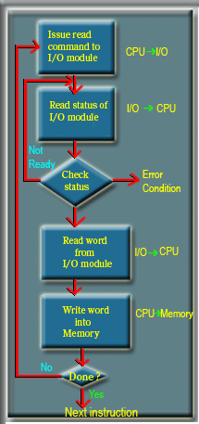

Data transfer using Programmed I/O

From the context of hardware, I/O ports are used in programmed I/O technique for data transfer between the CPU and I/O devices. I/O ports are usually of two types. For one type, each bit in the data port can be individually configured either as input or output. For the other type, all bits in the data port can be setup as either all parallel input or output bits. The I/O device is connected through the data port using proper interfaces e.g., drivers in case of a stepper motor. Each data port is configured by another register called command or data control register. The data port contains the actual input or output data. The data control register is an output register and can be used to configure the bits in the data ports as input or output.

From the software context, in programmed I/O, the data transfer between CPU and I/O device is carried out with the help of programs only, which involve special I/O instructions. In programmed I/O, the CPU basically executes two types of I/O commands
- Configure the data port as input/output by writing appropriate values in the data control register.
- Sends/receives data to/from the I/O device via the data port.

Question 2: What are the different types of data transfer schemes that are based on Programmed I/O technique.

Solution 2:
There are basically to types of programmed I/O techniques.

- Unconditional Programmed I/O

In Unconditional Programmed I/O the CPU initiates the data transfer and assumes that the external device is always ready. In case of an output data transfer, the CPU assumes that the output device is always ready and sends the desired data using corresponding instructions without looking for status (busy or not) of the device. An example is a seven segment display. Once a data is sent for display by the CPU to the 7-segment display through the I/O port it is immediately displayed; speed of displaying is almost same as that that of the CPU. Similarly in case of an input data transfer, the microprocessor requests the input device to send data, assuming that the input device is always ready to accept data and process it immediately (speed nearly same as CPU).

- Conditional Programmed I/O
In case of Conditional Programmed I/O, CPU initiates conditional or polled I/O transfer because CPU does not assume that the peripheral device is always ready for data transfer. So before data transfer, the CPU checks the readiness of the device. This checking involves testing one or more status lines associated with the I/O device. This is known as control signals. Scanner is a good example of controlled program I/O based input device. When the CPU wants to scan a page and input the data in the memory, it sends a start signal. Immediately it cannot take the data from the buffer of the scanner through the I/O port. The CPU continuously pools the “Ready” status signal of the scanner. Once the scanning is done and data is placed at the output buffer of the scanner, it makes the Ready signal 1. Now the CPU reads the Ready signal as high and then inputs the scanner output through the corresponding I/O port. A simple example of output data transfer in case of programmed I/O is a printer. Once the CPU is ready to send a character to be printed, it cannot directly send the value to be printed. This is because the printer is very slow compared to CPU. So first the CPU checks the “Ready” status line of the printer to verify if it is already printing something or is idle. If the status line of the printer states that it is free then the CPU send the character to be printed.

Question 3: Consider a simple input device Keyboard. Illustrate how CPU takes the data from the keyboard using Programmed I/O technique.

Solution 3:

The keyboard device accepts character input from the user and sends its ASCII equivalent 8 bit data to the CPU. Flowchart for programmed I/O data transfer from keyboard to CPU is shown in the figure below.

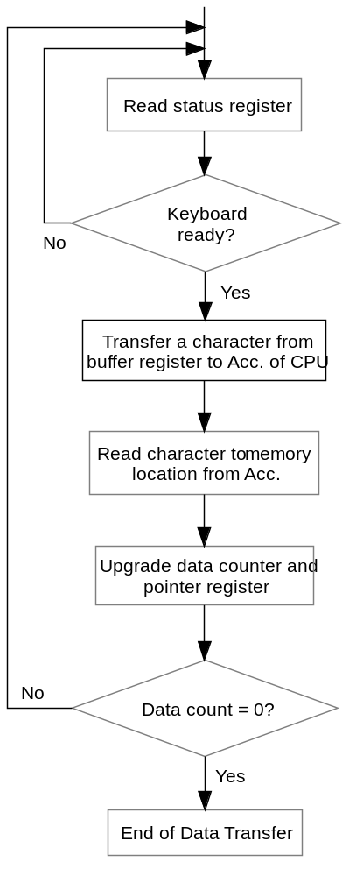
Flowchart for programmed I/O data transfer

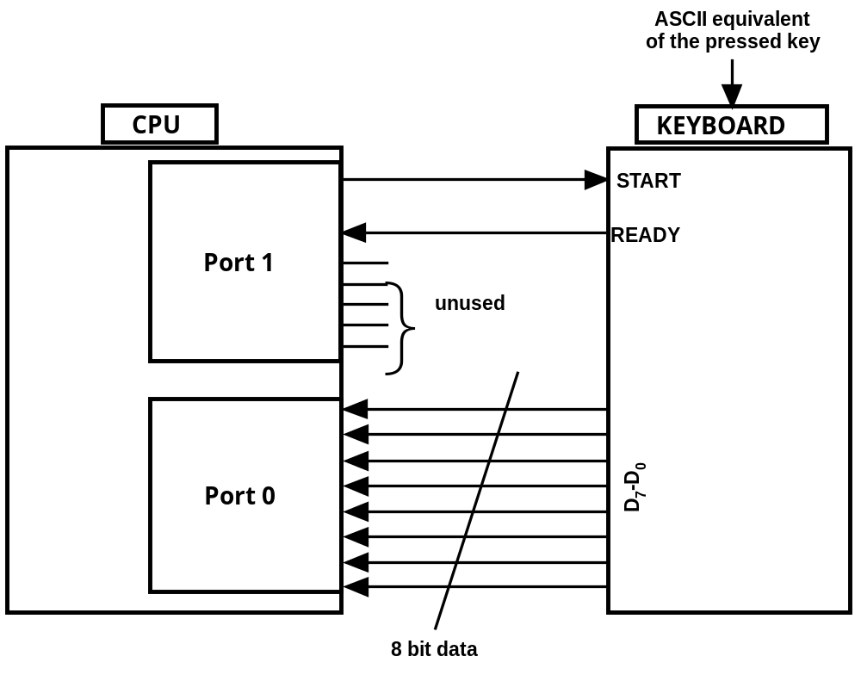Interfacing of input Keyboard with CPU

The interface of the keyboard with the CPU in terms of I/O ports is shown in the figure above. The code for getting inputs from keyboard to memory via CPU is as follows

BEGIN: LDI DCR0 #00_{H}
LDI DCR1 #80_{H}
LDI Acc, #80_{H}
OUT Port 1
WAIT: IN Port 1
AND Acc, #40_{H}
BNEQ Acc, #40_{H} WAIT
IN Port 0
ST Acc, 2020_{H}
END: LDI Acc, #00_{H}
OUT Port 1

Now we explain the working of the code step wise.

- LDI DCR0, #00_{H}--In port 0 all bits are configured as input using Data Control register DCR0. The inputs from the keyboard will be taken from this port. The command when executed loads all 0s in the data control register of Port 0 i.e., DCR0.

- LDI DCR1, #80_{H} --Each bit in the port 1 is individually configured either as input or output using Data Control register DCR1. The control signals to/from the keyboard will be transferred using port 1. When the command is executed it loads 1 in Bit position 7 in the CDR1; this bit is configured as output. All other bits are configured as inputs.

The 7th bit of data register DR1 is connected to “Start” input pin of the keyboard. The 6th bit of data register DR1 is connected to “Ready” output pin of the keyboard. Other bits of port 1 are not used for keyboard interface.

The figure given below illustrates the control registers for port 0 and port 1.

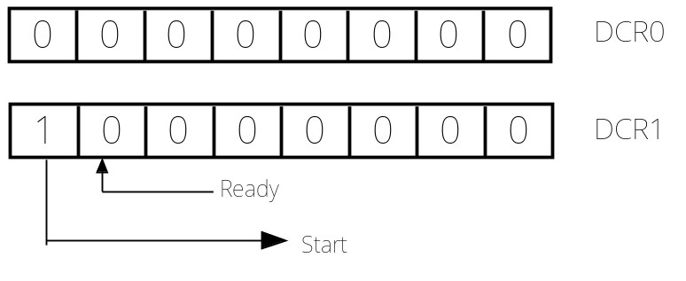
The control registers for port 0 and port 1.

- LDI Acc, #80_{H}--The accumulator is loaded with 1000 0000.

- OUT Port 1—1000 0000 is loaded into the data register of port 1 i.e., DR1. This makes Start signal of Keyboard 1 implying, CPU wants to read data from keyboard. The 6th bit of the DR1 being configured as input, its value being set 0 has no implication.

- IN Port 1---The value of port 1 i.e., DR1 is read into the accumulator. The 6th bit of the DR1 is configured as input and connected to “Ready” output of the keyboard. Bits from 0th till 5th are configured as inputs but not used for keyboard interface. So only the 6th Bit read in accumulator is taken into consideration (using the instruction discussed next).

- AND Acc, #40_{H}---This instruction makes Bit wise AND of the Accumulator content with 0100 0000. Now the Accumulator has all the bits excepting the one at 6th position as 0. The value of the Bit at 6th position depends on the value read from Port 1.

- BNEQ Acc, #40_{H} WAIT---Checks the Ready output signal of the keyboard. If the keyboard is ready i.e., Ready signal is 1, then the code comes out from the loop. Otherwise the loop continues. This is implemented by comparing Accumulator value with 0100 0000, and jumping to label WAIT in case of non-equality.

- IN Port 0—As the keyboard is ready with the data latched upon key press, the CPU reads the value at Port 0 in Accumulator.

- ST Acc, 2020_{H}—The value of Accumulator is stored in memory location 2020_{H}. So, keyboard input is stored in memory location.

- LDI Acc, #00_{H}—The Accumulator is loaded with 0000 0000.

- OUT Port 1--0000 0000 is loaded into the data register of port 1 i.e., DR1. This makes Start signal of Keyboard 0 implying, CPU does not wants to read data from keyboard.

Question 4: Consider a simple input device Display. Illustrate how CPU outputs the data to the Display using Programmed I/O technique.

Solution 4:

In the simplest form a printer device accepts a character from memory and prints it. Flowchart for programmed I/O data transfer from memory to CPU is shown in the figure below.

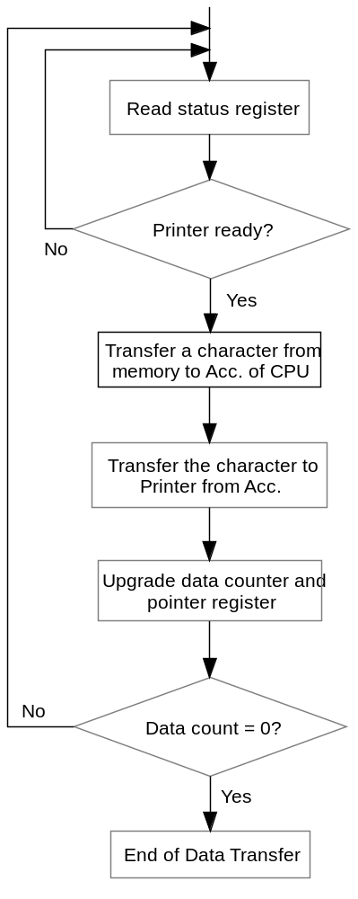
Flowchart for programmed I/O data transfer

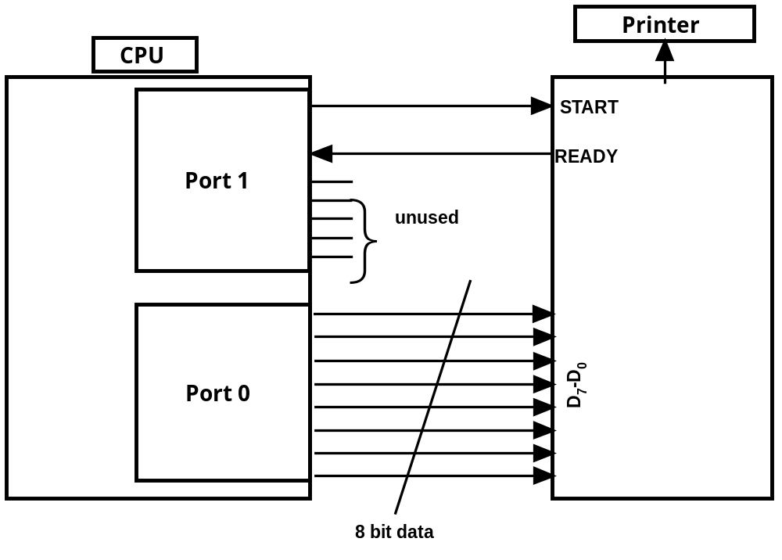Interfacing of Printer with CPU

The interface of the printer with the CPU in terms of I/O ports is shown in the figure above. The code for sending a character from memory to printer via CPU is as follows

BEGIN: LDI DCR0 #FF_{H}
LDI DCR1 #80_{H}
LDI Acc, #80_{H}
OUT Port 1
WAIT: IN Port 1
AND Acc, #40_{H}
BNEQ Acc, #40_{H} WAIT
LD Acc, 2020_{H}
OUT Port 0
END: LDI Acc, #00_{H}
OUT Port 1

Now we explain the working of the code step wise.

- LDI DCR0, #FF_{H}--In port 0 all bits are configured as output using Data Control register DCR0. The inputs to the printer will be taken from this port. The command when executed loads all 1s in the data control register of Port 0 i.e., DCR0.

- LDI DCR1, #80_{H} --Each bit in the port 1 is individually configured either as input or output using Data Control register DCR1. The control signals to/from the printer will be transferred using port 1. When the command is executed it loads 1 in Bit position 7 in the CDR1; this bit is configured as output. All other bits are configured as inputs.

The 7th bit of data register DR1 is connected to “Start” input pin of the printer. The 6th bit of data register DR1 is connected to “Ready” output pin of the printer. Other bits of port 1 are not used for printer interface.

The figure given below illustrates the control registers for port 0 and port 1.

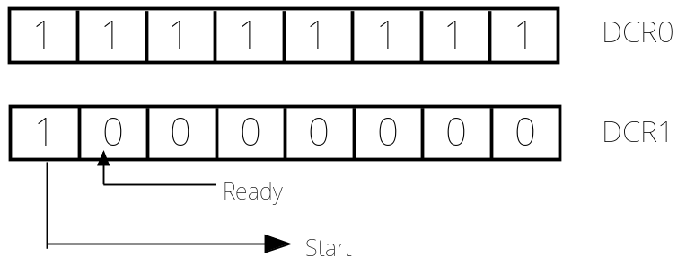
The control registers for port 0 and port 1.

- LDI Acc, #80_{H}--The accumulator is loaded with 1000 0000.

- OUT Port 1—1000 0000 is loaded into the data register of port 1 i.e., DR1. This makes Start signal of printer 1 implying, CPU wants to print data using printer. The 6th bit of the DR1 being configured as input, its value being set 0 has no implication.

- IN Port 1---The value of port 1 i.e., DR1 is read into the accumulator. The 6th bit of the DR1 is configured as input and connected to “Ready” output of the printer. Bits from 0th till 5th are configured as inputs but not used for printer interface. So only the 6th Bit read in accumulator is taken into consideration (using the instruction discussed next).

- AND Acc, #40_{H}---This instruction makes Bit wise AND of the Accumulator content with 0100 0000. Now the Accumulator has all the bits excepting the one at 6th position as 0. The value of the Bit at 6th position depends on the value read from Port 1.

- BNEQ Acc, #40_{H} WAIT---Checks the Ready output signal of the printer. If the printer is ready i.e., Ready signal is 1, then the code comes out from the loop. Otherwise the loop continues. This is implemented by comparing Accumulator value with 0100 0000, and jumping to label WAIT in case of non-equality.

- LD Acc, 2020_{H}—The Accumulator is loaded with contents of memory location 2020_{H}.

- OUT Port 0—As the printer is ready, the CPU outputs the value of accumulator at Port 0. So, the printer prints the value stored in the memory location.

- LDI Acc, #00_{H}—The Accumulator is loaded with 0000 0000.

- OUT Port 1--0000 0000 is loaded into the data register of port 1 i.e., DR1. This makes Start signal of printer 0 implying, CPU does not wants to print now.

