Module-5, Unit-2
Interrupt Driven I/O:

Question 1: What is the major issue with Programmed I/O technique for data transfer? How can it be handled?

Solution 1:

The main disadvantage of conditional programmed I/O is that the CPU needs to check the status bit (BUSY signal for the I/O device) by waiting in a loop. In programmed I/O, data transfer is dependent on the speed of the external device. For a slow device, the waiting may slow down the CPU’s capability of processing other data, because during waiting in the loop, the CPU does not perform any useful computation. In other words, the problem with programmed I/O is that the CPU has to wait a long time for the I/O module of concern to be ready for either reception or transmission of data and while waiting, the CPU must repeatedly interrogate the status of the I/O module without doing any useful computation. To generalize, in programmed I/O the CPU constantly tests an output(s) of the I/O device called “status” to see if computed data is available or it is ready to take data; this process of continuously checking is called polling. Programmed I/O is based on polling and all forms of Polled I/Os are inherently inefficient.

There are many computational problems where other tasks can be performed while waiting for an I/O device to become ready. To allow this to happen, we need a different scheme of I/O transfer i.e., to provide an interrupt mechanism. In the interrupt approach the CPU issues an I/O command to the corresponding I/O device and then moves on to do some other useful computation. The I/O device then interrupts the CPU to request service when it is ready to exchange data with the CPU. The processor then executes the data transfer. Once the data transfer is over, the CPU then resumes its former processing. Since the CPU is no longer required to continuously check the status of external device, it can use the waiting period to perform other useful computations. Indeed, by using interrupts, waiting periods of program based I/O can be minimized.

Question 2: Explain using examples how data transfer is performed between CPU and I/O devices using Interrupt based I/O technique. How does it resolve the issues with program based I/O?

Solution 2:

The term interrupt refers to an exceptional event which causes the CPU to temporarily suspend the current program being executed. The control is subsequently transferred to some other code segment referred to as interrupt service routine which specifies the actions to be taken if the interrupt occurs.

We consider the example of a printer. Consider a task having two sub-tasks that requires (i) some computations to be performed and (ii) the results to be printed on a line printer. This is followed by more computations and print, and so on. Let the program consists of two routines, COMPUTE and PRINT. We assume that COMPUTE produces a set of n lines of output, to be printed by the PRINT routine. The required task may be performed by repeatedly executing first the COMPUTE routine and then the PRINT routine. The printer accepts only one line of text at a time. Hence, the PRINT routine must send one line of text, wait for it to be printed, and then send the next line, and so on, until all the results have been printed; this is as per programmed based I/O. The disadvantage of this simple approach is that the CPU spends a considerable amount of time waiting for the printer to become ready.

If it is possible to overlap printing and computation, that is, to execute the COMPUTE routine while printing is in progress, overall a faster execution will result. This can be achieved as follows:

- First the COMPUTE routine is executed to produce the first n lines of output.
- Then the PRINT routine is executed to send the first line of text to the printer.
- At this point, instead of waiting for the line to be printed, the PRINT routine may be temporarily suspended and execution of the COMPUTE routine continued.
- Whenever the printer becomes ready, it alerts the processor by sending an interrupt-request signal.
- In response, the processor interrupts execution of the COMPUTE routine and transfers control to the PRINT routine.
- The PRINT routine sends the second line to the printer and is again suspended.
- Then the interrupted COMPUTE routine resumes execution from the point of interruption.
- This process continues until all n lines have been printed and the PRINT routine ends.

The PRINT routine will be restarted whenever the next set of n lines is available for printing. If COMPUTE takes longer to generate n lines than the time required to print them, the CPU will be performing useful computations all the time.

The routine executed in response to an interrupt request is called the interrupt-service routine, which is the PRINT routine in our example. Assume that an interrupt request arrives during execution of instruction i in Figure given below.

- The CPU first completes execution of instruction i.
- Then, it loads the program counter with the address of the first instruction of the interrupt-service routine. (Let us assume that this address is hardwired in the CPU.)
- After execution of interrupt-service routine, the CPU has to come back to instruction i+1.
- When an interrupt occurs, the current contents of the Program Counter (PC), which points to instruction i+1, must be put in a temporary storage in a known location.
- A Return-from-interrupt instruction at the end of the interrupt-service routine reloads the PC from that temporary storage location, causing execution to resume at instruction i+1.

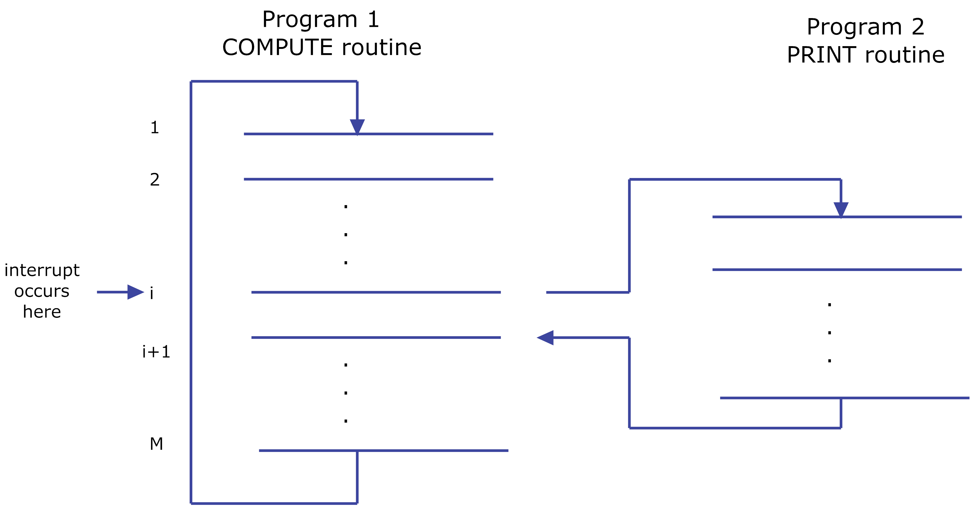

Transfer and return of Control from Normal Routine to Interrupt Service routine and back

Before starting execution of an interrupt-service routine any information of the main routine that may be altered during the execution of the interrupt-service routine must be saved. This information must be restored before execution of the main program is resumed. In this way, the original program can continue execution without being affected in any way by the interruption, except for the time delay. The information that needs to be saved and restored typically includes the condition code, flags and the contents of any register used by the interrupted program.

Question 3: What are the different types of Interrupts? Explain with examples where each type is applicable.

Solution 3:

There are typically three types of interrupts:

- External interrupt
- Traps or internal interrupts
- Software interrupts

External interrupt:

External interrupts are initiated through the CPU’s interrupt pins by external devices such as keyboard, mouse, A/D converter etc. External interrupts can further be divided into two types:
- Maskable External interrupt
- Non- maskable External interrupt

Maskable External interrupt: A maskable external interrupt is enabled or disabled by executing instructions such as EI or DI, respectively. If the CPU’s interrupt is disabled, it ignores the maskable interrupts. Some CPUs have an interrupt-flag bit in the status register. When the interrupt is disabled, the interrupt-flag bit is 1, so no maskable interrupts are recognized by the CPU. The interrupt-flag-bit is reset to zero when the interrupt is enabled.

Non-maskable External interrupt: As the name suggests such interrupts must be serviced. The non-maskable interrupt has higher priority than the maskable interrupt. If both maskable and non-maskable interrupts are activated at the same time, the CPU will service the non-maskable interrupt first. The non-maskable interrupt is typically used in extreme cases as a power failure interrupt. CPUs normally use low DC voltage, which is transformed from some higher AC voltage. If the power falls below a threshold AC voltage, the DC voltage required to operate the CPU cannot be maintained. However, it will take a few milliseconds before the AC power can drop this low (below threshold). In these few milliseconds, the power failure-sensing circuitry can interrupt the CPU. The interrupt-service routine can be written to store critical data in non-volatile memory such as battery-backed CMOS RAM. The interrupted program can continue without any loss of data when the power returns.

Traps or internal interrupts
As the name suggests, Internal interrupts or traps, are generated internally mainly by software for some exception conditions e.g., overflow, division by zero, or execution of an illegal op-code etc. However, internal interrupts are handled in the same way as external interrupts. There is an ISR for such cases to take corrective measures and provide an indication that an exceptional condition has occurred.

Software interrupts
Software interrupts are mainly used to switch from user mode to supervisor mode, also called system calls. In other words, software interrupt instructions are normally used to call the operating system. When software interrupt is executed, the CPU is interrupted and serviced similarly to external or internal interrupts. The ISR for software interrupts are shorter than subroutine calls, and the calling program need not know the operating system's address in memory.

Question 4: If there are multiple devices working on interrupt based I/O, how does CPU decide on their priorities?

Solution 4:

Broadly speaking, “Interrupt I/O” is a device controlled I/O transfer. The external I/O device is connected to a pin called the interrupt (INT) pin on the CPU. When the device needs an I/O transfer with the CPU, it enables the interrupt pin of the CPU. The CPU completes the current instruction and saves the contents of the PC in a stack. Also, other relevant information like values of registers, flags etc. are stored. The CPU then loads an address into the PC that branches to a subroutine called the interrupt-service routine (ISR). This program is to written by user based on the requirements of the I/O device. The I/O device wants the CPU to execute this ISR to transfer data. The last instruction of the ISR is a RETURN, which is generally the next instruction from which the main programmed jumped to ISR. In other words, the ISR loads the address (saved in the stack before going to the ISR) in the PC. Then, the CPU continues executing the main program as usual. The figure given below illustrates the sequence of actions executed in response to an interrupt signal
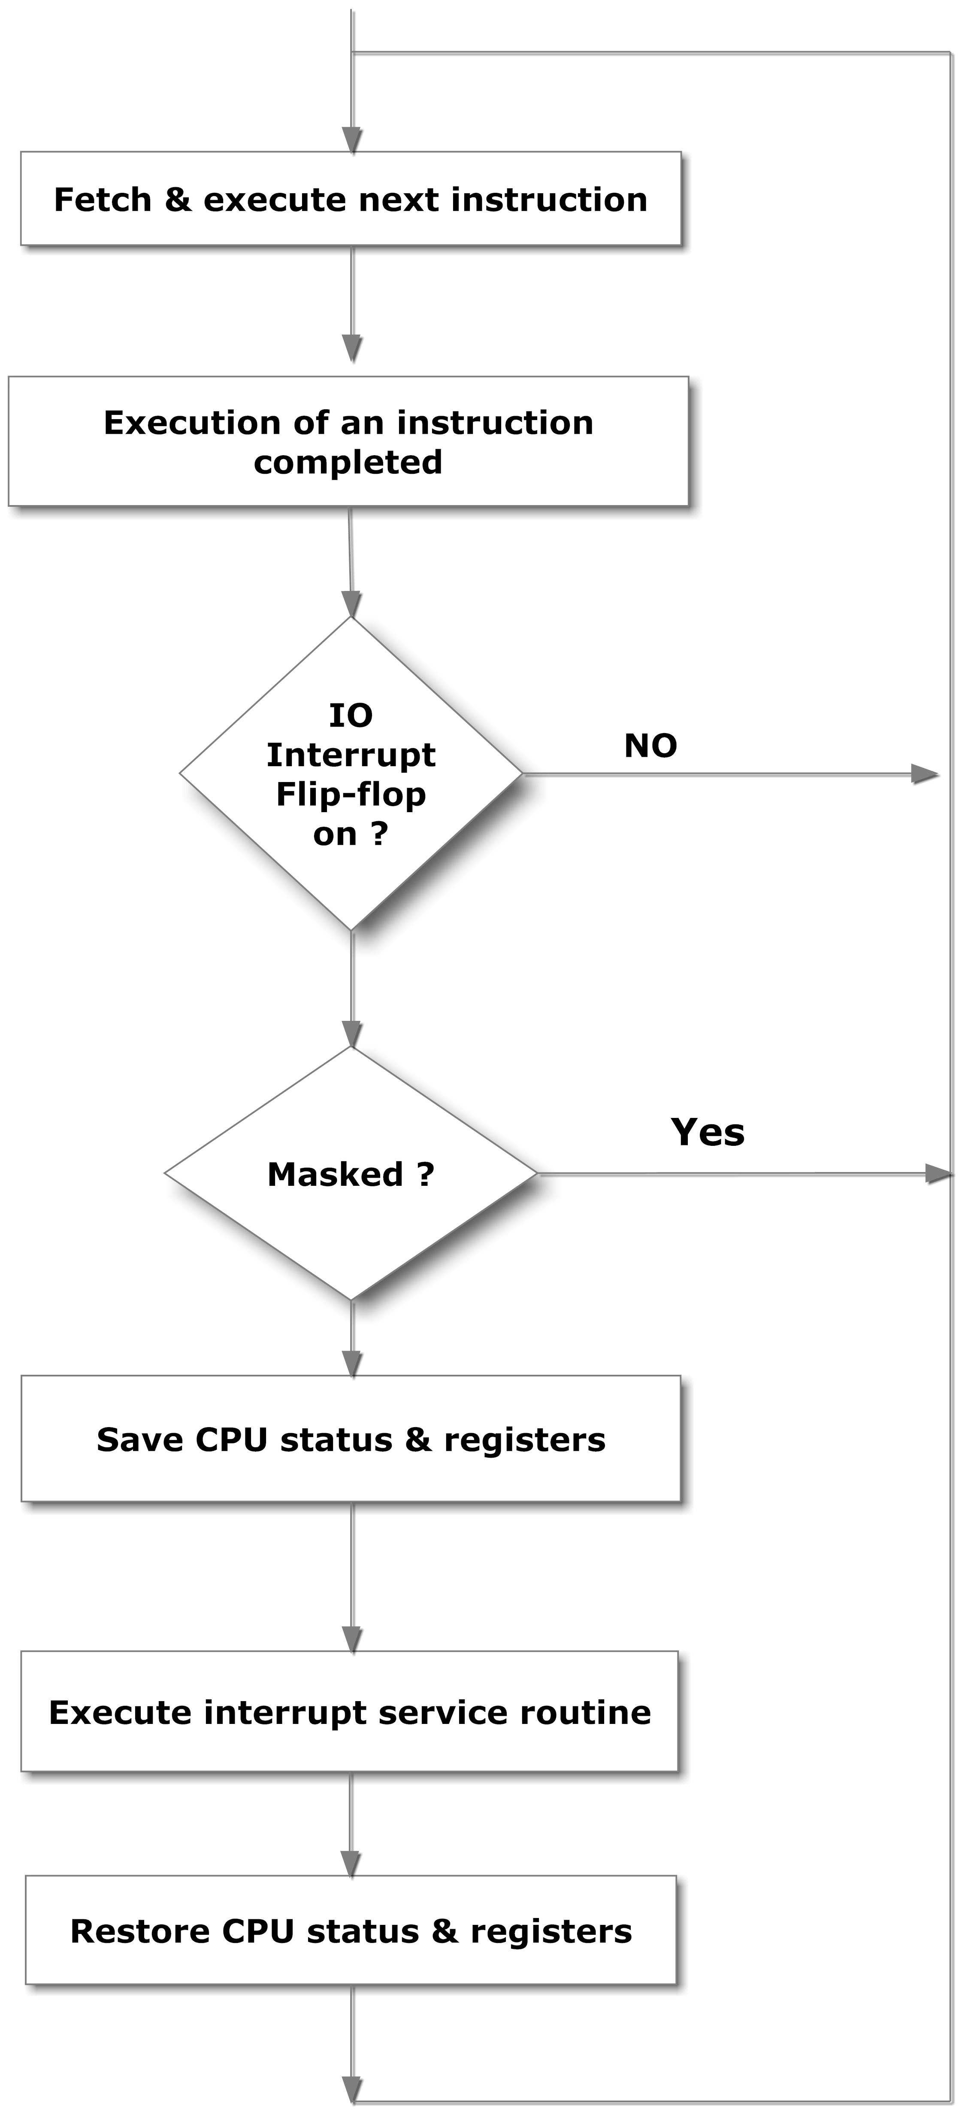
Sequence of actions executed in response to an interrupt signal.

Interrupt Priority
A CPU is typically provided with one or more interrupt pins to handle multiple I/O devices. However, the number of I/O devices is more than the number of interrupt lines. Therefore, a special mechanism is necessary to handle interrupts from several devices that share one of these interrupt lines. To handle multiple I/O interrupt situation, following issues are considered.

- Selection of the interrupting device(s).
- Priority and masking of interrupt.
- Generation of the starting address of the ISR corresponding to the interrupt signal generated by a specific IO device, which is currently given propriety.

There are two ways of servicing multiple interrupts:

- Polled technique
- Daisy chain technique

Polled Interrupts

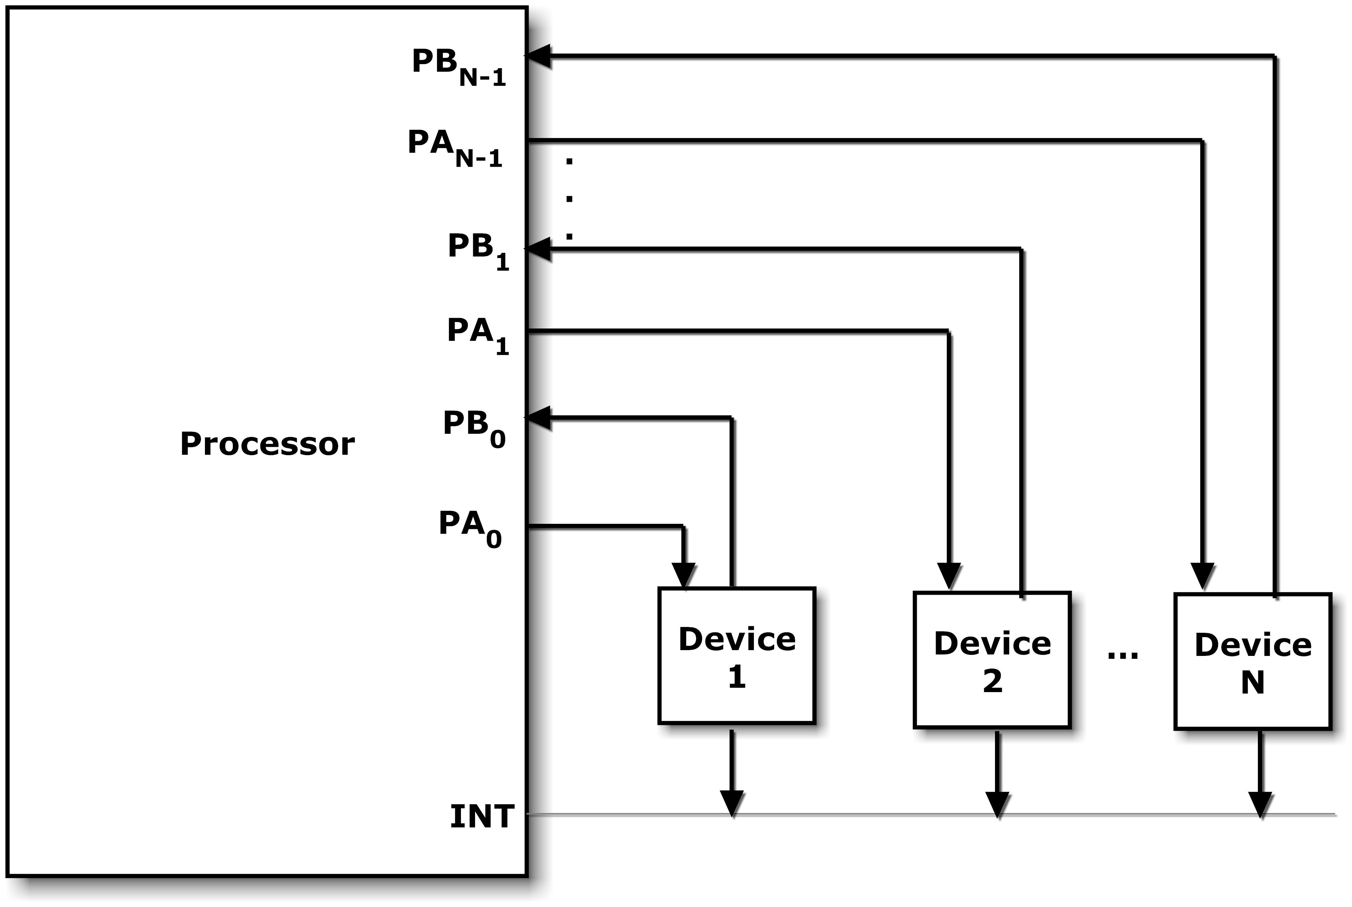
Block Diagram of Polled Interrupt

Polled interrupts are handled by software. The CPU responds to an interrupt by executing a single priority service routine for all devices. The priorities of devices are determined by the order in which the routine polls each device (programmed by the used in the routine). The CPU checks the status of each device in priority service routine, starting with the highest priority device, to service an interrupt. Once the CPU determines the source of interrupt, and is under the current priority, it branches to the ISR routine for the device. Figure given above shows the typical configuration of the polled interrupt system.
In the figure, several I/O devices (namely, device 1, device 2, . . . , device N) are connected to a single interrupt line of a processor via an OR gate (OR gate not shown explicitly in the figure). When one or more I/O devices make the INT line HIGH, the CPU finishes executing the current instruction and saves the PC, registers, flags etc. into the stack. It then branches to an address defined by the manufacture of the processor. The user can write a program at this address to poll each device, starting with the highest priority device to find the source of interrupt. If there are multiple interrupts, they are served sequentially based on priority. As already discussed, serving an interrupt implies jumping to the respective ISR. If multiple interrupts are being serviced sequentially, then the CPU jumps to ISR for the device with highest propriety. Then it moves to the ISR of the next device in the priority list. This moves on till the ISR for the device last in the priority list is completely executed. Then the control moves to the user defined program which polls each device. Finally, the control returns to the instruction of main routing just before which the interrupt was called.
In the figure given above let the n devices be A/D converters. Now we illustrate the hardware logic required for the polled interrupt scheme. The N^{th} A/D converter along with the associated logic for polling is shown in the figure below.
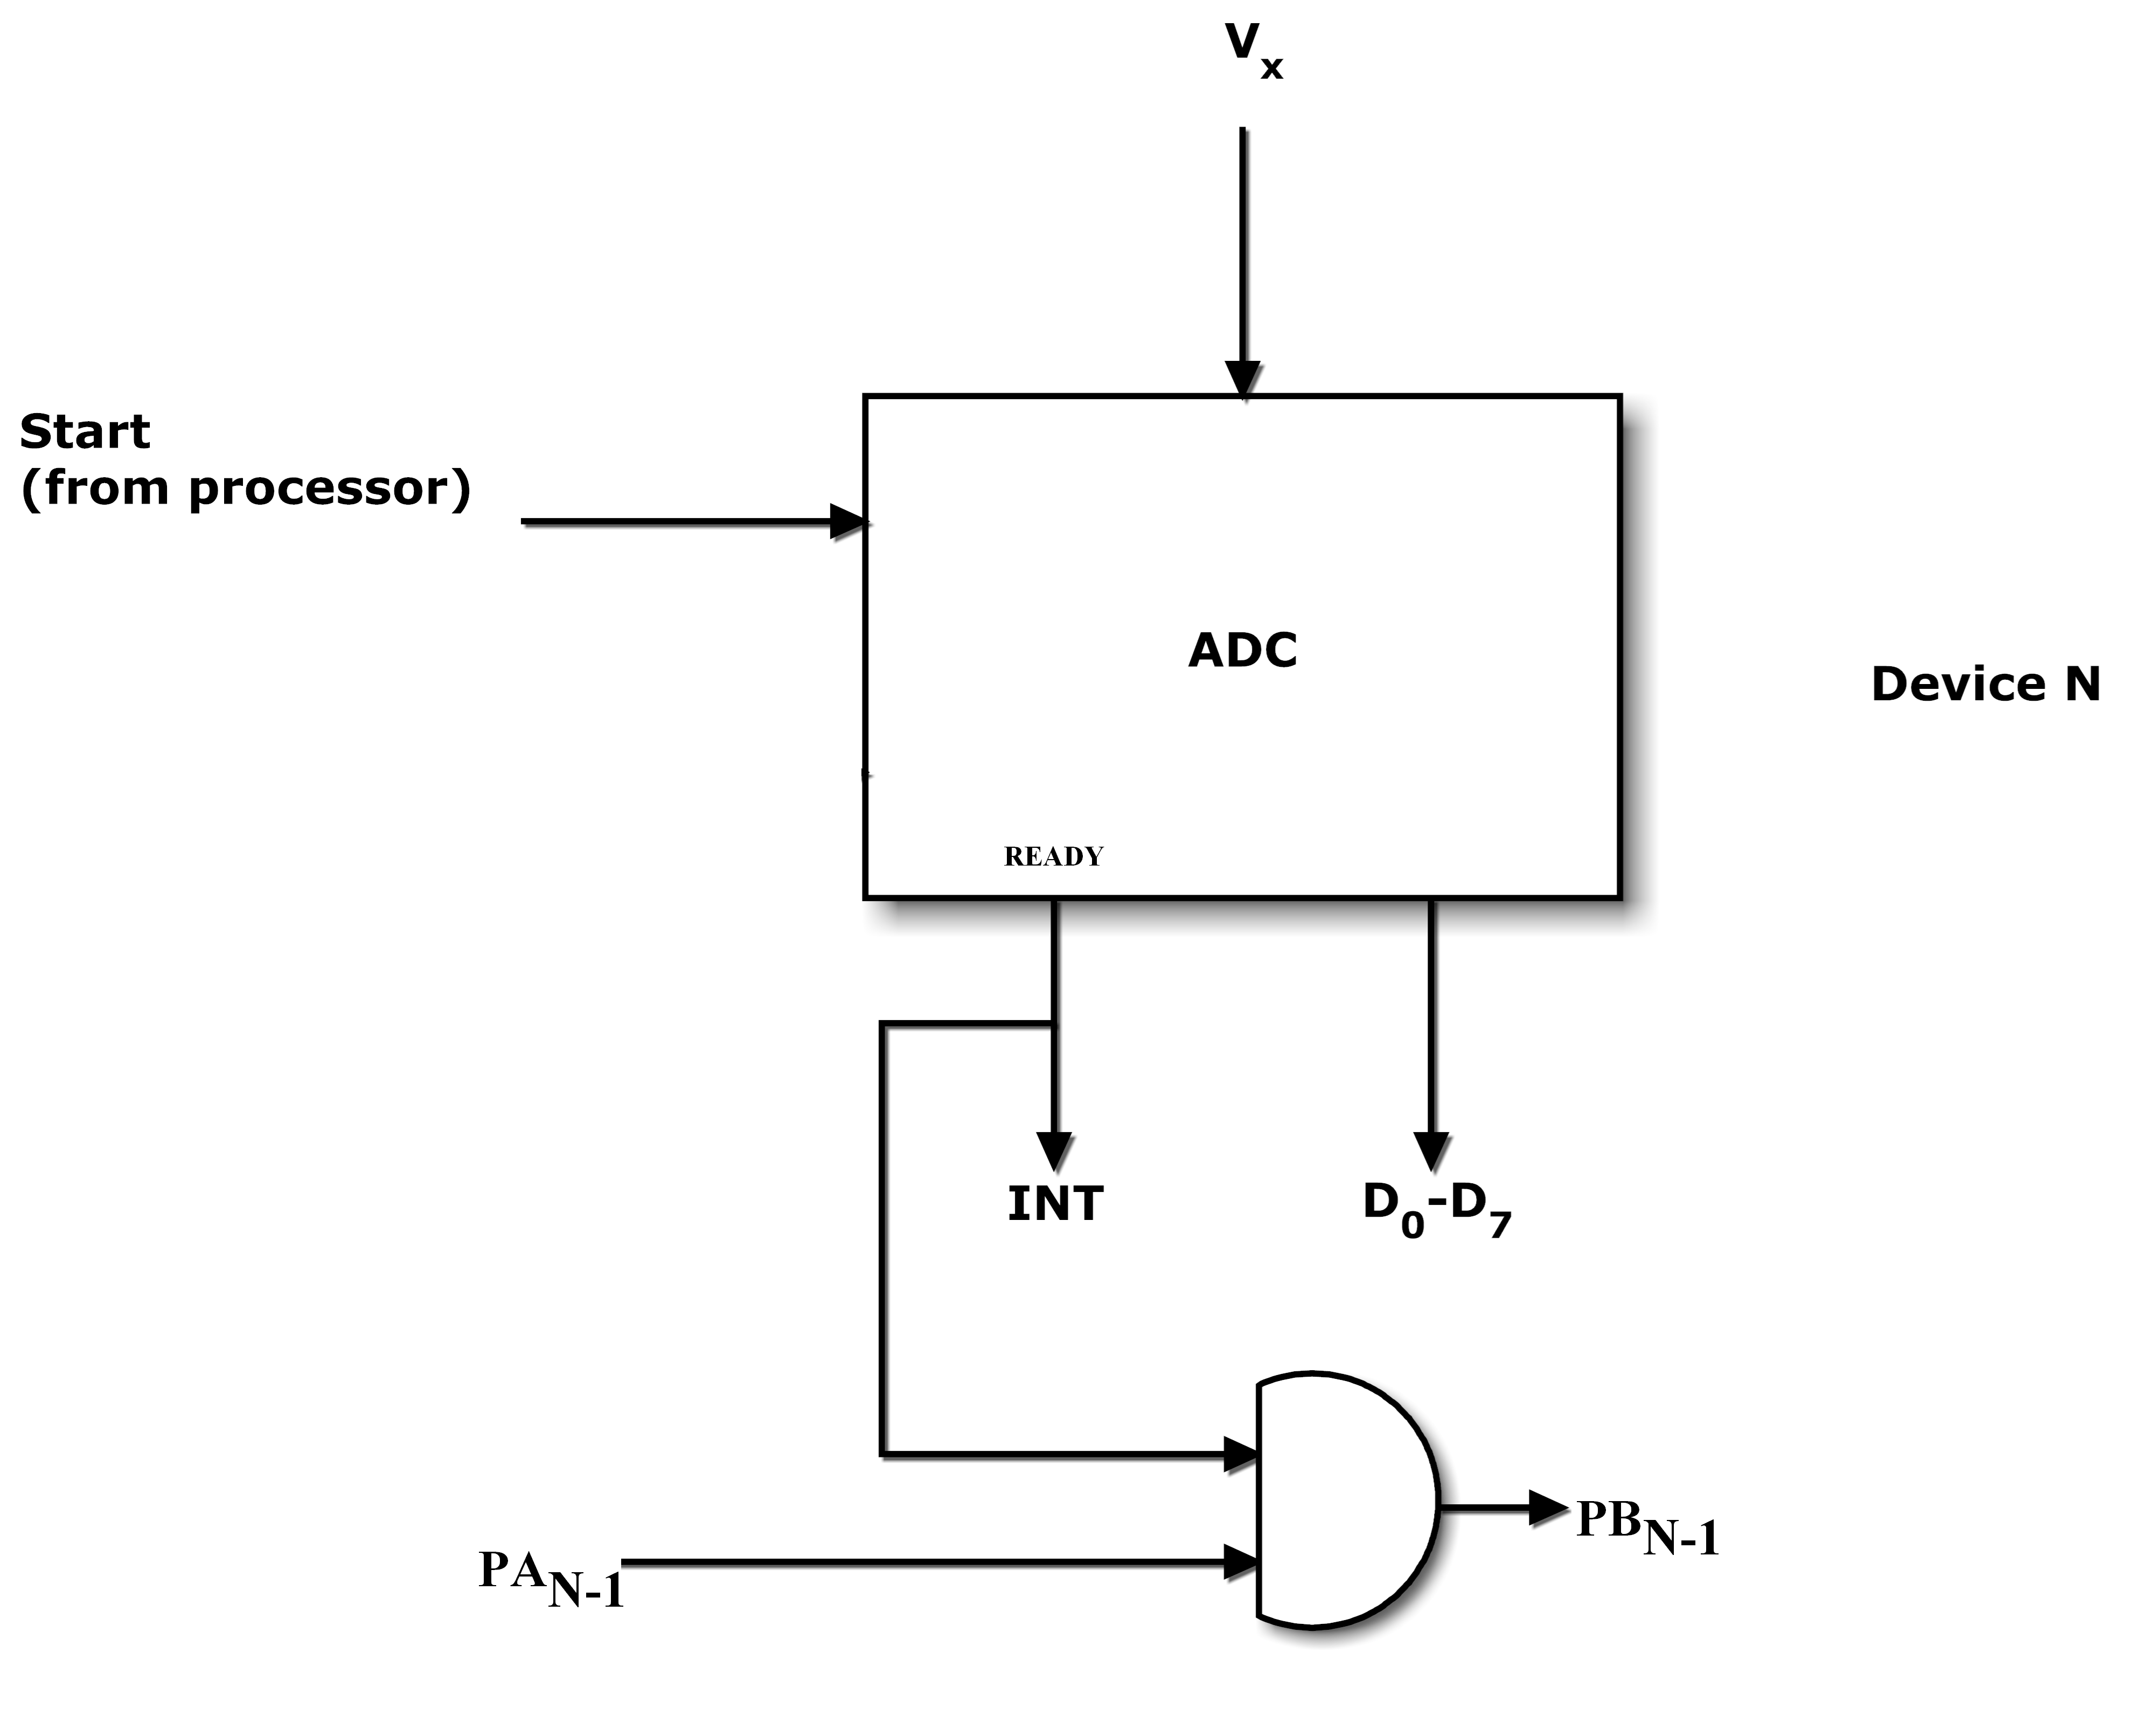
Device n and Associated Logic for polled Interrupt
Assume that there are two A/D converters (device 1 and device 2) and priority of Device 2 is higher than Device 1; the user codes this priority in the pooling service routine. Also, we assume that CPU generated the “START” signal for both the converters almost at the same time. Now say the READY signal from the device 1 and/or 2 becomes HIGH; indicating the end of conversion; the CPU is interrupted by the signal INT=1. In response, the CPU saves the values of PC, Registers, Flags etc., and loads the PC with the address of the user defined program which polls each device. The polling service-routine determines the source of interrupt as follows:

CPU sends 1 to PA1 (1st Bit of Port A) for device 2, since this device has the highest priority. If this device has generated an interrupt, the output PB1 (i.e., 1st Bit of Port B) of the AND gate becomes HIGH as shown in the last figure; PA1 AND INT= PB1. This indicates to the CPU that device 2 generated an interrupt. If the output of the AND gate for device 2 becomes 0 i.e., PB1=0, then surely “START” of device 2 is 0 because the processor sends a 1 to PA1; this implies that device 2 is not ready with the computation and hence has not generated the interrupt. Now the CPU sends a 1 to PA0 and checks the output at PB0. Once the source of the interrupt is determined, the CPU jumps to the ISR for that device. The ISR enables latching of inputs of the converter to the CPU via a port to which the A/D converter is interfaced. Once the ISR is complete the control returns to the main program which was interrupted. Flow chart of the polling scheme is shown the figure below.
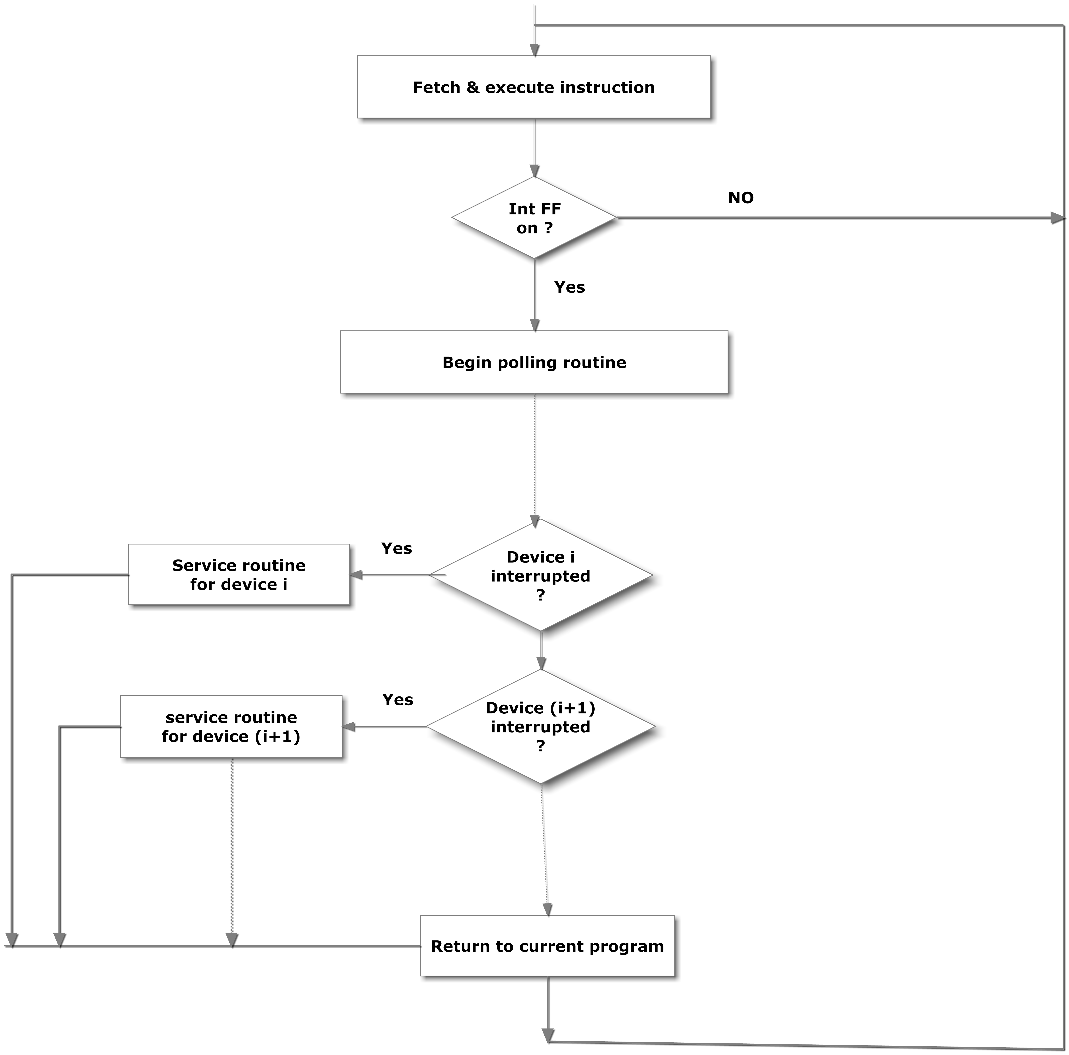
Polling scheme to service interrupt.

Polled interrupts are slow and if the number of devices is large, the time required to poll each device may exceed the time to service the device. In such a case, a faster mechanism, such as daisy chain approach is better as it is based on hardware.

Daisy Chain Interrupts
Devices are connected in a daisy chain fashion, as shown in the figure below to set up the priority scheme. Suppose one or more devices interrupt the processor. In response, the CPU saves the PC, flags, registers etc. and generates an interrupt acknowledgement (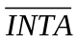) signal to the highest priority device (device 1 in this case). If the device has generated the interrupt, it will accept the ; otherwise it will pass the onto the next device until the is accepted. Once accepted, the interrupting device provides the CPU the address of the ISR for the corresponding I/O device, using the external hardware.

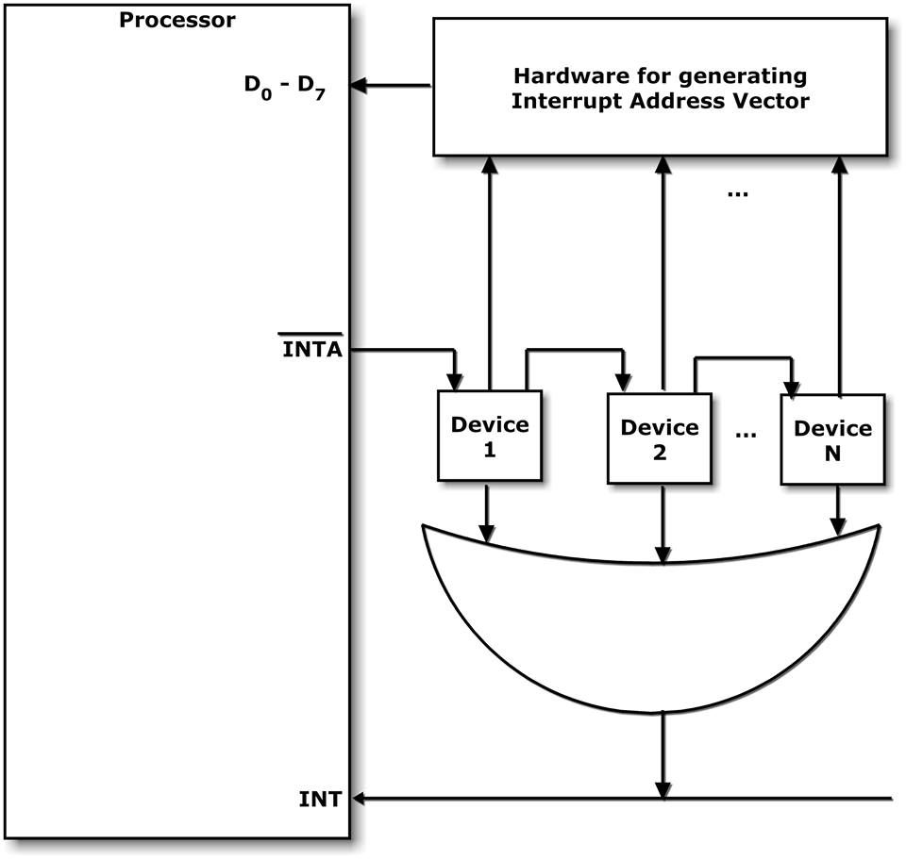

Block Diagram of Daisy Chain Interrupt

As before, we assume the devices as A/D converters. Figure below provides a schematic for the A/D converter and the associated logic for daisy chain scheme. Suppose the CPU starts the conversion using A/D converters of device 1 and device 2 at nearly the same time. When the READY signal goes to HIGH, the CPU is interrupted through the INT line. The CPU pushes PC, registers, flags etc. in a stack. CPU then generates a LOW at the interrupt acknowledge () for the highest-priority device (i.e., device 1 in the figure below). It may be noted that device 1 has the highest priority by hardware connectivity, because it is the first device in the daisy chain configuration to receive. If the A/D converter 1 has generated the READY signal as 1, the output of the AND gate becomes HIGH (shown in the figure below). This signal is used to enable external hardware to provide the ISR address to the CPU. The process then branches to the service routine. This program takes the outputs of the A/D converter to the CPU. If A/D converter 1 does not generate the BUSY signal as 1, the output of AND gate becomes LOW. Then the next device (i.e., device 2) hardwired in daisy chain, gets a chance to execute its ISR if it had generated the interrupt. This process repeats, with exception of last device which must accept the.

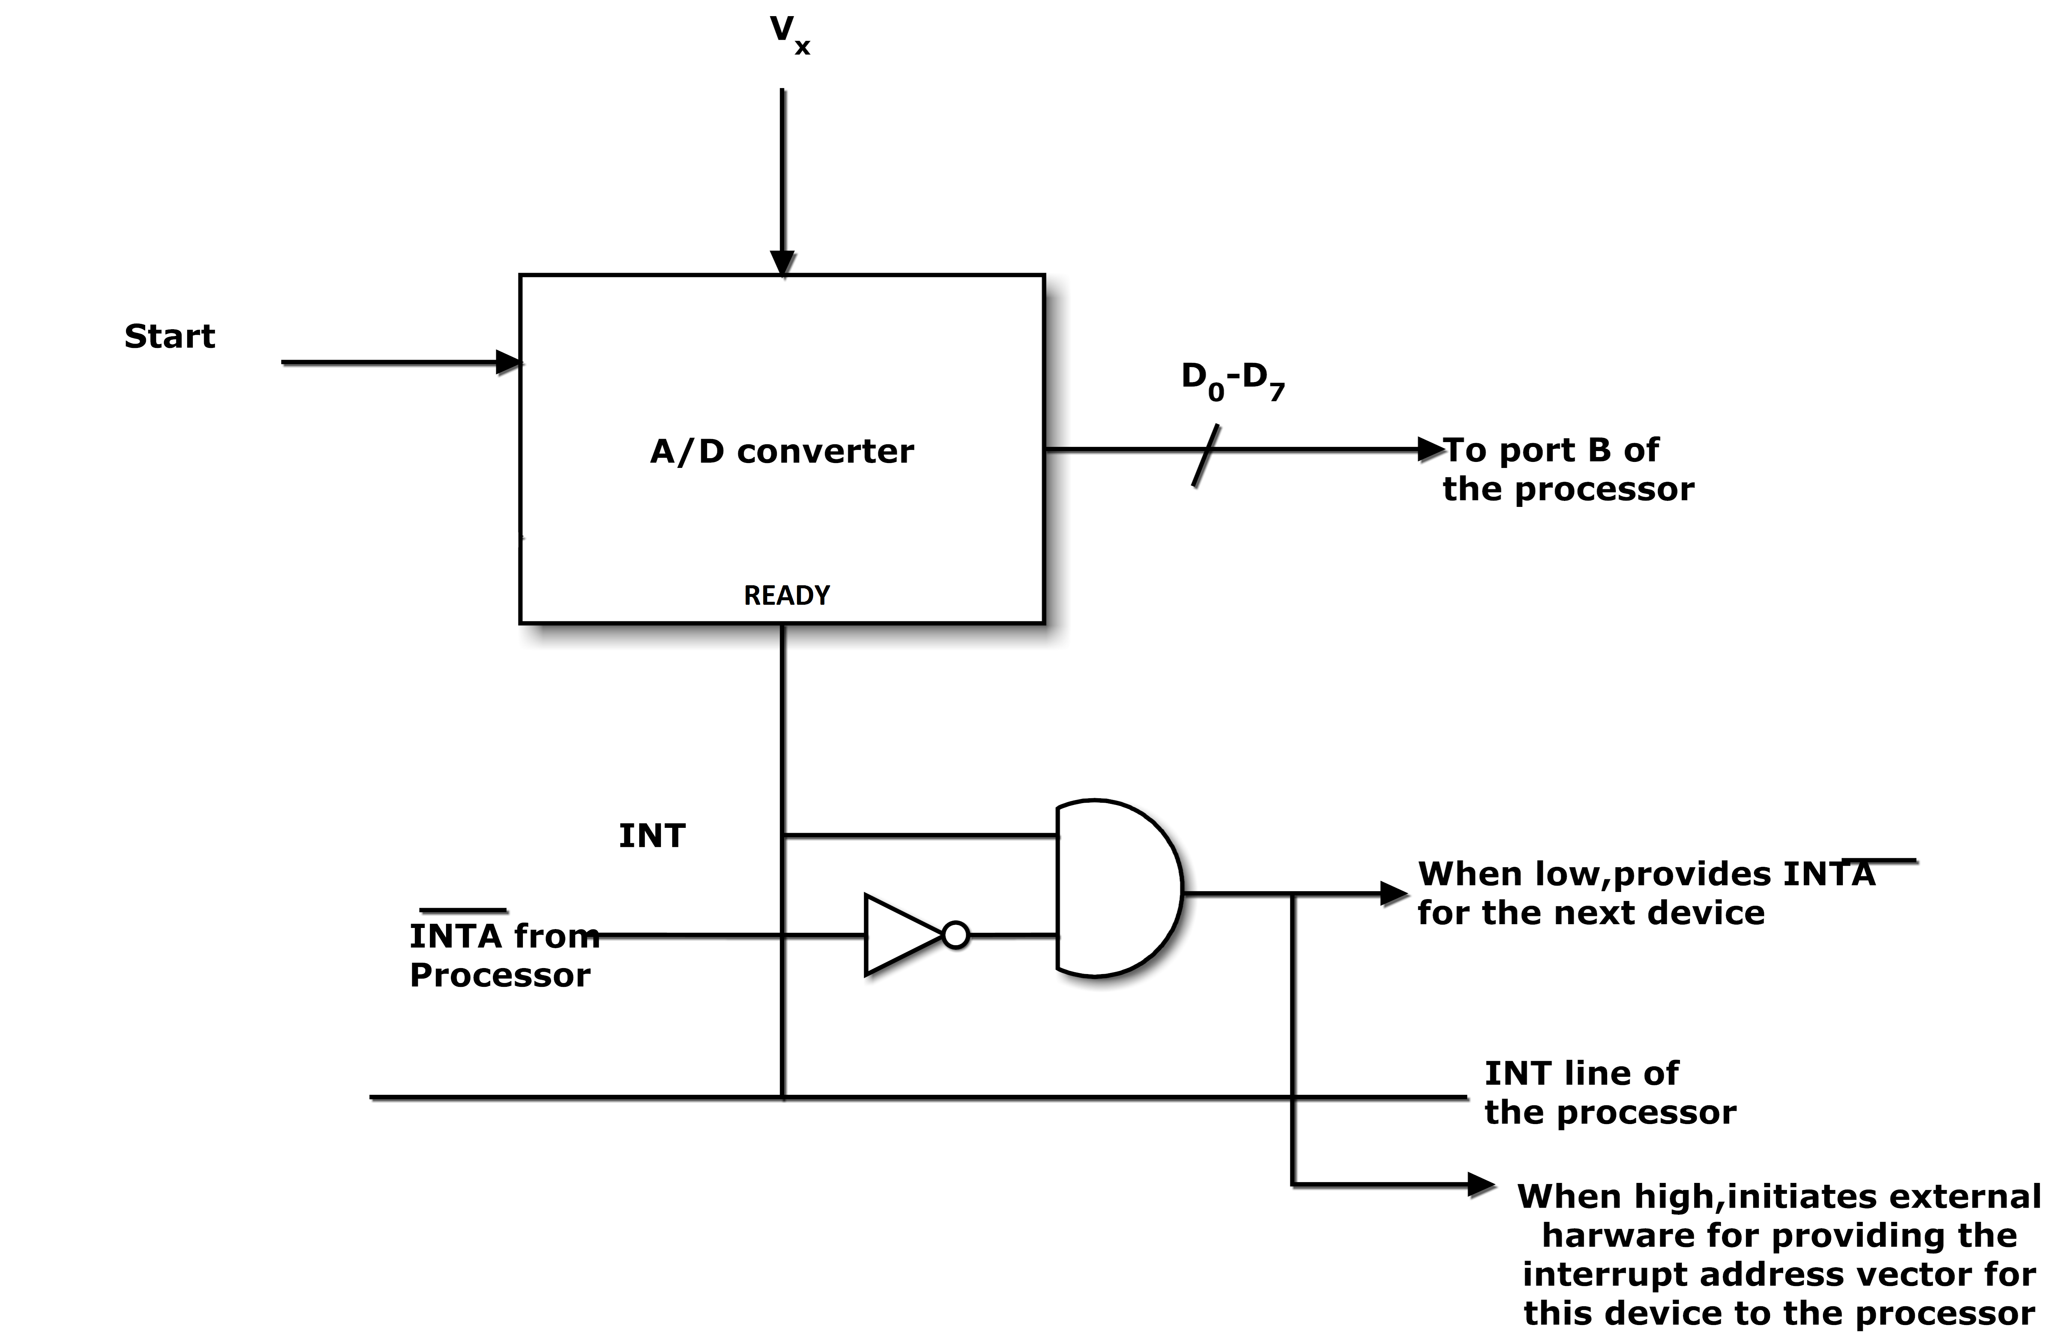

Device Associated Logic for Daisy Interrupt

Daisy chain interrupt scheme is fast as there is no software routine to check the interrupting devices based on priority. In-fact, as daisy chain is based on hardware, priority is fixed and hardwired. The check and skip (if not interrupted) is based on simple AND gate based hardware as illustrated in the figure above; hence the high speed of operation.

