Module-5, Unit-5
DMA based I/O

Question 1: Explain the major issue with Program I/O and Interrupt I/O?

Solution 1:

In programmed I/0 and Interrupt-driven I/O the CPU is actively involved in transfer data between memory and the I/0 module. Also, any data transfer must transverse a path through the CPU (register, accumulator). In case of programmed I/O the CPU is involved throughout the I/O process and in case of interrupt based I/O the CPU is involved during data transfer and handshaking between the I/O device and the CPU; only when the I/O device is processing the data the CPU is free for other computation. Thus both these forms of I/O suffer from two inherent drawbacks.

- The I/O transfer rate is limited by the speed with which the CPU can process interrupts and service an ISR.
- The CPU is tied up in managing an I/O transfer, partially or totally.

So, if an I/O application is considered, where data processing by the device takes very less time, then even in case of interrupt I/O, CPU will be highly engaged in I/O processing. This is because the CPU will be interrupted very often and it will not get sufficient time to execute the routine. A typical example of such an I/O transfer is an external memory e.g., flash. In data transfer from external memory to main memory, if programmed or interrupt I/O is used, CPU will be highly engaged. This is because I/O transfer involves reading a block from external memory (i.e., data processing by I/O is just memory read) which is extremely fast. Then the block of data which is read from the external memory is stored in main memory via CPU registers. It may be noted that even if the CPU is not doing any meaning computation, still it is engaged because it reads data from port to accumulator and stores to the main memory.

To address this issue, a special control unit may be provided which transfers data directly between an external device and the main memory, without continuous intervention by the CPU. In such a transfer the CPU needs to relinquish the data and address bus for I/O transfer. So this approach is useful only if the processing time of the I/O device is extremely fast (comparable to CPU speed), because during the data transfer, CPU cannot access the main memory. CPU can perform computation only on the data and instructions which are available in the cache. So, this technique can be useful only if I/O device (for the given application) is extremely fast and during the time when I/O is operational (CPU has relinquished the data and address buses) a large amount of data transfer can be accomplished.

Question 2: Explain the technique of data transfer using DMA I/O technique.

Solution 2:
The process of DMA transfers is controlled by a block called DMA controller. Broadly speaking, the DMA controller mimics a part of the CPU that access the main memory; like CPU the DMA controller also transfers data from I/O device to main memory and vice-versa. DMA controller sequentially generates the memory address of all the words to be transferred and also all the bus signals that control data transfer. Although a DMA controller can transfer data without intervention by the CPU (by taking control of system buses), its operation is controlled by a program executed by the CPU. A block transfer is initiated by the CPU by sending the starting address (of the block), the number of words in the block (i.e., the ending address), and the direction of the transfer. On receiving this information, the DMA controller proceeds to perform the requested operation by (i) incrementing the address by 1 at each step (ii) based on the data direction specified, the transfer is from (or to) main memory to (or from) I/O device. The figure below shows the block diagram of data transfer using DMA controller.

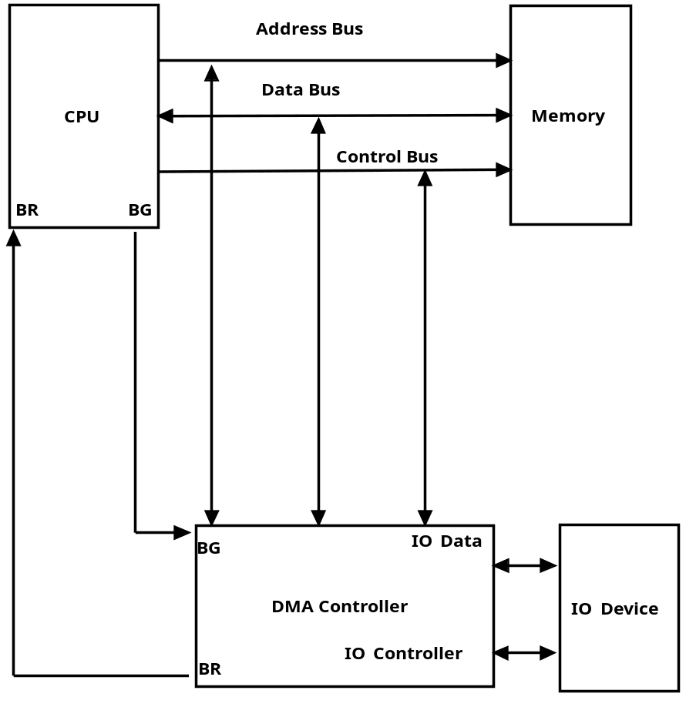
Data transfer using DMA controller

After completion of transfer of the block (i.e., last word is being accessed), the controller informs the CPU by raising an interrupt signal and then relinquishes the system buses. While a DMA transfer is on, the program that requested the transfer need to wait till the transfer is complete. So the CPU executes another program from the cache (as it does not have access to the system bus to fetch data/instruction from main memory). After the DMA transfer is completed, the CPU can resume the program (that requested the transfer) using the data revived/transferred in the DMA cycle. Just like the CPU, the DMA based I/O controller has its own set of registers, local memory, control circuitry. The advantage is that it can take the I/O work load of the CPU. The figure given below shows the block diagram of a DMA controller.

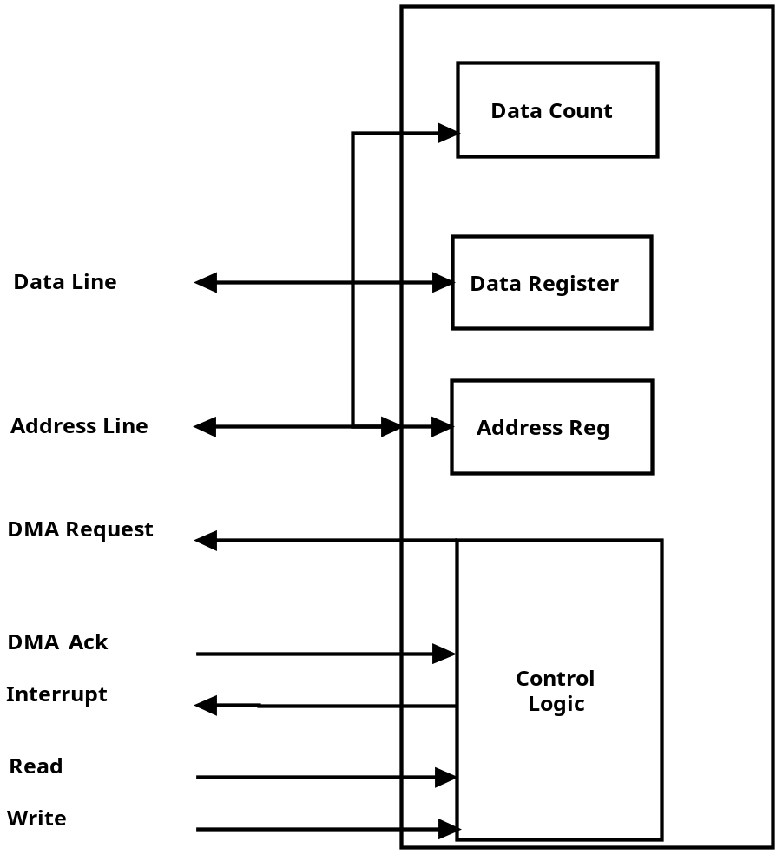
DMA controller

The DMA controller shares the main memory and I/O buses (Data, Address and Control) with the CPU and has both bus master and slave capability. DMA controller includes many registers and some important ones are discussed as follows.

- Address Register: It contains the memory address (of the first word) to be used in the data transfer.
- DMA Count Register (also called Word Count Register): It contains the number of bytes of data to be transferred. Using the value of this count register and Address register, the address of the last word to be transferred can be calculated.
- DMA Control Register: The CPU controls the DMA transfer through certain commands, which is sent to DMA control register.
- Status Register: It informs the CPU about the status of I/O device (ready, busy etc.).

The figure given below illustrates the flow of DMA operation.

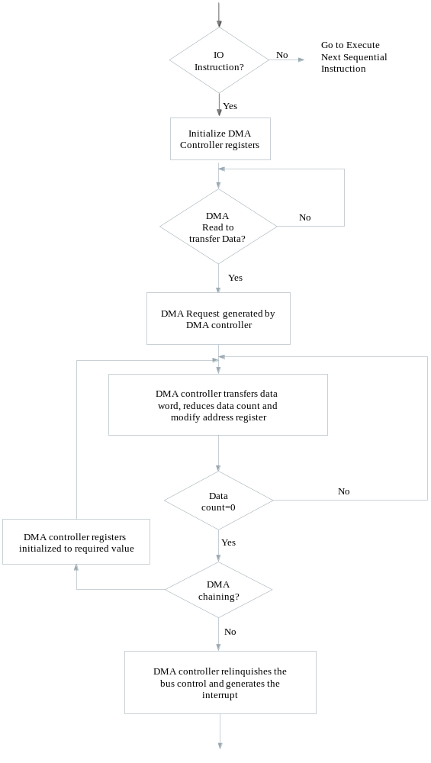
Flowchart illustrating DMA operations
To transfer data from an I/O device to memory, the DMA controller first sends a Bus Request to the CPU by setting Branch Request (BR) to 1. When CPU is ready to grant this request, the CPU sets its Bus Grant (BG) signal, BG to 1.The CPU then tri-states its address, data, and control lines thereby relinquishing control of the system buses to the DMA controller. The CPU will continue to be in tri-state mode as long as BR is asserted. To initiate a DMA transfer, the CPU loads the address of the first memory location of the memory block (to be read or written from) into the DMA address register, using an I/O instruction (which is loaded in control register). CPU then writes the number of bytes to be transferred into the DMA count register in the same manner. Finally, CPU writes control commands to the DMA control register. These commands specify transfer options such as the DMA transfer mode, the direction of the transfer, either from I/O to memory or from memory to I/O etc.

During the data transfer using DMA the sequence of steps that takes place are illustrated pictorially below (step wise from 1 through 8):

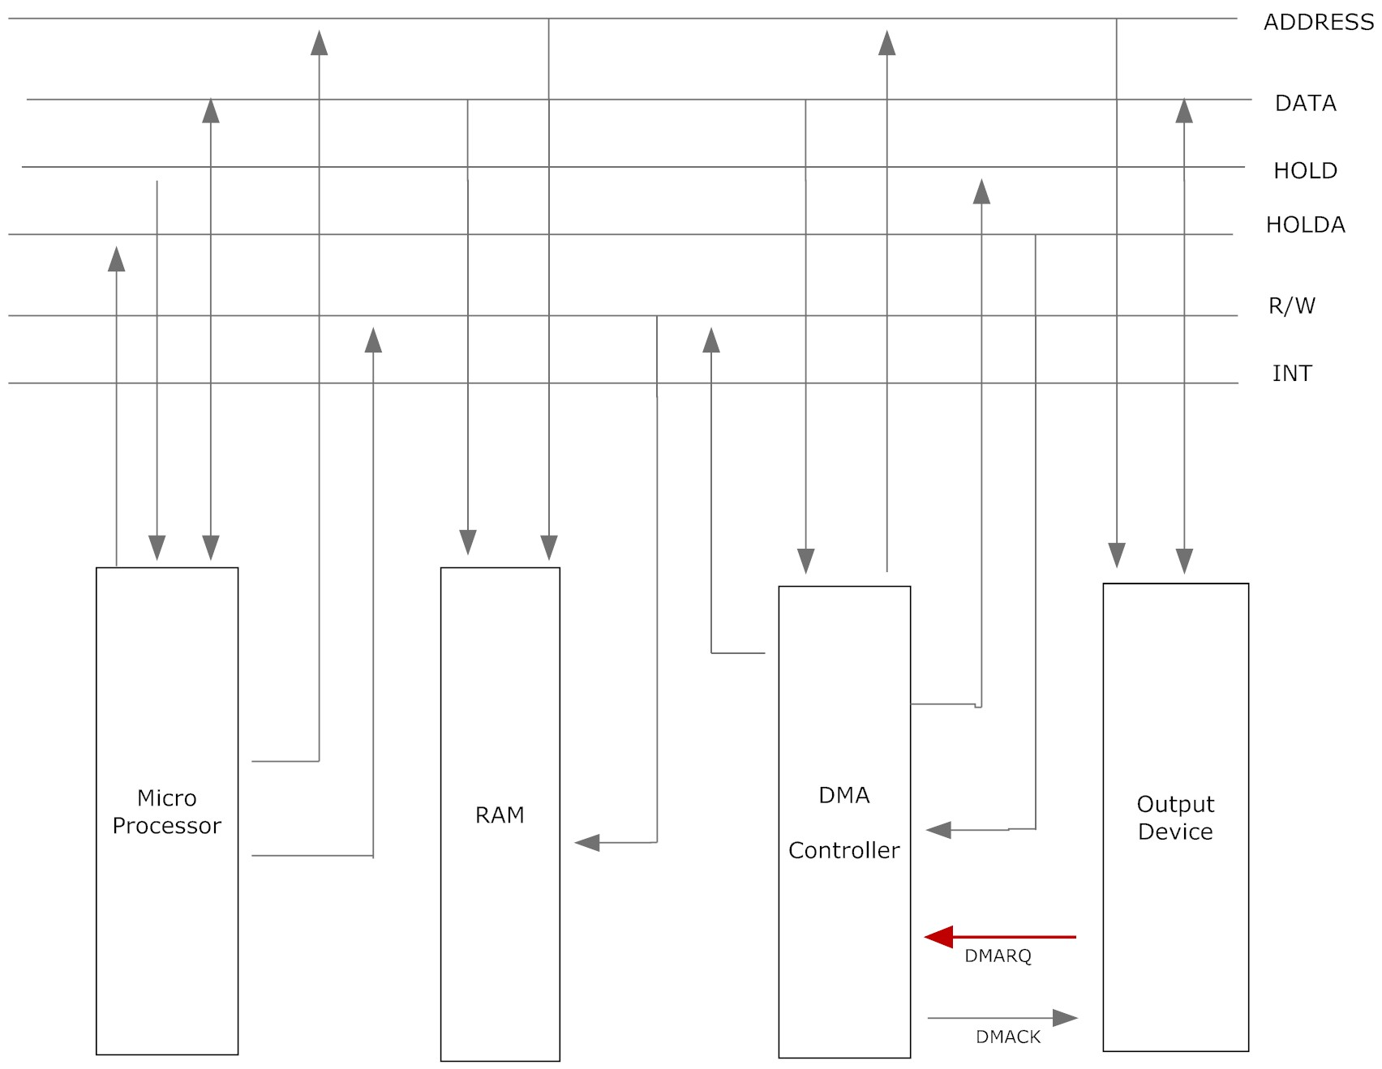
Step-1: The IO devices request DMA operation via the DMA request line of the controller chip.

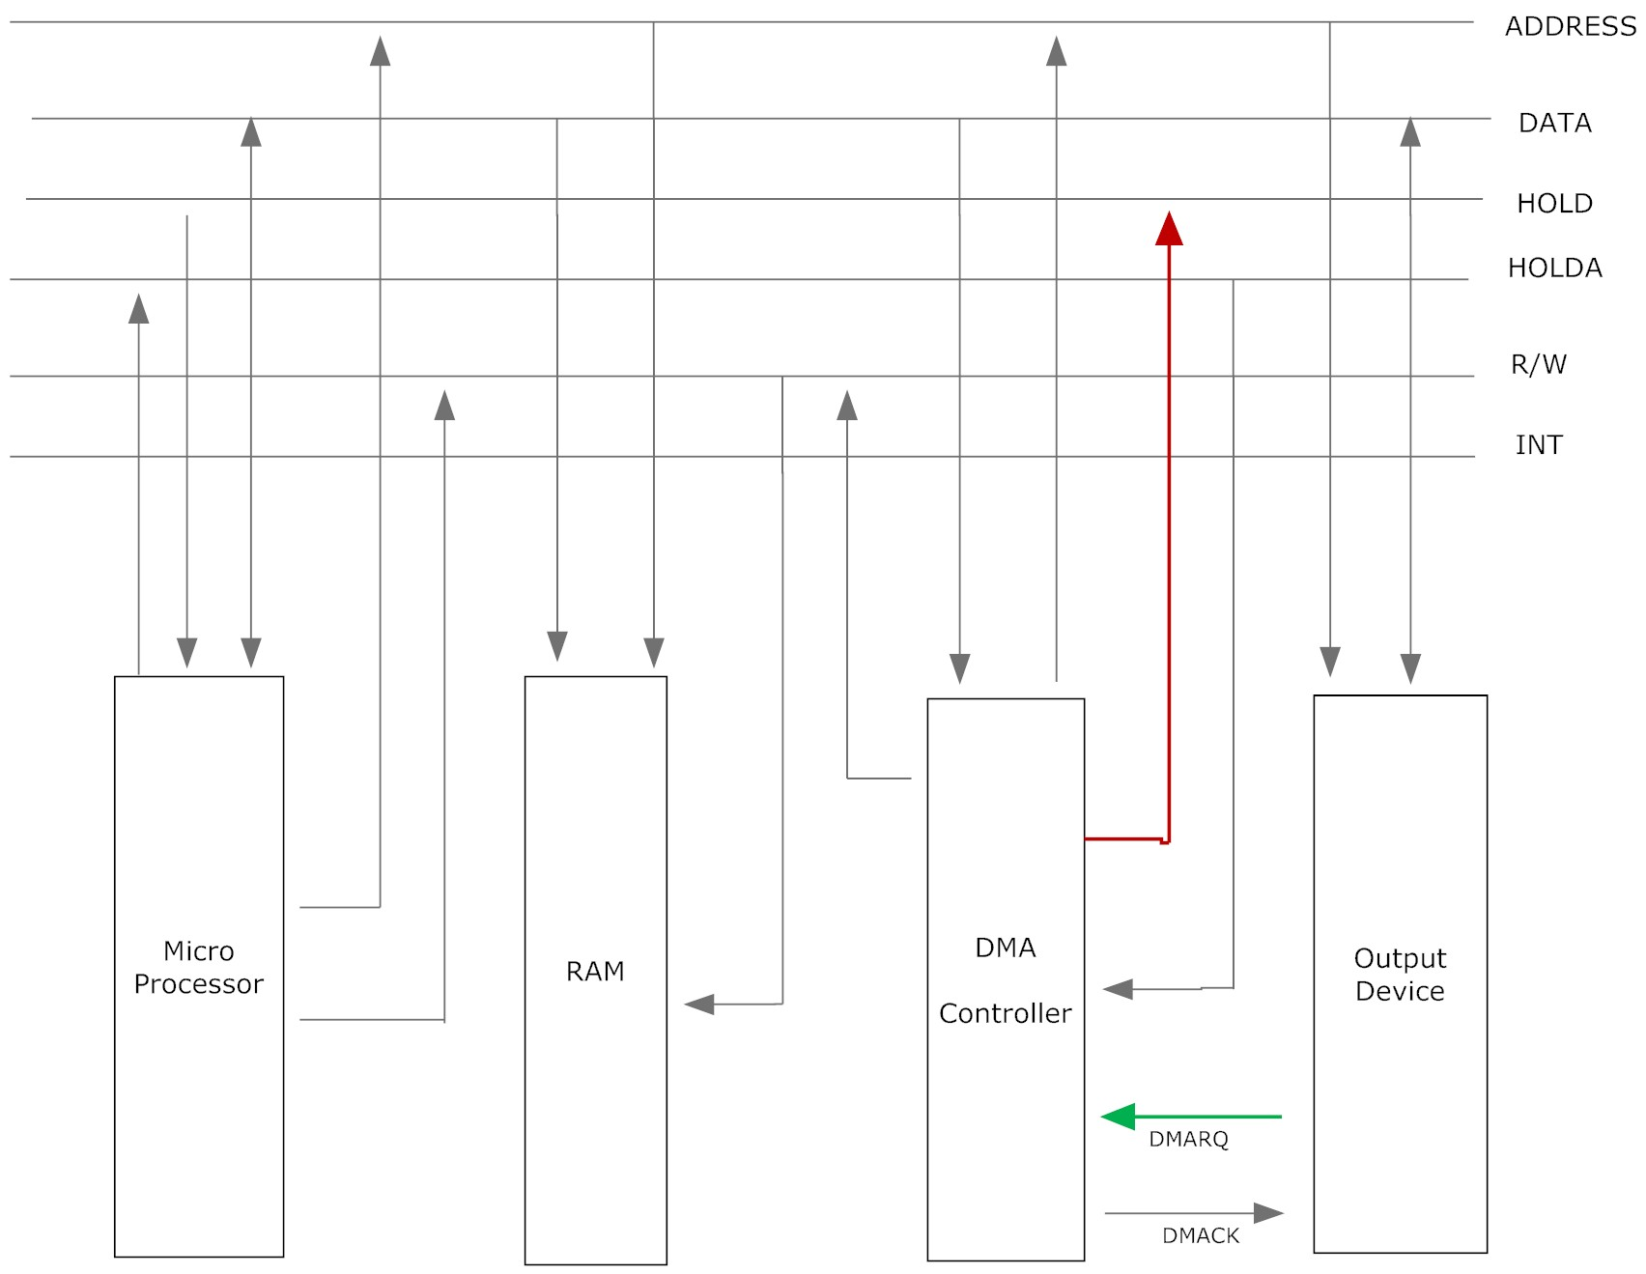
Step 2- The controller chip activates the CPU HOLD pin (it goes high), requesting the CPU to release the system bus.

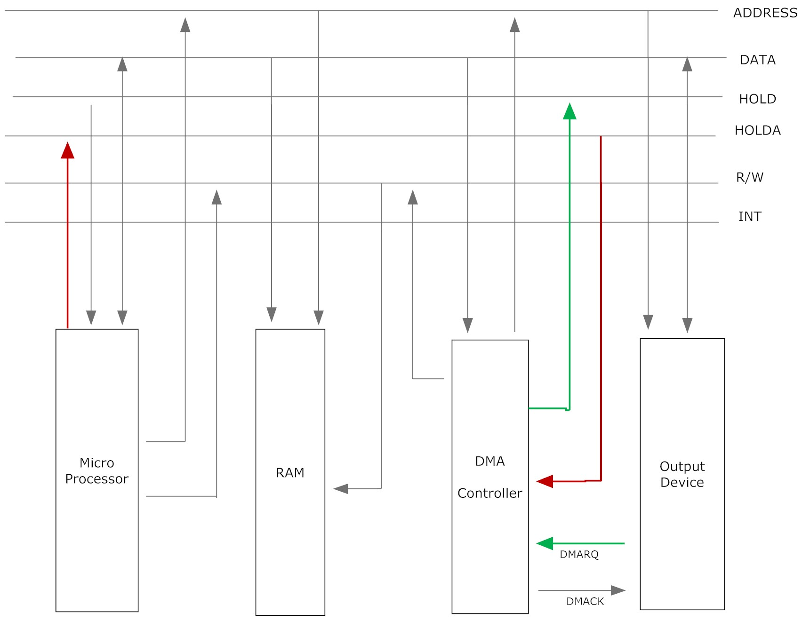
Step 3: The processor sends the HLDA (Hold Acknowledge goes high) back to the DMA controller, indicating the system bus is disabled.
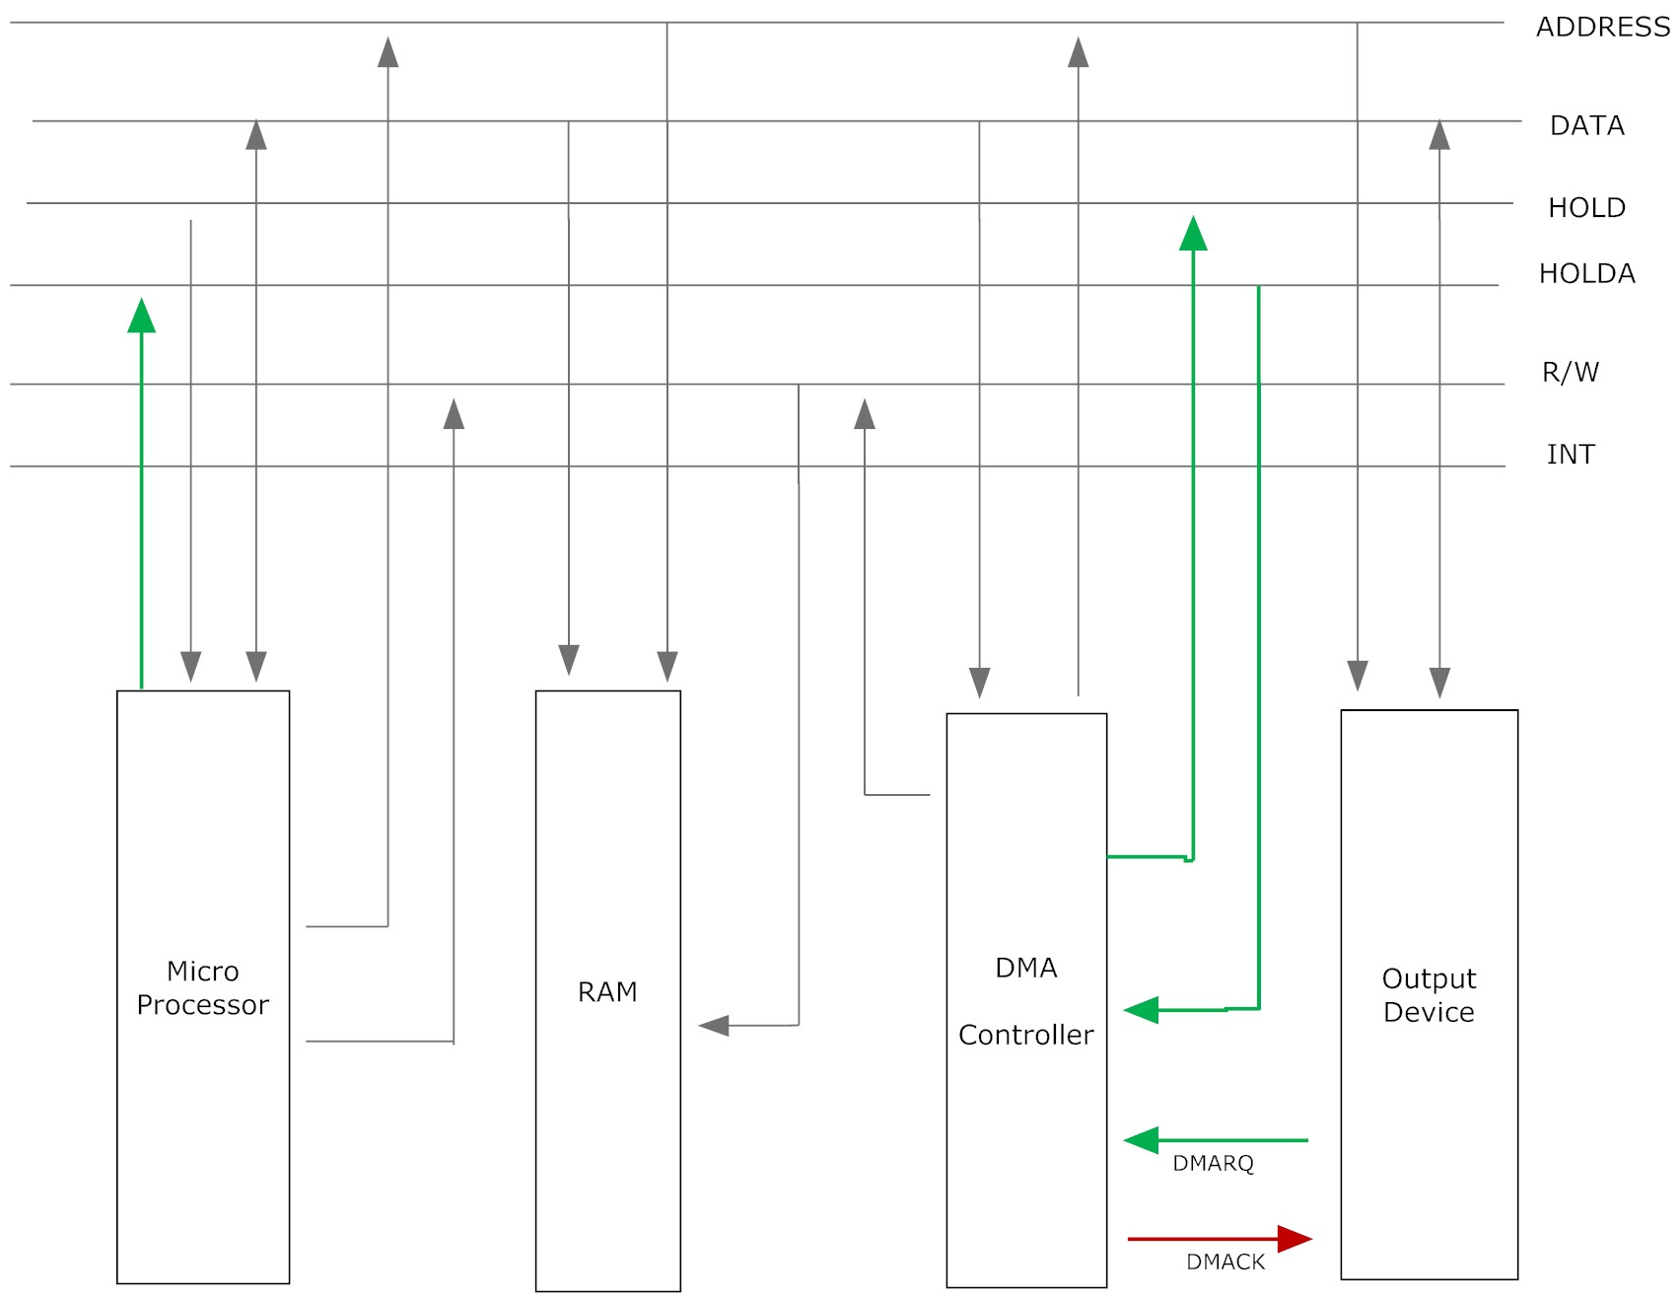

Step 4-DMA controller sends acknowledgement DMACK to the device.

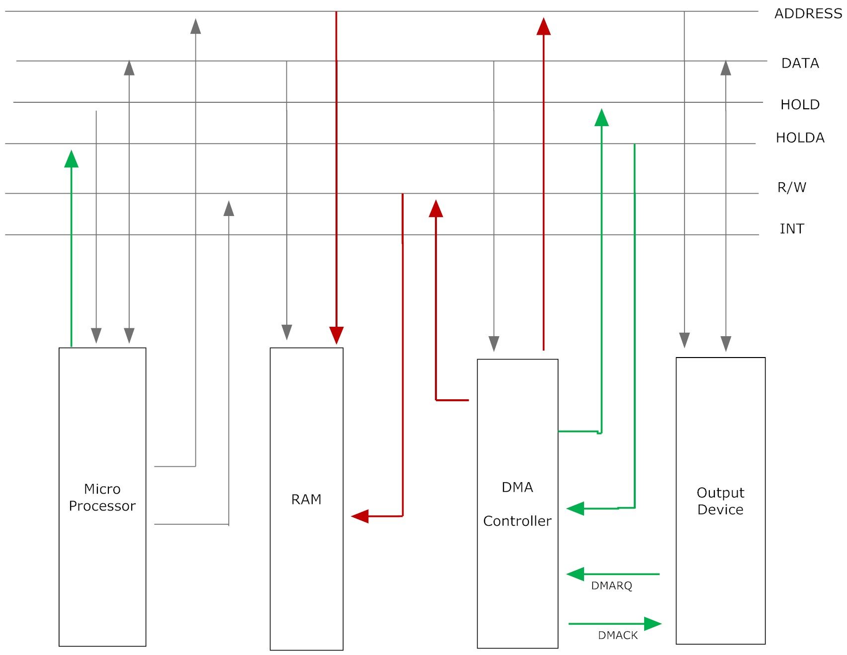

Step 5- After the bus is disabled for CPU, it is now controlled by the DMA controller which places the contents of its address register onto the address bus.

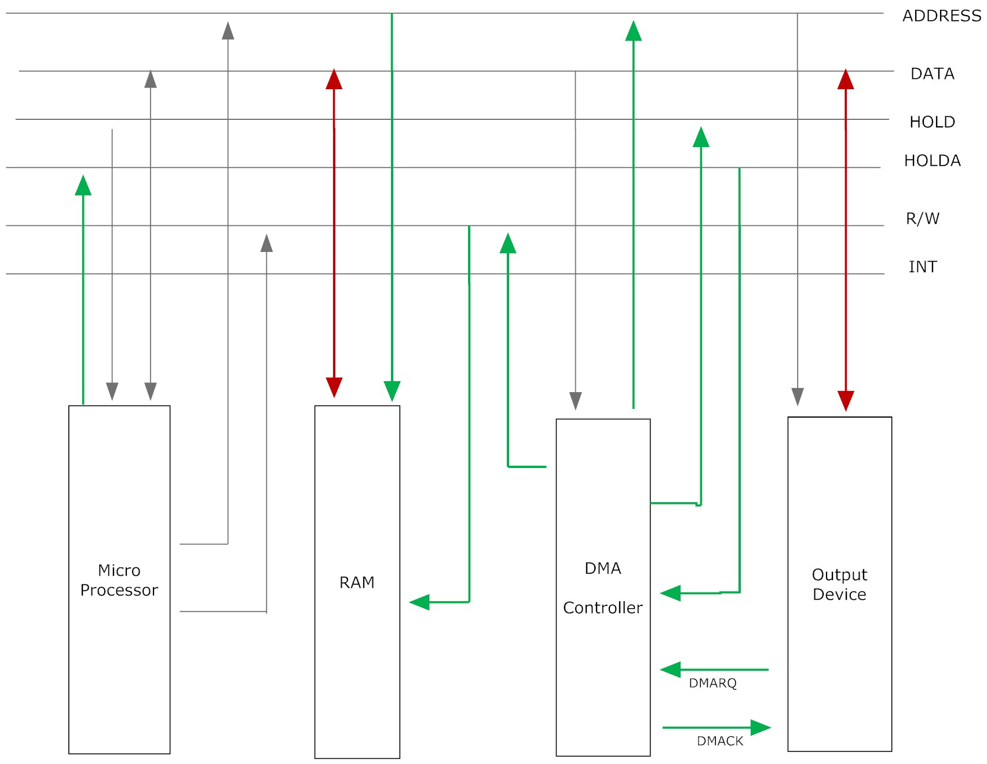

Step 6--The controller sends the IO interface a DMA acknowledgment, which tells the IO interface to put data on the data bus.

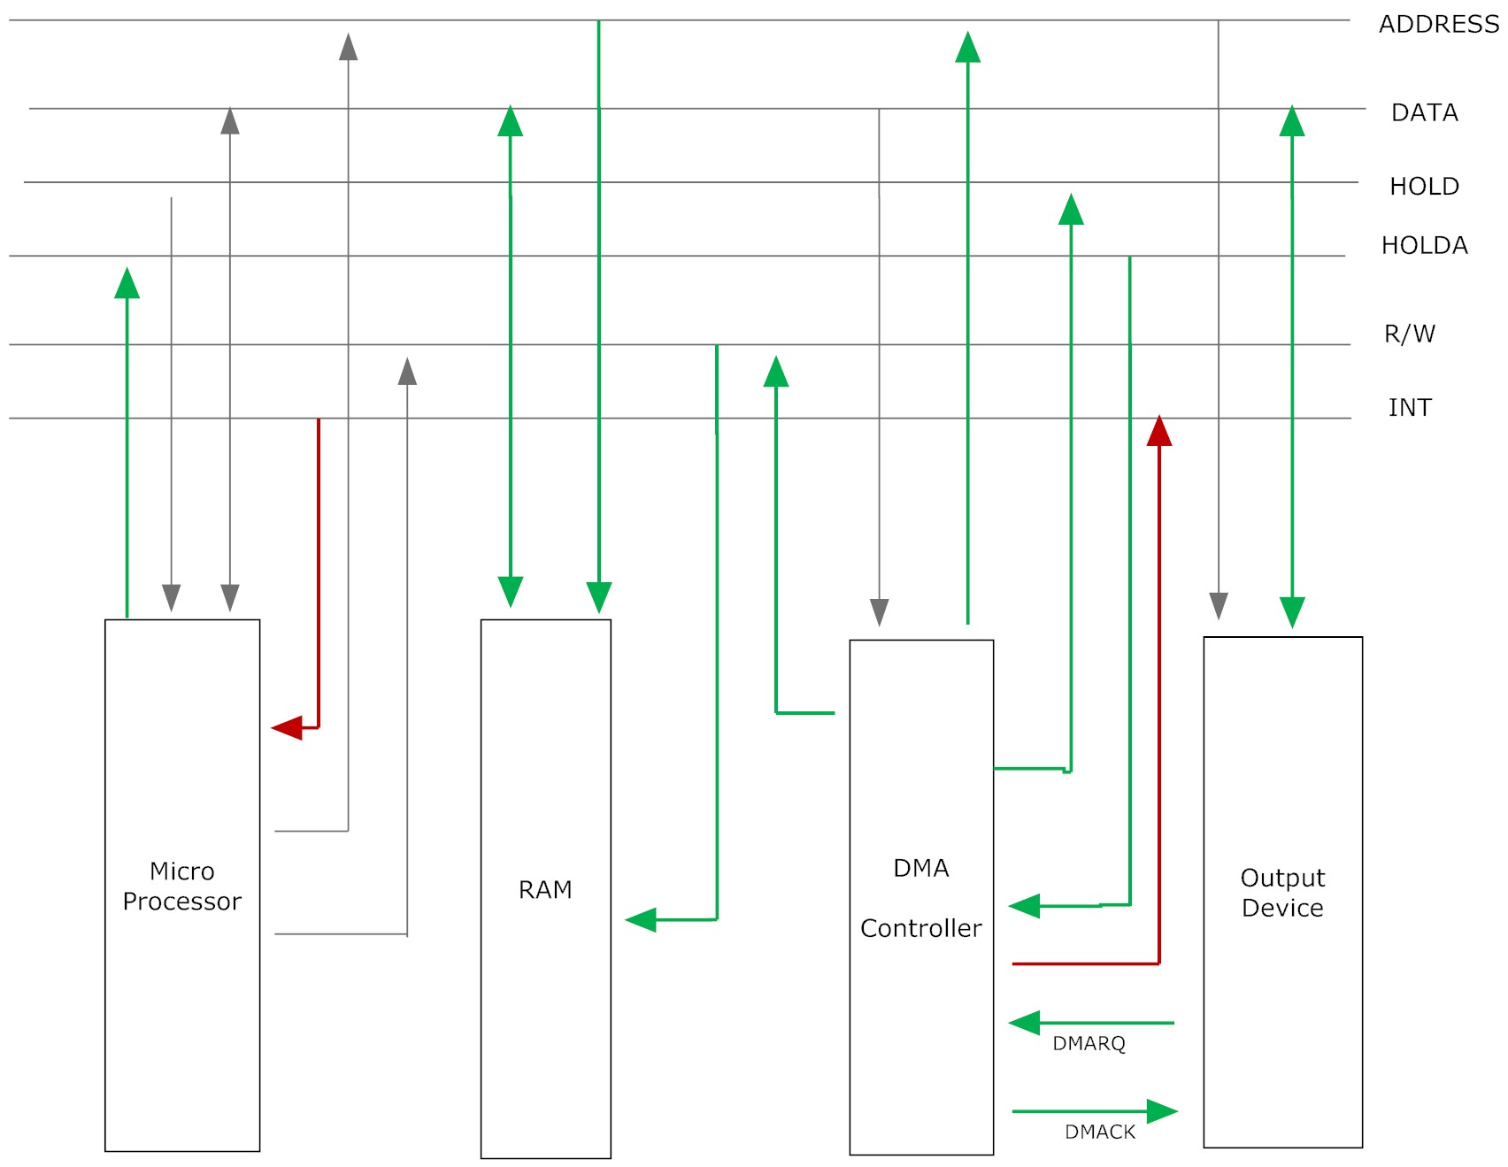
Step 7--When the transfer is completed, the DMA module sends an interrupt signal to the processor.
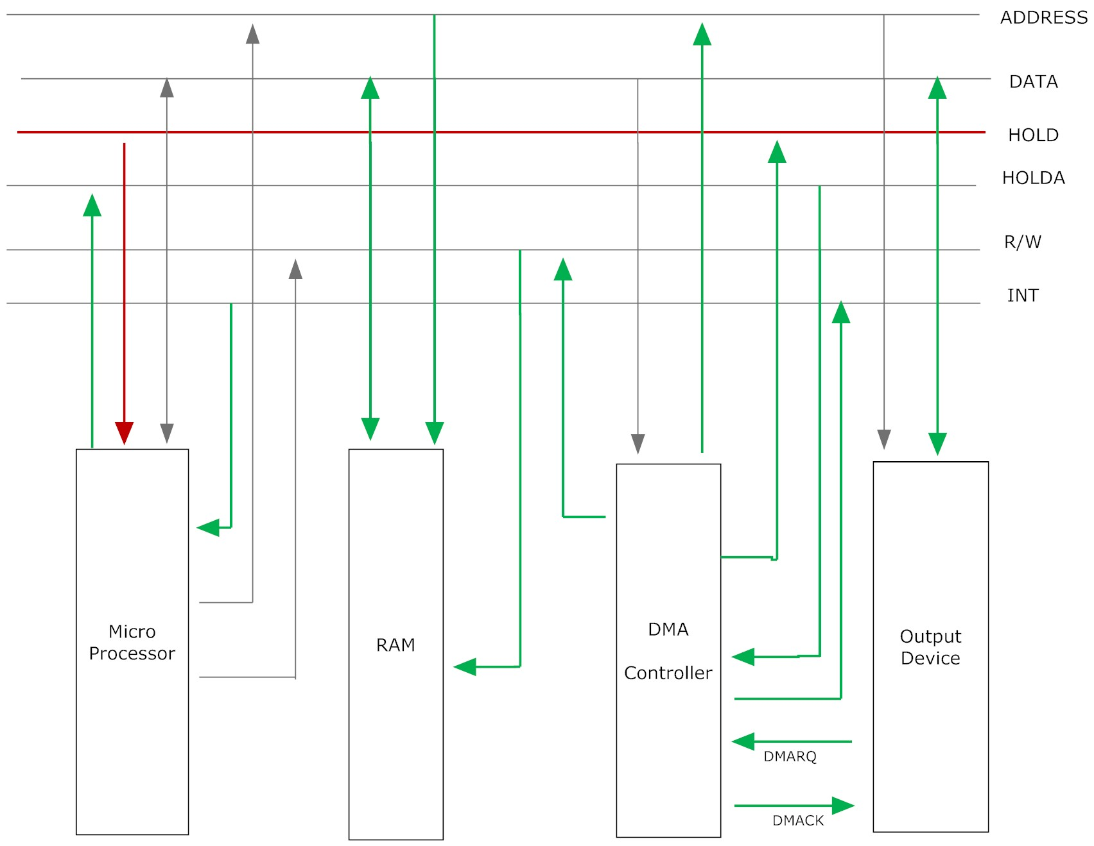
Step 8---After the data is successfully transferred the HOLD pin goes low which results in the CPU taking control of the system bus.

Question 3: What are the different modes of transfer in DMA based I/O transfer?

Solution 3:

There are three common modes of data transfer in DMA,
- Burst
- Cycle Stealing
- Interleaved Mode

Broadly speaking, mode is defined by how the DMA controller determines when to transfer data in the DMA cycle.

Burst Mode
In Burst Mode transfer, an entire block of data is transferred from I/O device to main memory as one single continuous sequence. As the name suggests, once the DMA controller is granted access to the data and address buses by the CPU, it transfers the entire data block before releasing the system buses back to the CPU. This mode is useful for applications like, loading programs or data files into memory, but makes the CPU idle for relatively long periods of time.

Cycle Stealing Mode
In the Burst mode the CPU has to halt execution if the required data or instruction is not available in the cache and DMA transfer is on-going. This option is not possible if the CPU executes real time applications. A viable alternative is where the CPU should not be disabled for the entire length of DMA cycle; rather it should be given access to the system bus in between the DMA cycle so that it can replace the cache bocks where there were misses. DMA controller obtains access to the system buses as in burst mode. However, it transfers one byte of data and then returns control of the system buses to the CPU. Then the DMA controller continually issues requests for the system buses from CPU, transferring one byte of data per request, until it has transferred its entire block of data. By continually obtaining and releasing control of the system buses, the DMA controller essentially interleaves instruction and data transfers. In this process the CPU fetches data/instruction and then the DMA controller transfers a data, and so on. The data block is not transferred as quickly as in burst mode, but the CPU is not idled for long waiting for data/instruction to be fetched from main memory.

Interleaved Mode
This scheme utilizes the basic idea of cycle seating and burst mode. This scheme basically uses burst transfer mode unless the CPU process halts due to requirement of some data/instruction from the main memory. At this juncture, the technique moves to cycle stealing mode and the CPU takes control of the system bus to get the information from main memory. Following that again burst mode is followed. In other words, the DMA controller only transfers data when the CPU is performing operations that do not use the system buses (by using the data/instruction present in the cache). For example, let the code given below be loaded in the CPU cache when DMA transfer is on.

ADD R1, R2, R3
BEQ R1 R2 Label
………………….
………………….

………………….
JMP Label

Al long as this code is being executed the CPU does not require system bus i.e., DMA transfer is operational but CPU is not required to be halted.

Primary advantage in this approach is that CPU never stops executing its programs and DMA transfer is free in terms of time. The only disadvantage is that the hardware needed to determine when the CPU is not using (do not require) the system buses can be relatively expensive.

Question 4: What are the different configurations of DMA transfer?

Solution 4:

The DMA mechanism can be configured in different ways. The most common among them are:
- Single bus, detached DMA –I/O configuration.
- Single bus, Integrated DMA-I/O configuration.
- Using separate I/O bus.

Single bus, detached DMA- I/O configuration.

In this organization all modules share the same system bus. The DMA module here acts as a surrogate processor. This method uses programmed I/O to exchange data between memory and an I/O module through the DMA module. For each transfer it uses the bus twice. The first one is used when transferring the data between I/O device and DMA module, and the second one is when transferring the data between DMA module and memory. Since the bus is used twice while transferring data, so the bus will be suspended twice. The transfer consumes two bus cycles.

The interconnection organization is shown in the figure below.

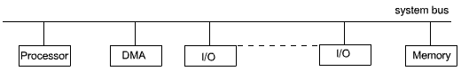

Single bus, Integrated DMA-I/O configuration.

Single bus, Integrated DMA - I/O configuration

By integrating the DMA module and I/O module, the number of required bus cycles for data transfer can be reduced. In this configuration, the DMA module and one or more I/O modules are integrated together in such a way that the system bus is not involved in transfer of data/control in-between the I/O module and DMA module. In this case DMA logic may actually be a part of an I/O module, or it may be a separate module that controls one or more I/O modules. The DMA module, CPU and the memory module are connected through the system bus. In this configuration each transfer will use the system bus only once when data is transferred between DMA module and main memory; so the CPU is suspended only once. The configuration is shown in the figure below.

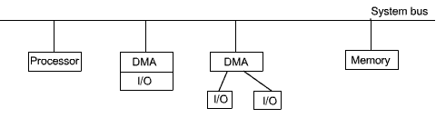
Single bus, Integrated DMA - I/O configuration

Using separate I/O bus.

In this configuration the I/O modules are connected to the DMA through another bus called I/O bus. In this case the DMA module is reduced to one. Transfer of data between I/O modules and DMA module is carried out through this I/O bus. In this transfer, system bus is not in use and so the CPU does not need to relinquish the data and address buses. There is a transfer phase between DMA module and main memory; for this transfer, system bus is needed for transfer and CPU will be suspended for only one bus cycle. The configuration is shown in the figure below.

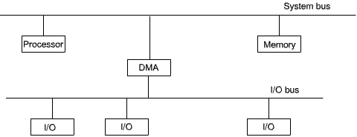

Using separate I/O bus

