Module-5, Unit-6
Storage Devices

Question 1: What is external memory and why is it required? How external memory is generally implemented?

Solution 1:

Main memory is mandatory in the working of computer that works on Von-Neumon stored program principle. The information (instruction/data) is stored in main memory and CPU access the information only from the main memory. The main memory is made up of semiconductor devices and by nature it is volatile. For permanent storage of information we need some non-volatile memory.

The memory devices needed to store information permanently are termed as external memory. While a code is being executed and the data/instruction which is not available in the main memory are transferred from external memory to main memory. When a code is to be executed or a file is to be read, the code or the file is transferred from external memory to main memory. It may be noted that deepening on the size of the code or the file, and free space available in the main memory, the code or the file may be loaded partially. After working on the partial part that is loaded, the next part (again may be partially) of the code or file is read from external memory to main memory. This continuous till the full code is executed or the entire file is processed.

The external memory devices need to store information permanently and are either magnetic or optical devices. Some examples are given below.

Magnetic devices:

- Magnetic disc(hard disk)
- Floppy disc
- Magnetic tape

Optical device

- CD- ROM
- CD-Recordable( CD –R)
- CD-R/W
- DVD
Question 2: Explain the basic working principle of a magnetic disk?

Solution 2:

A disk is a circular platter constructed of metal or of plastic coated with a magnetizable material. Data is recorded and later retrieved from the disk via a conducting coil named head. During a read or write operation, the head is stationary while the platter rotates beneath it. The write mechanism is based on the fact that electricity flowing through a coil produces a magnetic field. Pulses are sent to the head, and magnetic patterns are recorded on the surface below. The pattern depends on the positive or negative currents; positive current for information ‘1' and negative current for information ‘0'. The read mechanism is based on the fact that a magnetic field moving relative to a coil produces an electric current in the coil. When the surface of the disk passes under the head, it generates a current of the same polarity as the one already recorded. The figure given below shows Read/ Write head.
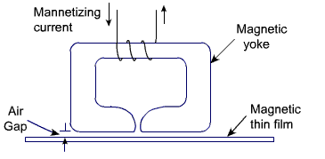
The Read and Write Head

The head is a relatively small device capable of reading from or writing to a portion of the platter rotating beneath it. The data on the disk are organized in a concentric set of rings, called track. Each track has the same width as the head. Adjacent tracks are separated by gaps. This prevents error due to misalignment of the head or interference of magnetic fields. For simplifying the control circuitry, the same number of bits is stored on each track. Thus the density, in bits per linear inch, increases in moving from the outermost track to the innermost track. Data is transferred to and from the disk in terms of blocks. Usually, the block is smaller than the capacity of the track. Accordingly, data is stored in block-size regions known as sector. A typical disk layout is shown in the figure below.
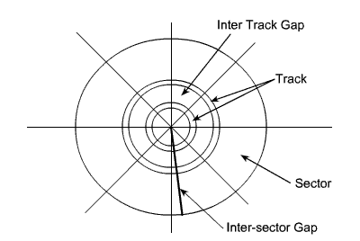

Disk Layout

To avoid, high precision requirements on the disk control system, adjacent tracks (sectors) are separated by intratrack (intersector) gaps. Some means are needed to locate sector positions within a track. Clearly there must be some starting points on the track and a way of identifying the start and end of each sector. These requirements are handled by means of a control data recorded on the disk. Thus, the disk is formatted with some extra data used only by the disk drive and not accessible to the user.

Since data density in the outermost track is less and data density is more in inner tracks so there is wastage of space on outer tracks. To increase the capacity, the concept of zone is used instead of sectors. Each track is divided in zone of equal length and fix amount of data is stored in each zone. So the number of zones is less in innermost track and number of zones is more in the outermost track. Therefore, more number of bits is stored in outermost track. The disk capacity increases due to the use of zone, but the complexity of control circuitry is also more. The concept of Zone and Sector is shown in the figure below.
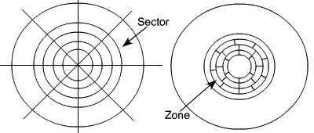

Concept of Zone and Sector
The head may be either fixed or movable with respect to the radial direction of the platter. In a fixed-head disk, there is one read-write head per track. All of the heads are mounted on a rigid arm that extends across all tracks. In a movable-head disk, there is only one read-write head. Again the head is mounted on an arm. Because the head must be able to be positioned above any track, the arm can be extended or retracted for this purpose. The disk itself is mounted in a disk drive, which consists of the arm, the shaft that rotates the disk, and the electronic circuitry (needed for input and output of the binary data and to control the mechanism). Fixed and movable disks are shown in the figure below.

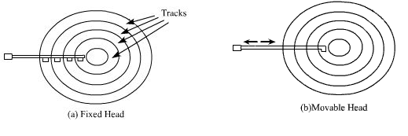

Fixed and Movable head disk

For most disks, the magnetizable coating is applied to both sides of the platters, which is then referred to as double-sided. If the magnetizable coating is applied to one side only, then it is termed as single sided disk. Some disk drives accommodate multiple platters stacked vertically above one another. Multiple arms are provided for read write head. The platters come as a unit known as a disk pack. The physical organization of a multiple platter disk is shown in the figure given below.

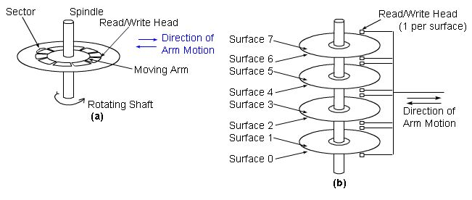
Multiple platter disks
Question 3: How is data organized and accessed in a magnetic disk?

Solution 3:
The organization of data on a disk is shown in the figure below.

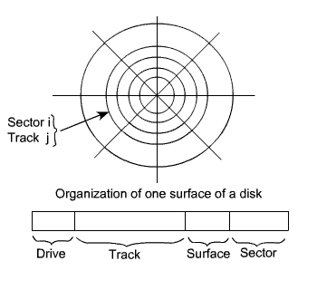
Organization of Data on a Disk

As shown in the figure, each surface is divided into concentric tracks and each track is divided into sectors. The set of corresponding tracks on all surfaces of a stack of disks form a logical cylinder. Data bits are stored serially on each track. Data on disks are addressed by specifying the surface number, the track number, and the sector number. In most disk systems, read and write operations always start at sector boundaries. If the number of words to be written is smaller than that required to fill a sector, the disk controller repeats the last bit of data for the remaining of the sector. During read and write operation, it is required to specify the starting address of the sector from where the operation will start, i.e., the read/write head must be positioned to the correct track, sector and surface. Therefore, the address of the disk contains track number, sector number, and surface number. If more than one drive is present, then drive number must also be specified. The format of the disk address word is also shown in the figure above. It contains the drive number, track number, surface number and sector number. The read/write head will first be positioned to the correct track. In case of fixed head system, the correct head is selected by taking the track number from the address. In case of movable head system, the head is moved so that it is positioned at the correct track. By the surface number, it selects the correct surface. To get the correct sector below the read/write head, the disk is rotated and bring the correct sector with the help of sector number. Once the correct sector, track and surface are decided, the read/write operation starts next.

Let us take an example. Suppose the disk system has 8 data recording surfaces with 4096 track per surface. Tracks are divided into 256 sectors. Then the format of disk address word is given below.

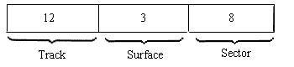

Suppose each sector of a track contains 512 bytes of disk recorded serially, then the total capacity of the disk is:
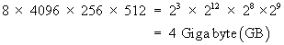

For moving head system, there are two components involved in the time delay between receiving an address and the beginning of the actual data transfer.

Seek Time:
Seek time is the time required to move the read/write head to the proper track. This depends on the initial position of the head relative to the track specified in the address.

Rotational Delay:
Rotational delay, also called the latency time is the amount of time that elapses after the head is positioned over the correct track until the starting position of the addressed sector comes under the Read/write head.

Communication between a disk and the main memory is done through DMA. The following information must be exchanged between the CPU and the disk controller in order to specify a transfer.

- Main memory address: The address of the first main memory location of the block of words involved in the transfer.
- Disk address: The location of the sector containing the beginning of the desired block of words.
- Word count: The number of words in the block to be transferred.

The word count may correspond to fewer or more bytes than that are contained in a sector. When the data block is longer than a track, the disk address register is incremented as successive sectors are read or written. When one track is completed then the surface count is incremented by 1. Thus, long data blocks are laid out on cylinder surfaces as opposed to being laid out on successive tracks of a single disk surface. This is efficient for moving head systems, because successive sector areas of data storage on the disk can be accessed by electrically switching from one Read/Write head to the next rather than by mechanically moving the arm from track to track. The track-to-track movement is required only at cylinder-to-cylinder boundaries.

Question 4: Explain how is the performance of a magnetic disk measured? What are some common techniques to enhance the performance?

Solution 4:

There are many parameters to measure the performance of a disk. Among them access time and reliability are important ones.

Access time

When a disk drive is operating, the disk is rotating at constant speed. To read or write, the head must be positioned at the desired track and at the beginning of the desired sector on the track. Track selection involves moving the head in a movable-head system or electronically selecting one head on a fixed head system. On a movable-head system, the time taken to position the head at the track is known a seek time. Once the track is selected, the disk controller waits until the appropriate sector rotates to line up with the head. The time it takes to reach the beginning of the desired sector is known as rotational delay or rotational latency. The sum of the seek time, (for movable head system) and the rotational delay is termed as access time of the disk, i.e., the time it takes to get into appropriate position (track and sector) to read or write. Once the head is in position, the read or write operation is then performed as the sector moves under the head, and the data transfer takes place. One of the basic parameters to measure the disk performance is access time. Now we elaborate some of the terms introduced above.

Seek Time

Seek time is the time required to move the disk arm to the required track. The seek time is approximated as

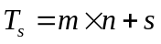
where
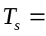 estimated seek time
number of tracks traversed
constant that depends on the disk drive
startup time

Rotational Delay

Disk drive generally rotates at 3600 rpm, i.e., to make one revolution it takes around 16.7 ms. Thus on the average, the rotational delay will be 8.3 ms.

Transfer Time

The transfer time to or from the disk depends on the rotational speed of the disk and it is estimated as
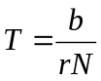
where
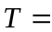Transfer time
Number of bytes to be transferred.
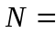Numbers of bytes on a track
Rotational speed, in revolution per second.

Thus the total average access time can be expressed as
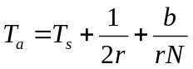
where 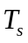 is the average seek time.

Obviously, lower the access time better is the disk performance.

Reliability:

The disk drive contains some mechanical parts and it involves mechanical movement, so the failure rate is also high. So better the reliability or lesser the number of faults (e.g., erroneous data read/write), higher the performance.

Improving the Disk performance:

A disk array is an arrangement of several disks, organized to increase performance and improve reliability of the resulting storage system. Performance is increased through data striping. Reliability is improved through redundancy. Disk arrays that implement a combination of data striping and redundancy are called Redundant Arrays of Independent Disks (RAID)

Data Striping:

In data striping, the data is segmented in equal-size partitions and distributed over multiple disks. The size of the partition is called the striping unit. The partitions are usually distributed using a round-robin algorithm--if the disk array consists of D disks, then partition i is written in to disk (i mod D).

Let us consider a striping unit equal to a disk block. In this case, I/O requests of the size of a disk block are processed by one disk in the array. If many I/O requests of the size of a disk block are made, and the requested blocks reside on different disks, we can process all requests in parallel and thus reduce the average response time of an I/O request. Since the striping units are distributed over several disks in the disk array in round robin fashion, large I/O requests of the size of many continuous blocks involve all disks. We can process the requests to all disks in parallel and thus increase the transfer rate.

Redundancy:

While having more disks increase storage system performance, it also lowers overall storage system reliability, because the probability of failure of a disk in disk array increases. Reliability of a disk array can be increased by storing redundant information. If a disk fails, the redundant information is used to reconstruct the data on the failed disk. One design issue involved is where to store the redundant information. There are two choices---either store the redundant information on a small number of check disks, or distribute the redundant information uniformly over all disks.

In a RAID system, the disk array is partitioned into reliability group, where a reliability group consists of a set of data disks and a set of check disks. A common redundancy scheme is applied to each group. RAID has several levels as explained below.

RAID levels

- RAID Level 0: Non-redundant

A RAID level 0 system is not a true member of the RAID family, because it does not include redundancy, i.e., no redundant information is maintained. It uses data striping to increase the I/O performance. For RAID 0, the user and system data are distributed across all the disks in the array, i.e.., data is striped across the available disks. If two different I/O requests are there for two different data blocks, there is a good probability that the requested blocks are in different disks. Thus, the two requests can be issued in parallel, reducing the I/O waiting time. RAID level 0 is a low cost solution, but the reliability is a problem since there is no redundant information to retrieve data in case of disk failure. RAID level 0 has the best write performance of al RAID levels, because there is no need of maintaining or updation of redundant information.

- RAID level 1: Mirrored

RAID level 1 is the most expensive solution to achieve the redundancy. In this system, two identical copies of the data on two different disks are maintained. This type of redundancy is called mirroring. Data striping is used here similar to RAID 0. Every write of a disk block involves two write due to the mirror image of the disk blocks. These write may not be performed simultaneously, since a global system failure may occur while writing the blocks and then leave both copies in an inconsistent state. Therefore, the technique is -- write a block on a disk first and then write the other copy on the mirrored disk. A read of a block can be scheduled to the disk that has the smaller access time. Since we are maintaining the redundant information, accessing the disk for mirror copy may be less costly.

- RAID level 2

RAID levels 2 and 3 make use of a parallel access technique where all member disks participate in the execution of every I/O requests. Data striping is used in RAID level 2 and 3, but the size of strips is very small, often as small as a single byte or word. With RAID 2, an error-correcting code is calculated across corresponding bits on each data disk, and the bits of the codes are stored in the corresponding bit positions on multiple parity disks. RAID 2 requires fewer disks than RAID 1. The number of redundant disks is proportional to the log of the number of data disks. For error-correcting, it uses Haming code. On a single read, all disks are simultaneously accessed. The requested data and the associated error correcting code are delivered to the array controller. If there is a single bit error, the controller can recognize and correct the error instantly, so that read access time is not slowed down. On a single write, all data disks and parity disks must be accessed for the write operation.

- RAID level 3

RAID level 3 is organized in a similar fashion to RAID level 2. The difference is that RAID 3 requires only a single redundant disk. RAID 3 allows parallel access, with data distributed in small strips. Instead of an error correcting code, a simple parity bit is computed for the set of individual bits in the same position on all of the data disks. In the event of drive failure, the parity drive is accessed and data is reconstructed from the remaining drives. Once the failed drive is replaced, the missing data can be restored on the new drive.

- RAID level 4

RAID levels 4 through 6 make use of an independent access technique, where each member disk operates independently, so that separate I/O request can be satisfied in parallel. Data striping is used in this scheme also, but the data strips are relatively large for RAID level 4 through 6. With RAID 4, a bit-by-bit parity strip is calculated across corresponding strips on each data disks, and the parity bits are stored in the corresponding strip on the parity disk. RAID 4 involves a write penalty when an I/O write request of small size has occurred. Each time a write occurs, update is required both in user data and the corresponding parity bits.

- RAID level 5:

RAID level 5 is similar to RAID 4, only difference is that RAID 5 distributes the parity strips across all disks. The distribution of parity strips across all drives avoids the potential I/O bottleneck.

- RAID level 6:

In RAID level 6, two different parity calculations are carried out and stored in separate blocks on different disks. The advantage of RAID 6 is that it has got a high data availability, because the data can be regenerated even if two disk containing user data fails. It is possible due to the use of Reed-Solomon code for parity calculations. In RAID 6, there is a write penalty, because each write affects two parity blocks.

