Module-6, Unit-1
Performance enhancement: Pipeline and Parallism

Question 1: We know that the execution cycle of an instruction involves—Fetch, decode, and execute. Sometimes it is also called fetch-execute cycle. Both the parts of the cycle are executed on a single block in the CPU. Now we divide this block of CPU into two individual sub-blocks to perform (i) Fetch and (ii) Execute (also decode). Explain how would the performance in terms of rate of program execution change with this modification?

Solution 1:

It can be well anticipated that organization enhancements to the CPU can improve performance, e.g., multiple registers rather than a single accumulator, and use of cache memory improves the performance considerably. Another organizational approach, which is quite common, is instruction pipelining. Pipelining is particularly effective way of organizing parallel activity in a computer system. The basic idea is very simple. It is frequently encountered in manufacturing plants, where pipelining is alternatively known as an assembly line operation. By laying the production process out in an assembly line, product at various stages can be worked on simultaneously. This process is also referred to as pipelining, because, as in a pipeline, new inputs are accepted at one end before previously accepted inputs appear as outputs at the other end. To apply the concept of instruction execution in pipeline, it is required to break the instruction in different sub-tasks. Each sub-task will be executed in different processing elements of the CPU. At the very crude level, there are two distinct phases of instruction execution: one is instruction fetch and the other one is instruction execution. Therefore, the processor executes a program by fetching and executing instructions, one after another. Let 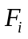 and 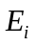 refer to the fetch and execute steps for instruction. Execution of a program consists of a sequence of fetch and execute steps is shown in the figure below.

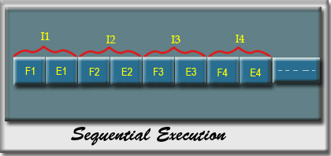

Sequential Execution-Fetch and Execute
Now consider a CPU that has two separate hardware units, one for fetching instructions and another for executing them. The instruction fetch by the fetch unit is stored in an intermediate storage buffer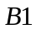. The results of execution are stored in the destination location specified by the instruction. For simplicity it is assumed that fetch and execute steps of any instruction can be completed in one clock cycle.

Basic idea of instruction pipelining with hardware organization is shown in the figure below.
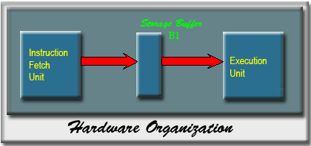
Basic idea of instruction pipelining

The operation of the processor on an instruction proceeds as follows:

- In the first clock cycle, the fetch unit fetches an instruction (instruction, step ) and stores it in buffer at the end of the clock cycle.
- In the second clock cycle, the instruction fetch unit proceeds with the fetch operation for instruction 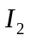(step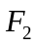).
- Meanwhile, the execution unit performs the operation specified by instruction, which is already fetched and available in the buffer (step 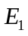).
- By the end of the second clock cycle, the execution of the instruction is completed and instruction is available.
- Instruction is stored in buffer, replacing, which is no longer needed.
- Step 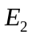 is performed by the execution unit during the third clock cycle, while instruction 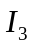 is being fetched by the fetch unit.

Both the fetch and execute units are kept busy all the time and one instruction is completed after each clock cycle except the first clock cycle. If a long sequence of instructions is executed, the completion rate of instruction execution will be twice that achievable by the sequential operation with only one unit that performs both fetch and execute. This flow is pictorially shown in the figure below.

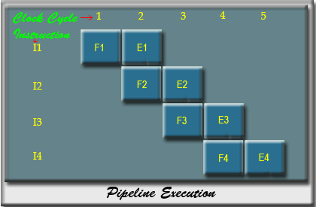
Step of processing of instructions, when instruction unit divided into two parts

Question 2: Question 1 deals with the fact that efficiency of CPU is enhanced if the instructing execution unit is divided into two pipelined stages. How can the CPU efficiency be further improved?

Solution 2:

The processing of an instruction need not be divided into only two steps. To gain further speed up, the pipeline must have more stages.

Let us consider the following decomposition of the instruction execution:

- Fetch instruction (FI): Read the next expected instruction into a buffer.
- Decode instruction ((DI): Determine the operation to be performed based on op-code.
- Calculate operand (CO): Calculate the effective address of each source operand(s).
- Fetch operands (FO): Fetch each operand from memory.
- Execute Instruction (EI): Perform the indicated operation.
- Write operand (WO): Store the result in memory/register.

There will be six different stages for these six subtasks. For the sake of simplicity, let us assume the equal duration to perform all the subtasks. It the six stages are not of equal duration, there will be some waiting involved at various pipeline stages.
The timing diagram for the execution of instruction in pipeline fashion is shown in the figure below for 8 instructions.
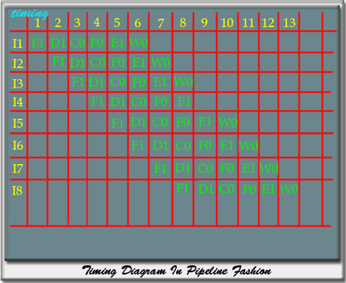
Timing diagram of 6 stage pipeline
From this timing diagram it is clear that the total execution time of 8 instructions in this 6 stages pipeline is 13-time units. The first instruction gets completed after 6 time unit, and thereafter, in each time unit it completes one instruction. Without pipeline, the total time required to complete 8 instructions would have been 48 (6 X 8) time units. Therefore, there is a speed up in pipeline processing and the speed up is related to the number of stages.

Question 3: Assume that we have a CPU with instruction pipeline and the following specifications:
- 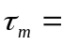maximum stage delay (delay through stage which experience the largest delay)
- number of stages in the instruction pipeline.
- 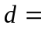time delay of a latch, needed to advance signals and data from one stage to the next.

What is the speedup achieved compared to a non-pipelined implementation? What will be changes in the speedup if practical factors like overhead involved in moving data from buffer to buffer, control logic required to handle memory and register dependencies etc. are considered.

Solution 3:

The cycle time of an instruction pipeline is the time needed to advance a set of instructions one stage through the pipeline. The cycle time can be determined as

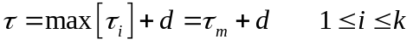
where

maximum stage delay (delay through stage which experiences the largest delay)
number of stages in the instruction pipeline.
time delay of a latch, needed to advance signals and data from one stage to the next.

In general, the time delay is equivalent to a clock pulse and 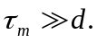

Now suppose instructions are processed and these instructions are executed one after another. The total time required 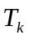 to execute all instructions is
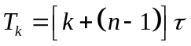
because, a total of cycles are required to complete the execution of the first instruction, and the remaining 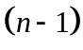 instructions require cycles.

The time required to execute instructions without pipeline is
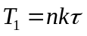
because to execute one instruction it would take 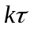 time (on an average).

The speed up factor for the instruction pipeline compared to execution without the pipeline can be calculated as:
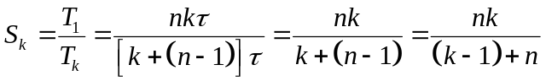

In general, the number of instructions executed is much higher than the number of stages in the pipeline. So, if 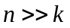, then 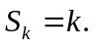

To summarize, the speed up factor is a function of the number of stages in the instruction pipeline. Though, it has been seen that the speed up is proportional to number of stages in the pipeline, but in practice the speed up is less due to some practical reasons. Some of the factors that affect the pipeline performance are discussed next.

- Effect of Hardware related issues:

Consider a pipeline processor, which process each instruction in four steps;
F: Fetch the instruction from the memory
D: Decode the instruction and fetch the source operand(s)
O: Operate i.e., perform the operation
W: Write the result in the destination location.

The hardware organization of this four-stage pipeline processor is shown in the figure below.

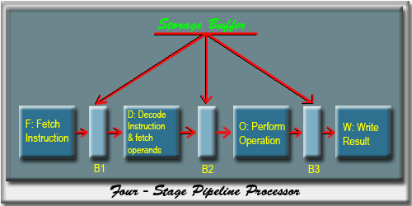
Hardware organization of the four-stage pipeline processor

The speed up of pipeline processor is related to number of stages in the pipeline, i.e., greater the number of stages in the pipeline, faster the execution rate. But the organization of the stages of a pipeline is a complex task and if affects the performance of the pipeline. The problem related to more number of stages is discussed below.

At each stage of the pipeline, there is some overhead involved in moving data from buffer to buffer and in performing various preparation and delivery functions. This overhead can appreciably lengthen the total execution time of a single instruction. The amount of control logic required to handle memory and register dependencies increase enormously with the number of stages. Such complexities slowdown the frequency of each pipeline stage.

- Unequal time requirement to complete a subtask:

Consider the four-stage pipeline with processing steps as Fetch, Decode, Operate and Write. The stage-3 of the pipeline is responsible for arithmetic and logic operation, and in general one clock cycle is assigned for this task. Although this may be sufficient for most operations, but some operations like divide may require more time to complete. Following figure shows the effect of an operation that takes more than one clock cycle to complete an operation.

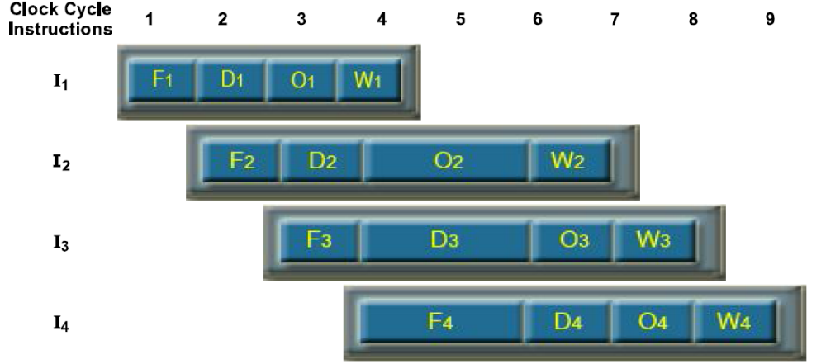

Effect of an operation that takes more than one clock cycle

The operate stage for instruction takes 3 clock cycles to perform the specified operation. Clock cycles 4 to 6 are required to perform this operation and so write stage cannot perform anything during the clock cycle 5 and 6, because no data is available to be written. Meanwhile, the information in buffer B2 must remain unchanged until the operate stage has completed its operation. This means that stage 2 and stage 1 are blocked from accepting new instructions because the information in B1 cannot be overwritten by a new fetch instruction. The contents of B1, B2 and B3 must always change at the same clock edge. Due to that reason, pipeline operation is said to have been stalled for two clock cycles. Normal pipeline operation resumes in clock cycle 7. Whenever the pipeline is stalled, some degradation in performance occurs.

- Dependency Constraints:
Consider the following program that contains two instructions, followed by .
: 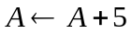
: 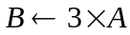

When this program is executed in a pipeline, the execution of begin before the execution of is completed. The pipeline execution is shown in below:

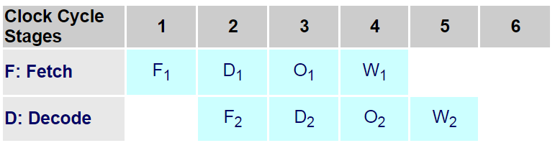
Pipeline execution of two instructions

In clock cycle 3, the specific operation of instruction, i.e., addition takes place and at that time only the new updated value of A is available. But in the clock cycle 3, the instruction is fetching the operand that is required for the operation of . Since in clock cycle 3, operation of instruction is taking place, so the instruction will get the old value of A; as will not get the updated value of A, it will produce a wrong result.

Consider that the initial value of A is 4. The proper execution will produce the result as 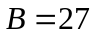

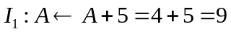
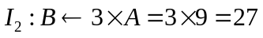

But due to the pipeline action, we will get the result as
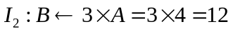

Due to the data dependency, these two instructions cannot be performed in parallel. Therefore, no two operations that depend on each other can be performed in parallel. So under such dependencies pipeline solution involves extra delay.

Question 4: Originally, the computer has been viewed as a sequential machine. Most computer programming languages require the programmer to specify algorithms as sequence of instruction. Explain with an example where some sub-problems of the overall problem can be executed in parallel. Consider any parallel architecture of Flynn's taxonomy for the answer.

Solution 4:

We will explain the concept of parallelism using the example of matrix multiplication on Single instruction, multiple data (SIMD) architecture. SIMD is a class of parallel computers in Flynn's taxonomy, where there are similar types of multiple processing elements that perform the same operation on multiple data simultaneously. To elaborate, SIMD based computers perform parallel computations on multiple data but the operation is similar at a given instant. Array processors are best example of SIMD architecture. To elaborate, in array processor there is an array of processing elements which are synchronously controlled by a controller. Such processors are appropriate for vector operations like, matrix algebra, image processing etc.

The organization of an array processor is shown in the figure below.
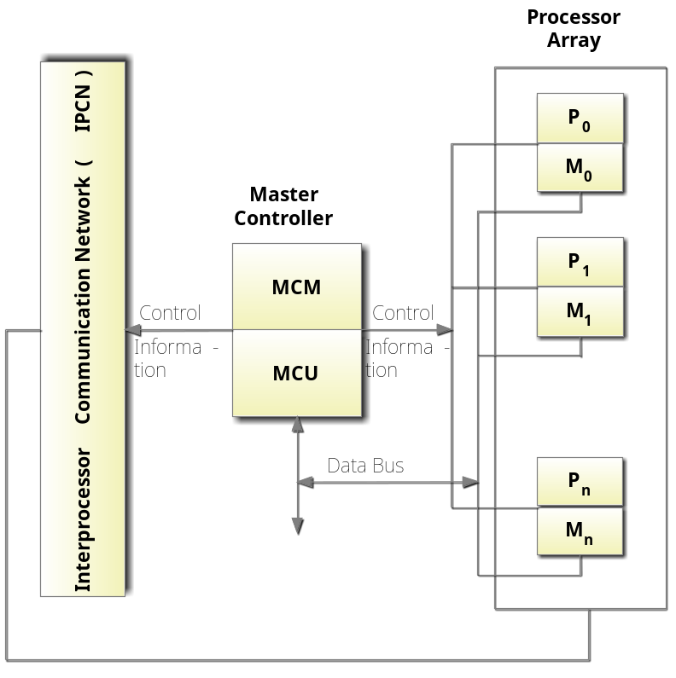
A typical Array Processor

Master Controller: It has two parts, master control unit (MCU) and master control memory (MCM). All processing units (termed as P₁, P₂, P_{n}) are controlled by MCU. The programs and data are loaded into the MCM. The vector instructions in the program are fetched and decoded by MCU. The same instruction (that is decoded) is broadcast to the array of processing elements. However, the data being processed by each processing elements are different and taken from vector instruction.

Processing elements (P): Each processing element is a reduced scale processor in itself. It comprises ALU, registers and local memory (designated as M₁, M₂, M_{n}) for storage of the individualized data sent by MCM for that particular processing element. All processing elements are interconnected via an interconnection network and they perform same operation at a given instance synchronously in a lock-step fashion under the control of the MCU. In other words, all processing elements receive the instructions from the MCU and the different operands are fetched from their local memory.

Array processors are generally connected to a host computer through the master controller. When the host computer identifies a code that requires vector processing it sends the sequence of vector instructions to the processing units through the master controller. The individualized data are sent to the local memory of the respective processing elements.

Example:

We will use a wave front processor array to demonstrate multiplication of two 2X2 matrices using parallel processing.

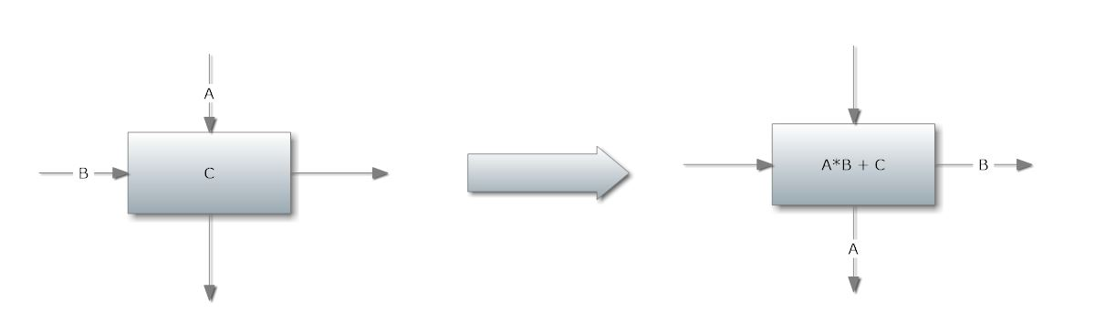
Function of the processing units involved: When both inputs are present, the execution unit multiplies the two inputs together and adds the result onto the data stored in the local memory. The top input is transferred out to the bottom output, and the left input is transmitted to the right output. The figure given below illustrates the block diagram of the processing unit.
Bock diagram of the processing unit

The matrix multiplication operation which we would perform is:
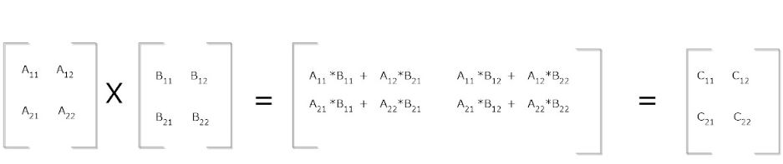

Steps involved in the computation process are demonstrated below:

Step I: The initial contents of internal memory of each processing elements are set to 0. Inputs are provided to each computation unit as shown in the figure below.
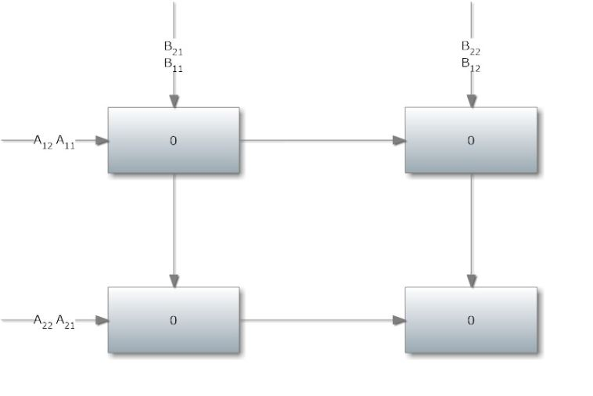
Processing elements at Step-1

Step-2:
Computation is performed in left-uppermost unit and inputs are provided to left-lowermost and right-uppermost units.

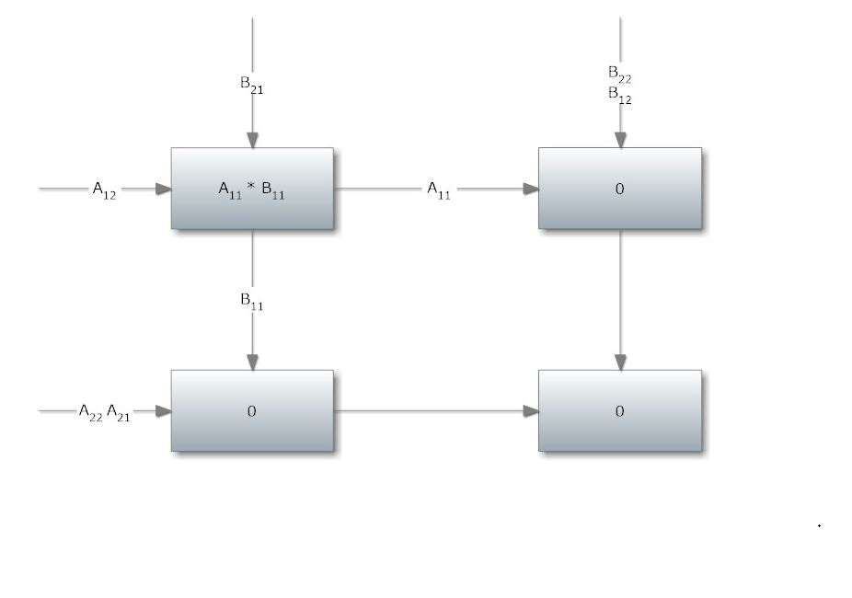 Processing elements at Step-2

Step-3:
Next series of computations are carried out. All cells except bottom right cell perform execution. 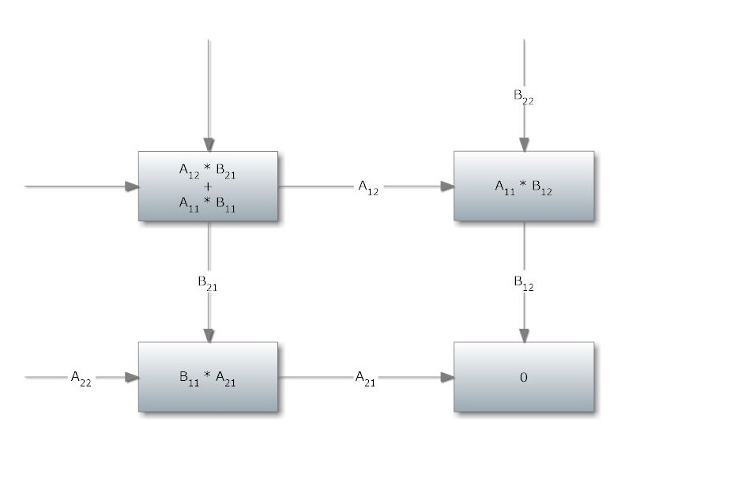
Processing elements at Step-3
Step 4:
At this step all cells except the upper-left cell executes.
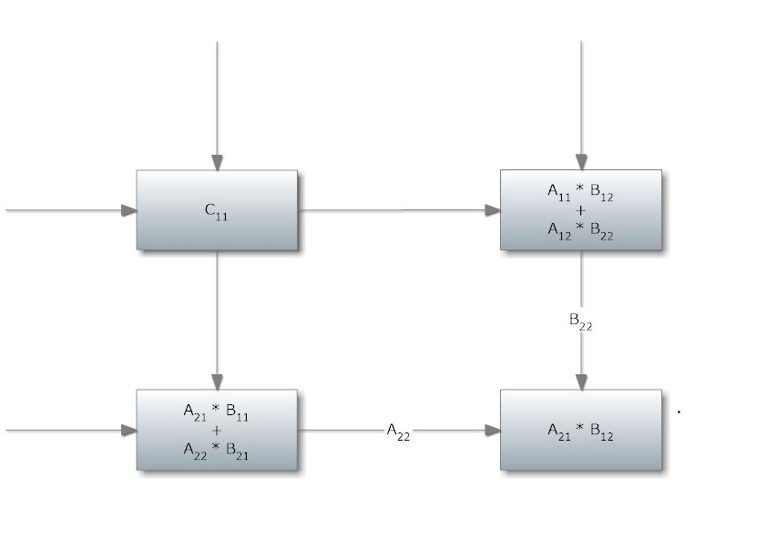 Processing elements at Step-4

Result Obtained:
At this stage registers of each execution unit stores values of the result computed.
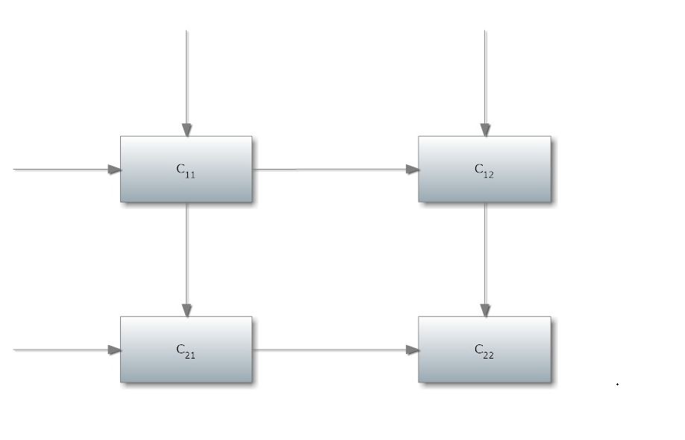

After Step-4, final results are obtained

