Module-6, Unit-3
Multi-Processor

Question 1: Describe the taxonomy introduced by Flynn for categorizing systems with parallel processing capability.

Solution 1:

Originally, the computer has been viewed as a sequential machine. Most computer programming languages require the programmer to specify algorithms as sequence of instructions. Processor executes programs by executing machine instructions in a sequence and one at a time. Each instruction is executed in a sequence of operations (fetch instruction, fetch operands, perform operation and store result). As computer technology has evolved, and as the cost of computer hardware has dropped, computer designers have sought more opportunities for parallelism, usually to enhance performance and, in some cases, to increase availability. The taxonomy first introduced by Flynn is still the most common way of categorizing systems with parallel processing capability. Flynn proposed the following categories of computer system:

- Single instruction, multiple data (SIMD) system: A single machine instruction controls the simultaneous execution of a number of processing elements on a lockstep basis. Each processing element has an associated data memory, so that each instruction is executed on a different set of data by the different processors. Vector and array processors fall into this category.

- Multiple instruction, single data (MISD) system: A sequence of data is transmitted to a set of processors, each of which executes a different instruction sequence. This structure has not gained much popularity.

- Multiple instruction, multiple data (MIMD) System:
A set of processors simultaneously execute different instruction sequences on different data sets. SMPs, clusters, and NUMA systems fit into this category. With the MIMD organization, the processors are general purpose; each is able to process all of the instructions necessary to perform the appropriate data transformation. Further MIMD can be subdivided into two main categories:

- Symmetric multiprocessor (SMP): n an SMP, multiple processors share a single memory or a pool of memory by means of a shared bus or other interconnection mechanism. A distinguishing feature is that the memory access time to any region of memory is approximately the same for each processor.

- Non-uniform memory access (NUMA): The memory access time to different regions of memory may differ for a NUMA processor.

Question 2: What is a symmetric multi-processor and what are its basic properties? Also, highlight the advantages of a symmetric multi-processor over uni-processor.

Solution 2:

A symmetric multiprocessor (SMP) can be defined as a standalone computer system with the following characteristics:

- There are two or more similar processors of comparable capability.
- These processors share the same main memory and I/O facilities and are interconnected by a bus or other internal connection scheme.
- All processors share access to I/O devices, either through the same channels or through different channels that provide paths to the same device.
- All processors can perform the same functions.
- The system is controlled by an integrated operating system that provides interaction between processors and their programs at the job, task, file and data element levels.

The organization of a multiprocessor system is shown in the figure below.

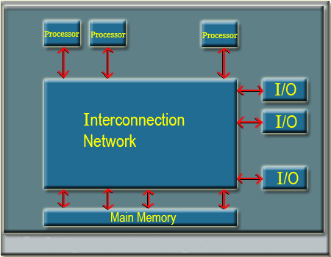
Organization of a multiprocessor system

A SMP facilitates the following.

- Performance: A system with multiple processors will perform in a better way than the one with a single processor of the same type, if the task can be organized in such a manner so that some portion of the work done can be done in parallel.

- Availability: Since all the processors can perform the same function in a symmetric multiprocessor, the failure of a single processor does not stop the machine. Instead, the system can continue to function at reduce performance level.

- Incremental growth: A user can enhance the performance of a system by adding an additional processor.

- Scaling: Vendors can offer a range of product with different price and performance characteristics based on number of processors configured in the system.

Question 3: Discuss the basic bus architecture required in a multi-processor system.

Solution 3:

Time shared bus is the simplest mechanism for constructing a multiprocessor system. The bus consists of control, address and data lines. The block diagram of time shared bus is shown in the figure below.

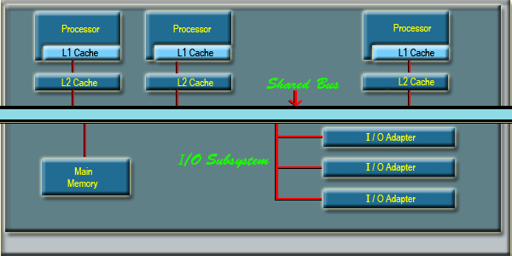

Block Diagram of a Timed Shared Bus

The following features are provided in time-shared bus organization:

- Addressing: It must be possible to distinguish modules on the bus to determine the source and destination of data
- Arbitration: Any I/O module can temporarily function as “master”. A mechanism is provided to arbitrate competing request for bus control, using some sort of priority scheme.
- Time shearing: When one module is controlling the bus, other modules are locked out and if necessary, operation is suspended until bus access in achieved.

The bus organization has several advantages compared with other approaches:

- Simplicity: This is the simplest approach to multiprocessor organization. The physical interface and the addressing, arbitration and time sharing logic of each processor remain the same as in a single processor system.
- Flexibility: It is generally easy to expand the system by attaching more processors to the bus.
- Reliability: The bus is essentially a passive medium and the failure of any attached device should not cause failure of the whole system.

The main drawback to the bus organization is performance. Thus, the speed of the system is limited by the bus cycle time.

Question 4: Discuss the basic multi-port memory architecture required in a multi-processor system. Also, highlight the benefits and issues therein.

Solution 4:

The multiport memory system is shown in the figure below.

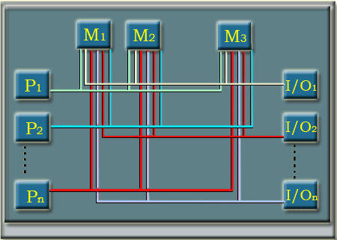
Block Diagram of a Multi-port Memory

The multiport memory approach allows direct, independent access of main memory modules by each processor and I/O module. However, this approach is more complex than the bus approach, requiring a fair amount of logic to be added to the memory system. Logic associated with memory is required for resolving conflict. The method often used to resolve conflicts is to assign permanently designated priorities to each memory port.

Non- uniform Memory Access (NUMA)

In NUMA architecture, all processors have access to all parts of main memory using loads and stores. The memory access time of a processor differs depending on which region of main memory it accessed. However, for different processors, which memory regions are slower and which are faster may differ.

A NUMA system in which cache coherence is maintained among the caches of the various processors is known as cache-coherence NUMA (CC-NUMA)

A typical CC-NUMA organization is shown in the figure below.

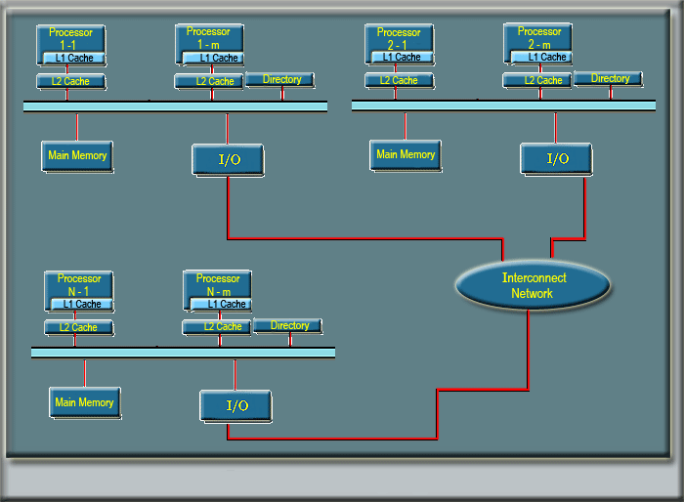
Block Diagram of CC-NUMA organization

As seen in the figure, there are multiple independent nodes, each of which, in effect, follows an SMP organization. Each node contains multiple processors, each with its own 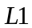 and 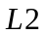 caches, plus main memory. The node is the basic building block of the overall CC NUMA organization. The nodes are interconnected by means of some communication facility, which could be a switching mechanism a ring, or some other networking facility.

From the point of view of the processors, there is only a single addressable memory, with each location having a unique system-wide address. When a processor initiates a memory access, if the requested memory location is not in the processor’s cache, then the cache initiates a fetch operation. If the desired line is in the local portion of the main memory, the line is fetched across the local bus. If the desired line is in a remote portion of the main memory, then an automatic request is send out to fetch that line across the interconnection network, deliver it to the local bus, and then deliver it to the requesting cache on that bus. All of this activity is atomic and transparent to the processors and its cache.

In this configuration, cache coherence is a main concern. For that each node must maintain some sort of directory that gives it an identification of the location of various portions of memory and also cache status information.

