Module-6, Unit-4

Interconnection Networks

Question 1: What is the simplest and most economical means of interconnecting modules in multi-processor systems? Discuss the performance issues with such an Interconnection network.

Solution 1:

In a multiprocessor system, the interconnection network must allow information transfer between any pair of modules in the system. The traffic in the network consists of requests (such as read and write), data transfers, and various commands.

The simplest and most economical means of interconnecting a number of modules is to use a single bus. Since several modules are connected to the bus and any module can request a data transfer at any time, it is essential to have an efficient bus arbitration scheme. In a simple mode of operation, the bus is dedicated to a particular source-destination pair for the full duration of the requested transfer. For example, when a processor uses a read request on the bus, it holds the bus until it receives the desired data from the memory module. Since the memory module needs a certain amount of time to access the data, the bus will be idle until the memory is ready to respond with the data. Then the data is transferred to the processor. When this transfer is completed, the bus can be assigned to handle another request.

A scheme known as the split-transaction protocol makes it possible to use the bus during the idle period to serve another request. Consider the following method of handling a series of read requests possibly from different processors. After transferring the address involved in the first request, the bus may be reassigned to transfer the address of the second request; it is assumed that this request is to a different memory module. At this point, we have two modules proceeding with read access cycle in parallel. If neither module has finished with its access, the bus may be reassigned to a third request and so on. Eventually, the first memory module completes its access cycle and uses the bus to transfer the data to the corresponding source. As other modules complete their cycles, the bus is needed to transfer their data to the corresponding sources.

The split transaction protocol allows the bus and the available bandwidth to be used more efficiently. The performance improvement achieved with this protocol depends on the relationship between the bus transfer time and the memory access time. In split- transaction protocol, performance is improved at the cost of increased bus complexity. There are two reasons why complexity increases:
- Since a memory module needs to know which source initiated a given read request, a source identification tag must be attached to the request.
- Complexity also increases because all modules, not just the processor, must be
able to act as bus muster.

The main limitation of a single bus is that the number of modules that can be connected to the bus is not that large. Networks that allow multiple independent transfer operations to proceed in parallel can provide significantly increased data transfer rate.

Question 2: What is Crossbar Network and how is it better than single bus interconnecting system? Discuss the major design issues with Crossbar Network.

Solution 2:

Crossbar switch is a versatile switching network. It is basically a network of switches. Any module 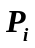 can be connected to any other module 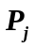 by closing the appropriate switch. Such networks, where there is a direct link between all pairs of nodes are called fully connected networks.
In a fully connected network, many simultaneous transfers are possible. If n sources need to send data to n distinct destinations then all of these transfers can take place concurrently. Since no transfer is prevented by the lack of a communication path, the crossbar is called a non-blocking switch.
The figure given below illustrates a crossbar interconnection network. A single switch is shown at each cross point. In actual multiprocessor system, the paths through the crossbar network are much wider.

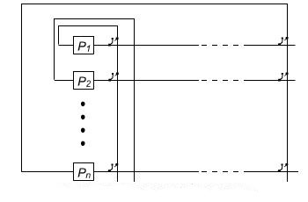
Crossbar interconnection network

If there n are modules in a network, than the number of cross point is n² in a network to interconnect n modules. The total number of switches becomes large as n increases. In a crossbar switch, conflicts occur when two or more concurrent requests are made to the same destination device. These conflicting requests are usually handled on a predetermined priority basis.

The crossbar switch has the potential for the highest bandwidth and system efficiency. However, because of its complexity and cost, it may be cost effective for a large multiprocessor system.

Question 3: What is Multistage Network and how is it better than single bus or Crossbar interconnecting systems?

Solution 3:

The bus and crossbar systems use a single stage of switching to provide a path from a source to a destination. In multistage network, multiple stages of switches are used to setup a path between source and destination. Such networks are less costly than the crossbar structure, yet they provide a reasonably large number of parallel paths between source and destinations.

In the figure below, it shows a three-stage network that called a shuffle network that interconnects eight modules. The connection path between 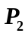 and 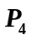 is indicated by RED lines in the figure.

The term "shuffle" describes the pattern of connections from the outputs of one stage to the inputs of the next stage. The switchbox shown in the figure is a 2x2 switch that can route either input to either output. If the inputs request distinct outputs, they can both be routed simultaneously in the straight through or crossed pattern.
If both inputs request the same output, only one request can be satisfied. The other one is blocked until the first request finishes using the switch.

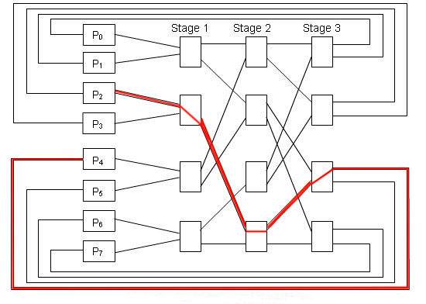
Multistage Shuffle Network

A network consisting of s stages can be used to interconnect 2^{S} modules. In this case, there is exactly one path through the network from any module to any module . Therefore, this network provides full connectivity between sources and destinations. However, many request patterns cannot be satisfied simultaneously. For example, the connection from P₂ to P₇ cannot be provided at the same time as the connection from P₃ to P₆.

A multistage network is less expansive to implement than a crossbar network. If n nodes are to be interconnected using this scheme, then we must use 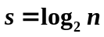 stages with n/2 switches per stage. Since each stage contains four switches, the total number of switches is
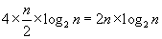
which, for a large network, is considerably less than the n² switches needed in a crossbar network. Multistage networks are less capable of providing concurrent connection than crossbar switches.

Question 4: Discuss some interconnecting architectures suitable to connect large number of processors?

Solution 4:

A hypercube is an n-dimensional cube that interconnects 2^{n} nodes, and is suitable for systems with large number of nodes. In addition to the communication circuit, each node usually includes a processor and a memory module as well as some I/O capability. The following figure shows a three dimensional hypercube. The small circles represent the communication circuits in the nodes. The edges of the cube represent bi-directional communication links between neighboring nodes.

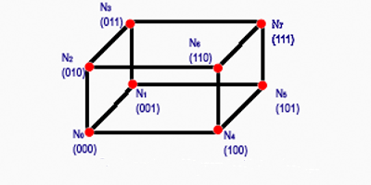
A 3-dimensional Hypercube Network

In an n-dimensional hypercube each node is directly connected to n- neighbors. A useful way to label the nodes is to assign binary addresses to them in such a way that the addresses of any two neighbors differs in exactly one bit position. The functional units are attached to each node of the hypercube.

Routing messages through the hypercube is easy. If the processor at node 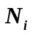 wishes to send a message to node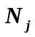, it proceeds as follows:
- The binary addresses of the source, i, and the destination, j, are compared from least to most significant bits.
- Suppose that they differ first in position P.
- Node then sends the message to its neighbor whose address, k , differs from i in bit position P.
- Node 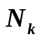 forwards the message to the appropriate neighbor using the same address comparison scheme.
- The message gets closer to destination node with each of these hops from one node to another.

For example, a message from node 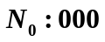 to 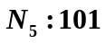 transverses in the following way:
- Message traverses from node 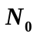 to N₁, as they differ in 1st bit position.
- Then message traverses from 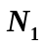to 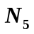, they differ in 3rd bit position. Therefore, it takes two hops.
The maximum distance that any message needs to travel in a n- dimensional hypercube is n-hops.

Mesh networks

Mesh network is another way to interconnect a large number of nodes in a multiprocessor system. An example of a mesh with 16 nodes is given in the figure below.
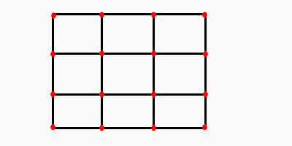
A 2-D Mesh Network

The links between the nodes are bi-directional. The functional units are attached to each node of the mesh network. Routing in a mesh network can be done in several ways. One of the simplest possibilities is to choose the path between a source node and a destination node such that the transfer first takes place in the horizontal directional from towards . When the column in which resides is reached, the transfer proceeds in the vertical direction along this column.

Question 5: Discuss some interconnecting architectures suitable to connect processors in hierarchical scheme?

Solution 5:

A hierarchically structured network implemented in the form of a tree is another interconnection topology. A four way tree that interconnects 16 modules is shown in the figure below. In this tree, each parent node allows communication between two of its children at a time. An intermediate-level node, for example node A in the figure, can provide a connection from one of its child node to its parent. This enables two leaf nodes that are any distance apart to communicate. Only one path at any time can be established through a given node in the tree.
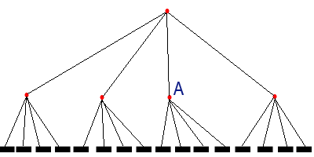
A four way Tree Network

To reduce the possibility of a bottleneck, the number of links in the upper levels of a tree hierarchy can be increased. This is done in a fat tree network, in which each node in the tree (except at the top level) has more than one parent. The figure below shows a fat tree in which each node has two parents.

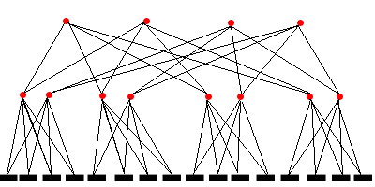
A Fat Tree

